Google Ads API — Tool Design Document
Company: Alleviate Lab
Product: Duct · https://getduct.ai
Location: Valencia, Spain
Contact: hello@getduct.ai
Version: 2.0
Updated: April 2026

1. Company Name
Alleviate Lab (product: Duct — https://getduct.ai)

2. Business Model
Duct is a software product built by Alleviate Lab that helps advertisers understand Google Ads performance through structured reports and goal-oriented analysis (for example: efficiency, ROAS, scaling, or spend audits). We are not a traditional agency managing third-party ad accounts as the primary business, though end users (including marketers and agencies) may use Duct with their own Google Ads accounts where permitted.
We use the Google Ads API only to read performance and account metadata that the authenticated user is authorized to access. We do not use the API to create Google Ads accounts, create or edit campaigns or ads, or to run Keyword Planner as a service.

3. Tool Access / Use

Who uses the tool
- Primary: Authenticated users (internal team during development; external customers as the product matures) who connect their Google Ads account via OAuth and run reports on demand.
- Access model: Users initiate a report generation flow in the web app: they choose Google Ads as a data source, select an account, an analysis goal, optional business context, and a date range. The backend calls the Google Ads API with that user’s OAuth credentials and returns a structured report rendered in the UI. Users may save reports locally; production deployments persist reports according to our data policy.

What we do not do
- We do not expose our developer token to third-party tools.
- We do not run scheduled batch jobs that mutate Google Ads entities. Duct is read-only toward Google Ads.
- We do not grant agency partners direct login unless they are normal product users.

4. Tool Design
Duct is a three-tier web application: a browser-based client, a server-side backend, and the Google Ads API (read-only). Users authenticate via Google OAuth with the Google Ads scope, then request on-demand reports. The backend fetches performance data via GAQL queries, normalizes it into a structured report, and optionally adds AI-powered narrative synthesis. No data is written back to Google Ads.

5. API Services Called (Read-Only)
All access is read-only via the Google Ads Reporting API (GAQL) and the Customer Service for account discovery. We do not call any mutate or write services.
Purpose | Google Ads API Usage
List accessible accounts | Customer Service — list accessible customers; then query account metadata (id, name, currency, time zone, manager flag).
Campaign performance | Reporting API — query campaign resource with date segments, performance metrics (clicks, impressions, cost, conversions, conversion value), and channel type. Excludes removed campaigns.
Search terms (top by spend) | Reporting API — query search term view.
Device segmentation | Reporting API — query campaign resource with device segment.
Geography | Reporting API — query geographic view.
Ad group rollups | Reporting API — query ad group resource.

Campaign types: We do not filter by channel; any non-removed campaign returned by reporting is in scope (Search, Performance Max, Display, Shopping, Video, etc., per Google’s classification).

6. Security and Compliance
- Transport: HTTPS between client and backend.
- Authentication: API key on protected backend routes; OAuth 2.0 for Google Ads access.
- Secrets: Developer token, OAuth client secret, and other credentials are server-side environment variables, not committed to source control.
- Logging: We do not log OAuth refresh tokens. Operational logs may record customer ID and errors for support.
- Token handling: Aligned with Google’s OAuth and Ads API policies; server-stored refresh tokens per end-user account for production.
- Compliance: We comply with the Google Ads API Terms of Service and Required Minimum Functionality (RMF) requirements for reporting tools.

7. Tool Mockups / Screenshots
Below is a prototype of the primary reporting UI. Additional captures of the connection and report generation flows are available on request.

Prototype — Paid Ads Performance Report
This screen shows how users view Google Ads performance: headline ROAS with period-over-period context, spend sparkline, ROAS by campaign, key metric cards (CPA, spend, conversions) with trend indicators, and a signals section for notable issues.
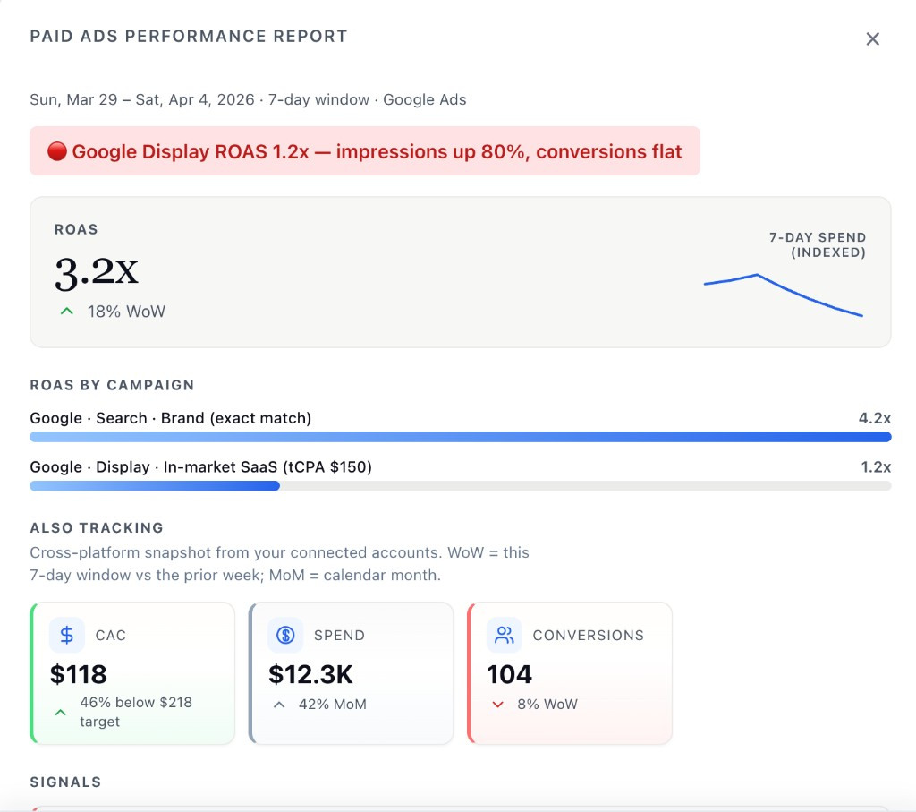
Figure 1: Prototype report surface. Production UI is data-driven from live Google Ads data.

8. Core Business Model (Detailed)
Duct (getduct.ai) is a B2B SaaS product built by Alleviate Lab, based in Valencia, Spain. Our customers are performance marketers and growth teams at small-to-mid-size companies (typically 20–200 employees) who run paid advertising across multiple platforms — Google Ads, Meta, LinkedIn, and others — and currently have no unified way to understand how those platforms interact.
The value exchange is straightforward: customers connect their advertising accounts to Duct via OAuth, and Duct delivers structured performance intelligence — on-demand reports and scheduled daily briefs — that surface what’s working, what’s inefficient, and what requires attention, in plain language. We charge a recurring SaaS subscription (currently in free beta while onboarding the first cohort of teams).
The problem we solve is time: our target customer spends 4–8 hours per week manually pulling data from multiple ad platforms, correlating it in spreadsheets, and writing internal summaries. Duct eliminates that entirely by reading and synthesising the data automatically, then generating narrative reports with cross-platform signals — for example, flagging that Google Search ROAS dropped 18% in the same week a competitor launched a new campaign, while Meta spend held steady.

9. Functional API Necessity
Google Ads API access is essential because Duct’s entire reporting layer is built on live account data. Specifically, we use the following API services:
Customer Service — to enumerate accessible Google Ads accounts when a user connects via OAuth, allowing them to select which account(s) to report on.
Reporting API (GAQL) — for all performance data. The specific resources we query:
- campaign — Campaign-level spend, clicks, impressions, conversions, ROAS-related metrics, segmented by date and device
- ad_group — Ad group rollups within campaigns
- search_term_view — Top search terms by spend, for search query analysis
- geographic_view — Geographic performance segmentation
- customer — Account metadata (currency, time zone, manager flag)
All access is strictly read-only. We do not call any mutate services. We do not use Keyword Planner, bidding automation, or any campaign management endpoints.
This access is critical because the intelligence Duct delivers is only meaningful when it reflects a customer’s actual live account. A user asking “why did my ROAS drop last week?” requires their real campaign data, real spend figures, and real conversion events — not synthetic test data. The cross-platform correlations (e.g. comparing Google Ads search term trends against GA4 landing page bounce rates) only produce actionable signals when drawn from live production accounts.

10. Operational Impact if Restricted to Test Accounts
Test account restriction would make the product non-functional for all end users. The entire user journey is:
- User connects their Google Ads account via OAuth
- User requests a report on their real account and date range
- Duct fetches live data, synthesises it, and returns a structured brief
There is no version of this workflow that operates on test account data, because the user’s goal is always to understand and act on their own live campaigns. Restricting us to test accounts would mean we could not serve a single paying customer — the product simply would not work.
For context, we are currently in a closed beta with a small number of real advertisers who have explicitly connected their accounts and are using Duct to generate weekly performance briefs. Production API access is required to continue serving them.

End of document.

