DSA Project 2
Group 12

2026

Programming Questions
- Snakes and Ladders
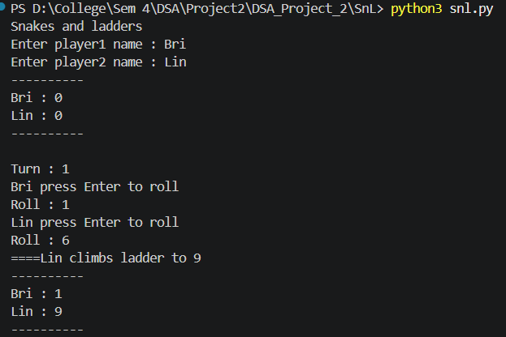
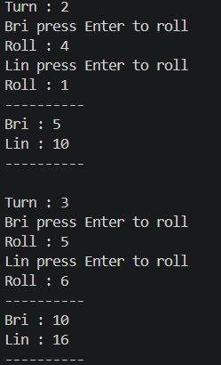
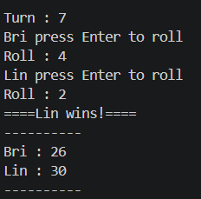
- Student Records

- Library System

Research questions
1. How does using a dictionary compare to a 1D list in terms of:
- Lookup Efficiency
- Memory Usage
Ans :- Lookup Efficiency
Both Dictionary and list would give an average lookup efficiency of O(1). In the case of Snakes and ladders since we know which index has
snakes and ladders we do not need to use a loop to search through the list if we encounter snake or ladder.
Memory Usage
Dictionary is better at memory management as we only need to store the positions of snakes and ladders whereas for list we would have to
leave empty spaces for the positions where snakes and ladders do not exist.

2. What are the advantages of using a hash table over a sorted list for:
- Retrieving student records
Ans :-
Advantages of hash table over sorted list for student records:
- Hash table provides average O(1) search, insert, delete.
- Sorted list requires O(log n) search (binary search) but O(n) insert/delete due to shifting elements.
- Hash table is better for dynamic data with frequent updates.
- Sorted list only beneficial if sorted order is needed for range queries.
3. How do different tree traversal methods serve distinct purposes?
- In-order Traversal
- Pre-order Traversal
- Post-order Traversal
Ans :- In order traversal is primarily used for sorting. Since the BST is organized by book titles, in-order traversal visits the nodes in
ascending alphabetical order. This would generate an alphabetically sorted catalog.
Pre-order traversal can be used for cloning or exporting the tree structure. For example if you need to save the library database to a file
such as json and want to rebuild it later, pre-order is best. By recording the root first, you ensure that when the data is re-inserted, the tree
maintains its original shape and balance.
Post-order traversal is used for deletion or memory cleanup. For languages such as C++ where memory is managed by the programmer, the root must be deleted last
or else there will be dangling pointers and memory leaks. Thus the best way to delete is the left then right then root. Post-order ensures you don't lose the pointers
to the sub-branches before they are processed which makes it the safest way to deallocate memory. (Though for python's garbage collector, we don't need to worry about that)

4. What are the Big-O time complexities of:
- Dictionary Operations
- Binary Search Tree (BST) Operations
- Best Case
- Worst Case
Ans:-
Dictionary (Hash Table)
Insertion
Best/Average case O(1): Insertion uses a hash function to compute an index for the key, allowing the value to be placed directly into the table without needing to traverse other elements.
Worst case O(n): If many keys collide and map to the same index, the dictionary may need to check multiple existing elements, resulting in linear time behavior.
Search
Best/Average case O(1): The key is hashed to directly access its corresponding value, making lookup extremely fast regardless of the size of the dictionary.
Worst case O(n): In the event of excessive hash collisions, the dictionary may need to scan through multiple elements stored at the same location.
Deletion
Best/Average case O(1): The key is hashed to locate and remove the element directly without scanning the entire structure.
Worst case O(n): Similar to insertion and search, collisions may require checking multiple elements before deletion.
Traversal
All cases: O(n): Every key-value pair must be visited once when iterating through the dictionary.

BST
Insertion
Best/Average case O(log n): Insertion for a relatively balanced tree traverses down one specific path which effectively cuts the number of remaining nodes to check in half
(similar to binary search) at each step
Worst case O(n): The tree is "skewed" and is one long chain effectively a linked list. This can occur if the tree is constructed/inserted with alphabetically sorted titles.
This results in a one long branch. Because you have to traverse that entire chain (to insert for example Z), every node has to be visited.
Search
Best/average case O(log n): For a balanced tree the search time is logarithmic because you eliminate half of the remaining books with every step.
Worst case O(n): If the books are added in perfect alphabetical order, the tree becomes "skewed" essentially having very long chained subtrees.
This is essentially a linked list and thus would require you to check every single book to find the one you want.
Traversal (in, pre, post)
All cases: O(n). All nodes have to be visited once.
5. How would you improve the game to support:
- Multiple Players
- GUI Interface
- Persistent Game State
Ans :-
Multiple players
Game can ask in the beginning for total players and then use loop to add all players to a dictionary with all values to 0 as initial or starting positions.
GUI Interface
GUI can be implemented using libraries such as Tkinter or Pygame. Instead of printing outputs to the console, the board can be visually displayed with numbered tiles, and player positions can be represented using icons or markers. Buttons can be added for actions like rolling the dice, and animations can be used to show player movement, snakes, and ladders.
Persistent game state
To support persistent game state, the game can save player positions and other relevant data to a file. When the game starts, it can check if a saved file exists and load the previous state, allowing players to continue from where they left off. This prevents loss of progress.

Group 12
# | Name | ID
1 | Shubhkarman Saharan | 164698219
2 | Brian Wu | 182531236
3 | Linsheng Zhang | 120073242

