***Artificial Cow Intelligence Milk***

***Members***

Waranthorn Chansawang

Pasit Sriwatanasak

***Advisor***

Khunthong Klaythong

***Abstract***

Nowadays, technology has a great impact on living, whether it is a computer, smartphone, making our lives easier. Every age period takes advantage of different technologies, it is said to be artificial intelligence can be changed the world to the digital age.

Childhood is a requirement for learning. It is open to many things that adults but in some children with slow development. Whether it is the body, emotional, learning and symptomatic expression such as muscle weakness. The relationship between the hands and the eyes of ADHD is a problem that should be resolved quickly. By using existing technology to create a work that attracts the attention of this group. To develop the body, learning and emotional.

This has made our education even more evolving. For the development of the muscles of the body, we see that it should develop in the matter of the finger first because of the study of the finger to hold devices such as pencil or pen. So the child development is delayed. Muscular development is slow as well. Should develop the muscles along with the development of learning to learn. Better performance.

***Introduction***

Among lots of shared ideas, select one that is the most cost-efficient and creative solution. It can be used with conventional technology or future technology. To provide a visual aid to others, describe the selected idea in a sheet.

For innovation, inventors designed the equipment to attract and strengthen such aspects with AI technology as a characteristic of an Artificial Cow Intelligence Milk Doll where the stomach will have a monitor. The monitor of the abdomen, and the belly of the stomach has breast milk to allow the child to strengthen the development of the hand muscles. The equipment use easily to study and your child's reach, and has a passionate color. Help kids to match colors and characters as learning by using color as the main factor in brain development and computational dexterity.

***Materials and Methods***

**Materials and tools.**

1. Computer

2. Unity

3. Raspberry Pi R3

4. Squeeze Ball

5. Monitor

**Method**

1. Think of the project topics, study the details. Find a teacher Find out more.

2. Learn about Unity. How to use and programmatically control or read.

3. Make a draft of the project to draft. Plan for working, and design prototype workflows.

4. Create a prototype of Artificial Cow Intelligence Milk based on design and planning.

5. Make a poster.

6. Prepare a project report.

7. Evaluation by teachers, students and interested persons.

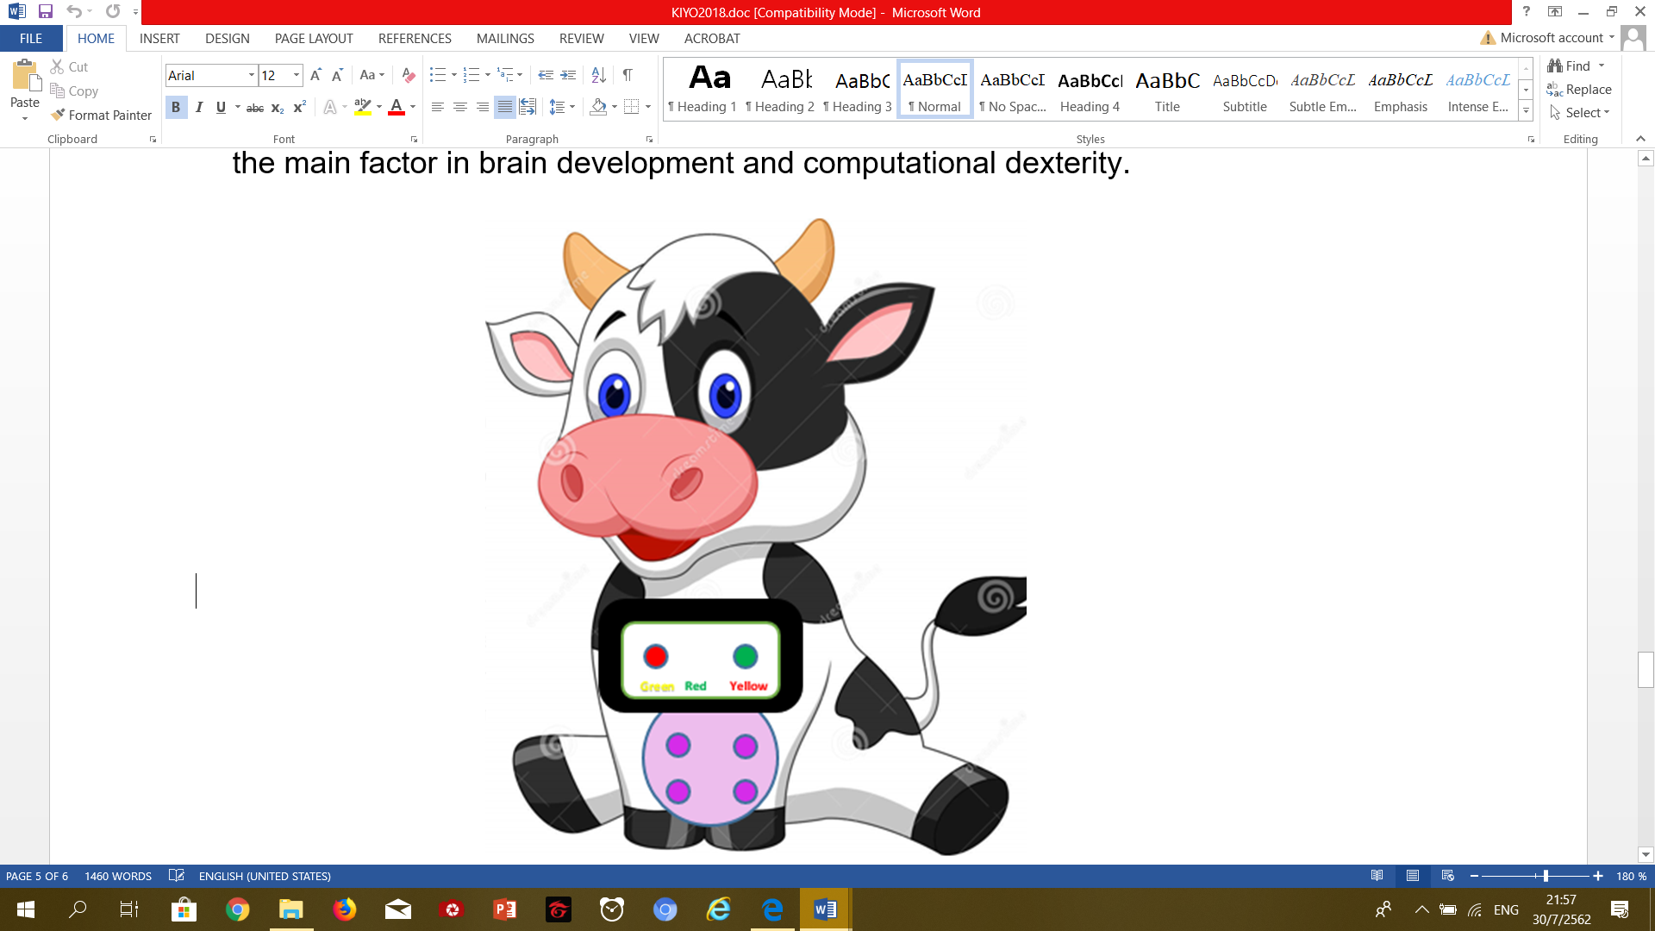

Figure 1. Prototype Image

***How to play***

1. Understanding Color Theory
2. Remember the opposite color

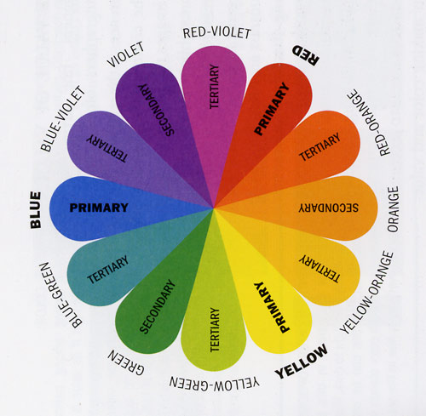

1. The first color bar moves to the right
2. Message bar moves to the left
3. Message bar moves to the left and Push

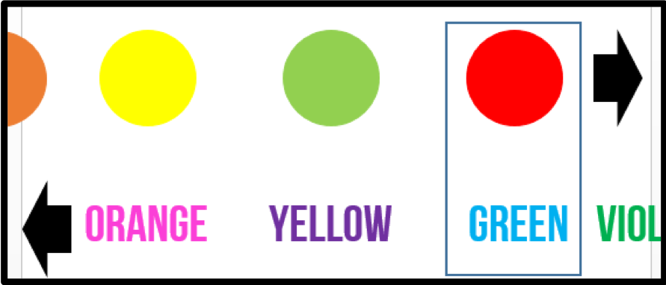

Figure 2. Game play

***Conclusions***

1. The prototype that we do are not available at this time but we will develop this in the future by using real Artificial Intelligence to analysis the children who play Artificial Cow Intelligence Milk by collecting data from children answer the color.

2. We will have to do an assessment for develop Artificial Cow Intelligence Milk in the future for can actually be used.

***Acknowledgments***

This project is a computer project on the “Artificial Cow Intelligence Milk” that can be the first prototype with well by the introducing and we are thankful for the encouragement from many people. Teacher Khunthong Klaythong and Supavitch Sangsuwan, thank you all for your patience and support.

***References***

1. Color theory and line drawing from http://www.thaigoodview.com/node/94096