1. Magic: The Gathering (MTG) is a card game that aj. Toe plays (he also plays Yu-Gi-Oh). A Card in this game has the following properties (this exercise only considers a subset of this game):

Casting cost (total = 7 here, with red and white )

Casting cost has 0 or more generic color and other mixed of 5 colors:

white, blue, black, red, green

This is also a card color. a card that has more than one color is “multicolor”. A card that only contains generic color is “colorless”.

A land costs 0. An “X” is considered to cost 0.

Card Name

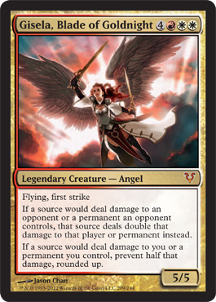

Card Type:

Creature, Spell, Land.

(Spell is something that is not Creature and not land)

Toughness (only for creature).

Power (only for creature).

Card text.

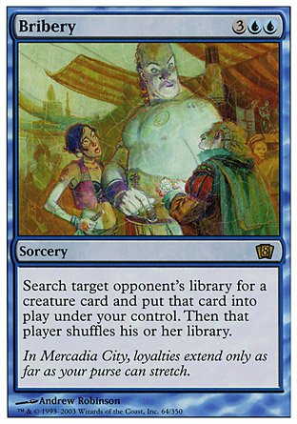Example of a spell card (total casting cost = 5)

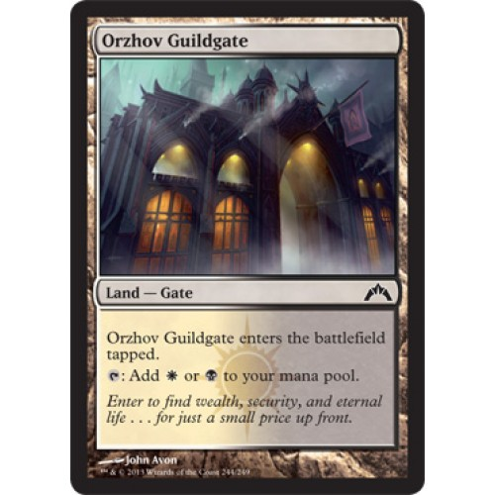Example of a land card.

A deck of cards in a deck management program contains more than one copies of each card. It has the following method:

**public void readDeck(String fileName)**

* read cards from file and store them in the deck.
* the file is one line per one card name. It has the following format:

cardtype, cardname, cost, text, power, toughness, number of cards

power and toughness are null if the card is not creature

Casting cost is represented using consecutive letters: number for colorless cost, W for white, U for blue, B for black, R for red, G for green.

An example:

Artifact Creature, Ornithopter, 0, Flying, 0, 2, 4

Creature, Glint-Nest Crane, 1U, Flying When…, 1, 3, 4

Sorcery, Battle at the Bridge, XB, Improvise…, null, null, 4

Enchantment, Tezzeret’s Touch, 1UB, Enchant artifact…, null, null, 4

Land, Evolving Wilds, 0, tap sacrifice…, null, null, 4

**public void printByType()**

* This method prints out all cards in the deck, sorted by type. One card name per 1 line.

Cards are sorted by type using the following rules:

* + creature comes before spell, spell comes before lands.
  + if cards are the same type, then the smaller total casting cost comes first.
  + if cards are the same type and have the same cost, then it is organized alphabetically by name.

**public void printByColor()**

* This method prints out all cards in the deck, sorted by color. One card name per 1 line.

Cards are sorted by color using the fillowing rules:

* + white < blue < black < red < green < multicolor < colorless < land
  + if cards are the same color, then the smaller total casting cost comes first.
  + if cards are the same color and have the same cost, then it is organized alphabetically by name.

Design class Deck (design variables and methods!) and any additional classes as necessary, for storing and sorting the cards.

Decked Builder, a program that inspires this exercise, is available at <http://www.deckedbuilder.com/>

A deck file that keeps a deck example, in Decked Builder format, is given with this exercise.

A deck file for this exercise is also given (the file name is Thopter.txt).

A call to main like this:

**public** **static** **void** main(String[] args) {

Deck d = **new** Deck();

d.readDeck();

d.printByType();

System.***out***.println("-----------------------");

d.printByColor();

}

should print out the following (power and toughness are not printed for non-creature cards):

