**Lab 5**

1.

A’ + B’D + C’D

2. 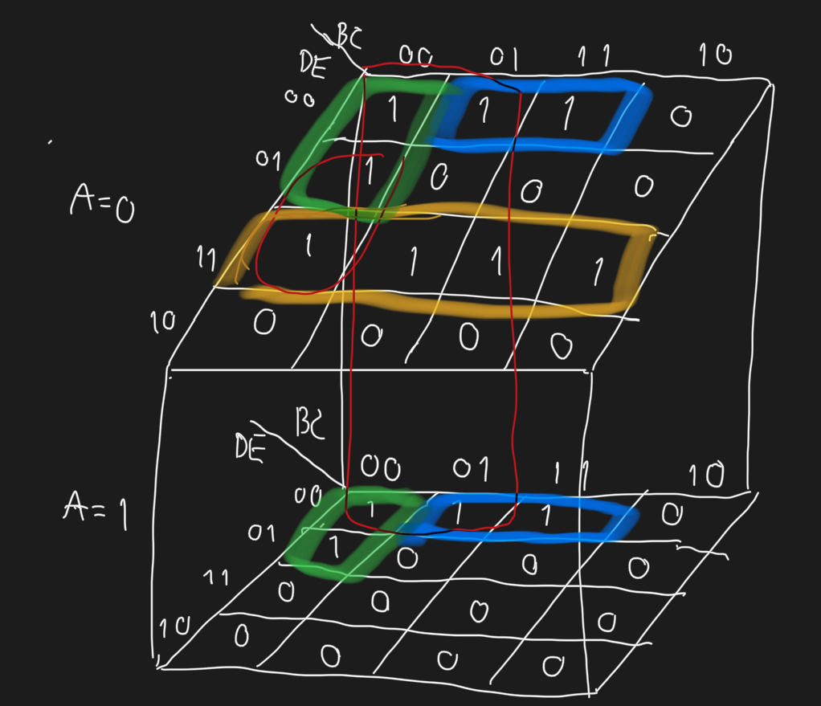

B’C’D’ + CD’E’ + A’DE + A’B’C’E + B’D’E’