**ข้อสอบย่อยครั้งที่ 1 วิชา 2110356**

**ภาคต้น ปีการศึกษา 2561 เวลา 90 นาที**

**ชื่อ-นามสกุล ………………………………… รหัสนิสิต …………………… ตอนเรียน………**

Creativity is ***always*** welcome as long as you can ***provide*** a good ***reason***.

***Communication Protocol***

1. Given the following timing diagram:

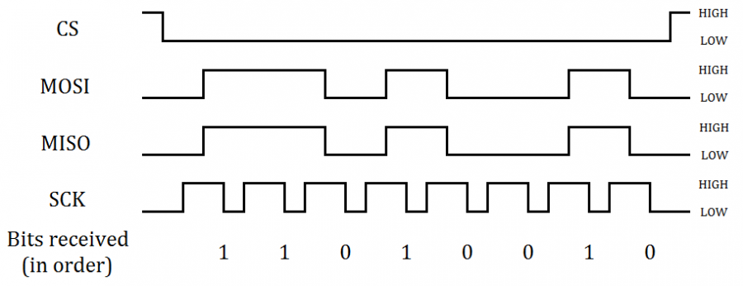

Answer the following questions

* 1. Is it asynchronous or synchronous? State your reasons.
  2. How many bits per data word? Would it be possible to extend to 16-bits or 32-bits?
  3. The current communication has one master and one slave. Draw a diagram describing how one would extend it to one master and 3 slaves using a daisy chain.

1. Suppose that you are building a low-power IoT devices and is required to connect many temperature sensors. What are the protocol you would choose for the communications? Given a clear concise reason

***Operational Amplifier***

1. Assume the op-amp is ideal, find V0 based on a step-by-step analysis of op-amp properties. (5 pts)



1. Draw an amplifier circuit such that $v_{o}={5 v}_{i}$ (3pt)
2. Find the relationship of $R_{1}{,R}_{2},R_{3},R_{4}$ such that the circuit has common mode rejection, i.e. $v_{o }=A{(v}_{I2}-v_{I1})$ regardless of the average values of $v_{I1}$ and $v_{I2}$. Show all your analysis.

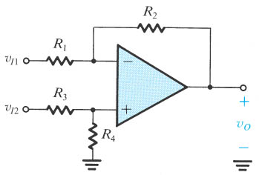

***Feedback Control & PID***

1. What is a gain of a system?
2. Given the following diagram

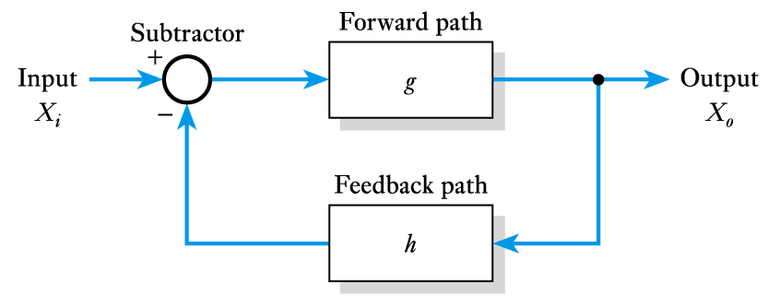

What is the condition(s) that makes the system has negative feedback?

1. Suppose that you are building a simple control system that has only P component. However, the system never reach the set point similar to the following graph

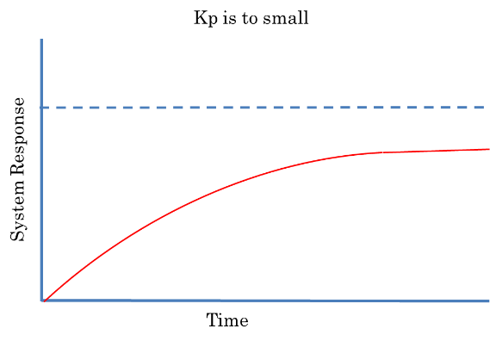

What would you do so that the system reach the set point? Give your reasons.

Interrupt, DMA and Booting Process

1. While DMA does not require CPU to process data from I/O, the CPU may still need to stall. Why? What is it called?
2. Suppose that you are writing a vending machine with a display, user inputs and a motor control system that use PID for control. How would you set the interrupt priority among the device and process? Why?
3. Most system set PC to 0x00000000 at boot time, however, many system allows booting from several devices such as flash, memory or external communication. However would it know how to boot a different system? Give an example of a method.