**API Security**

1. Capture your Postman screen to show that you logged out successfully. An example is in Slide#13.

2. Capture your Postman screen to show that you prevent SQL injection successfully. An example is in Slide#17.

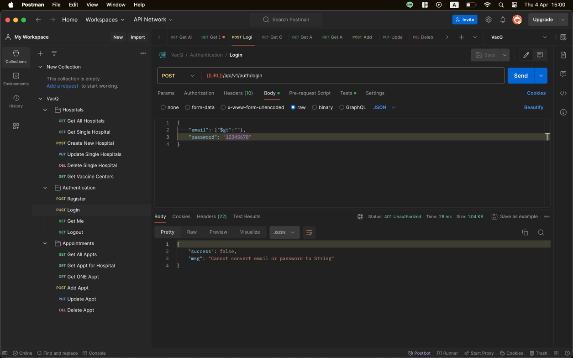

3. Capture your Postman screen to show that you apply Helmet successfully. An example is in Slide#20.

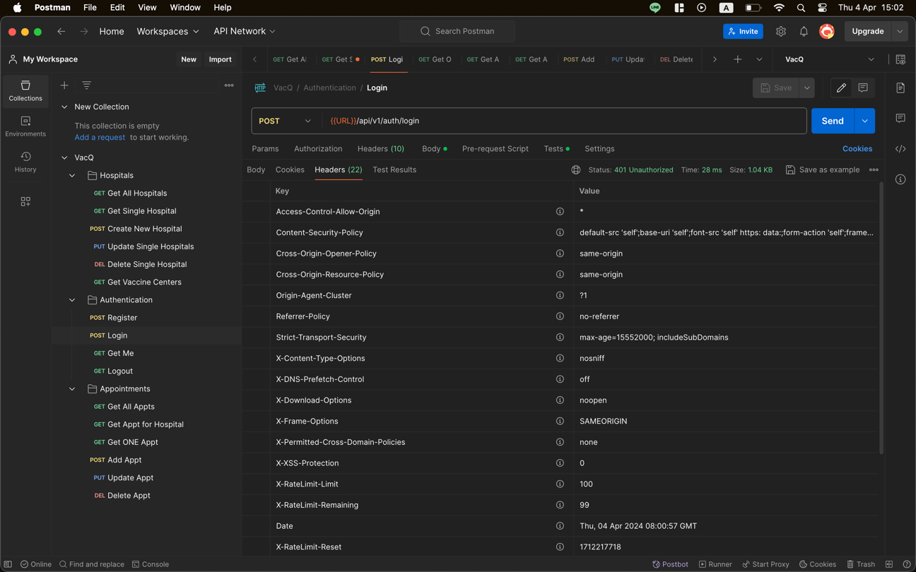

4. Capture your Postman screen to show that you prevent XSS successfully. An example is in Slide#24.

5. Capture your Postman screen to show that you apply Express-rate-limit successfully.

**Open API**

1. Capture your Api-docs screen to show that you add the following items:
   1. Hospital tag
   2. get all hospitals
   3. get one hospital
   4. add one hospital
   5. update the hospital
   6. delete the hospital to your OpenAPI document successfully. An example is in Slide#33.

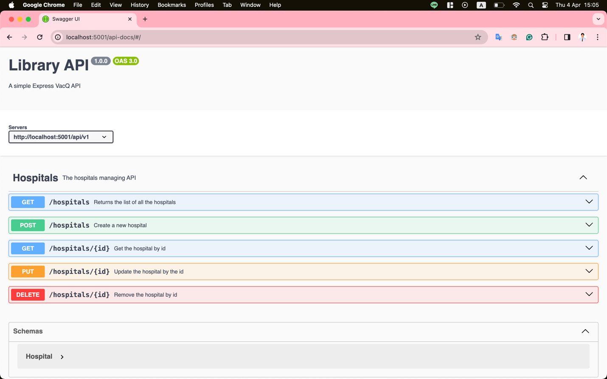

2. Capture your Api-docs screen to show that you add the server url to your OpenAPI document successfully. Also show that you can excute the get-all-hospitals API using your Api-Docs. An example is in Slide#35 and 37.

