**22100409 Siaw Jia Yuin**

**FlexBison program**

**Build command:**

bison -d calcParser.y

flex calcScan.l

gcc calcParser.tab.c lex.yy.c -o calcParser -lfl

./calcParser < *input txt file*

**Running output:**

Input1.txt:

Input2.txt

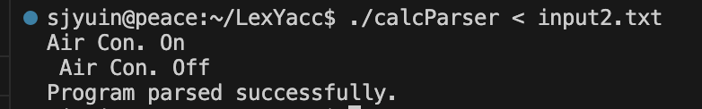

Input3.txt

