Background Information and Experiment Brainstorm

Table of Contents

- Reading - Understanding Bioremediation
- Activity - Chemical Case Study Jigsaw
- Activity - Get to Know Fast Plants
- Notes - Independent & Dependent Variables
- Brainstorm-Experiment Design

Reading-Understanding Bioremediation

Directions: Read the background information in Part 1 while answering the reflection questions for each section. Remember to highlight key terms or information that you think is important. In Part 2, read and summarize two Bioremediation case studies of your choice. You will share what you read with your teammates.

Part 1: Background Reading

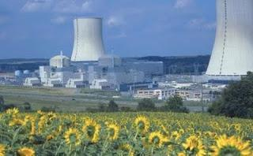
What is Bioremediation? What are different types of Bioremediation?
In biology you are researching how living organisms can be used to clean harmful substances, or toxins, out of air, soil and water. This process of using living organisms like bacteria, plants, or fungus to remove toxins from the environment is called bioremediation. Phytoremediation and mycoremediation are two kinds of bioremediation. Phytoremediation refers to using plants to remove toxins from the environment. Mycoremediation refers to using fungi (mushrooms) to remove toxins from the environment. Scientists can use these living organisms to remove harmful substances like oil, pesticides, nuclear waste, and/or heavy metals like mercury, zinc and copper from the soil.
One example of phytoremediation is when sunflowers are used to remove nuclear waste from the sites of nuclear disasters. In 1994, sunflowers were planted at Chernobyl in the Ukraine, the site of a nuclear accident in 1986. After the earthquake and tsunami in 2011, sunflowers were planted at nuclear power plants in Fukushima, Japan to help clean the radioactive soil. Phytoremediation using sunflowers works because sunflowers can absorb large amounts of radioactive cesium (a metal) and store it, removing it from the soil. After the sunflowers absorb and store radioactive substances, people need to destroy the sunflowers because the plants are then technically classified as nuclear waste.

Reflection Questions:
- What is Bioremediation?
- What are different types of Bioremediation?

How does bioremediation, or specifically phytoremediation, work?
Organisms can remove toxins from the environment in a few different ways. One way is through metabolizing the toxin. When organisms metabolize a toxin, they break toxins up into harmless substances. The diagram below shows how microbes, like bacteria, can digest and metabolize oil and turn it into harmless substances that are released into the soil or water.
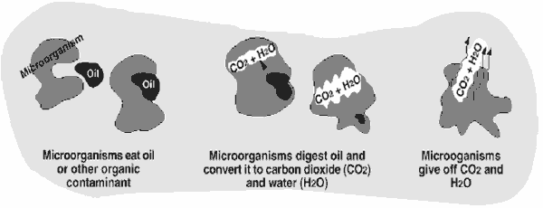
Plants can also remove toxic chemicals from the environment by storing them. These chemicals can be stored in the roots, stems, or leaves of the plant. The individual plant cells store these chemicals in the vacuole of the cell. In the sunflower example above, the sunflowers stored the radioactive material in their tissue without turning that material into harmless substances (which is why the sunflower plants then need to be destroyed; they are now radioactive!). The diagram below shows (using arrows) how toxins can move from soil, for example, into a plant. The second diagram shows the vacuole of a plant cell.
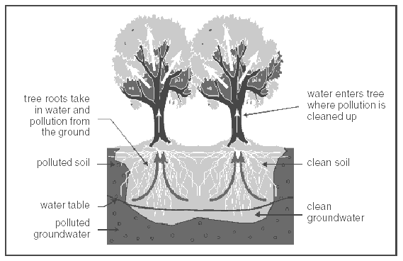

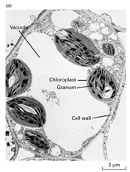
Vacuole: The place in the plant cell where toxins are stored

It is important to understand that not all plants are capable of performing phytoremediation. If a plant is exposed to a toxic substance and CANNOT phytoremediate it, the plant may stop growing, become discolored, and in some cases may die.

Reflection Questions:

- What does metabolizing mean?

- What happens when organisms metabolize a toxin?

- Where in the cell can some plants store toxins? Can all plants perform phytoremediation?

Part 2: Case Studies
Directions: Below is a list of Bioremediation case studies. Select any TWO case studies to learn about below. When finished reading, write a summary for each case study that you read in the boxes below.

- Case Study 1: Using Sunflowers to clean up the radiation left over from the Fukushima Nuclear Power Plant accident
http://thewatchers.adorraeli.com/2011/08/18/sunflower-radiation-absorption-project-grows-around-japan/
- Case Study 2:Using microbes to clean up the Gulf of Mexico oil spill: http://www.scientificamerican.com/article.cfm?id=gulf-oil-eating-microbes-slide-show
- Case Study 3:Using fungi in Puget Sound and the Duwamish River superfund site in Washington State:
http://pugetsound.org/blog/how-mushrooms-can-help-save-the-sound
- Case Study 4:Using algae in Chesapeake Bay to remove toxins and create biofuels at the same time:
http://www.vims.edu/newsandevents/topstories/archives/2009/algal_biofuels.php
- Case Study 5:Using sunflowers to clean up radiation after the Chernobyl nuclear power plant explosion in Ukraine
http://www.mhhe.com/biosci/pae/botany/botany_map/articles/article_10.html
- Case Study 6:Using bacteria to clean up garbage:
http://www.sciencedaily.com/releases/2012/06/120625165449.htm
- Case Study 7:Using oyster mushrooms to break down human diapers (called nappies in this article) in landfills:
http://www.economist.com/node/18584104

Title of Case Study #1:________________________________

Summary of Case Study #1:

Title of Case Study #2:________________________________

Summary of Case Study #2

Activity - Chemical Case Study Jigsaw

Directions: Check out your assigned chemical below then read about it by clicking on the blue link. Answer the 3 questions on the table below while you read. Make sure to include as much information as possible because you will be sharing this information with your teammates in 12 minutes. After all teammates are finished with their assigned chemical, each of you will share out in order to complete the full table below.
Team Captain: Copper
Resource Manager: Lead
Facilitator: Zinc
Recorder/Reporter: Mercury
 | What is this chemical used for? How does it get into the environment? | What are the health effects of this chemical? | What are the environmental effects of this chemical?
1. Lead

Name of Student Expert (Resource Manager): ___________
2. Mercury

Name of Student Expert (Recorder/Reporter): ___________
3. Zinc

Name of Student Expert (Facilitator) :
___________
4. Copper

Name of Student Expert (Team Captain): ___________

After you are done completing the table above, discuss and answer the following TEAM DISCUSSION QUESTIONS with your team. Make sure you justify your answers with the facts you collected in your notes.

TEAM DISCUSSION QUESTIONS:
- Which chemical is the most common?

- Which chemical is the worst for human health?

- Which chemical is the worst for the environment?

- What chemical do you think is the worst overall?

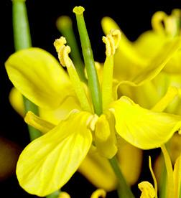
Activity - Get to Know Fast Plants

Purpose: To better understand plants, especially Fast Plants (Brassica’s), so we can use this knowledge to plan our Bioremediation experiments!
Directions: As a team, complete each step of the activity below. Leave no black bear behind! Make sure to meet the responsibilities of your team role:
- Facilitator: Read each step/question aloud
- Team Captain: Make sure everyone is working on the same question and not skipping ahead
- Recorder/Reporter: Make sure to record detailed and accurate answers in case someone in your team needs help

Step 1. Read the Fast Plant Story and how they were discovered here: Fast Plant Story

Step 2. Investigate the Fast Plant Life Cycle by going to this website and completing the table below

Before completing the table, you can watch this video to see a timelapse video of the complete life cycle of fast plants.

Day | What happens to the Fast Plant during this time? | Make a couple predictions about what might happen if toxic chemicals were added at this point (Hint: Use the information about what is happening to the plant)
1-2
3
4
7
9
14
18
28

Step 3. Read about the 3 different species of Fast Plants that you could use in your Bioremediation experiment by clicking on the links below.
Brassica rapa
Brassica nigra
Brassica juncea
After exploring each species, what species of Fast Plant is your team thinking of using for your Bioremediation experiment? _______________________

Step 4. Investigate plant structures by going to this website and completing the table below - you may discover something new!

Name of Plant Part | Function (What does it do in the plant?)
Roots
Stems
Leaves
Flowers
Fruit
Seeds

Think you got? Take these quick quizzes to find out.
Record your score after you take the quiz.

- Quiz #1-Function of Plant Parts (My Score: _____/6)
- Quiz #2-Location of Plant Parts (My Score: _____/6)

Step 5. Go to this website to investigate the necessary requirements that plants need to grow then complete the table below.

Requirement | Why do they need this? | What happens if they don’t have this? (Use information from the website, otherwise make a prediction)
Room to Grow
Temperature
Light
Water
Air
Nutrients
Time

Step 6. Investigate flower structure and the different flower parts by going to this website and completing the table below.

Name of Flower Part | Male or Female Part? | Function (What does it do in the plant?)
Stamen
Anther
Filament
Pistil
Stigma
Style
Ovary
Ovule

Step 8: Think you know your plants? Play this game! (Optional)

Game-Supermarket Botany (My Score: _____/15)

Notes - Independent & Dependent Variables

- Independent Variable: What the scientist is ________________.
- Dependent Variable: The __________ of the scientist’s _________.

 | Experiment 1 | Experiment 2 | Experiment 3
Independent Variable (IV)
Dependent Variable (DV)

Mistakes in designing experiment?

B. Practice
Think you got? Take this quick quiz to make sure you remember this information. Record your score after you take the quiz.
- Quiz #1-Identifying IV & DV (My Score: _____/16)
- Still a little confused? Watch this quick video that explains IV & DV. Please wear headphones.

C. Design your own Experiment
- What is your IV?
  - How will you measure your IV? What are the units?
- What is your DV?
  - How will you measure your DV? What are the units?
- Make a list of materials.
- Write a step by step procedure for you to conduct your experiment. Make sure it is detailed enough that a complete stranger could follow it.

Brainstorm-Experiment Design

Directions: Answer all of the questions as a group to help you brainstorm the design of your experiment. As you answer these questions as a group, remember to focus on testing one thing in your experiment. For example if you test 3 kinds of plants, with 2 toxins, and 4 different levels of toxins (that’s 24 different tests)! The purpose of this brainstorm to start thinking about the experiment you want to do as a group and to get feedback from the teacher on your design.

- Are you studying multiple kinds of plants or just one?
  - Brassica Nigra
  - Brassica Juncea
  - Brassica Rapa
- What stage(s) of plant life cycle are you interested in studying? (Refer to Fast Plants info above)
  - Seeds (Day 0-3)
  - Seedling (4-13)
  - Flowering (14-20)
  - Seed Production (21-40)
- What toxin(s) are you interested in studying? (Refer to Chemical Case Study above)
  - Copper
  - Zinc
- Are you studying different levels of toxins or just one? (Refer to Chemical Case Study above.)
  - Low level
  - Medium level
  - High level
  - All of the above
- Are you interested in how the
  - toxin affects the plant
  - plant affects the toxin
- What parts of the plant are you studying? (Refer to Fast Plants info above.)
  - Roots
  - Stems
  - Leaves
  - Flowers
  - Seeds

Experiment Outline
- For the experiment, we are going to be studying how does _______________________ affect _______________________

- The reason why we are interested in studying this is ___________________________ _____________________________________________________________________

- In order to study this, we plan to do the following things to our plant: __________________________________________________________________________________________________________________________________________

- In order to measure the effect of our experiment we will __________________________________________________________________________________________________________________________________________

- Some questions we have for the teacher are __________________________________________________________________________________________________________________________________________

