Bioremediation Experimental Design
Directions: Identify your team’s Bioremediation experimental variables to finalize your Bioremediation experimental design. Use your answers from Step 3 Brainstorm to help you.

Remember! for an experiment to be accurate, no more than 2 variables are involved in your experiment. For example, if you test 3 kinds of plants, with 2 toxins, and 4 different levels of toxins - that’s way too many variables! You need to narrow your focus to find the relationship between just 2 variables - your Independent Variable and Dependent Variable

Research Question: what about Bioremediation and Fast Plants is your team interested in investigating? Make this as specific and detailed as you can! Remember to mention the exact species, toxin, toxin level, part of the plant, stage of the plant life cycle etc. that you are interested in studying.

Rationale: Why are you interested in studying this? What have you already learned that inspired you to ask this question?

Hypothesis: What is a testable proposed answer to your Research Question? Why do you think this will happen?

If ________________________, then ____________________. We think this will happen because ________________________.

Independent Variable: What are YOU (the scientists) changing in your experiment? Be specific.

Dependent Variable: What will you be measuring? (this will be your data) Be specific and use units.

Control: What will you use as a control?

Potential Confounding Variables: What are some potential confounding variables that might be introduced into your experiment? List at least 4 below. Think of what things can vary or change . . .

- ____________________________
- ____________________________
- ____________________________
- ____________________________

What is your team’s plan to control your potential Confounding Variables (to make sure they stay the same or DO NOT change/vary)?

Plan to test your Hypothesis: How does your team plan to test your hypothesis to see if it is supported or not supported? Describe your proposed procedure in 3-4 sentences.

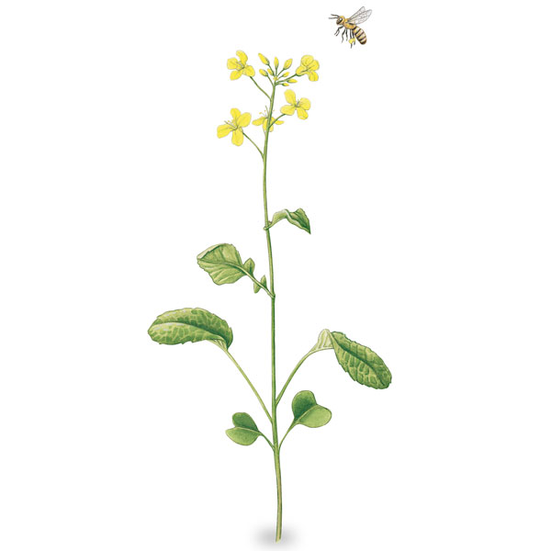
Instructions for Writing your Lab Report Introduction

Directions: The purpose of your introduction is to provide the reader with background information and context about your Bioremediation Experiment. Use the information you learned in Step 3 to write your paragraphs. There should be 3 paragraphs in your introduction.
Paragraph 1: Background information on Bioremediation | Paragraph 2: Background information on Fast Plants | Paragraph 3: Your Bioremediation Experimental Design

Paragraph 1 - Background Information on Bioremediation
Guiding Questions
- What is Bioremediation?
- What are the 2 different types of Bioremediation?
- How do some plants Bioremediate?
- How do toxins get into the environment?
- What specific toxins get into the environment and what harm do they cause to living things? What are some health effects of your toxin?
- What toxin will you be investigating in your Bioremediation experiment?
- Explain background information on the toxin you are using - copper and/or zinc
- What is an example (case study) of Bioremediation in nature?

Your Paragraph

Paragraph 2 - Background Information on Fast Plants
Guiding Questions
- What are Fast Plants?
  - What makes them so unique compared to other plants?
- What species of Fast Plant (Brassica) will you be using in your experiment?
- Explain background information about your Brassica species
- Why are you using Fast Plants in your Bioremediation Experiment?
- What does the current research say about Fast Plants being good bioremediators?
NOTE: Use one of these articles for evidence.
- Mild:Phytoremediation - using plants to clean the environment (mentions Brassica juncea)
- Medium: Bioremediation Case Study #5 - Brassica Juncea used as a Phytoremediator
- Spicy: Young Scientist: Phytoremediation of Arsenic and Lead using Brassica rapa

Your Paragraph
Paragraph 3 - Your Bioremediation Experimental Design
Guiding Questions
- Describe your team’s Bioremediation Experimental Design.
  - What are your team’s experimental variables?:
    - Research Question
      - Explain WHY you are interested in this question
    - Hypothesis
      - What evidence is your hypothesis based on?
    - Independent Variable
    - Dependent Variable
    - Control
    - Possible confounding variables that you plan to keep consistent
- How do you plan to test your hypothesis?

Your Paragraph

