How to Write a Procedure
Directions: Being able to write directions that are clear, detailed, and easy for someone else to follow is surprisingly hard to do! We are going to be doing several activities that demonstrate and practice how to write good directions.
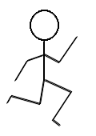
Part 1 (Stickfigure Activity)
- Draw a picture of a stick figure in a random pose. Be as creative as you want!
  - Go to “Insert” on the menu above.
  - Click on “Drawing”
  - Click on the arrow next to the line icon and choose “Scribble.”
  - Use the Scribble tool to make a stick figure.
  - Save and close your drawing
  - Add it here:

[ADD YOUR DRAWING HERE]

- Write detailed instructions describing to another person how to get in the pose of your stick figure.
  - Ex. “Turn your body sideways.” or “Raise your right hand upwards at an angle.”
- You will be reading these instructions out loud to your partner, BUT they won’t be able to see your drawing.
- The goal is to try to get them to stand in the same pose that you drew.

Your Directions

- (Once Ms. Kircher says) Take turns reading your directions out loud to your partner.
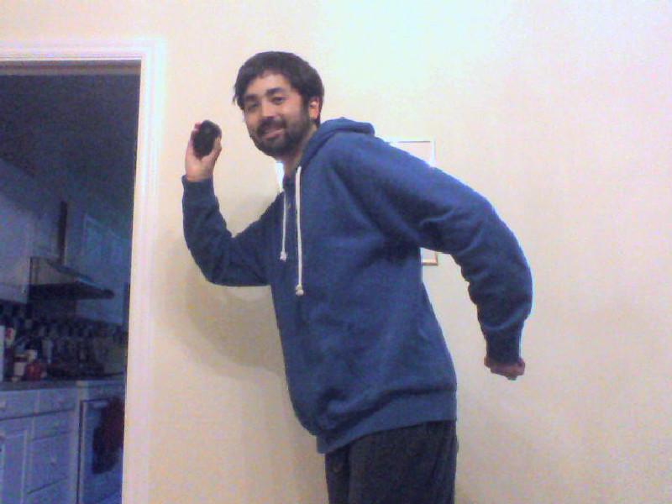
  - You can ONLY say your directions (nothing else).
  - You can repeat your direction more than once, but you cannot add any extra directions.
  - Writing good directions is harder than you think!

- Take a picture of your partner in your pose after you have given your instructions. Don’t worry if they are in the wrong pose.
  - Go to “Insert” on the menu above.
  - Click on “Image”
  - Click on the “Take a Snapshot”
  - Click on the green “Allow” button
  - Click on “Take Snapshot”
  - Select the picture you want
  - Add it here:

[ADD YOUR PICTURE HERE]

- After you are finished, discuss with your partner and write down your answers to the following reflection questions.
  - How did you and your partner do? [2 sentences min.]

  - What made this activity hard? [2 sentences min.]

  - What changes could you have made to your directions to make them clearer or help your partner understand? [2 sentences min.]

  - If you were to give another student 1 piece of advice about how to do this activity, what would it be?

Part 2 (How to Write a Procedure in Science)
Use this reading to answer the questions below: Reading-Writing the Procedure

- What is a procedure in science?

- Why do good procedures need to have lots of details? Think about the Peanut Butter & Jelly sandwich example

- Why is it important that procedures can be repeated by other scientists?

- Make a list of the characteristics of a great procedure.

Lab Report - Procedure

Directions: In the sections below, list all the materials you used and the exact steps you followed (and will follow) throughout your Bioremediation Experiment. Make sure to be as detailed as possible, using measurements and units whenever possible.

Materials

Stage 1: Plant Fast Plants

Stage 2: Add Toxins

Stage 3: Collect Data

