53
LST 手工修改

68
下图 IS3.1如何处理？
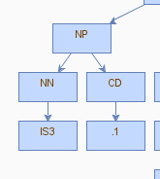

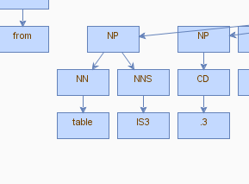

70
LST 手工修改

73
是否正确？
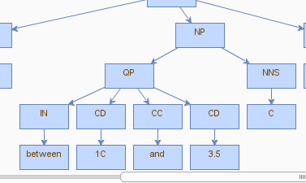

84
Social , environmental and economic changes
Social 词性手工改为“JJ”

85

M -LRB- i -RRB- ，即“M(1)”是否改为LST？
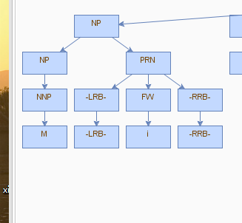

85
(that ) UNOPS is to provide a recipient Government for an agreed fee ;
结构如何确定？

106
LST 手工修改

131
have to [be] made 根据语法添加be

