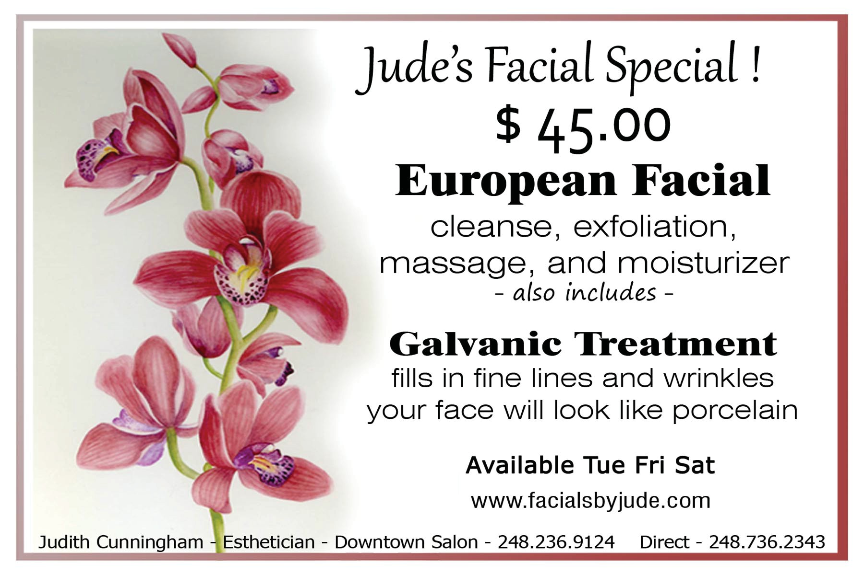

Facials by Jude – 40 S. Washington Street, Oxford MI – (248) 736-2343
Women and men at any age can renew their healthy, youthful complexion through a facial using the newest
technology and professional hydration, and without surgery and harsh chemicals
Downtown Oxford, Mich. — Healthy, luminous skin is a gift we all enjoy at birth. From day one it’s a present under attack by the sun, stress, genes, and everything else that undermines our birthright. Regular, comprehensive facials are the first – and best – tools to turn back time and restore your skin to that youthful appearance instilling confidence personally and professionally.
Esthetician Jude Cunningham’s Facials by Jude helps clients improve tone, texture and moisture balance by utilizing the newest technology and quality products through a wide range of available 90-minute facial treatments tailored to address unique client needs. Jude’s business is located inside Downtown Salon, 40 S. Washington Street.
More than a dozen facial treatments are available, including the: Signature European, Stimulating Deep Pore Cleansing, Anti-Aging, Blemish Control, Glycolic, Aromatherapy, Naturally Soothing (for sensitive skin), Galvanic (facial or treatment only), Teen, Express, Back Treatment, Ultra Brightening, Ultra Hydrating and a Full Body Salt Scrub (softening and detoxifying skin). Downtown Salon also offers a full line of waxing services from head to toe, along with complete nail and hair care services. Galvanic treatments can be added to any facial, addressing skin conditions related specifically to congestion and extreme dehydration. Glycolic facial peels are also available to reduce skin oil, which in turn combats skin impurities.
A member of the Oxford Chamber of Commerce, Jude’s also an Oxford/Orion Local Business Network member. She is ideally suited to provide referrals to fellow LBN members, through her close interaction with clients. Regarding referrals directing customer’s through Jude’s door, ideal guests would be starting to experience the first signs of maturity in their early 30’s and beyond, perhaps in the appearance of fine lines around the eyes or dull skin. ANYONE can benefit from a facial, so every referral is viable. LBN members? Use the $20 coupon below!
Appointments are always recommended, although walk-in guests are always welcome. Facials by Jude offers flexible hours Tuesdays, Fridays and Saturdays; call (248) 736-2343. Contact Downtown Salon by calling (248)
236-9124. Learn more about Facials by Jude at her Web site: www.facialsbyjude.com, then follow her on Facebook.

