MOBILE & DEVICE

Choose the most suitable plan to optimize your corporate mobile expense: -

Get latest Handset on installment @ 0 Upfront fee

Fixed sevice

Start your business with a Business complete with Broad band landline and other free benefits

Refer & Earn steps: -

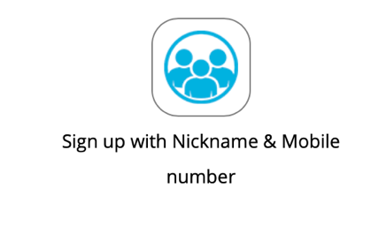

We are not interested in your name but your reference: -

Sign up now and start earning incentive on the go:-

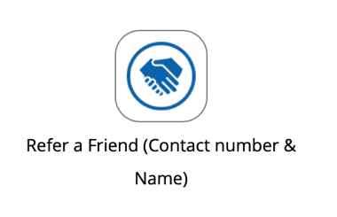

Refer a Lead who is starting a new business in UAE & let us full fill their telecom needs such as Broad band & Landline

Share a lead who is interested to reduce their business mobile expense & you start earning Rewards

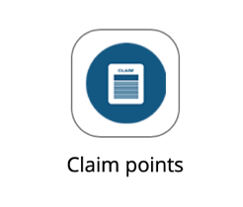

Once your reference is activated, Claim your reward as Cash instantly

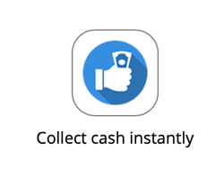

Visit a nearest ATM to with our unique code to collect your cash ( Code is valid for 24 hours )

**CONTACT US**

Our Expert Advisers will contact you as soon as possible

PBX

A complete solution for a business startup with IP/Analogue phones installation and configuration

Web development

Say not to template website, Make your own custom website @ affordable   
price.

Mobile apps ( IOS/APK ) are designed and Hosted @ affordable price for new and existing business