Documet

Bank-Account project

Raihan kabir:

**Topics: Home, withdraw, transaction, transfer, All-account Details, All-Account Display ,Account Holder.(Exception handle).**

*Home page:*

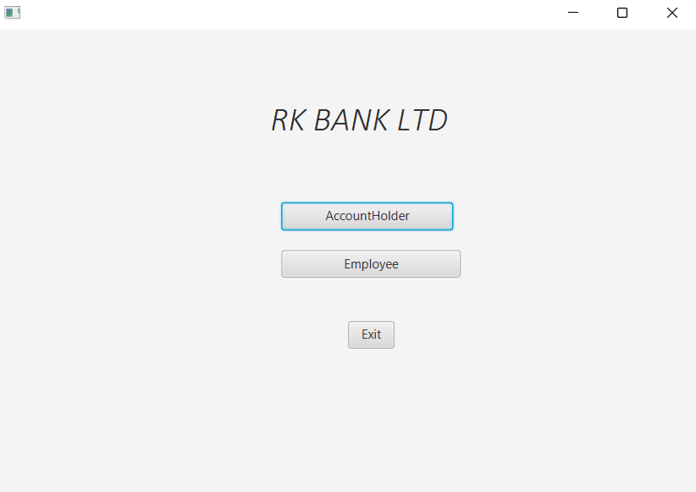

All-Account Display:

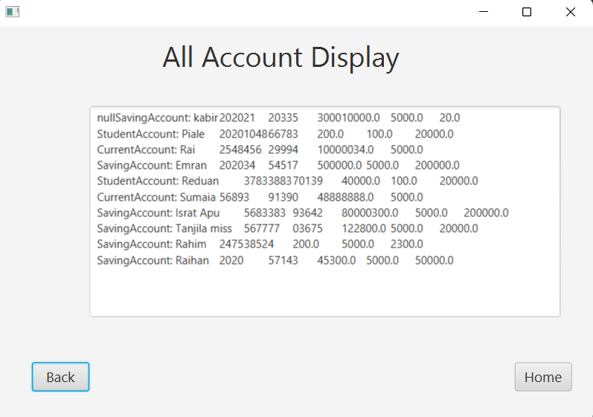

**Balacne Transfer:**

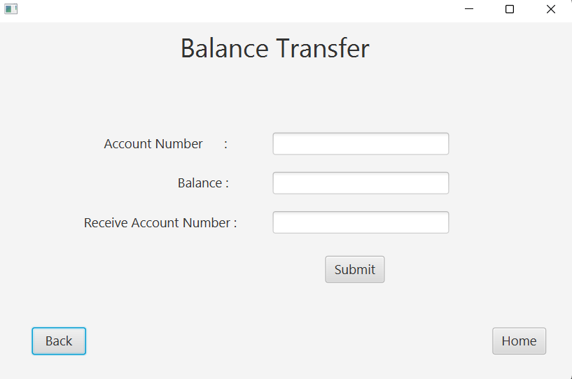

Transaction Details:

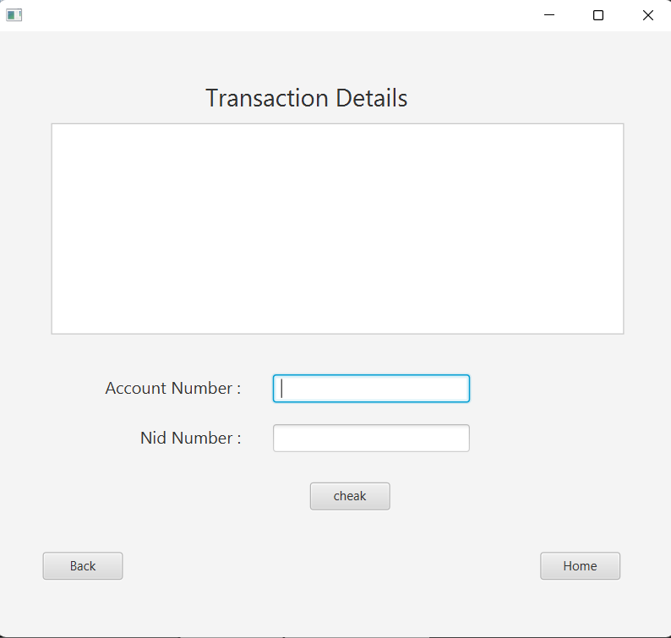

All-account Details:

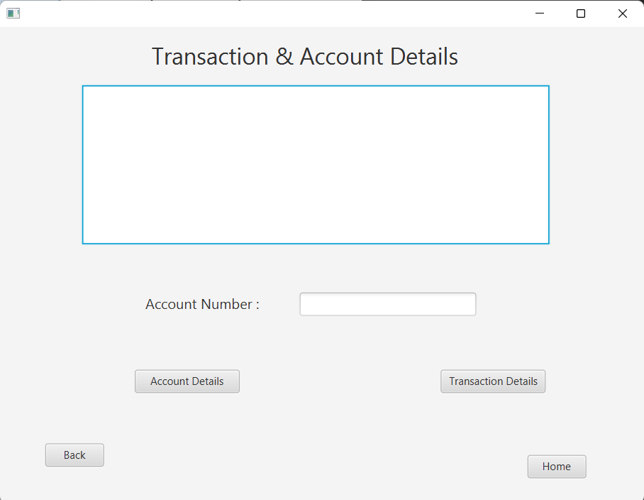

Withdraw:

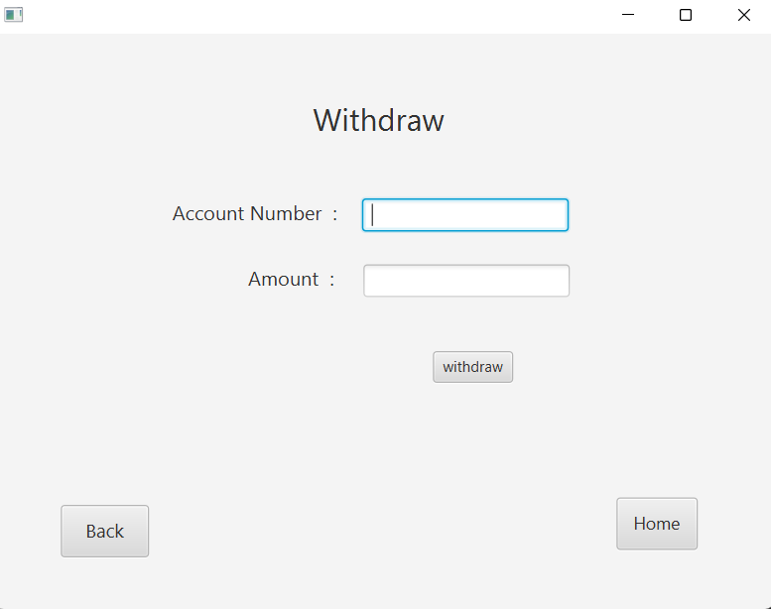

Emran Ahmed :

**Topics: Savings Account, Current Account.**

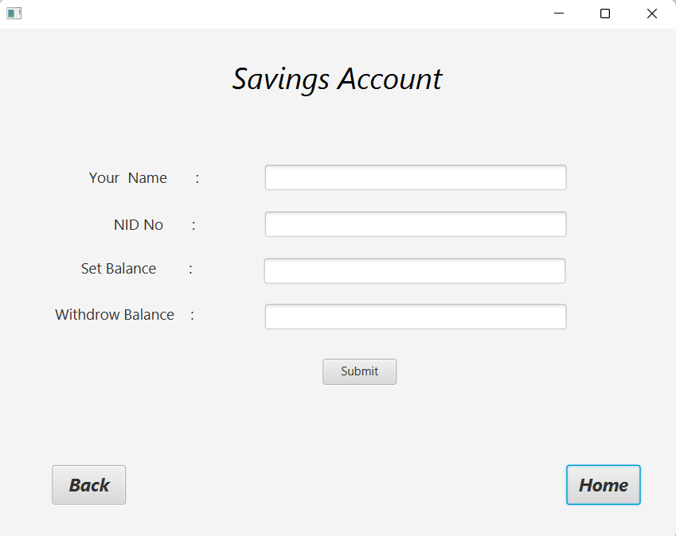

Current Accout:

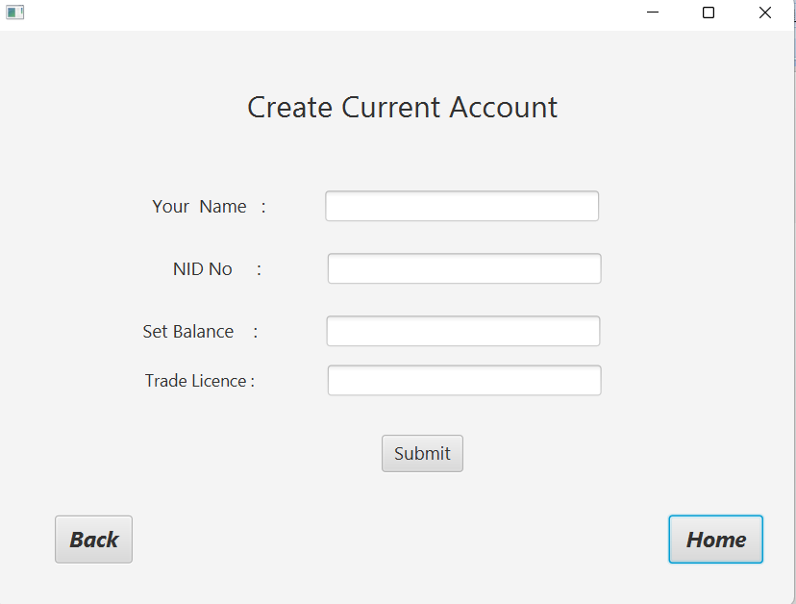

Ishrat jahan:

**Topics: Account Details and Employe menu fxml**.

Account Details:

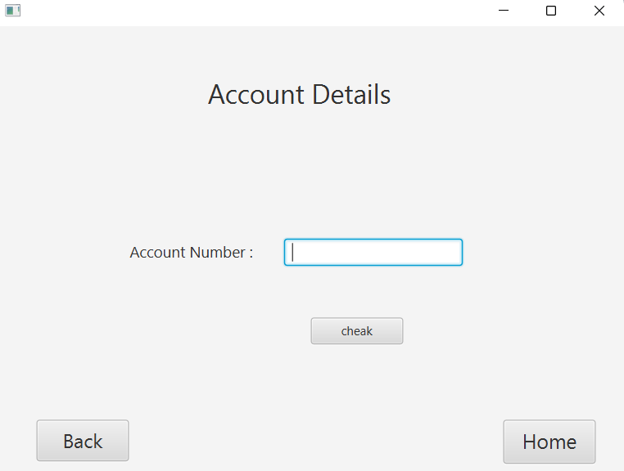

Sumaia Akter :

**Topics: Deposite.**

Deposite:

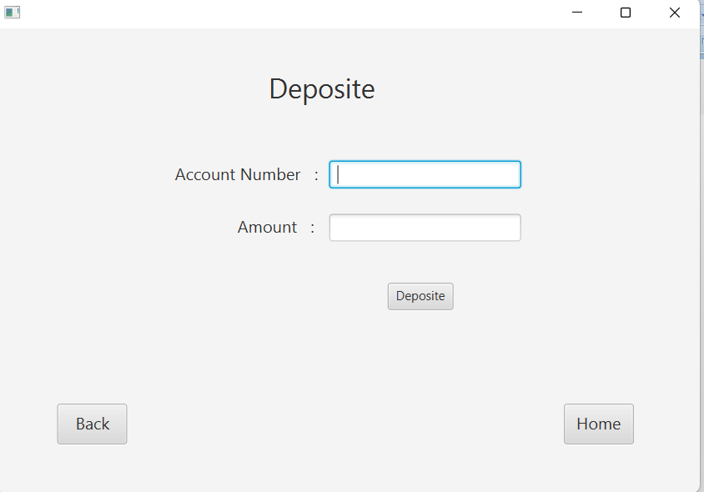

Sarker Mohammad Riduan:

**Topics: Student Account.**

Student Account.

