CHAPTER I

INTRODUCTION

Education is important for a child's development, and preschool serves as the foundation of their learning. For a child, play is not only for fun, but it also helps them learn. It is best for child to understand shapes, colors, numbers, and letters quickly by making lessons fun, interesting, and interactive. Technology helps preschool education through the use of digital tools that enhance teaching and allow children to learn more.
According to Hsiao and Chen (2016) To engage children and enhance their learning performance, integrating game-based learning (GBL) should continue to be used in the classroom along with the newest, to effectively attract the children's interest of learning and improve their learning performance, the effort of integrating GBL with classroom learning has to be continued and should be connected to the latest and most innovative technology at hand. GBL engages the children in a game world, allowing them to interact with the learning material while motivating them to improve their knowledge and skills via competitive activities with rules, goals, feedbacks, interactions, and outcomes (Kim, Park, & Baek, 2009).
A key feature of the application is artificial intelligence, specifically speech recognition, which provides feedback to help children identify whether they are pronouncing words correctly or wrongly. There are also scores on it that let the teacher keep track of the child's progress and see how they change over time. It also comes with games and quizzes to make learning more fun and interactive.
The application helps preschool teachers improve their lessons and reducing the need to teach topics repeatedly. It has different activities about shapes, colors, numbers, and letters that make learning more fun, interactive, and interesting through the use of technology. It also helps children stay interested because the activities are fun and engaging. This makes them listen more to their teacher.
The application is designed for both teacher and children. It helps to reduce the teacher's reliance on manual teaching. For the children, learning becomes easier because the lessons are now digital and automated. They will also enjoy it more because the application has many interactive features. It also helps the teacher and the children interact and communicate better.

Statement of the Problem
Teaching young children topics like shapes, colors, numbers, and letters can be challenging for school teachers. Many still rely on traditional manual methods. However, children often have a challenging time learning through these methods because they are not engaging or interesting. Sometimes parents believe their children are not capable of doing the activities on their own, so they end up doing them for them. As a result, the child doesn’t truly learn. Nowadays, most child prefer using gadgets or devices because they are more fun, interactive, and interesting.

Specially, this study aims to answer the following questions:
- What challenges do you face when teaching preschool topics?
- How do you keep preschool kids interested during lessons?
3. How can technology enhance the learning experience for young children?
4. How can interactive tools help make learning more fun and effective for preschool children?
5. How does the “Kidtastic” application improve engagement and learning outcomes in preschool education?

General Objectives
The main objective of this study is to develop a digital game-based learning application with integrated speech recognition to enhance teaching and learning in preschool. It will help teachers make teaching easier and keep children interested in the topic, while also allowing children to practice pronunciation and receive immediate feedback.
The following are the specific objectives;
- To develop a user-friendly application for young children to learn shapes, colors, numbers, and letters, including a login page for teachers.
- To integrate interactive features such as games and quizzes to keep children interested while they are learning.
- To integrate both audio and video to support different ways of learning and help kids learn and remember things more easily.
- To integrate artificial intelligence (AI) speech recognition technology to allow children to practice pronunciation and receive immediate feedback.
- To test and evaluate the application to ensure that it works properly and is simple to use.

Significance of the Study
This project aims to develop a digital game-based learning application with speech recognition to support early childhood education in San Carlos City, Negros Occidental. By using automation instead of manual methods, it benefits both teachers and children. It makes learning more fun, which helps children learn better and makes teaching easier and more interactive.

Teachers. The study provides preschool teachers a digital tool they can use to teach letters, numbers, shapes, and colors. This app saves time, makes it easier to plan lessons, and makes teaching more fun and interactive.
Children. The app provides preschool children a fun and engaging learning experience by using speech recognition to allow children to practice pronunciation and receive immediate feedback. It also has audio, video, games, and quizzes to help children learn in different ways.
Information Technology Students. This study benefits early childhood education by providing a simple and modern learning tool. It uses technology to help schools and teachers in providing better learning opportunities for young children.

Researchers. This project provides useful information for researchers studying educational platforms. It demonstrates how automation and digital game-based can enhance teaching and learning, which makes it a useful source for future research.
Overall, this study shows how technology can enhance both learning and teaching in preschool education. It highlights the role of digital tools in enhancing the teaching process through automation rather than manual methods.

Scope and Limitations
This capstone project, entitled "Kidtastic: Development of an E-Learning Application with Speech Recognition for Preschool Education in San Carlos City" is developed to enhance teaching and learning in early childhood education. The app aims to teach fundamental concepts such as shapes, colors, numbers and letters. It includes features like speech recognition to allow children to practice pronunciation and receive immediate feedback. It also has both audio and video to support different ways of learning and help children learn and remember things more easily. It also includes games and quizzes to keep children engaged while they learn, as well as storytelling features because children enjoy hearing stories. Additionally, it provides a video lesson on specific animal sounds.
One limitation of our app is that young children (ages 3–6) may need adult assistance to use it. Since the app works offline, it does not automatically update. It is designed specifically for preschoolers and only covers fundamental concepts such as shapes, colors, numbers, and letters. It does not include advanced topics, and it only uses the English language. Additionally, it is not suitable for online use.

Definition of Terms
Artificial Intelligence (AI). In this study, it refers to the smart technology in the app that helps with features like speech recognition and making learning more useful for everyone.
Automation. In this study, it refers to a computer system that performs tasks automatically, resulting in faster performance and reducing errors.
Digital Game-Based. In this study, it refers to how interactive games in the app can make learning fun, engaging, and interesting for preschoolers.
Digital Tools. In this study, it refers to computer-based applications and resources that help teachers and children learn in new ways.
Early Childhood Education. In this study, it refers to the level of education that provides young children with the basic skills and knowledge they need to learn and grow.
Fundamental Concepts. In this study, it refers to simple topics such as shapes, colors, numbers, and letters that young children should learn first.
Interactive Features. In this study, it refers to app features that allow children to interact through touching, speaking, or playing games to support their learning.
Offline. In this study, it refers to the application's ability to function without an internet connection, allowing for continuous learning even without online access.
Speech Recognition: In this study, it refers to the technology that enables the application to recognize and process spoken input from users. This allows children to speak into the app, practice their pronunciation, and receive immediate feedback, helping them improve their speaking, listening, and language skills.
Technology. In this study, it refers to using modern digital tools and devices to help young children learn more effectively.

CHAPTER II

REVIEW OF RELATED LITERATURES AND SYTEMS

The review of related literature for this study includes both local and foreign sources, such as books, academic journals, websites, and other forms of media that are relevant to the development of this study. These sources provide essential background on the importance of early childhood education, the role of technology in modern classrooms, and the effectiveness of game-based and interactive learning.

Foreign Related Literature
The integration of technology in early childhood education is becoming more important today. It helps make learning fun, interesting, and interactive for young children. In preschool, digital tools like learning application can help child enjoy lessons and stay focused. These tools also help teachers by reducing the need to repeat lessons and by giving quick feedback on how children are doing. Features like speech recognition and games allow children to learn in new ways while also helping teachers track their progress. As more schools use technology, it becomes a useful way to teach topics like shapes, colors, numbers, and letters.
Behnamnia, Najmeh, et al. (2020) examined the role of DGBL applications in nurturing creativity among young children, focusing on how features such as challenge, curiosity, and fantasy support imagination and problem-solving. Their review of 20 empirical studies revealed that these interactive elements could significantly enhance motivation and promote creative thinking in early education. However, they also noted a lack of standardized assessment tools for measuring creativity and limited longitudinal studies on the long-term effects of DGBL. Similarly, Tsai and Lin (2019) emphasized the effectiveness of mobile learning apps in boosting cognitive development among preschool learners. Their study highlighted that multimedia and touch-responsive features increase engagement, especially when combined with age-appropriate educational content and interactive feedback. The data shown that apps designed with interactive features (like touch responsiveness) can increase engagement by up to 30-50% compared to traditional learning methods.
In a similar vein, Moreno, Alexander, et al. (2019) supported the value of immersive digital tools, indicating that such environments positively impact cognitive and emotional development, particularly for users with neurocognitive challenges. While their study focused on older individuals, the findings reinforce the broader applicability of interactive technology in enhancing engagement and learning outcomes. Li and Chu (2020) further explored DGBL, finding that it encourages exploratory learning and creative expression by allowing child.
The importance of designing affordable, accessible, and user-friendly technologies for preschool education is underscored by Yasir et al. (2018) in their examination of child-computer interaction (CCI) systems. They reviewed various technologies, including voice-command interfaces and interactive whiteboards, which align with constructionist learning theories. While these tools support cognitive and motor skill development, they also identified challenges such as the high cost of specialized hardware, which limits their scalability, especially in under-resourced educational settings. Prasetyo et al. (2018) investigated the feasibility of implementing digital preschool models, finding that digital platforms like interactive videos and mobile learning applications enrich learning experiences but are hindered by issues like excessive screen time, the digital divide, and the need for guided use.
Cakir and Yildirim (2023) conducted a systematic review of the impact of digital technology on preschool education, analyzing over 40 peer-reviewed studies. They found that digital tools—ranging from tablets to smartboards—enhance cognitive, social, and emotional development when integrated with age-appropriate pedagogy. The study emphasized that digital tools are particularly effective in developing early literacy and numeracy skills, especially when supported by interactive features such as animations and multimedia content.
Furthermore, Suartama et al. (2022), the development of educational games for early literacy has also been highlighted in studies which examined a desktop-based game designed to help early learners recognize the alphabet. Their research demonstrated that game-based environments improve motivation and concentration among preschool-aged children. In terms of language development, Ongoro and Mwangoka (2019) explored how digital games enhance language learning in Tanzanian preschools. Their study found that gamified learning systems significantly improved children's language skills, particularly in articulation. Papadakis, Kalogiannakis, and Zaranis (2018) investigated the effectiveness of tablet-assisted interventions in preschool children's understanding of numbers. The study revealed that both tablet and computer-based interventions improved numeracy skills compared to the control group, with tablet-based interventions showing better results. Additionally, Miller (2018) explored the role of interactive technology in developing numeracy skills in a play-based learning environment. Although the study noted some positive effects on numeracy, the gains were not statistically significant.
Lai, Ang, Por, and Liew (2018) conducted a case study on the impact of an intuitive, voice, and gesture-based interactive virtual learning environment (VGVLE) in teaching preschool children basic concepts like colors and shapes. Their findings showed that children using the VGVLE demonstrated better learning outcomes compared to those receiving traditional instruction. The interactive nature of the technology fostered greater engagement and helped bridge knowledge gaps among children with varying levels of prior knowledge. Hughes and Wilson (2019) examined the use of gestural interface games in enhancing numeracy learning among young children. Their study found that digital play with gestural interfaces significantly improved children's understanding and application of numeracy concepts.

Foreign Related System
In a similar vein, Istiono (2022) developed a bilingual (Indonesian-English) color learning application aimed at improving color recognition skills in preschool students. The interactive features of the app included color identification, selection, and pronunciation exercises. Using a pretest-posttest methodology, the study demonstrated significant improvements in color recognition abilities, with a t-statistic of 8.69. User acceptance testing showed high satisfaction among users, with a rate of 86.72%.
Additionally, Putri, Yusman, and Pratama (2022) developed an Android-based educational application for the Binayah Raudhatul Athfal Foundation, an Islamic kindergarten in Indonesia. The application aimed to complement traditional teaching methods and cater to the increasing use of smartphones among young children. The app included various features, such as interactive audio pronunciations, videos, and thematic content on subjects like numbers, colors, animals, and professions.
Long-term impact of such technology integration or potential challenges in diverse Chen (2022) examined the use of deep learning technology in the design of preschool education resource platforms. By creating learning scenarios that align with children’s cognitive preferences and presenting content through games, music, and videos, the platform aimed to foster positive thinking and creative exploration. The study found that deep learning platforms maintained children's attention for approximately 90% of the time, suggesting their effectiveness in early childhood education.
Zygouris et al. (2021) developed a web-based application to assess executive functions in preschool-aged children, focusing on tasks such as inhibitory control, visual and auditory working memory, and phonological discrimination. Their findings indicated that five - year - olds outperformed four - year- olds, with female participants showing higher accuracy and faster response times. Furthermore, Samarakoon and Usoof (2020) further highlighted the importance of user-centered design in e-learning applications, emphasizing that technological interfaces must align with the motor and cognitive abilities of young children. Their study showed that socio - economic background, exposure to technology, and native language all influence a child's ability to interact effectively with touch-sensitive devices. Moreover, studies such as that of Chen (2022) underscore the importance of incorporating deep learning technologies to enhance preschool education platforms. By designing engaging and meaningful learning scenarios, deep learning can provide real-time personalized content, which can better support the cognitive development of young learners. However, challenges related to scalability and accessibility remain a concern, particularly in resource-limited educational settings.
Collectively, these studies reflect the growing recognition of digital applications as powerful tools for enhancing early childhood education. They highlight the potential for interactive, engaging, and developmentally appropriate technologies to support children's cognitive, motor, and language skills. However, they also identify challenges, such as the need for more empirical evidence on long-term learning outcomes, the importance of culturally sensitive designs, and the need for further research into the scalability of these tools in diverse educational contexts.
Local Related System

Technology is always transforming education. According to the latest surveys, 76% of students say that technology makes learning more engaging (EdWeek, “Technology in Schools: A Teacher Survey”, 2023) and 90% of teachers say that technology helps them to assess student learning more effectively (2023 State of Technology in Education Report, 2023).
Tamanu (2021) assessed the effectiveness of Recorded Teacher Model Video Lessons (RTMVLs) in enhancing letter sound recognition skills among kindergarten pupils in San Isidro Elementary School. The study involved 29 pupils and used a pretest - posttest experimental design. Results showed a significant improvement in letter sound recognition, with statistical analysis confirming the intervention's effectiveness. Cornito (2023) evaluated the use of a contextualized digital game-based learning resource to improve vowel recognition in kindergarten pupils. The study, conducted at Camp 1 Elementary School, found a significant increase in vowel knowledge after the intervention. The findings also explored how private kindergarten schools in the Philippines adapted during the COVID-19 pandemic. The study revealed that schools transitioned to online learning, modified curricula, and increased parental involvement to sustain education.
Additionally, Al - Bataineh and Al - Bataineh (2020) analyzed the effects of technology on student learning, finding both positive and negative impacts. Technology enhanced engagement and supported diverse learning styles, but it also posed risks like distraction. The study concluded that technology should complement traditional methods and recommended ongoing professional development for teachers. Furthermore, Garcia (2020) developed the "Kinder Learns" educational visual novel game to enhance preschool learning. The game covered multiple subjects and was well-received by both students and teachers. The study demonstrated the potential of digital educational games in early childhood education, reinforcing the positive impact of technology in preschool curricula.
Lastly, Dy, Dy and Santos (2023) examined the impact of screen time on child development in the Philippines. The study found that moderate screen time had minimal negative effects, but excessive exposure (over 4–5 hours daily) was linked to delays in language and social skills. Parental involvement was identified as crucial in managing screen time effectively.

CHAPTER III

METHODOLOGY

Kidtastic: Development of an E-Learning Application with Speech Recognition for Preschool Education in San Carlos City is designed for preschool teachers and young learners. Its development followed a clear, organized plan, ensuring a smooth and engaging learning experience.
The application development process included identifying preschool education needs, particularly those related to teaching shapes, colors, numbers, and letters. Specific tasks included gathering teacher requirements, choosing suitable development tools, incorporating interactive learning features, and integrating AI-powered speech recognition. These features were created to make lessons more fun and interactive for children, as well as to help them improve their pronunciation and receive immediate feedback.
The application was designed to be accessible to teachers and children via desktop, tablet, and mobile devices. Teachers can log in to track each child's progress, and children learn through interactive games and quizzes. The methodology also included testing the application's usability, performance, and effectiveness to ensure that it is appropriate for young learners and useful in the classroom.
This chapter describes the application development life cycle, which includes requirements gathering, design, development, testing, and evaluation. It also discusses the tools, platforms, target users, and how the process ensures that the application achieves its educational objectives.

- Design Method
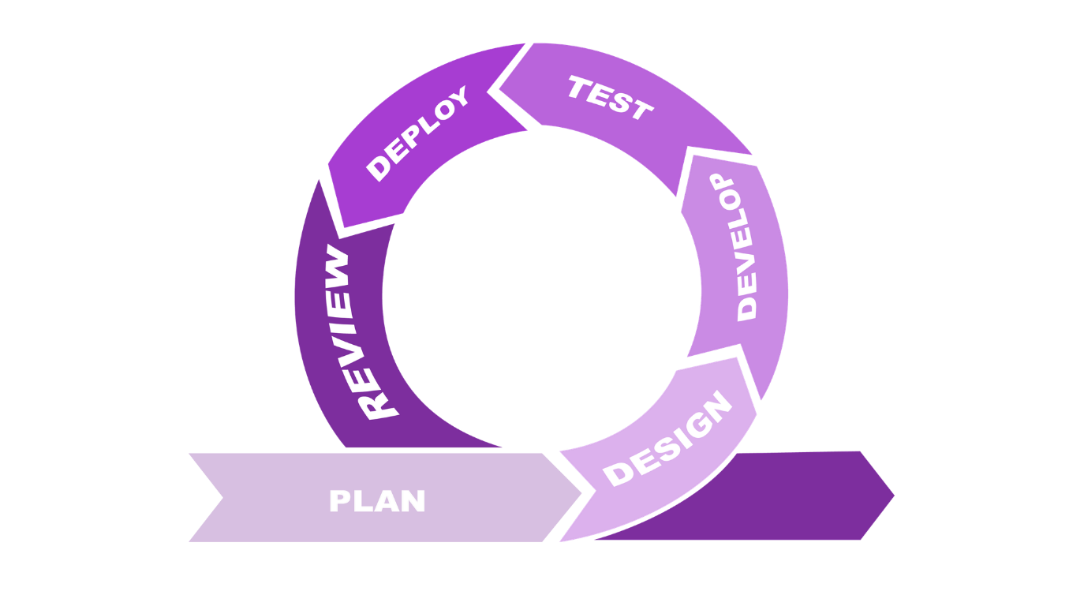

Figure 1. Agile Model (Application Development Life Cycle)
Agile methodologies are ideal for software development because they emphasize flexibility, continuous progress, and user feedback. The Agile model is well-suit for developing Kidtastic: Development of an E-Learning Application with Speech Recognition for Preschool Education in San Carlos City because preschool education is always changing. Agile allows the development team to respond quickly to changes in teaching needs, feedback from teachers, and new technology. It also promotes communication among the team, teachers, and other stakeholders to ensure that the app meets everyone's requirements. Using Agile, the team can make changes, improve the app's interactive features, and keep making it better, ensuring that the app continues to provide useful educational content.

Planning Stage
In the planning stage the researchers conducted interviews and consultations with preschool teachers to understand the challenges they faced with traditional teaching methods. They discovered that teachers struggled with engaging children, tracking progress, and providing consistent feedback on topics like shapes, colors, numbers, and letters. By listening to the teachers' concerns and experiences, the researchers gained valuable insights that helped them create a solution tailored to the needs of preschool education. The planning stage involved careful collaboration between the researchers and their advisor to develop a clear plan to address the identified challenges.

Designing Stage
After understanding the challenges, the researchers moved to the design stage. They created a user-friendly, interactive, and visually engaging interface for preschool education, ensuring that it was easy for both teachers and children to use. The design also incorporated speech recognition technology to provide instant feedback on pronunciation, as well as games and quizzes to make learning fun and effective. The goal was to create an application that would help children grasp foundational concepts while making the teaching process easier and more engaging for teachers.

Development Stage
In the development stage, the researchers used programming languages like JavaScript, Html, and Css along with AI tools for speech recognition, to build the application. They focused on creating an interactive, functional, and engaging learning environment. The development followed the Agile methodology, ensuring that regular feedback from teachers and stakeholders was integrated into the development process. This allowed the development team to continuously refine the app’s features, enhancing its usability and effectiveness in supporting preschool education.

Testing Stage
During the testing phase, the researchers conducted user testing with preschool teachers and children to ensure that the application met the expectations and requirements of its users. This involved testing the application’s functionality, ease of use, and speech recognition accuracy. By simulating real-world classroom scenarios and gathering feedback from both teachers and children, the researchers identified areas for improvement in the application. The goal was to ensure that the application provided a smooth, engaging learning experience and was effective in supporting children’s educational development.

Deployment Stage
Once the testing was complete, the application was deployed in classrooms for real-world use. The researchers ensured that the application was properly set up on devices and made available to both teachers and students. The deployment process involved installing the app on various platforms via desktop, tablet, and mobile ensuring that it was fully functional for classroom activities. The success of the deployment was marked by positive feedback from teachers and children, confirming that the app addressed the identified issues in preschool education.

Reviewing Stage
After deployment, the researchers collaborated with teachers and educational stakeholders to review the app’s performance and effectiveness. Feedback was collected on the functionality, user interface, and educational impact of the app. Any identified issues or areas for improvement were addressed in order to enhance the application’s performance and user experience. The reviewing stage allowed the researchers to improve the application, ensuring it met the desired objectives and was optimized for continuous use in classrooms.

- Flow of the Study
The Kidtastic: Development of an E-Learning Application with Speech Recognition for Preschool Education in San Carlos City " is developed to enhance teaching and learning in early childhood education. The app aims to teach fundamental concepts such as shapes, colors, numbers and letters. It includes features like speech recognition to allow children to practice pronunciation and receive immediate feedback. It also has both audio and video to support different ways of learning and help children learn and remember things more easily. It also includes games and quizzes to keep children engaged while they learn, as well as storytelling features because children enjoy hearing stories. Additionally, it provides a video lesson on specific animal sounds.
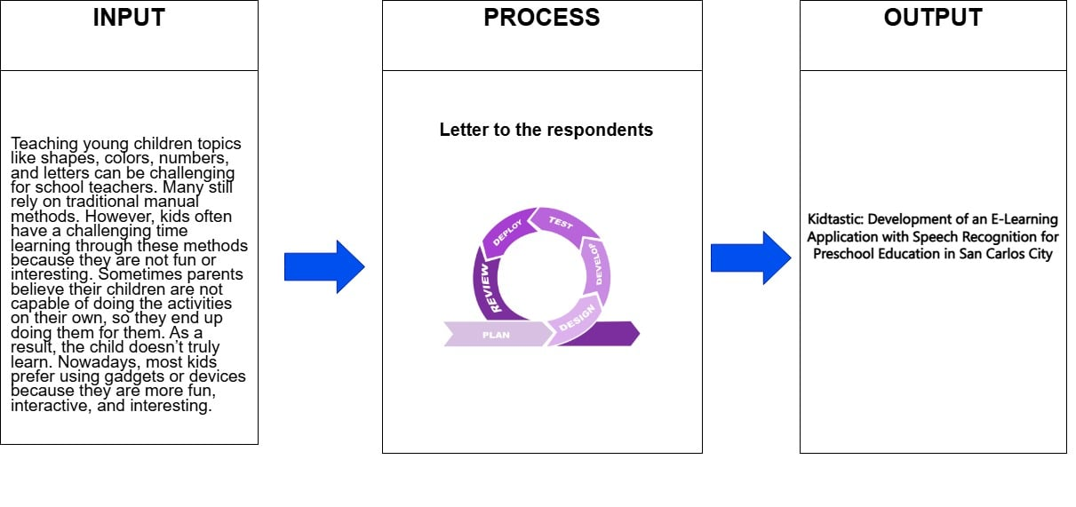
Figure 2. Flow of the Study

- Functional and Non-Functional Requirements
c.1. Software Requirements
The software tools needed to create the Kidtastic: Development of an E-Learning Application with Speech Recognition for Preschool Education in San Carlos City are shown in the table below. It displays the minimum versions required for smooth and effective development.
Table 1. Software Requirements (Minimum)
Software | Version
SQLITE | 5.1.7
ELECTRON FRAMEWORK | 27.0.0
VISUAL STUDIO CODE | 1.99.3
CAPASITOR | 5.0.3
ANDROID STUDIO | 3.1.15

These tools are essential for ensuring a smooth development process and efficient testing, particularly for features that support offline use and speech recognition. Each tool plays a specific role in enhancing the application's functionality, usability, and cross-platform compatibility. Visual Studio Code is used for writing and debugging code. The Electron Framework is used to build the desktop version for different operating systems. SQLite stores user data locally to support offline use. Capacitor connects the app to native mobile features such as speech recognition. Android Studio is used to compile and test the app on Android devices to ensure stability and performance.
c.2. Hardware Requirements
Table 2. Hardware Requirements (Recommended)

Device | Specifications
Central Processing Unit (CPU) | Intel Core i5 / AMD Ryzen 5
Smart TV | 17’’ 1024x768 resolution
Desktop or Laptop | 17’’ 1024x768 resolution
Smartphone
Keyboard | Standard Keyboard
Mouse | Standard Mouse
Random Access Memory (RAM) | 4gb or higher
Hard Disk Drive (HDD) / SSD | 128GB or higher

To develop, test, and deploy Kidtastic: Development of an E-Learning Application with Speech Recognition for Preschool Education in San Carlos City, the following hardware components are necessary to ensure the app runs smoothly, especially in offline mode. A desktop or laptop with at least an Intel Core i5 or AMD Ryzen 5 processor is required to handle the app's educational features and voice recognition tasks efficiently. A minimum of 4GB of RAM is needed, though higher memory is recommended for better performance and multitasking. For data storage and faster access, a Hard Disk Drive (HDD) or Solid-State Drive (SSD) with at least 128GB of capacity is recommended. Standard peripherals such as a keyboard and mouse help users navigate the app easily, particularly for teachers managing content and monitoring student progress. A Smart TV can be used in classroom settings to display content to larger groups of learners, supporting interactive and group-based learning. Smartphones are also essential, allowing children to access the app individually. These devices should have at least 4GB of RAM to ensure smooth app usage.

c.3. System/Application Flowchart
A flowchart is a visual diagram that uses arrows and symbols to show the steps in a process. It helps people understand how a system, application, or process works step by step.
The flowchart for Kidtastic: Development of an E-Learning Application with Speech Recognition for Preschool Education in San Carlos City illustrates the logical flow of user interaction within the application, particularly focusing on how teachers and children engage with its features. It outlines the step-by-step processes involved in launching the app, selecting learning modules such as shapes, colors, numbers, and letters, using the speech recognition tool for pronunciation practice, and receiving immediate feedback. The flowchart also includes the decision points for navigating between activities, tracking progress, and exiting the app. This structured visual representation ensures clarity in understanding how the application operates, highlighting its user-friendly and interactive design tailored to preschool learners. Through this flow, the system promotes an efficient, engaging, and accessible learning experience, even in offline environments.

PROPOSED FLOWCHART FOR USER
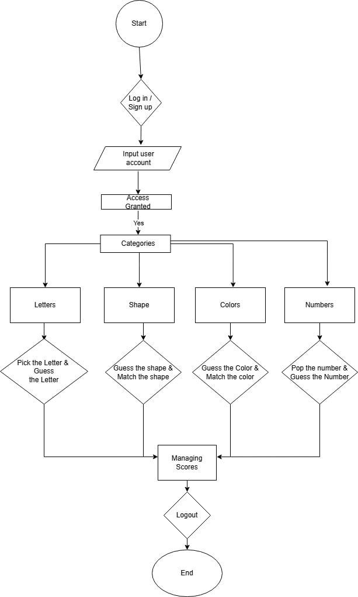
The flowchart begins with the teacher controlling the system via a computer interface. This computer is connected to a web server, which handles requests and retrieves educational content and activity information from a central database. The teacher can select learning modules from the database, such as shapes, colors, numbers and letter recognition. Once an activity is selected, it is displayed and broadcast to a TV screen visible to the children. This setup ensures that the content is clearly displayed in a large format that allows for group interaction. Children interact with the content on the television while the teacher facilitates learning and monitors their responses. The web server is critical because it serves as a link between the teacher's actions and the database, ensuring that content is delivered smoothly and that data such as scores or participation is recorded in real time. This lets the teacher check progress and change lessons if needed. With this application, teaching becomes more dynamic and organized. The application enhances the classroom experience by centralizing educational content and simplifying its delivery, supporting learning outcomes, and providing teachers with real-time insights into children progress.
This flowchart effectively demonstrates a structured, technology-integrated approach to early childhood education, showing how digital tools can create interactive and engaging learning environments.
c.4. System Architecture

The system architecture defines the structural design and interaction of its core components, resulting in an efficient educational experience. It consists of a teacher's computer interface, a web server, a central database, and a TV screen for students. The teacher commands the computer, which communicates with the web server to retrieve educational content from the database, such as lessons on the alphabet, numbers, shapes, and colors. The selected content is then shown on the television screen for group interaction. The architecture manages communication, content delivery, and data logging using defined protocols and real-time processing, enabling teachers to monitor children performance. This system structure ensures functionality, allows for scalability, and encourages an organized, interactive, and dependable approach to early childhood education.
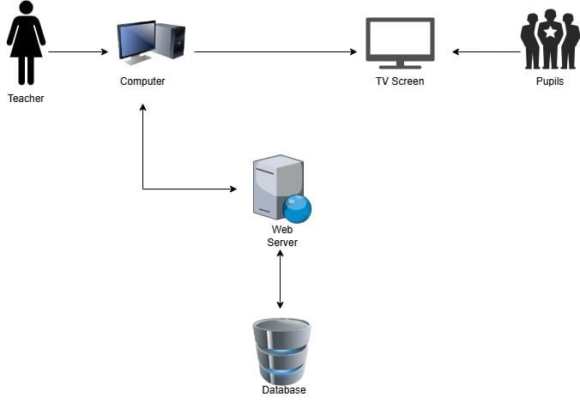

Figure 7. System/Application Architecture

c.6. Context Diagram

The respondents of the study are the kindergarten teachers and children who will be using the Kidtastic: Development of an E-Learning Application with Speech Recognition for Preschool Education in San Carlos City. The teachers are included as respondents because they are responsible for managing the app, navigating through its features, and facilitating learning sessions. Their insights are crucial in evaluating the system’s usability, effectiveness, and overall support for teaching goals. Children on the other hand, are the primary users of the educational content and activities within the app. Their interaction with the app, such as tracing, identifying, and recognizing fundamental concepts, provides valuable feedback on the app’s engagement level, ease of use, and educational impact on early learners
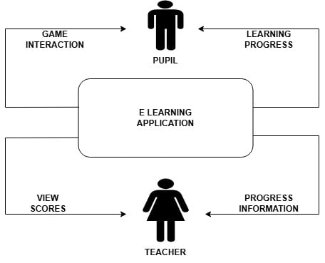

Figure 8. Context Diagram

c.7. Data Flow Diagram
The data flow diagram illustrates how data is transmitted and processed within the application. It shows how information flows between the main users Teacher and children and application components including the Computer, Web Server, Database, and TV Screen.
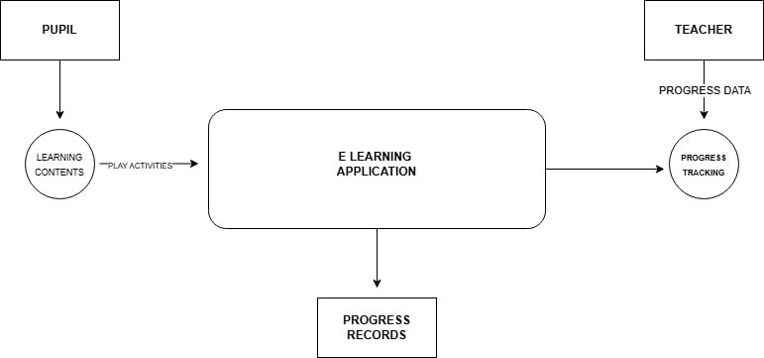
Figure 9. Data Flow Diagram
The teacher initiates the process by logging in and selecting educational modules such as shapes, colors, numbers, ands letters. This input is processed by the web server, which retrieves the corresponding content from the database. The selected content is then sent back to the teacher’s computer and projected to the TV screen for children to view and interact with. During the session, participation and performance data are collected and sent back through the system to be stored in the database. This enables real-time monitoring and future performance reviews. The data flow clearly demonstrates how each user and component collaborates to ensure an interactive, responsive, and efficient learning experience for preschool classrooms.

c.8. Entity Relationship Diagram (ERD)

The diagram shows the relationships of the entities the database.

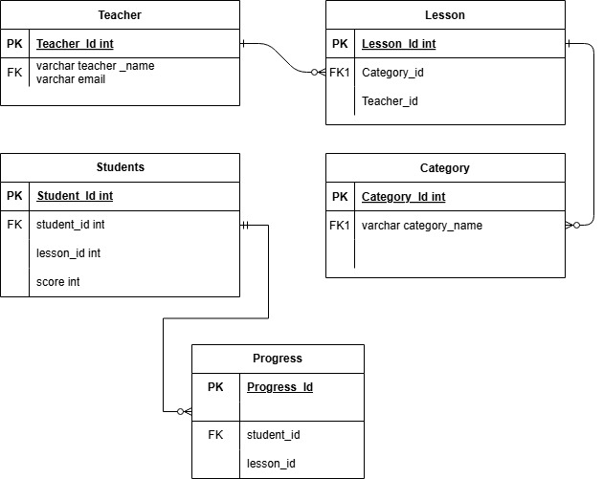

Figure 10. Entity Relationship Diagram

c.9. Use case Diagram
A use case diagram visually represents the interactions between actors (users) and an application. Remember to keep the use case diagram simple and focused on the key interactions between actors and the application. Use common symbols and terms so others can easily understand the diagram.
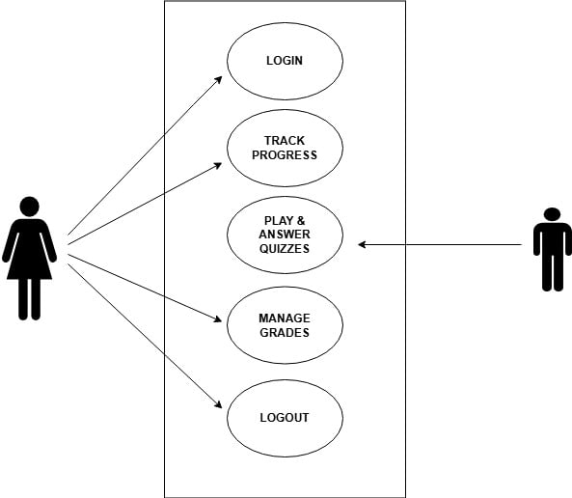

Figure 11. USE

Figure 11. Use Case Diagram

- Respondents

The respondents of the study are preschool teachers and preschool learners who will use the Kidtastic: Development of an E-Learning Application with Speech Recognition for Preschool Education in San Carlos City. Teachers were included for their role in managing and facilitating the app, while children were selected as the main users of its educational features. Both groups helped evaluate the app’s usability and effectiveness.
Table 3. Distribution of Respondents

Respondents | Frequency | Percentage
Teacher | 40 | 60 %
Children | 40 | 40 %
Total | 80 | 100.00%

e. Environment
The application was created and designed to be used in preschool learning environments, where the researchers conducted the study. The study was carried out in selected preschool classrooms within San Carlos City, Negros Occidental. Questionnaires and observation methods were used to collect relevant information from both preschool teachers and learners.


Figure 12. Environment

The purpose of the teacher and children survey was to evaluate the Kidtastic: Development of an E-Learning Application with Speech Recognition for Preschool Education in San Carlos City, focusing on its user interface, speech recognition feature, and effectiveness in enhancing preschool education. Only the teachers were given a questionnaire, as the application was still in development and younger children required guided observation rather than direct survey responses. The questionnaire given to the teachers assessed the application usability, responsiveness, and how well it supported teaching tasks such as lesson delivery, children engagement, and progress tracking. Observations were conducted to evaluate the children's interaction with the app’s features, including games, quizzes, and voice recognition tasks. A Likert Scale was used in the teacher questionnaire to measure the application's effectiveness, ease of use, and overall impact on teaching and learning outcomes.

f. Instrument
Table 4. Likert Scale for Usability (User Evaluation)

Score Range | Interpretation
1.00 - 1.75 | Needs Improvement (NI)
1.76 - 2.50 | Fair (F)
2.51 - 3.25 | Good (G)
3.26 - 4.00 | Very Good (VG)
4.01 - 5.00 | Excellent (E)

g. Data Gathering Procedures
Participants were surveyed and observed to gather primary data for the study. Before the full implementation of the application, a questionnaire was given to preschool teachers to understand their current teaching methods, challenges in engaging students, and needs related to tracking learning progress. This helped evaluate how the application could improve classroom instruction and learning experiences.
In addition to the teacher survey, observations were conducted with preschool learners to assess their interaction with educational activities such as games, quizzes, and speech recognition. The feedback and behavioral responses of children provided valuable insights for designing features that are developmentally appropriate and engaging.
Although a full review of the app's performance is planned, it is not yet complete as development is still in progress. All participants were informed of the study’s purpose, and their responses were kept confidential in line with ethical research guidelines. The data collected will be analyzed to determine how the application can enhance teaching efficiency and early childhood learning.

h. Statistical Treatment of Data
The data gathered from the respondents were analyzed using the weighted mean to effectively evaluate the results. This method was used to assess feedback from preschool teachers and observations of preschool learners, and will also be applied to future evaluations once the full implementation of the application is completed.
Data collected from respondents were treated using the following statistical method. The weighted mean of the responses was computed using a modified Likert Scale to measure the application's usability, effectiveness, and educational value.
Where, WM= (f ₄ × 4) + (f₃ × 3) + (f₂ × 2) + (f₁ × 1)
N

WM = Weighted Mean
f = Frequency
N = Total Number of Respondents

