Gamified Learning Application

Volcano Quest: Explore, Predict, and Survive
Based on DepEd Modules:
- Science 9 Quarter 3 Module 1 – Different Types of Volcanoes
The application transforms the lessons and activities from the modules into interactive 3D missions and simulations.
Game Mechanics of the Application
The application incorporates several gamification mechanics to enhance engagement and motivation among learners. Students earn experience points (XP) for completing missions, answering questions correctly, and finishing learning challenges. As they progress, they unlock achievement badges such as Volcano Explorer, Lava Investigator, and Eruption Expert.
A progress bar is displayed on the interface to show how much of the volcano learning journey has been completed. Students also play using a scientist avatar that represents them in the exploration environment. Completing missions unlocks the next level and rewards students with new challenges and interactive scenes.

LEVEL 1 – VOLCANO RESEARCH BASE

Module Source
Module 1 – What I Need to Know

Purpose in the Module
This section introduces the learning objectives of the lesson.

Game Scene
Module 1 – What I Need to Know

Purpose in the Module
This section introduces the learning objectives of the lesson.
Students tap 3 glowing objects to discover:
- Types of volcanoes
- Volcano structure
- Signs of eruption
Animation
Objects glow when tapped.

This part serves as the introduction stage of the lesson. It prepares students for the topic by presenting the main learning goals in an interactive and engaging way. Instead of simply reading objectives, students discover them by tapping glowing objects inside the game environment.
What Happens in the Game
Students enter a volcanic-themed scene where they see 3 glowing interactive objects.
Each object represents an important lesson topic:
- Types of Volcanoes
- Volcano Structure
- Signs of Eruption
When a student taps an object:
- The object glows brighter
- A short animation appears
- A short explanation pops up
- A sound effect or reward appears
- The topic is unlocked
This makes students curious and motivated before the actual lesson begins.
Gamification Feature
Students earn 10 experience points (XP) for discovering each learning objective inside the research station. As objectives are discovered, the progress bar increases, showing how much of the exploration mission has been completed. When all objectives are found, students receive the “Volcano Explorer Badge” and unlock the next level.

LEVEL 2 – VOLCANO KNOWLEDGE SCANNER

Module Source
Module 1 – What I Know

Purpose in the Module
This part evaluates students’ prior knowledge about volcanoes.

Game Scene
- Students use a holographic quiz console.

Player Task
Answer multiple-choice questions about volcano.
Here is a shortened 5-item multiple choice quiz:
.

Choose the letter of the best answer.
- Which part of the volcano stores molten rock beneath the Earth’s surface?
A. Crater
B. Main vent
C. Magma chamber
D. Lava flow
- Which type of volcano is formed from wide, thin layers of lava?
A. Cinder cone
B. Composite volcano
C. Lava dome
D. Shield volcano
- Which volcano in the Bicol Region is considered the most active?
A. Isarog
B. Bulusan
C. Iriga
D. Mayon
- Which volcanic eruption is characterized by lava fountains?
A. Phreatic eruption
B. Vulcanian eruption
C. Strombolian eruption
D. Plinian eruption
- Which of the following is a sign of an impending volcanic eruption?
A. Occurrence of thunderstorms
B. Volcanic tremors
C. Calm weather
D. Decrease in steam activity

Answer Key:
- C
- D
- D
- C
- B

(Correct answers unlock the next level.)
Gamification Feature
Students earn 15 experience points (XP) for correctly answering volcano-related questions in the scanner challenge. As questions are answered correctly, the progress bar increases, showing the completion of the mission. When the required score is achieved, students receive the “Lava Investigator Badge”and unlock the next level.

LEVEL 3 – LAVA WORD BUILDER

Module Source

Module 1 – What’s In

Purpose in the Module
Students recall words related to volcanoes.

Game Scene
A river of lava flows across the screen.

Player Task
Drag floating letters to create volcano-related words.
Example words:
- magma
- lava
- ash
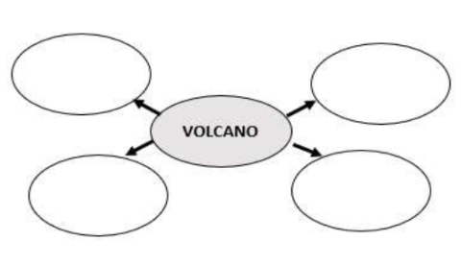
- eruption

Correct answers cause lava bursts and glowing animations.
Gamification Feature
Students earn 20 experience points (XP) for correctly forming volcano-related vocabulary words. Each completed word increases the progress bar and brings the player closer to finishing the mission. After completing all vocabulary challenges, students receive the “Volcano Vocabulary Badge” and unlock the next level.

INSERT A LESSON
What Is It
Structure of a Volcano
A volcano is a cone-shaped mountain or hill with an opening where lava, gases, hot vapor, and rock fragments erupt from Earth’s crust. These materials come from molten rock called magma beneath the Earth’s surface. The movement of magma toward or onto the surface is known as volcanism.
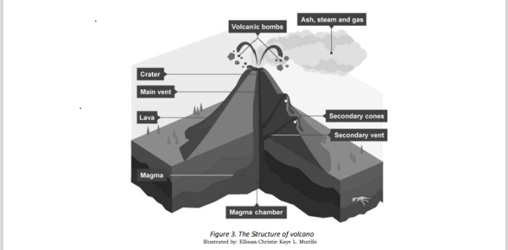

The Parts of a Volcano are:
⮚ Summit is the highest point or the apex of the volcano. At the summit,
you have an opening called vent.
⮚ Slopes are the sides or flanks of a volcano that radiate from the main or
central vent.
⮚ Base is lower outer part of the volcano.
Other Geologic features of a volcano:
➢ Magma Chamber is a region beneath the vent of a volcano where molten
rock or magma is deposited or stored before eruption.
➢ Main Vent is the main opening or outlet on the surface of a volcano that
emits lava, gases, ash or other volcanic materials.
➢ Conduit is an underground central tube-like or pipe-like structure of a
volcano that connects the magma chamber to the crater through which
the magma travels.
➢ Side Vent is a smaller outlet through which magma escapes.
➢ Crater is the mouth of the volcano which is a funnel-shaped or bowlshaped hollow at the top of the vent from where magma, ash and gas
comes out.
➢ Lava is a molten rock which is given off onto the surface of the Earth
when a volcano erupts.
➢ Ash and Gas Cloud is a of mixtures of rock, minerals, glass particles and
gases expelled or pushed out of the volcano during volcanic eruption.
Classification of Volcanoes
There are several ways by which volcanoes can be classified. They can be
classified based on structure and activity.
Types of Volcanoes Based on Structure
One way to classify different types of volcanoes is through the structure
characterized by their shape, parts and formation.
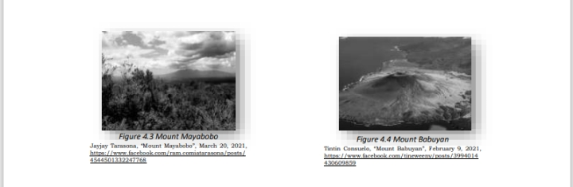
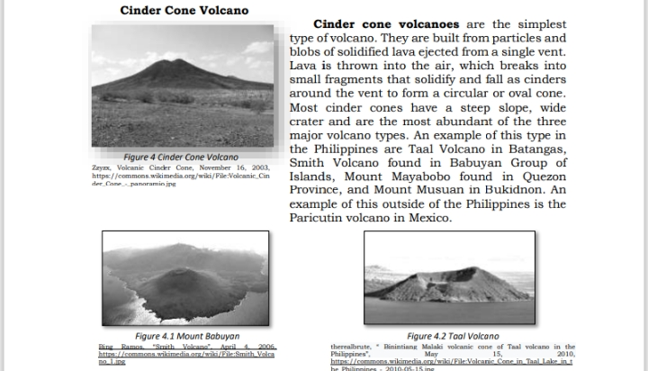

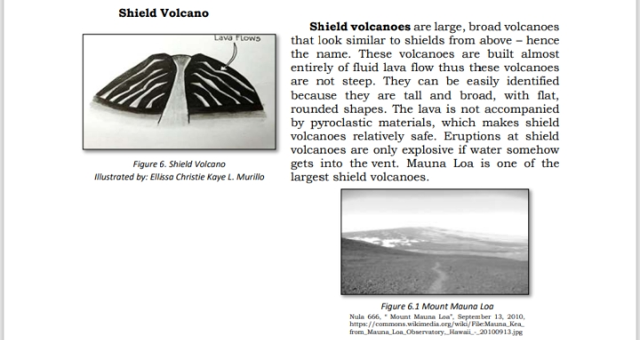
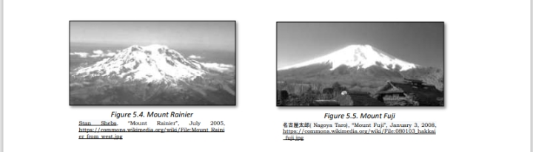
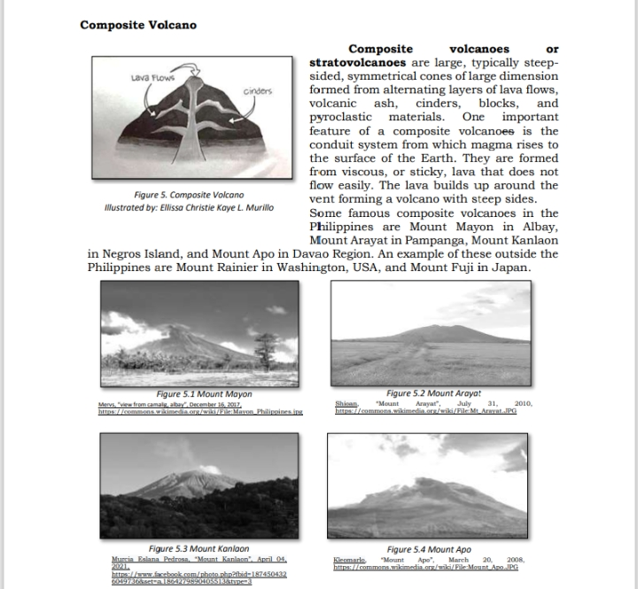
Types of Volcanoes Based on Activity
According to Philippine Institute of Volcanology and Seismology (PHIVOLCS), volcanoes are classified based on their activity and eruption history.
- Active volcanoes – erupted within the last 10,000 years and still show signs of activity like ash, gas, or lava release.
- Inactive volcanoes – have not erupted for over 10,000 years and show no signs of activity.
- Potentially active volcanoes – have no recorded eruption but still appear young in structure.
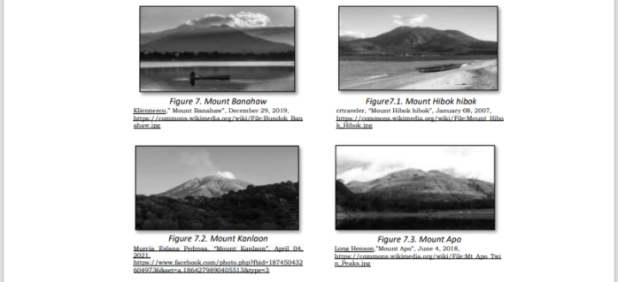
The Philippines has more than 100 volcanoes, and 24 of them are active.

Types of Volcanic Eruptions

Different types of volcanoes erupt differently. They are generally classified as

wet or dry depending on the magma’s water content. Volcanoes are described

according to the style of eruption as follows:

➢ Phreatic or hydrothermal is a stream-driven eruption as the hot rocks

come in contact with water. It is short lived, characterized by ash columns

but may be a beginning of a larger eruption.
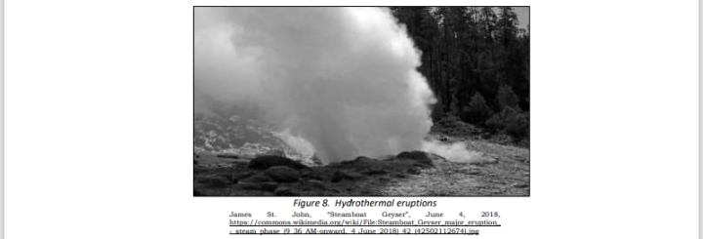

➢Phreatomagmatic is a violent eruption due to the contact between water

and magma. As a result, a large column of very fine ash and high-speed

and sideway emission of pyroclastic materials called base surges are observed.
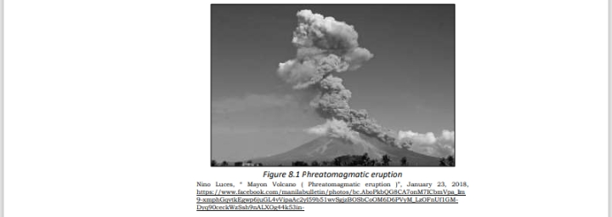
➢Strombolian a periodic, weak to violent eruption characterized by fountain
lava, just like the Irazu Volcano in Costa Rica.
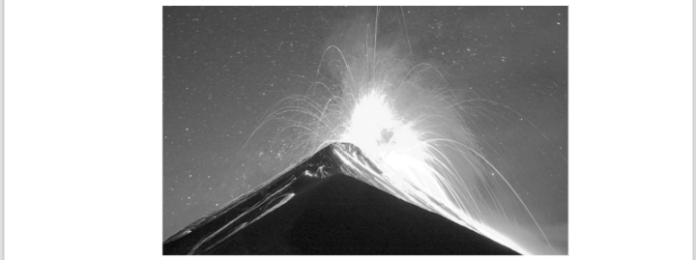

➢Vulcanian is characterized by tall eruption columns that reach up to 20
km high with pyroclastic flow and ash fall tephra like that of Paricutin
Volcano in Mexico.

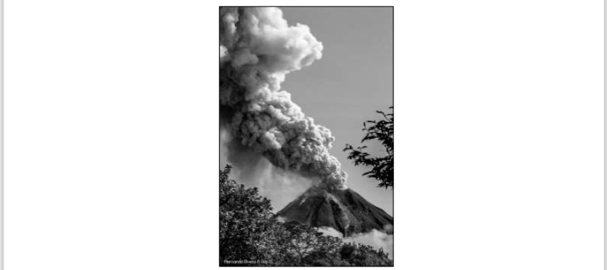
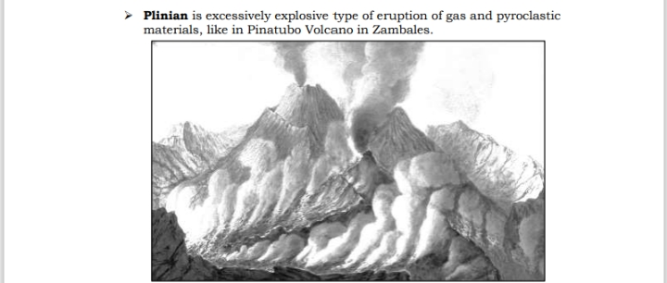
Signs of an Impending Volcanic Eruption

Philippine Institute of Volcanology and Seismology (PHIVOLCS) is the
government agency tasked with monitoring earthquakes and volcanoes in the
country. Based on their findings, here are the commonly observed signs when a
volcano is about to erupt.

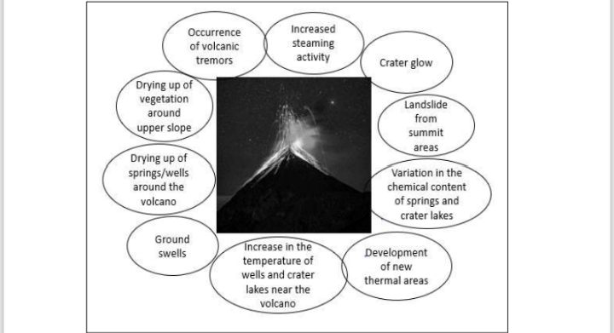

After the volcano lesson text, add this small part to maintain the game system.
ADD:
Interactive Learning Reward
After reading the lesson, students answer short interactive questions that check understanding of the volcano structure and classification. Correct responses earn 25 bonus XP, helping students unlock the next challenge called “Eruption Simulation Mission.”

LEVEL 4 – PHILIPPINE VOLCANO EXPLORER

Module Source
Module 1 – What’s New

Game Scene
A simple map of the Philippines appears on the screen with volcano icons.

Player Task
Students click a volcano to learn quick facts and answer one question correctly to earn points.

Mayon Volcano
Facts:
- Active volcano
- Located in Albay, Luzon
- Famous for its perfect cone shape
Question:
Why is Mayon Volcano famous?
A. Tallest volcano
B. Perfect cone shape
C. Biggest crater
Answer: B. Perfect cone shape

Mount Apo
Facts:
- Highest mountain in the Philippines
- Located in Mindanao
- Dormant stratovolcano
Question:
What is the highest mountain in the Philippines?
A. Mount Apo
B. Mount Makiling
C. Taal Volcano
Answer: A. Mount Apo

Mount Makiling
Facts:
- Inactive volcano
- Located in Laguna
- Has hot springs
Question:
Is Mount Makiling active or inactive?
A. Active
B. Inactive
C. Extinct
Answer: B. Inactive

Taal Volcano
Facts:
- Located in Batangas
- One of the most active volcanoes
- Known as a danger zone
Question:
Where is Taal Volcano located?
A. Albay
B. Batangas
C. Davao
Answer: B. Batangas

Mount Pinatubo
Facts:
- Active stratovolcano
- Located in Zambales area
- Popular trekking site
Question:
What activity is Mount Pinatubo popular for?
A. Swimming
B. Trekking
C. Fishing
Answer: B. Trekking

Game Goal
Answer all volcano questions correctly to become a Volcano Explorer Champion!

Gamification Feature

Students earn 30 experience points (XP) for correctly identifying warning signs of volcanic eruptions in the simulation. Each correct observation increases the mission progress bar. Once the activity is completed, students receive then “Eruption Expert Badge”nand unlock the next level.plorer.”

LEVEL 5 – VOLCANO ANATOMY LAB

Module Source
Module 1 – What’s More (Activity 1: Name My Parts)

Purpose in the Module
Students identify the parts of a volcano.

Game Scene
A 3D cross-section volcano model appears.

Player Task
Students drag labels to identify:
- magma chamber
- main vent
- secondary vent
- crater
- lava flow
- ash cloud

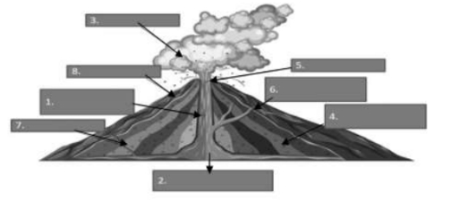
Correct answers trigger animated magma movement.
Gamification Feature
Students earn 40 experience points (XP)nfor identifying the correct parts of the magma chamber and their functions. As tasks are completed, the progress bar increases. After finishing the mission, students receive the “Magma Analyst Badge” and unlock the next level.

LEVEL 6 – VOLCANO BUILDER

Module Source
Module 1 – What’s More (Activity 2: Write My Type)

Purpose in the Module
Students identify different types of volcanoes.

Game Scene
A volcano construction simulator.

Player Task
- Students match volcano to its type
Types created:
- shield volcano
- cinder cone volcano
- composite volcano
Identify the type of volcano (CINDER CONE, SHIELD VOLCANO, COMPOSITEVOL s described by the following statements.
  - It is the most abundant and the simplest type of volcano.
  - It is built almost entirely of fluid lava flows.
  - It is slightly domed structure that resembles a warrior’s shield.
  - Mayon Volcano is an example of this type of volcano.
  - It has a steep slope and wide crater.
Only 5 matching items.
Animation
Correct matches build the volcano step-by-step.
Gamification Feature
Students earn 50 experience points (XP) for assembling the parts of a volcano correctly in the interactive model. Each correct placement fills the progress bar. When the structure is completed, students receive the “Volcano Architect Badge” and unlock the next level.

LEVEL 7 – VOLCANO INVESTIGATION CENTER

Module Source
Module 1 – What’s More (Activity 3: Active or Inactive)

Purpose in the Module
Students classify the active and inactive volcanoes

Game Scene
Students analyze volcano

Player Task
Review:
- eruption records
- gas emissions
- seismic activity
Then classify volcanoes as:
- Active
- Inactive
Students classify the volcanoes as Active or Inactive.
- Mayon Volcano
- Taal Volcano
- Mount Arayat
- Mount Makiling

Answer Key
- Mayon Volcano – Active
- Taal Volcano – Active
- Mount Arayat – Inactive
- Mount Makiling – Inactive

Animation
Correct answers activate glowing monitoring screens and volcano radar effects.
Gamification features
Students earn 60 experience points (XP) for correctly analyzing the monitoring data and classifying the volcanoes. Each correct classification awards 10 XP, and the points are added to the player’s total score. As correct answers are completed, the progress bar increases, showing how much of the investigation mission has been finished.
When all volcanoes are correctly classified, students receive the “Lava Bridge Champion Badge” and unlock the next level.

LEVEL 8 – ERUPTION WARNING LAB

Module Source
Module 1 – Discussion: Signs of Impending Volcanic Eruption

Purpose in the Module
Students learn warning signs before eruptions.

Player Task
Students look at 4 pictures and tap the correct warning sign.
- Shaking ground → Tremors
- Red glowing crater → Crater Glow
- Smoke coming out → Steaming
- Bulging ground → Ground Swelling

Game Mechanic
- One tap only
- Instant feedback after each answer
- Short 4-item activity

Animation
Correct answers trigger:
- Flashing warning alarm
- Green checkmark
- Small volcano alert sound
Gamification Feature
Students earn 70 experience points (XP) for successfully identifying the warning signs of a possible volcanic eruption. Each correctly identified warning sign awards 12.5 XP, which is added to the player’s total score. As students detect the correct signs using the monitoring instruments, the progress bar increases to show the completion of the laboratory investigation.
When all warning signs are correctly identified, students receive the “Eruption Warning Specialist Badge” and unlock the next level.
Assessment
Directions: Choose the letter of the best answer. Write the chosen letter on a separate sheet of paper.
Directions: Choose the letter of the best answer. Write the chosen letter on a separate sheet of paper.
- Which statement about volcanoes is INCORRECT?
A. Volcanoes provide information about Earth’s interior.
B. Volcanoes can be found on land and ocean floors.
C. Volcanoes always show signs before erupting.
D. Volcanoes without lava can still be dangerous.
- Which part of the volcano stores hot molten magma beneath Earth’s surface?
A. Lava flow
B. Main vent
C. Magma chamber
D. Secondary vent
- Which type of volcano is formed from sticky or viscous lava?
A. Shield volcano
B. Lava dome
C. Cinder cone
D. Composite volcano
- What is the basis for classifying volcanoes as active or inactive?
A. Shape of the volcano
B. Size of the cone
C. Records of eruptions
D. Height of the volcano
- Which of the following is NOT a sign of an impending volcanic eruption?
A. Crater glow
B. Volcanic tremors
C. Increased rainfall
D. Ground swelling
Answer Key:
- C
- C
- B
- C
- C
Gamification features

Students earn 80 experience points (XP) for analyzing volcanic ash scenarios and answering related questions. As correct responses are given, the progress bar increases. When the task is completed, students receive the “Ash Specialist Badge” and unlock the next level.
What’s New
Facts About Volcanoes
➢ More than 80% of the Earth’s surface is volcanic in origin.
➢ Mountains and seafloors were formed by volcanic eruptions.
➢ Volcanoes’ gaseous emission formed the Earth’s atmosphere.
➢ The danger zone around volcano covers about 32.187 km radius.
➢ Volcanic lightning is caused by friction between the ash particles moving
rapidly to the surface.
➢ Volcanic eruption can trigger earthquake, mudflow, rock falls, flash floods
and tsunamis.
➢ Volcanic ash is a mixture of rock fragments, glass particles, and minerals
thrown out from erupting volcano. It is acidic and has a sharp adges.
Facts About Taal Volcano Eruption in 2020
➢ Location: Batangas (Taal)
➢ Status: Second most active volcano
➢ Features: Caldera (Has water/lake within a lake)
➢ Eruption Started on: January 12, 2020
Ended on: January 22, 2020
➢ Last eruption: 1977 (43years ago)
➢ Type of eruption: Phreatomagmatic (main crater) has water in it
What is It

Magma and Its Composition
Magma is molten rock found beneath volcanoes. It forms at destructive plate boundaries and contains silica-rich materials.

Crystal Content
As magma cools, minerals begin to crystallize. High-temperature minerals form first, followed by low-temperature minerals.

Viscosity
Viscosity is the resistance of magma to flow.
- Low-silica magma flows easily.
- High-silica magma is thicker and more viscous.
Temperature also affects viscosity: hot magma flows faster, while cooler magma flows slowly.

Temperature
Magma temperatures vary depending on composition. Basaltic magma can reach over 1200°C, while rhyolitic magma is cooler and thicker.

Volatile Content
Magma contains dissolved gases such as water vapor, carbon dioxide, and sulfur dioxide. When pressure decreases, gases form bubbles. In thick magma, trapped gases build pressure and can cause explosive eruptions.

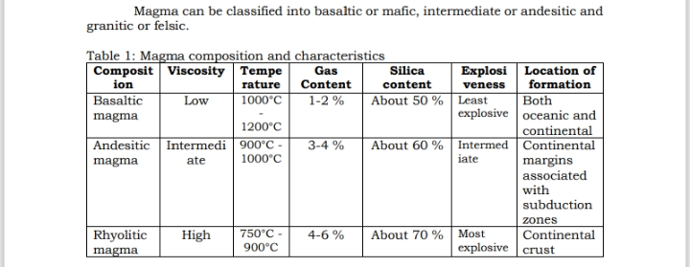
CLASSIFICATIONS OF MAGMA

Process of Volcanic Eruption
High temperature inside the Earth melts solid rocks in the mantle and turns them into magma. The continuous melting and accumulation of magma push it to the magma chamber of a volcano. Magma contains dissolved gases such as water vapor, carbon dioxide, and sulfur dioxide.
As gases are released from the magma, bubbles form through vesiculation. This can occur by decompression or crystallization. Decompression happens when pressure is lowered as magma rises, similar to opening a soda bottle. Crystallization also increases vapor pressure and leads to vesiculation.
Both decompression and crystallization can trigger an explosive eruption. As magma reaches the Earth’s surface, it explodes due to dissolved gases. The type of explosion depends on the composition of magma.

Volcanic Hazards and Their Effects
Volcanic hazards are phenomena arising from volcanic activity that pose potential threat to people and property. During major explosive eruptions, large amounts of volcanic gas, aerosol droplets, and ash are injected into the atmosphere.
Tephra or fragmented volcanic debris are violently ejected and can extend to tens of kilometers above. Carbon dioxide dispersed into the atmosphere can lead to global warming, while sulfur dioxide can cause global cooling, ozone destruction, and air pollution.
Below is a list of volcanic hazards common in Philippine active volcanoes.
➢ Ash fall – pulverized rocks, sand, gritty and harsh glasses shoot out in the
air by volcano.
➢ Mud flow – mixture of water, molten rocks and debris flowing down from
the side of volcano to the ground. It is also called as Lahar.
➢ Lava flow – streams of molten rocks and other fragmented materials
emitted by erupting volcano.
➢ Pyroclastic flow – fast moving hot mixtures of gas, ash, and molten rocks
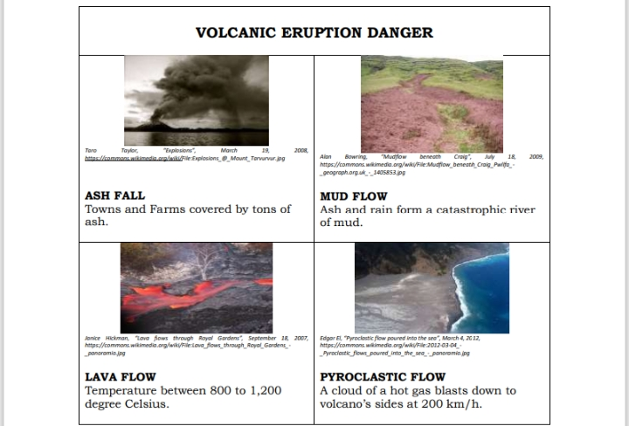
moving away from the volcano to the ground.
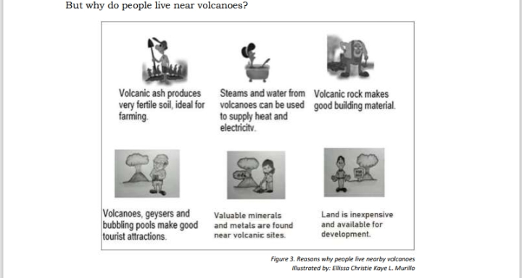
The following are list of the Precautionary measures that can be practiced to
lessen the danger before, during, and after a volcanic eruption:
BEFORE
➢ Know the facts about volcanoes in your area like danger zones and
history of eruptions.
➢ Know the location of designated evacuation site.
➢ Listen to the announcement of your authorities.
➢ Stock clean and safe drinking water and other food supplies.
DURING
➢ Stay inside your homes and keep doors and windows close.
➢ Secure you water and food supplies.
➢ Wear mask, eye googles or face shield if you need to go out.
➢ Do not go near the danger zones.
➢ Listen to the news via television or radio devices.
➢ Obey the evacuation orders of the authorities.
AFTER
➢ Assess the situation if it is safe to go out.
➢ Check the perimeter of your house for any possible damage.
➢ Clean and remove the volcanic ashes in the roof, gutters, and windows.
➢ Replace contaminated water and food supplies.
➢ Stay updated in news and announcements from your authorities.

Choose the letter of the best answer.
- Which statement is INCORRECT?
A. Volcanoes give information about inner Earth.
B. Volcanoes can be found on land and ocean floor.
C. Volcanoes show precursory signs before eruption.
D. Volcanoes that do not produce lava is not dangerous.
- What is the term used to represent the opening of the volcano where magma comes out?
A. Chamber
B. Crater
C. Summit
D. Vent
- Which type of volcano is formed from viscous or sticky lava that does not flow easily?
A. Cinder cones
B. Composite volcanoes
C. Lava domes
D. Shield volcanoes
- Which of the following statements is CORRECT about active volcanoes?
A. Active volcanoes do not have magma supply.
B. Active volcanoes have no record of eruption.
C. Active volcanoes erupted within the last 10,000 years.
D. Active volcanoes show no volcanic activity at all.
- What type of eruption is characterized by extremely explosive gas and pyroclastic activity, like Mt. Pinatubo (1991)?
A. Phreatic
B. Phreatomagmatic
C. Plinian
D. Strombolian

Answer Key:
- D
- D
- C
- C
- C
Students earn 100 experience points (XP) for successfully completing the final volcano mastery activities. By answering this assessment about volcanoes. After finishing the challenge, students receive the “Volcano Master Badge” and unlock the ultimate recognition in the volcano learning path.
Volcano Master Badge

Total Possible XP
If a student completes all levels:
Total XP = 535 XP

Final Game Progression Table
Level | Game Activity | Module Source
1 | Research Base | Module 1 – What I Need to Know
2 | Knowledge Scanner | Module 1 – What I Know
3 | Lava Word Builder | Module 1 – What’s In
4 | Volcano Explorer | Module 1 – What’s New
5 | Volcano Anatomy | Module 1 – Activity 1
6 | Volcano Builder | Module 1 – Activity 2
7 | Volcano Investigation | Module 1 – Activity 3
8 | Warning Signs Lab | Module 1 – Signs of Eruption
9 | Assessment
What was added

A new section that explains:
Leaderboard System:
- Shows top students based on total XP
- Displays avatar, level, badges, and points
- Encourages friendly competition and engagement
Reward System
Students receive:
- XP (Experience Points) for missions and correct answers
- Achievement Badges for completing levels
- Level Unlocking for progression
- Progress Bar to track learning journey
- Final Achievement: Volcano Master after completing all 15 levels

