Bilkent University

Department of Computer Engineering

CS 319

Object Oriented

Software Engineering

Project

Project name: Dribble and Score!

Analysis Report

25/02/2017

**Group name:**

2C

**Group Members:**

Batıkan HAYTA 21301382

Berke SOYSAL 21400908

Boran YILDIRIM 21401947

Sencer Umut BALKAN 21401911

**Instructor:**

Prof. Dr. Uğur DOĞRUSÖZ

Table of Contents

|  |  |  |  |
| --- | --- | --- | --- |
| 1 | Introduction................................................................................................. | | 3 |
| 2 | Game Overview………………………………………………………………… | | 4 |
|  | 2.1 | List of Bonuses..................................................................................... | 5 |
|  | 2.2 List of Obstacles ……………………………………………………………. | | 5 |
|  | 2.3 List of Goalkeeper………….……………………………………………….. | | 6 |
|  | 2.4 | Soccer Player........................................................................................ | 6 |
| 3 | Requirements.............................................................................................. | | 7 |
|  | 3.1 | Functional Requirements………………………………………………….. | 7 |
|  | 3.2 | Non-Functional Requirements .............................................................. | 8 |
|  | 3.3 | Pseudo Functional Requirements ……………………………………… | 8 |
| 4 | System Models ………………………………………………………………… | | 9 |
|  | 4.1 | Use Case Model ………………………………………………………….. | 9 |
|  | 4.1.1. Use Case Descriptions ……………………………………………… | | 10 |
|  | Use case #1 ……………………………………………………………………. | | 10 |
|  | Use case #2 .............................................................................................. | | 10 |
|  | Use case #3 ............................................................................................... | | 10 |
|  | Use case #4 .............................................................................................. | | 11 |
|  | Use case #5 .............................................................................................. | | 11 |
|  | Use case #6 …………………………………………………………………… | | 12 |
| 5 | References ................................................................................................. | | 27 |

Analysis Report

CS319 Project: Dribble and Score

**1.** **Introduction**

The “Dribble and Score” is a game that is the combination of road-running and football-shooting games. The aim of the game is to successfully deliver the ball to near the goal by passing the obstacles in the way of character, and then shoot the ball accurately to score. This is the analysis report that includes basic gameplay elements, rules, features. Functional and nonfunctional requirements, use case models and use-case diagrams will be described.

**2.** **Game Overview**

The game will have 5 levels, each of them consisting of dribbling and shooting parts. The dribbling part of the game will be 2D-platform type. The character, which is controlled by user, will move autonomously, but the user may give these instructions by keyboard buttons: jump, move left, move right. There will be three possible paths which character can dribble. By moving left or right, character will be escaped from obstacles and by jumping character will be escaped from mud.

The second part of the game, the player adjusts the speed and direction of the ball so that he can beat the goalkeeper and score. Firstly, the horizontal target roll will move right and left without stopping and the user will try to stop it in the right place. Then, the vertical target roll will move up and down without stopping and the user will try to stop it in the right place. The intersection of those two points will show where the ball will go. Secondly, the power option will move up and down without stopping and the user will be able to stop it in the right place and score a goal.

**2.1. List of Bonuses**

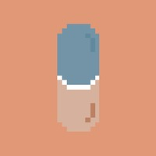

**Doping:** When player gets this bonus. It enables character to gain extreme speed and also character becomes untouchable until the bonus ends. That means the obstacles won’t have any effect on the character for 3 seconds.

Image 1: Doping’s appearance[1]

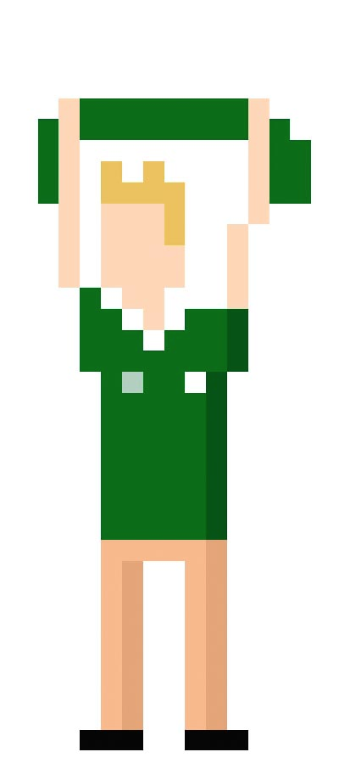

**Extra life:** For this bonus, player gains an extra shot chance for the second part of the game. This bonus will be visualized as a fan of the character’s team.

Image 2: Extra Life’s appearance[2]

**Football Shoe:** When player acquire this bonus, character becomes faster for 3 seconds. This will increase his score.

Image 3: Football shoes’s appearance[3]

* 1. **List of Obstacles**

**Mud:** This obstacle slow down the speed of the player. Player can dodge this obstacle, if they jump , going left or right.

**Referee:** When player hits the referees, they get 1 yellow card. If they hit referees again they will get another yellow card and lose their life’s. Player can dodge referees going left or right.

**Opponent team Fans:** If player encounter the opponent team fans, player has to jump to dodge them otherwise they will lose their lives.

**Defense players:** In order to dodge defense players, player need to go left or right. If player decided to jump to dodge them, defense player will get them.

* 1. **List of Goalkeepers**

**Standing Goalkeeper:** This type of goalkeeper will be standing on the middle of the goal and only save the shoot if it comes exactly towards him.

**Lentous Goalkeeper:** Lentous Goalkeeper will start from middle and go right until the end of goal, then return and will go left, and vice versa.

**Drunk Goalkeeper:** This goalkeeper moves randomly.

**Master Goalkeeper:** This goalkeeper will be focused to the shoot and try to move to the shot's direction to catch it.

* 1. **Soccer Player**

Soccer player is the source of the action in this game. Players can move soccer player using the arrow in the keyboard or ‘WASD’. Using keyboard, soccer player can jump, crouch, go left and right to avoid to obstacles and also get bonuses. Later on he has to shoot the ball accurately.

**3.** **Requirements**

3.1. Functional Requirements

3.1.1 Game Control

The game can be played in two ways, one is direction arrows and the other is ‘WASD’ keys. ‘W’ key and upper arrow are used for jumping of the character. ‘A’ and left arrow are used for shifting the character to left. ‘D’ and right arrow are used for shifting the character to right. ‘S’ and bottom arrow are used for slow down the character.

3.1.2 Score

Score system will be included and be given directly to user according to running time performance and shooting. If user used slow down option a lot in the parkour, time performance of this user will be reduced and score of the user will be decreased. If the user hits the ball at the corners, the highest score will be given.

3.1.3 Settings

Available settings are:

* 1. Changing the main character’s appearance.
  2. Changing the input keys.
  3. Resetting the highscores.

3.1.4 Help Menu

User will be able to access the help menu. Help menu contains information about game dynamics and game elements such as purpose of the game bonus descriptions and default controls.

3.1.5 Autosave

When a level is completed, the autosave function runs and saves all the user's data to the game's local database. Later, when the user re-enters the game, user can resume where left off.

3.1.6 Pause/Resume

The game can be paused at any time and can be resumed afterwards.

3.2. Non-Functional Requirements

* Game will contain open source 8-bit pictures. Main character, bonuses, goalkeepers and the whole level environment is going to be visualized in a retrospective way.
* Maps are going to be generated randomly according to specified difficulty of the current level. Thus, each level is going to be unique and computer generated.
* It will be a tile-based video game basically which will minimize the space requirements for our game “Dribble and Score”.

3.3. Pseudo Functional Requirements

* The Game will be implemented in Java.
* Some of the graphic objects will be designed using Adobe® Photoshop CS6.

1. **System Models**

**4.1. Use Case Model**

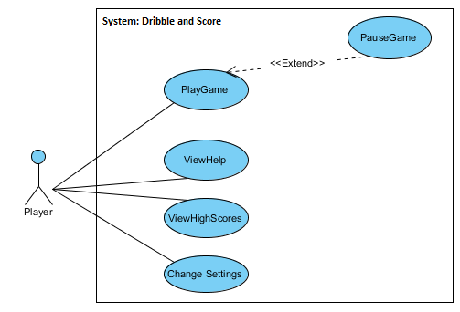

**Figure 1- Use Case Diagram**

4.1.1. Use Case Descriptions

**Use case #1**

**Use case name:** PlayGame

**Participating actors:** Player

**Entry Condition:** Player selects level and press “Start game” button from main menu

**Exit condition:**

* Player decided to choose exit game via pausing, and selecting “quit option.” from menu. OR
* Player is hit by a defender. OR
* Player overcomes the first part and finished his shootout.

**Main Flow of Events:**

1. Player starts the game
2. Player selects any of the levels which are unlocked.
3. Player plays the level until beats it.
4. System displays player’s score to the screen.
5. Next level unlocked.

Player repeats step 3 and 5 until all levels are finished.

6. System returns Main Menu screen.

Alternative Flow of Event

1. Player starts the game.
2. Player is getting hit by a defender. (Display game-over message, go step 6.)
3. Player presses exit game button from menu. (Go step 6)

**Use case #2**

**Use case name:** ViewInfo

**Participating actors:** Player

**Entry Condition:** Player opens the game and pauses game.

**Exit Condition:** Player returns to main menu

**Main Flow of Events**

1. Player choses to view help menu on main screen.
2. The game controllers and high score is displayed on menu. .
3. Player choses to return the menu, and then play may resume or quit.

**Use case #3**

**Use case name:** ViewHighScore

**Participating actors:** Player

**Entry condition:** Player opens the game and pauses game.

**Exit condition:** Player returns to main menu.

**Main Flow of Events:**

1. Player presses “Show High Scores” button.
2. The system displays high score of player for each levels.
3. Player returns main screen menu.

**Alternative Flow of Event:**

1. Player is getting hit by defender and loses game.

2. System displays high score of this level.

3. Player chooses either retry or go back to the main menu.

**Use case #4**

**Use case name:** ChangeSettings

**Participating actors:** Player

**Entry condition:** Player opens the game and is on main menu

**Exit condition:** Player returns to main menu.

**Main Flow of Events:**

1. On main screen menu, player presses settings menu
2. System displays different adjustments, change character, control, reset high score.
3. Player chooses the settings which are better for him/her.

**Alternative Flow of Event:**

**Use case #5**

**Use case name:** PauseGame

**Participating actors:** Player

**Entry condition:** Player is playing the game.

**Exit condition:**

-Player returns to main menu.

-Player chooses to exit the whole game

**Main Flow of Events:**

1. During the game, player presses the pause button.
2. While player is not pressed continue, game freezes.
3. Player presses continue.
4. Player continues the game

**Alternative Flow of Event:**

1. Player pauses the game.
2. System displays continue and go back buttons.
3. Player chooses the go back.
4. In main menu, Player selects another level to play.

**5.** **References**

1. http://www.stockunlimited.com/vector-illustration/capsule_1268415.html
2. http://sociable.co/wp-content/uploads/2013/01/Rugby_Guy.jpg
3. https://www.pixilart.net/art/create-your-own-8-bit-shoe-d0cd572d734ba21