**Use Case 1:** Entrance Page

**Actors:** User who hasn’t logged in

**Entry condition:** User has opened the webpage.

**Exit condition:**

* User closes the webpage.

**Main Flow:**

* User clicks to log in.

**Alternative Flow:**

* User chooses a pickup location and a destination
* User searches for a ride.

**Alternative Flow 2:**

* User clicks to sign in button.

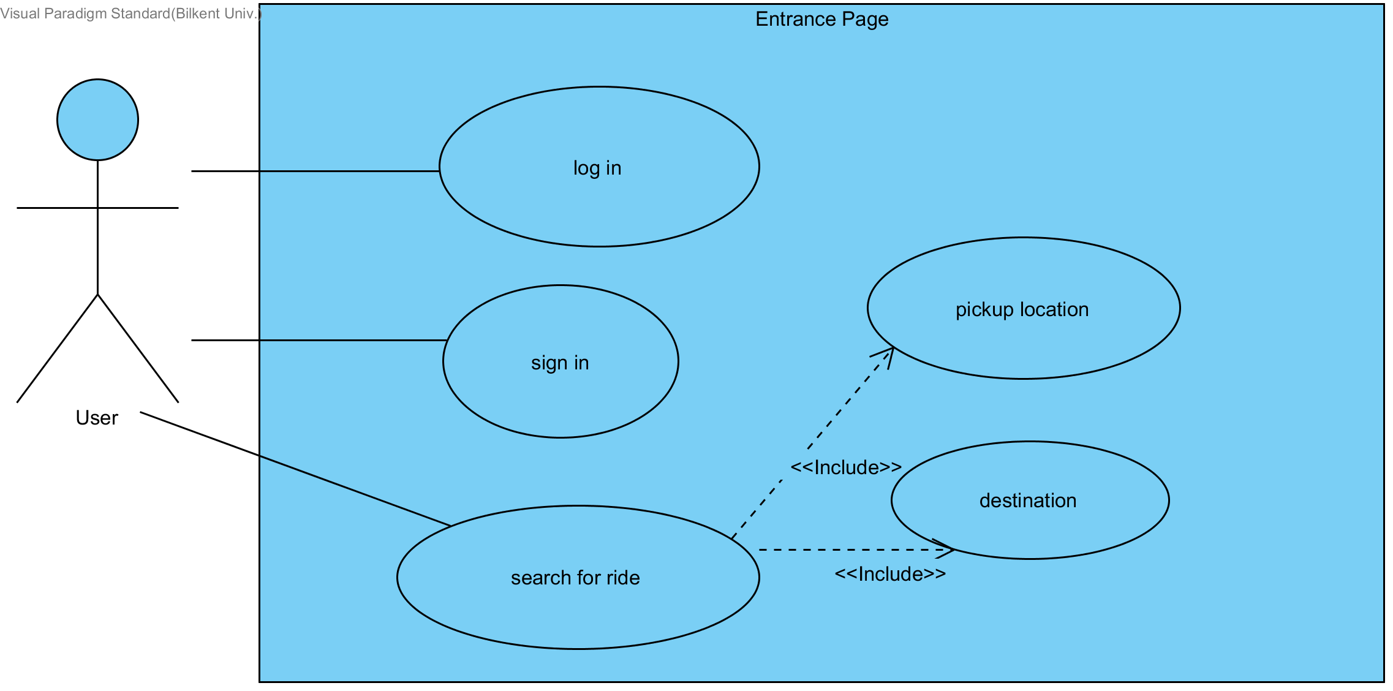

**Use Case 2:** Sign in Page

**Actors:** User who hasn’t logged in

**Entry condition:** User has clicked the sign in button on the entrance webpage.

**Exit condition:**

* User closes the webpage OR
* User clicks to “back” button.

**Main Flow:**

* User enters name, user type, password, phone no, age and e-mail.
* User clicks to sign in button.

**Alternative Flow:**

* User clicks to “back” button.

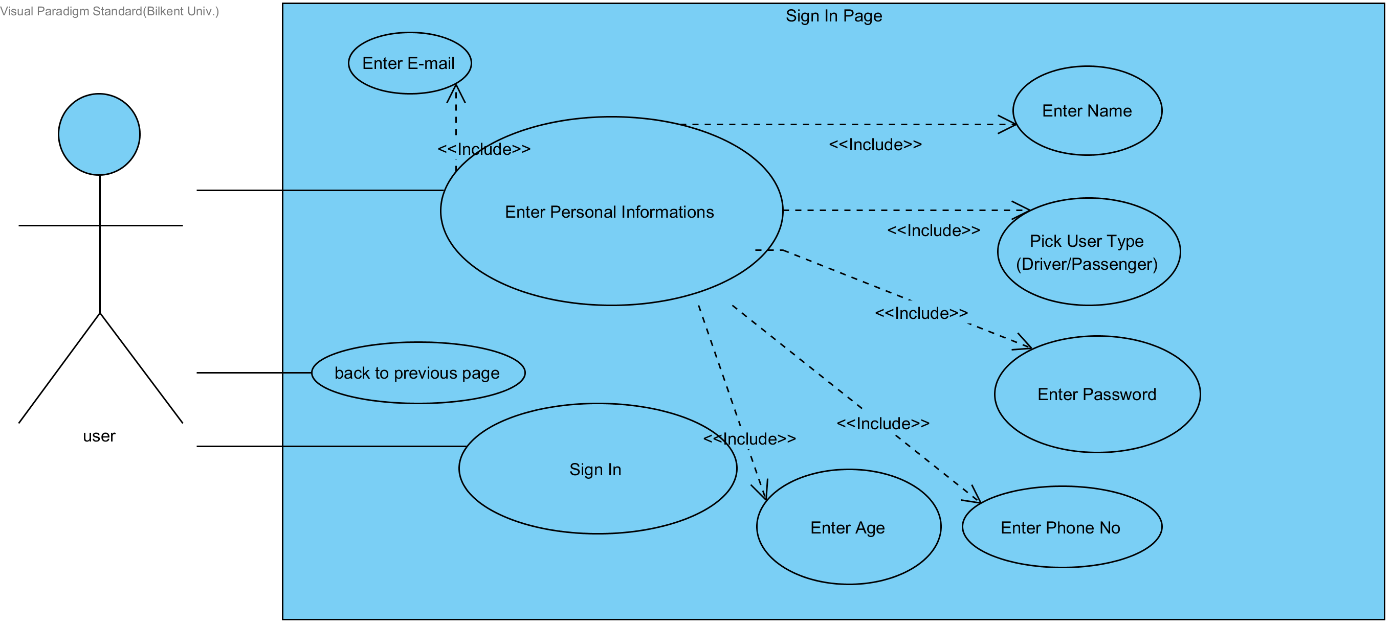

**Use Case 3:** Log In Page

**Actors:** User who hasn’t logged in

**Entry condition:** User has clicked to log in button on the entrance page.

**Exit condition:**

* User closes the webpage OR
* User clicks to “back” button.

**Main Flow:**

* User enters e-mail.
* User enters password.
* User clicks to log in button.

**Alternative Flow:**

* User clicks to “back” button.

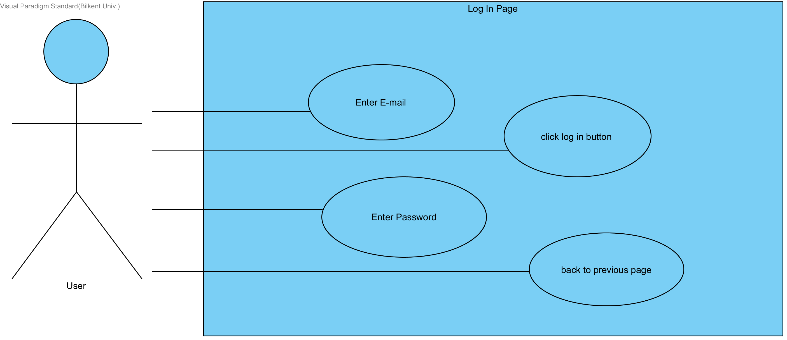

**Use Case 4:** Dashboard for Driver

**Actors:** Driver User

**Entry condition:** User has logged in as driver typed user.

**Exit condition:**

* User closes the webpage.

**Main Flow:**

* User clicks to view profile OR
* User clicks to add car OR
* User clicks to set a ride OR
* User clicks to vote OR
* User clicks to check for requests OR
* User clicks to check for (set) rides OR
* User clicks to change personal information.

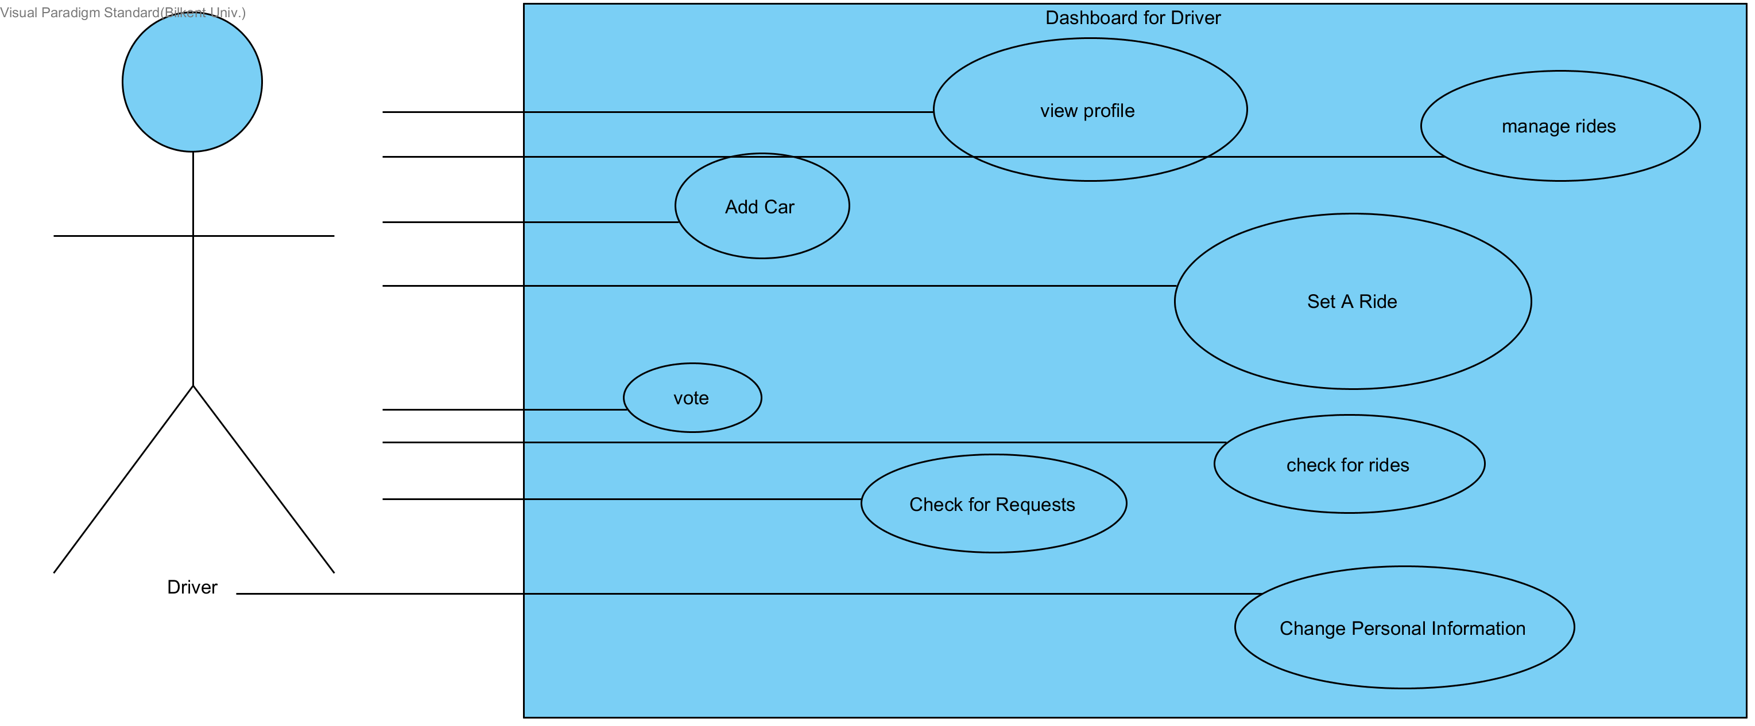

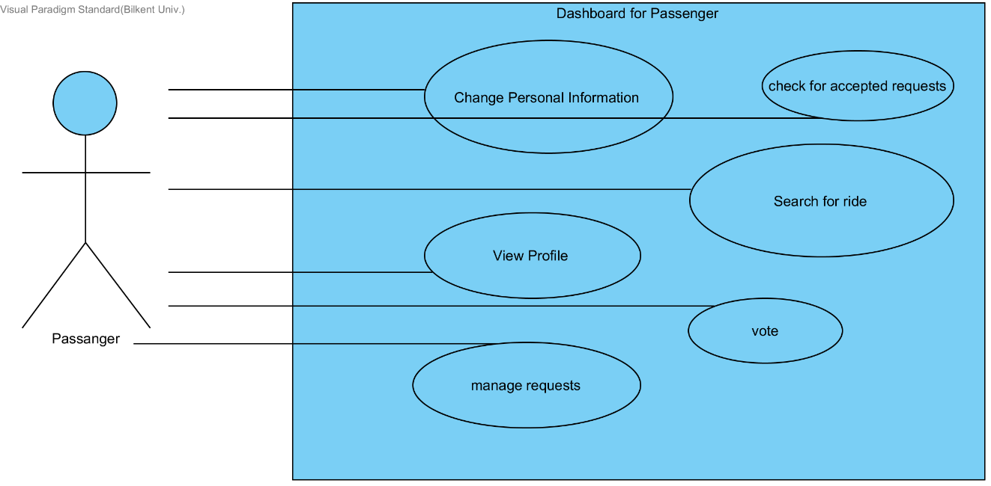

**Use Case 5:** Dashboard for Passenger

**Actors:** Passenger User

**Entry condition:** User has logged in as passenger typed user.

**Exit condition:**

* User closes the webpage.

**Main Flow:**

* User clicks to view profile OR
* User clicks to check for accepted requests OR
* User clicks to search for a ride OR
* User clicks to vote OR
* User clicks to check for requests OR
* User clicks to manage requests OR
* User clicks to change personal information.

**Use Case 6:** Add Car Page

**Actors:** Driver User

**Entry condition:** User has clicked to “add car” button on the dashboard for driver.

**Exit condition:**

* User closes the webpage OR
* User clicks to “back” button.

**Main Flow:**

* User enters the model.
* User enters the brand.
* User enters the safety score.
* User enters the year.
* User enters the engine power.
* User enters the license key.
* User enters the top speed of the car.
* User clicks to add car button.

**Alternative Flow:**

* User clicks to “back” button.

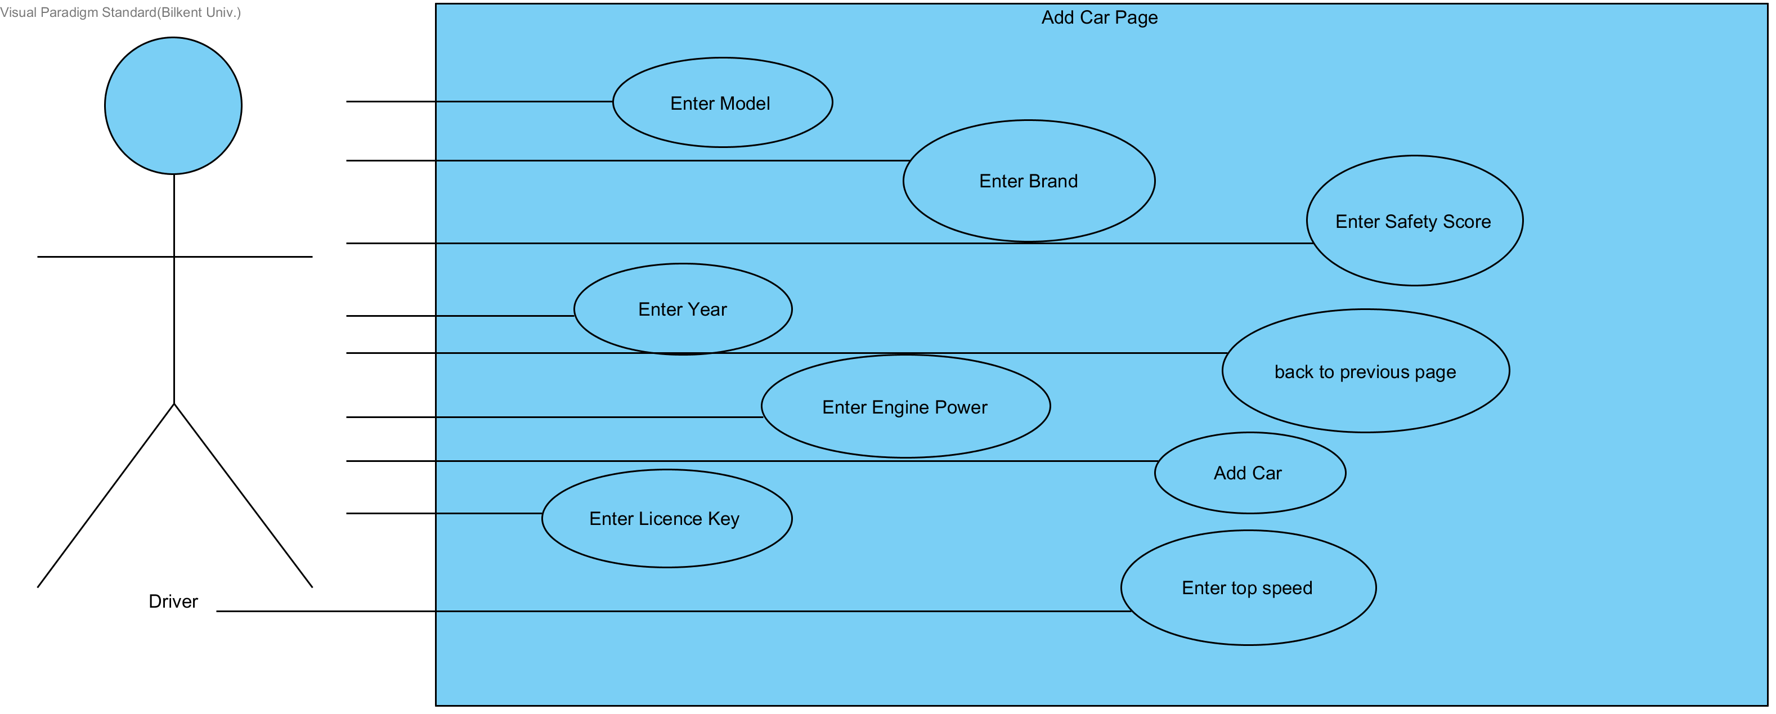

**Use Case 7:** View Profile

**Actors:** Driver User

**Entry condition:** User has clicked to “view profile” button on the dashboard for driver.

**Exit condition:**

* User closes the webpage OR
* User clicks to “back” button.

**Main Flow:**

* User clicks to view car ratings OR
* User clicks to view ratings (for driver ratings) OR
* User clicks to view number of votes taken OR
* User clicks to view number of rides AND
* User clicks to “back” button.

**Alternative Flow:**

* User clicks to “back” button.

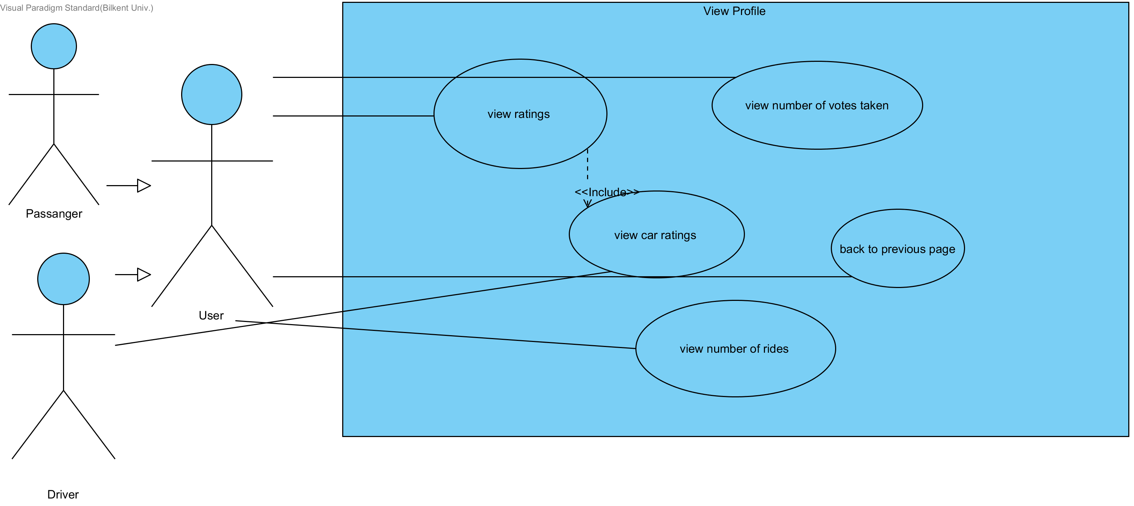

**Use Case 8:** View Profile

**Actors:** Passenger User

**Entry condition:** User has clicked to “view profile” button on the dashboard for passenger.

**Exit condition:**

* User closes the webpage OR
* User clicks to “back” button.

**Main Flow:**

* User clicks to view ratings (for passenger ratings).

**Alternative Flow:**

* User clicks to view number of votes taken.

**Alternative Flow 2:**

* User clicks to view number of rides.

**Alternative Flow 3:**

* User clicks to “back” button.

**Use Case 9:** Set A Ride

**Actors:** Driver User

**Entry condition:** User has clicked to “set a ride” button on the dashboard for driver.

**Exit condition:**

* User closes the webpage OR
* User clicks to “back” button.

**Main Flow:**

* User enters the starting point.
* User enters the destination.
* User enters the departure time.
* User enters the number of empty seats.
* User picks a car from added cars.
* User enters the price for per kilometer.
* User clicks to set the ride.

**Alternative Flow:**

* User clicks to “back” button.

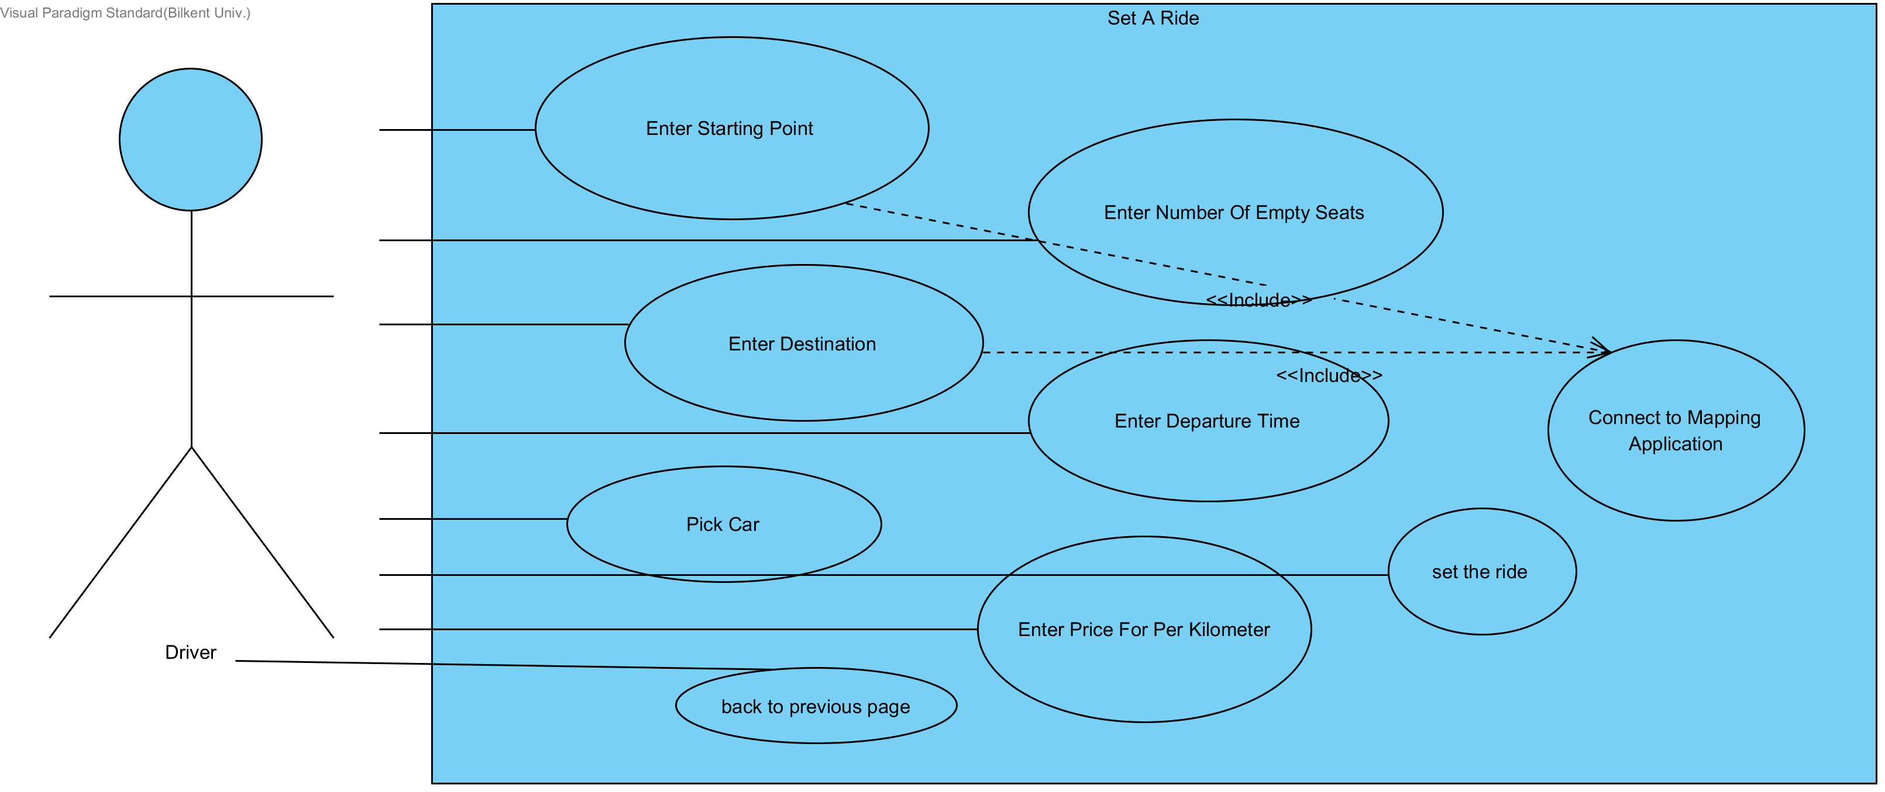

**Use Case 10:** Voting Page

**Actors:** Driver User

**Entry condition:** User has clicked to “vote” button on the dashboard for driver.

**Exit condition:**

* User closes the webpage OR
* User clicks to “back” button.

**Main Flow:**

* User votes for passengers.
* User clicks to “back” button

**Alternative Flow:**

* User clicks to “back” button.

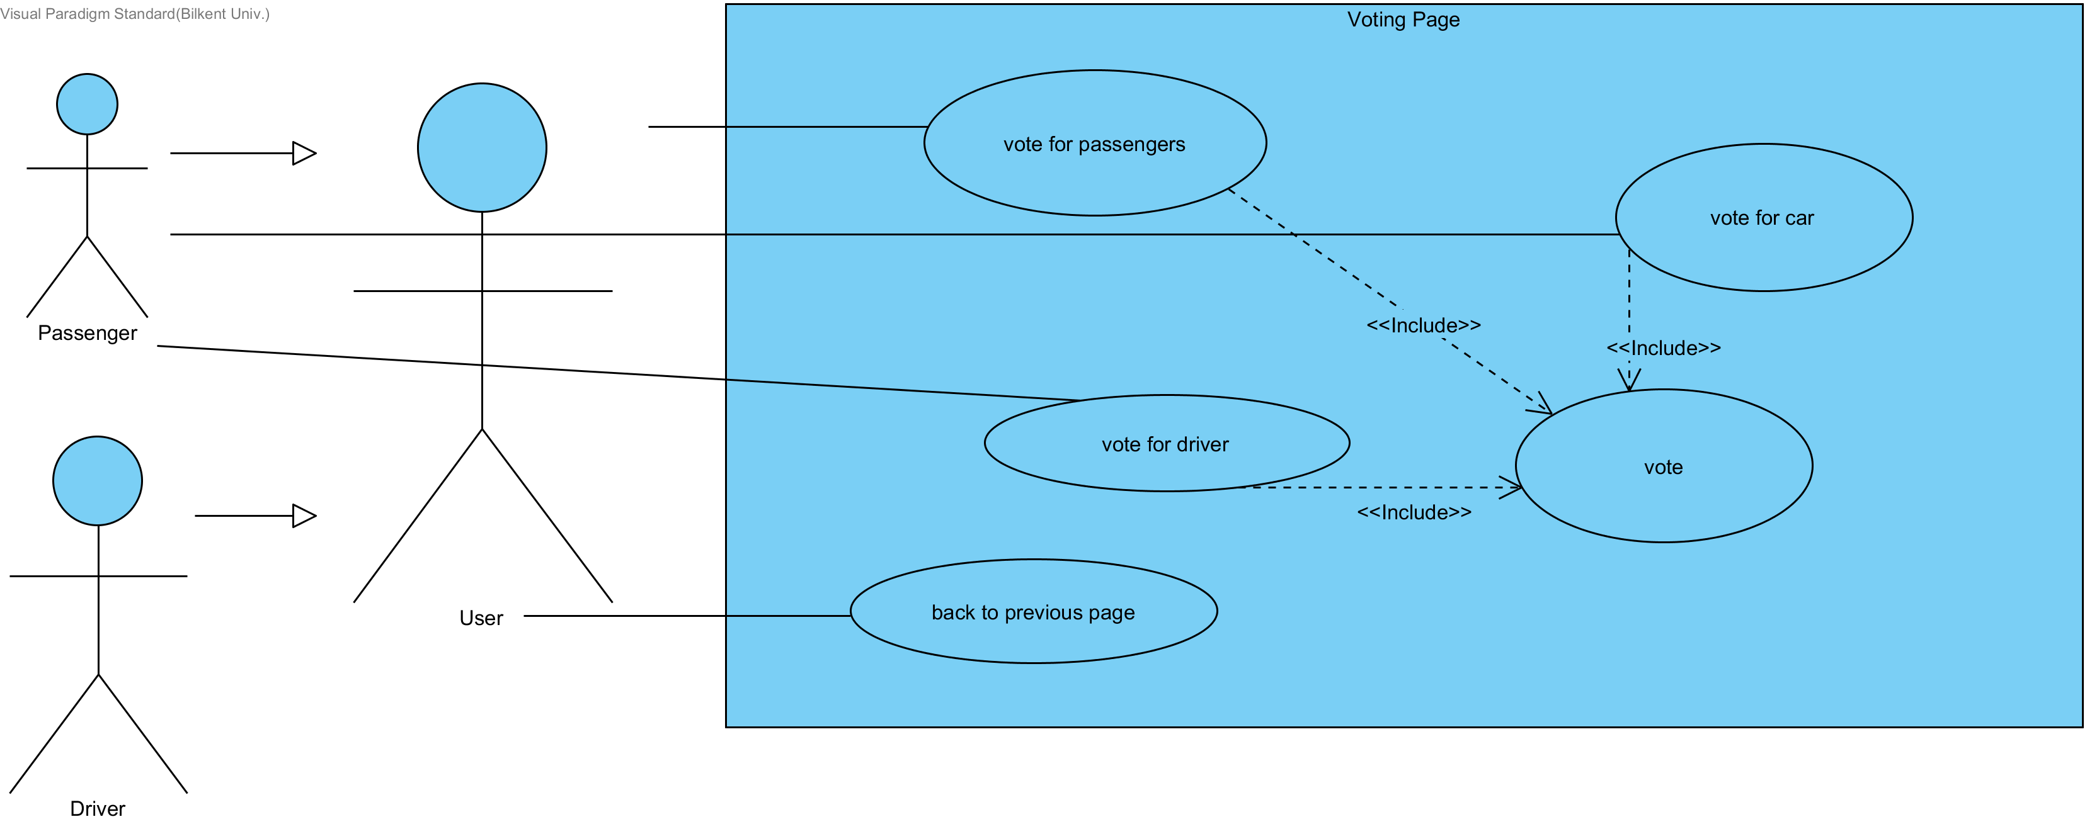

**Use Case 11:** Voting Page

**Actors:** Passenger User

**Entry condition:** User has clicked to “vote” button on the dashboard for passenger.

**Exit condition:**

* User closes the webpage OR
* User clicks to “back” button.

**Main Flow:**

* User votes for passengers OR
* User votes for drivers OR
* User votes for cars OR
* User clicks to “back” button.

**Alternative Flow:**

* User clicks to “back” button.

**Use Case 12:** Check for Rides

**Actors:** Driver User

**Entry condition:** User has clicked to “check for rides” button on the dashboard for driver.

**Exit condition:**

* User closes the webpage OR
* User clicks to “back” button.

**Main Flow:**

* User views empty seats OR
* User views departure times OR
* User views starting points OR
* User views pick up locations AND
* User clicks to “back” button.

**Alternative Flow:**

* User clicks to “back” button.

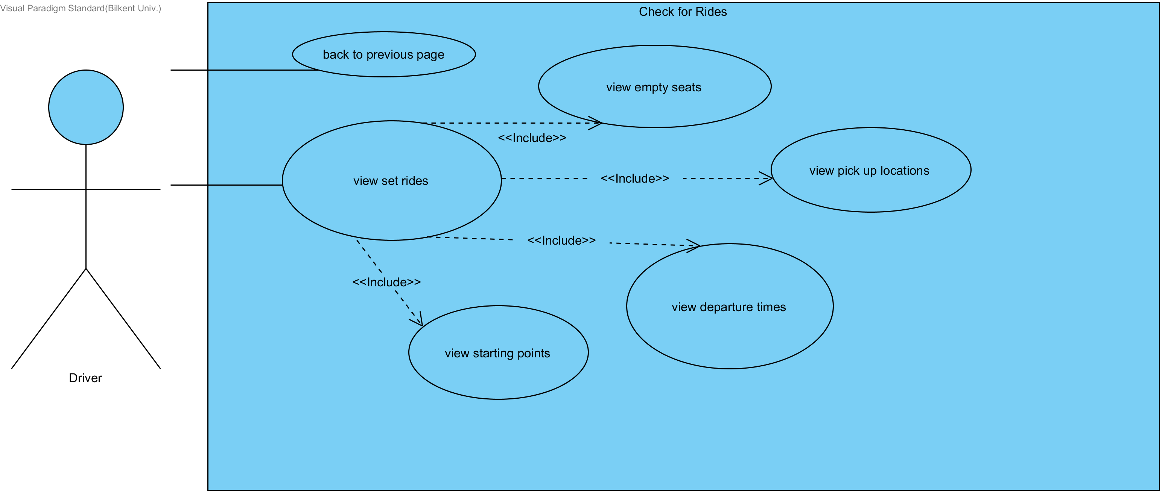

**Use Case 13:** Manage Rides Page

**Actors:** Driver User

**Entry condition:** User has clicked to “Manage Rides” button on the dashboard for driver.

**Exit condition:**

* User closes the webpage OR
* User clicks to “back” button.

**Main Flow:**

* User cancels ride.
* User clicks “back” button.

**Alternative Flow:**

* User changes time OR
* User changes destination OR
* User changes number of empty seats OR
* User changes departure location AND
* User clicks to “back” button.

**Alternative Flow 2:**

* User clicks to “back” button.

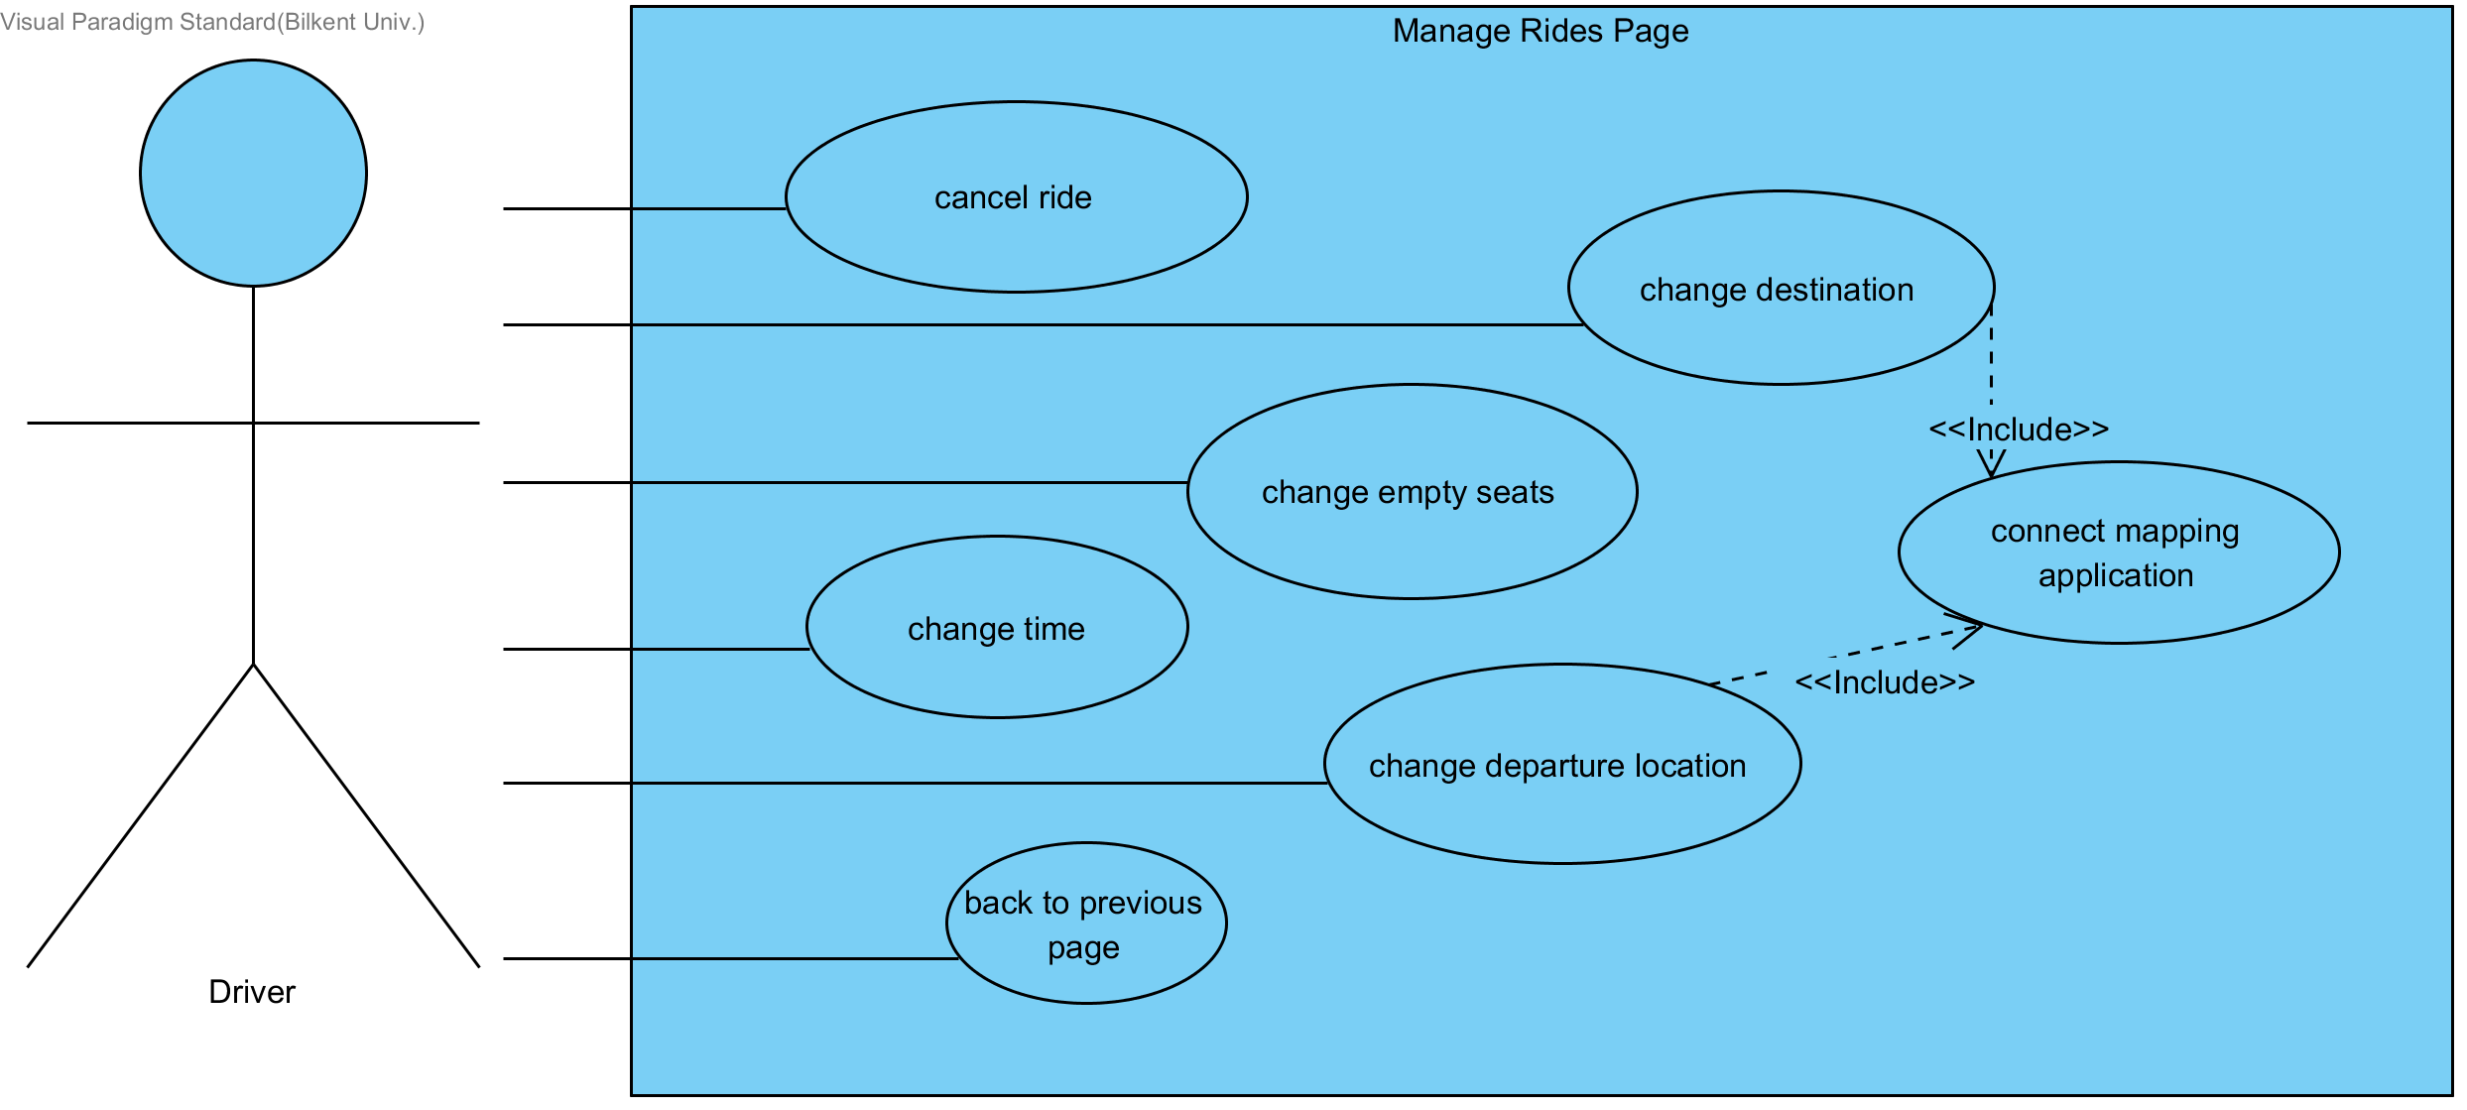

**Use Case 14:** Check for Requests

**Actors:** Driver User

**Entry condition:** User has clicked to “Check for Requests” button on the dashboard for driver.

**Exit condition:**

* User closes the webpage OR
* User clicks to “back” button.

**Main Flow:**

* User view requests, pickup locations, pickup times, ratings of passengers.
* User declines the request.
* User clicks “back” button.

**Alternative Flow:**

* User view requests, pickup locations, pickup times, ratings of passengers.
* User declines the request.
* User clicks “back” button.

**Alternative Flow 2:**

* User clicks to “back” button.

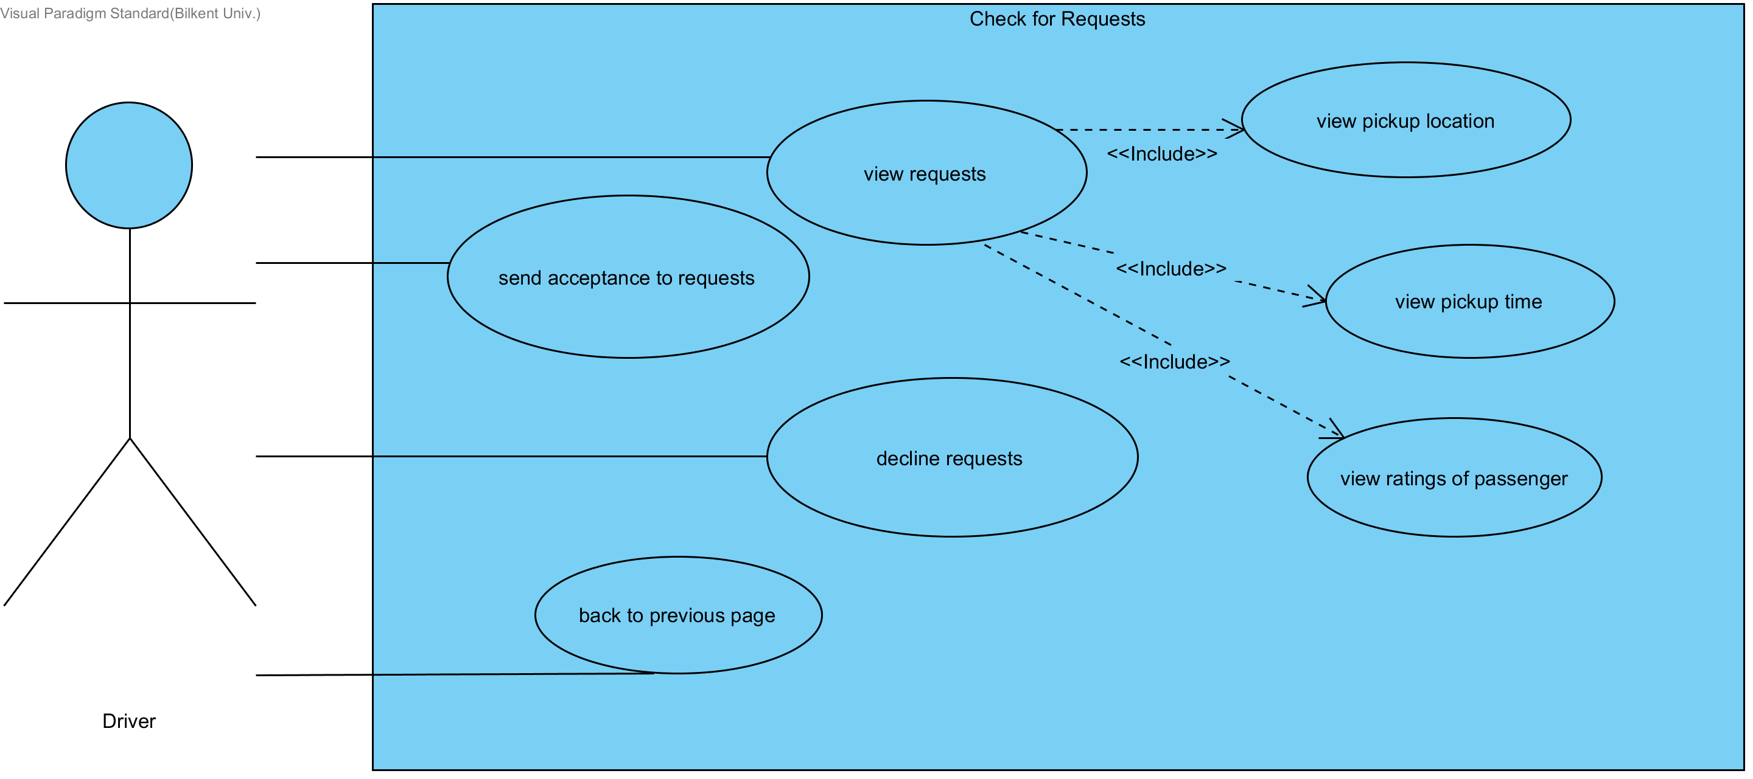

**Use Case 15:** Change Personal Information

**Actors:** Driver OR Passenger User

**Entry condition:** User has clicked to “Change Personal Information” button on the dashboard for passenger or dashboard for driver.

**Exit condition:**

* User closes the webpage OR
* User clicks to “back” button.

**Main Flow:**

* User changes name OR
* User changes e-mail OR
* User changes password OR
* User changes phone no.
* User clicks “back” button.

**Alternative Flow:**

* User clicks “back” button.

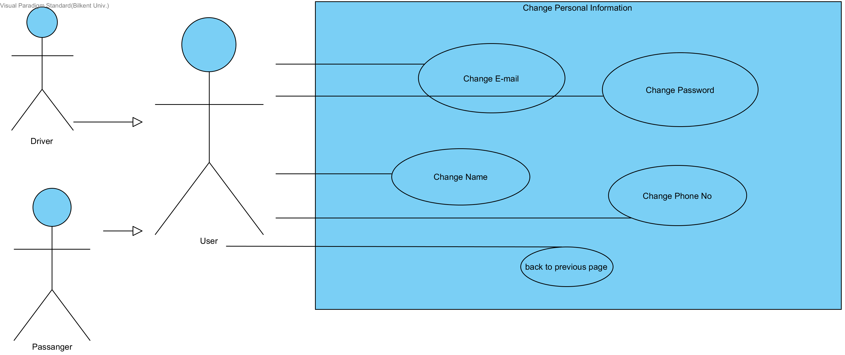

**Use Case 16:** Check for Accepted Requests

**Actors:** Passenger User

**Entry condition:** User has clicked to “Check for Accepted Requests” button on the dashboard for passenger.

**Exit condition:**

* User closes the webpage OR
* User clicks to “back” button.

**Main Flow:**

* User views accepted requests, pickup times, prices for per kilometer, number of empty seats, pickup locations, car information and driver information.
* User clicks “back” button.

**Alternative Flow:**

* User views unaccepted requests, departure times, car information and driver information.
* User clicks “back” button.

**Alternative Flow 2:**

* User clicks “back” button.

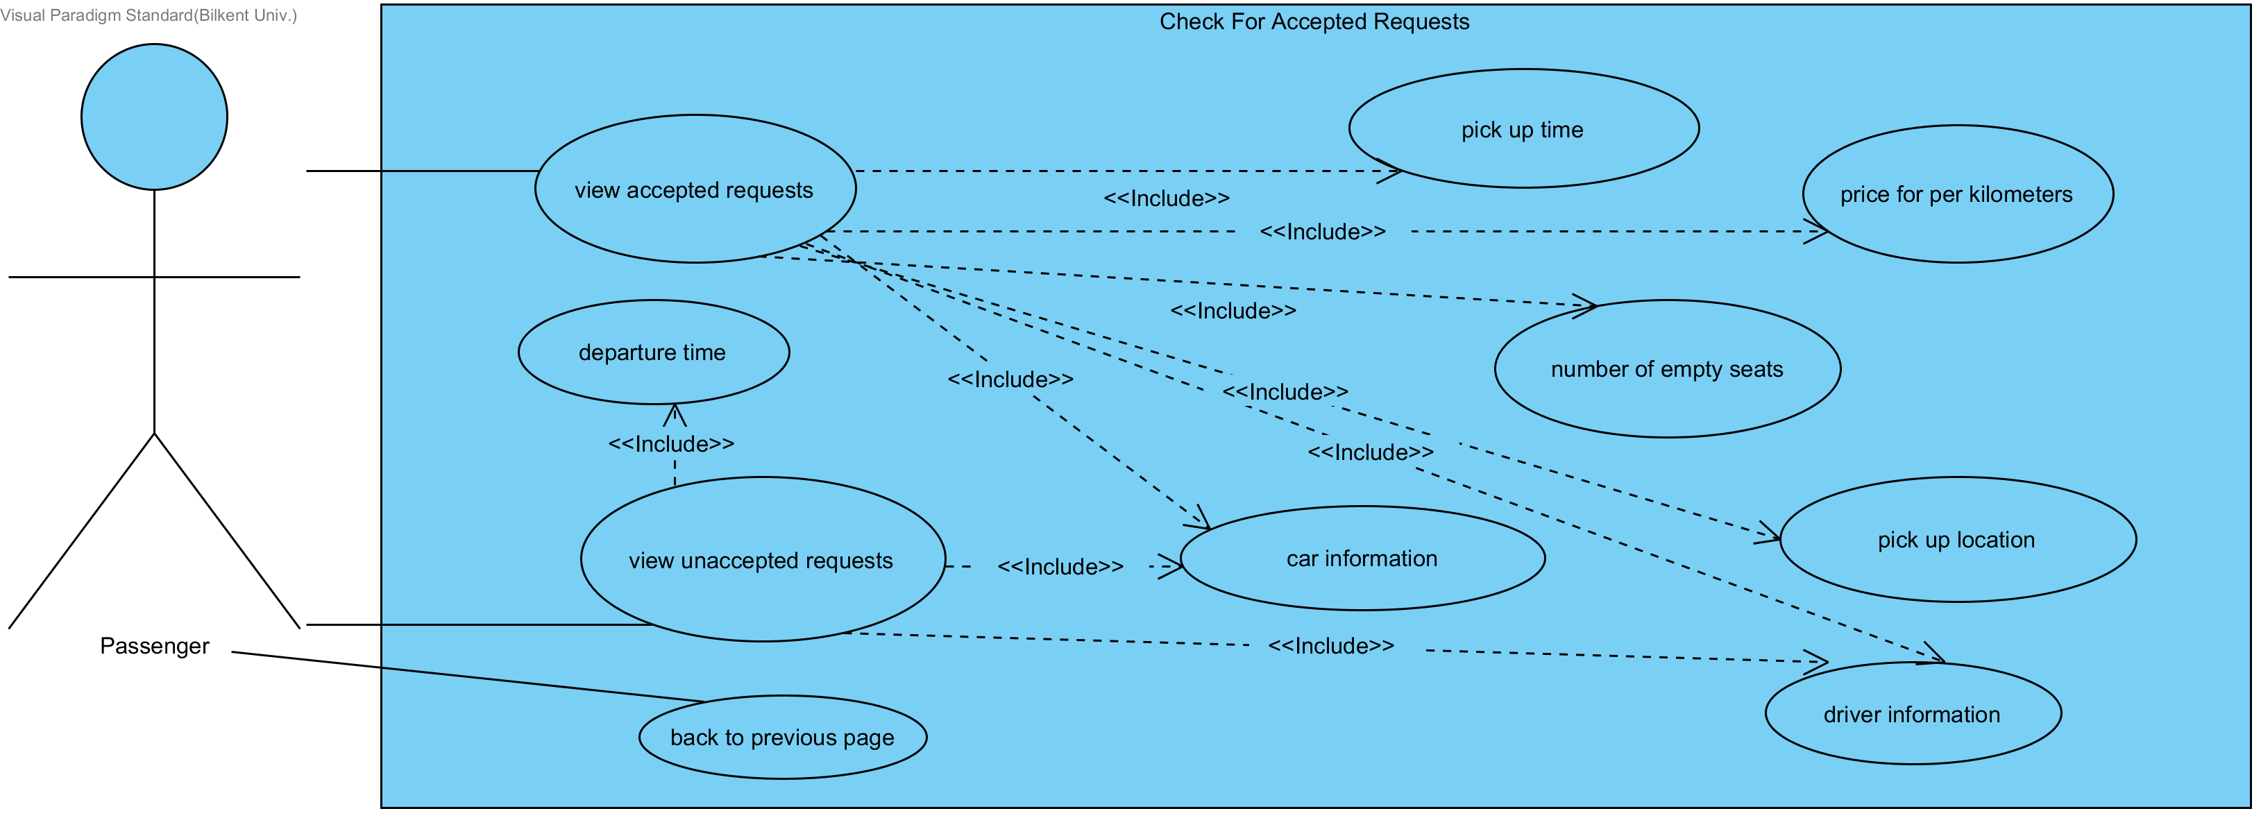

**Use Case 17:** Manage Requests

**Actors:** Passenger User

**Entry condition:** User has clicked to “Manage Requests” button on the dashboard for passenger.

**Exit condition:**

* User closes the webpage OR
* User clicks to “back” button.

**Main Flow:**

* User views requests, driver ratings, car ratings, pickup time and route OR
* User deletes accepted request OR
* User deletes unaccepted request.
* User clicks “back” button.

**Alternative Flow:**

* User clicks “back” button.

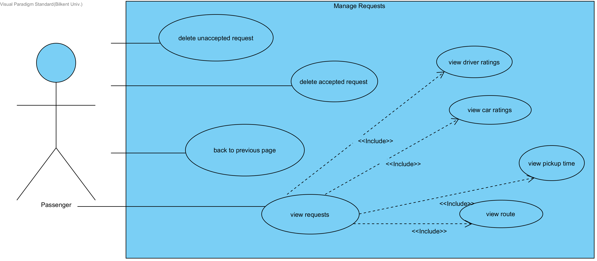

**Use Case 18:** Search for Ride

**Actors:** Passenger User

**Entry condition:** User has clicked to “Search for Ride” button on the dashboard for passenger.

**Exit condition:**

* User closes the webpage OR
* User clicks to “back” button.

**Main Flow:**

* User enters pickup location.
* User enters destination.
* User views rides.
* User sends request.

**Alternative Flow:**

* User clicks “back” button.

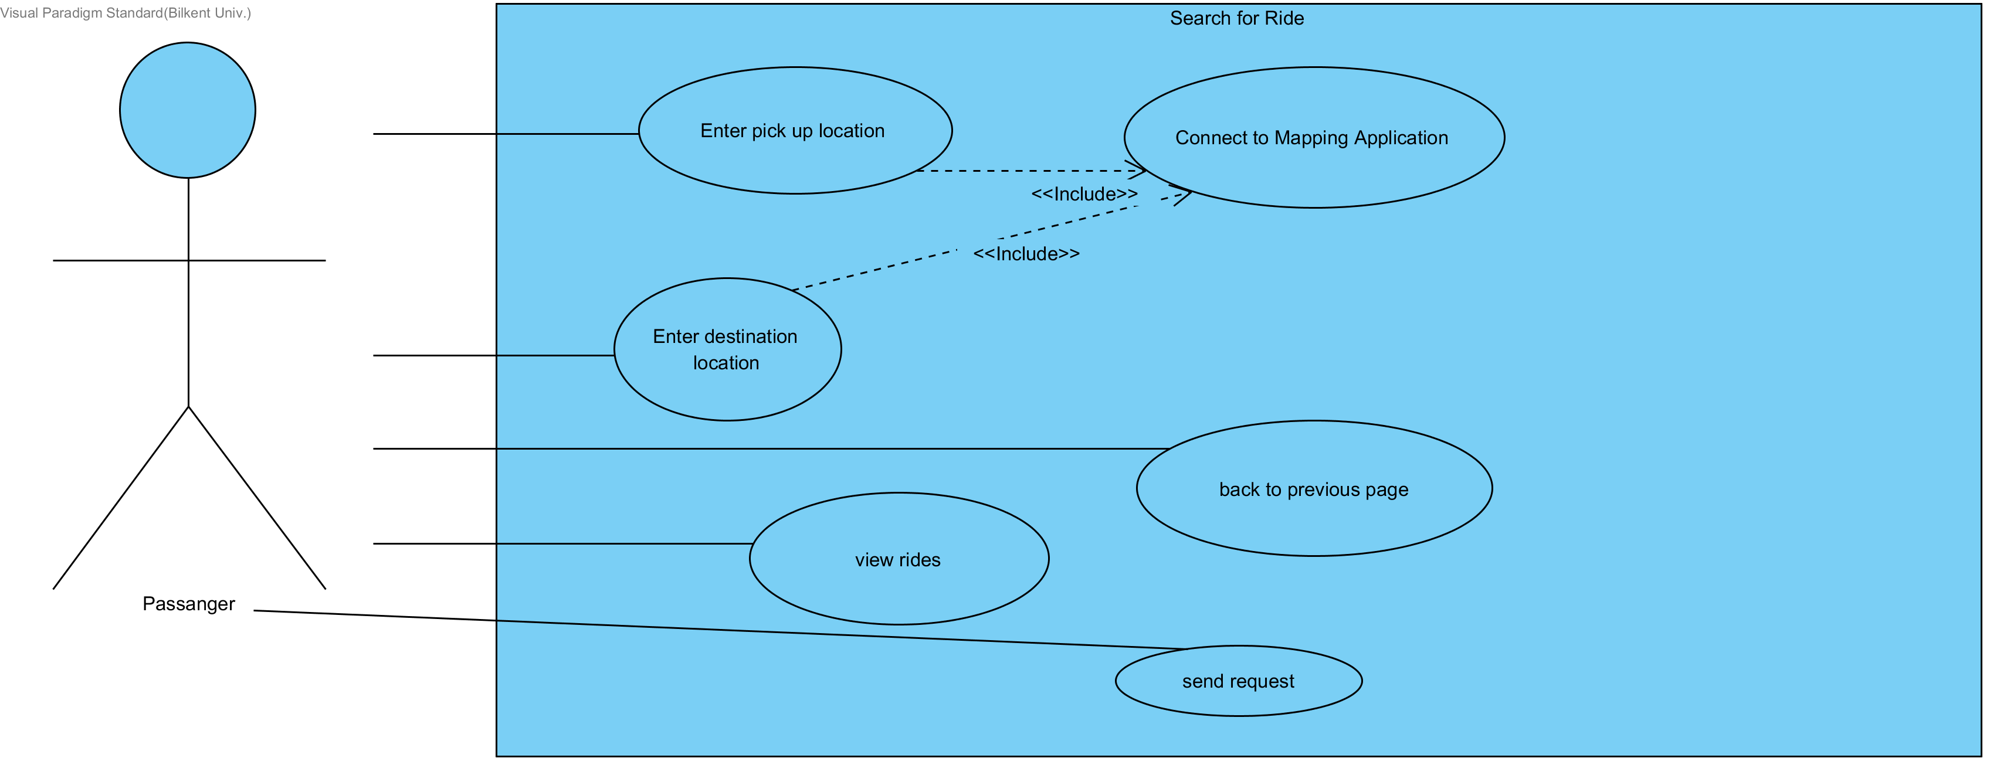

**Use Case 19:** View Rides Page

**Actors:** Passenger User

**Entry condition:** User has clicked to “View Rides” button on the search for rides page.

**Exit condition:**

* User closes the webpage OR
* User clicks to “back” button.

**Main Flow:**

* User views car ratings, driver ratings, departure time and route.
* User sends request OR
* User eliminate request.
* User clicks “back” button.

**Alternative Flow:**

* User clicks “back” button.

