E-Commerce Term Project

* Business Rules (Last version)

1-) Users: are assigned according to their authorization numbers. (Admin User auth_id = 1, Customer auth_id = 2) When user want to register in our system, he must enter email, password. We discard fullname, phone, address parts. If the user want to order an product in our project she will already have to give those informations in the order page. Thus its really easy to register.

2-) Product: If user want to buy any product, he have to be member in our system. User cannot add product. User can only buy products which predefined in our system.

3-) Order: User cannot order without registry. There are three types of order status. These are Order status, Cargo was given, On the way, Delivered.

4-) Communication: is removed. Because of weight of project.

5-) Cargo: company is either A or B

6-) Payment: is just credit card. Pay at home is removed.

7-) Category: Categories are divided into category and subcategory.

Sample Computers (Laptop, Tablet, Desktop),

Headphones (Microphone, Gaming Headphones, Phone Headsets, Bluetooth)

Home Electronics (Broom, Iron, Television)

We changed headphones to microphone category.

8-) User must enter phone without starting zero. (We keep phone as big int.)

9-) In customer table, we removed not null constraint for firstname, lastname, phone and address part. Remember that we cannot take this information from user in the registry.

10) Product name and description fields variable length changed from 150 to 300.

11) User can buy how many product she want.

* SQL Statements

Stored Procedures

# Get product attribute using product id

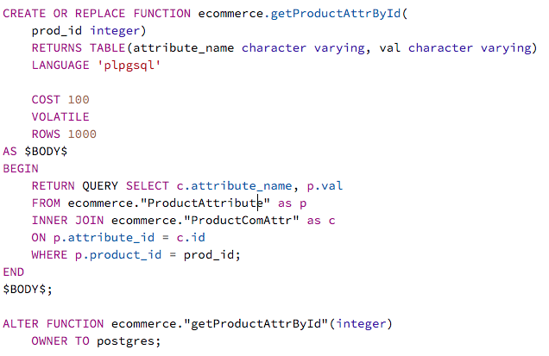

# Get product using product id

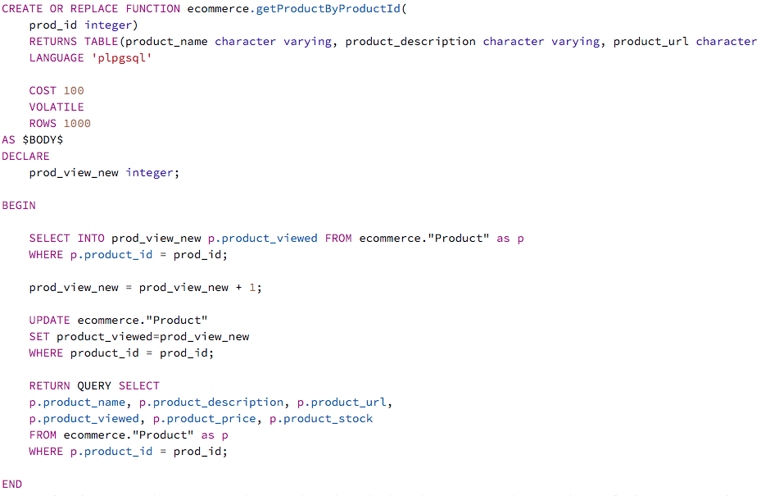

# Get products according to their sub categories

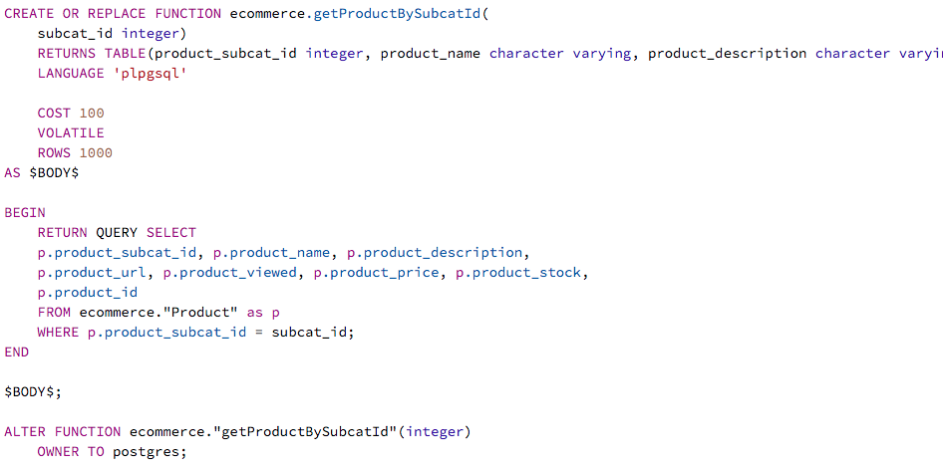

# Get product randomly

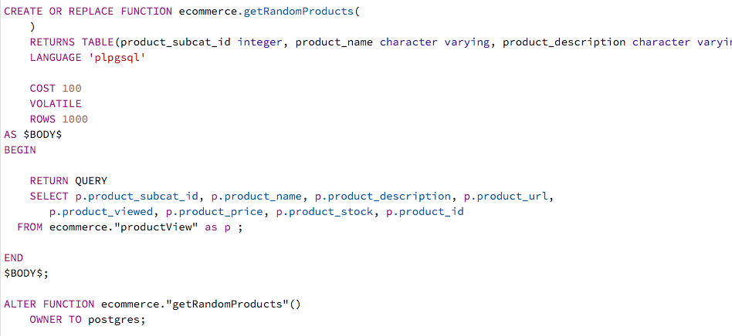

# Get top three products randomly

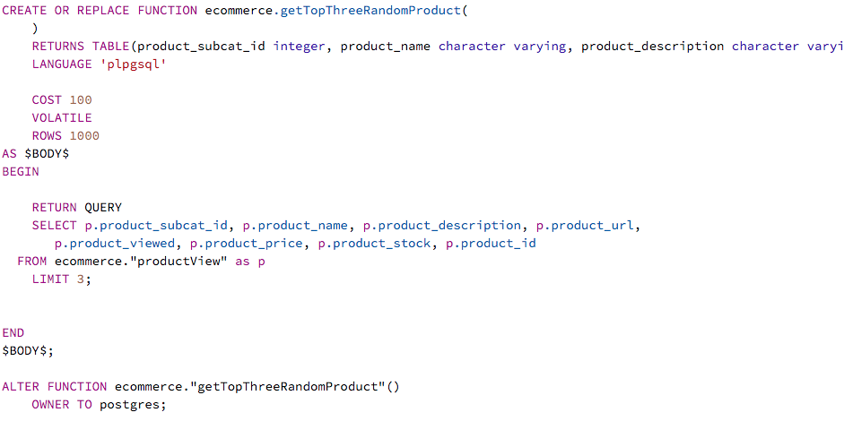

# Give order

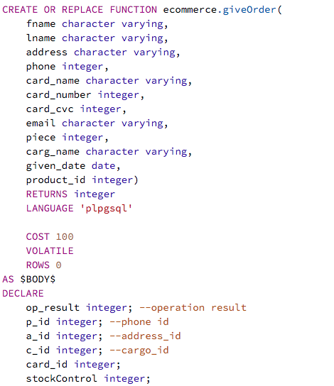

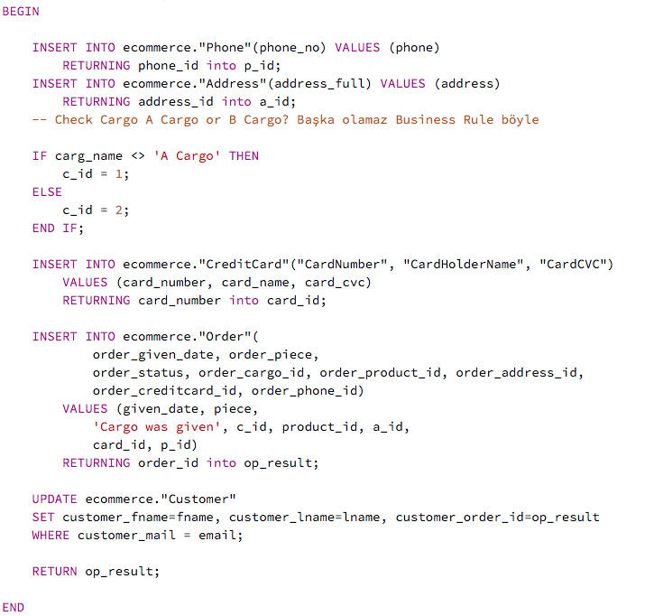

# insert product

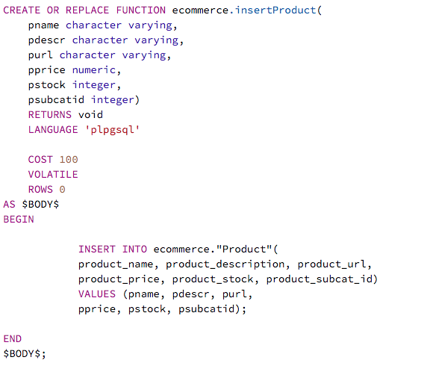

#login

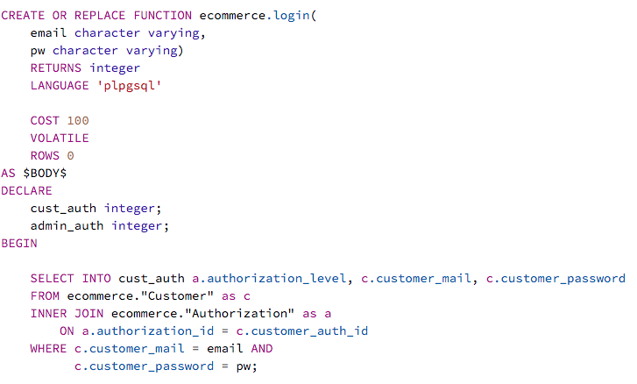

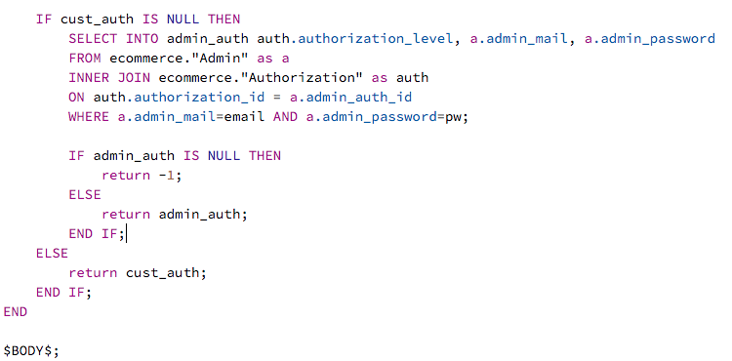

#register

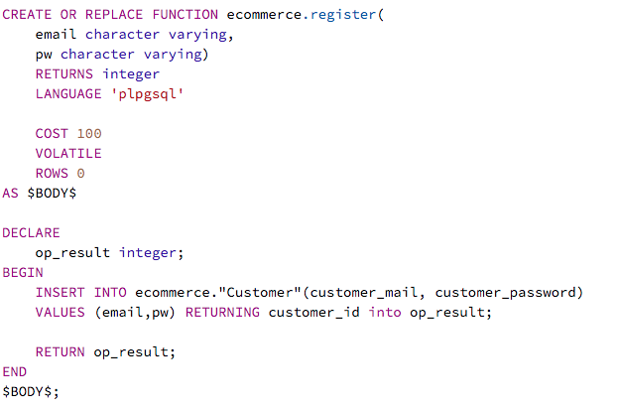

Triggers

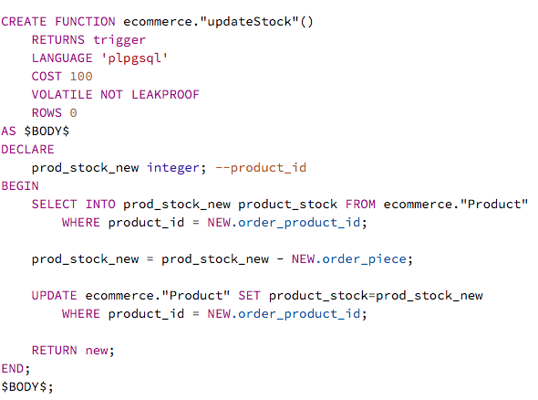

Views

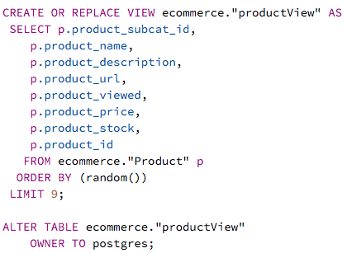

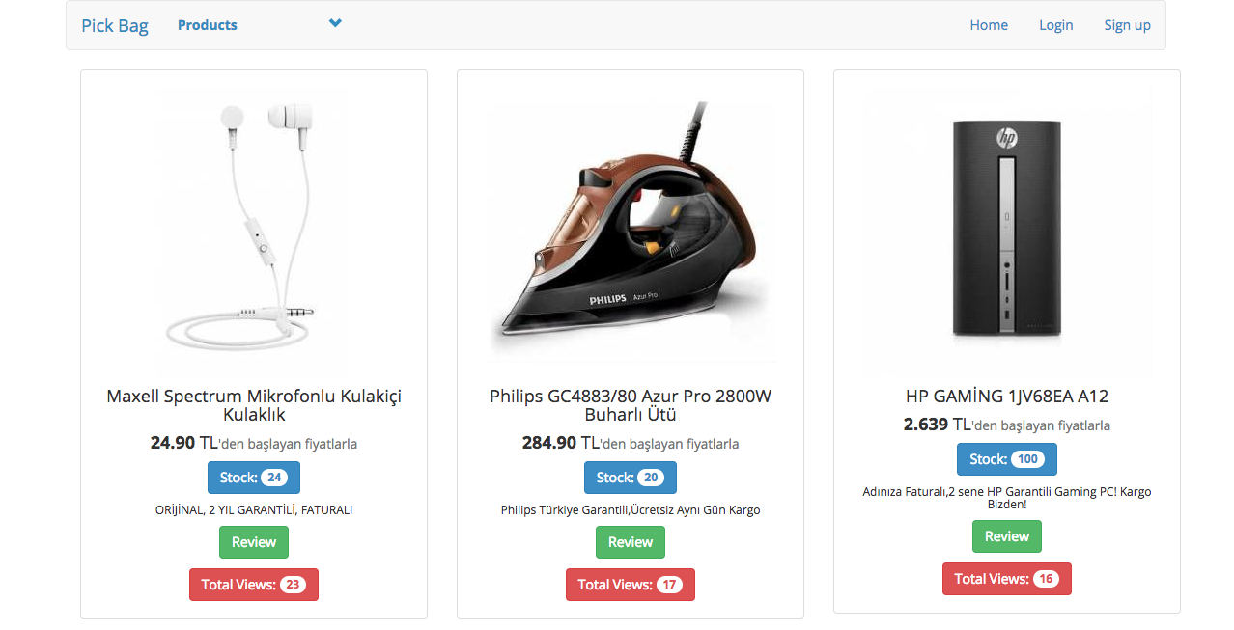

In quest home screen, the user or quest can view different products as selected randomly. Quest can only review the products. In order to give order the quest have to register in our system.

In member home screen, you should be careful the order button is activated. The user can buy products anymore.

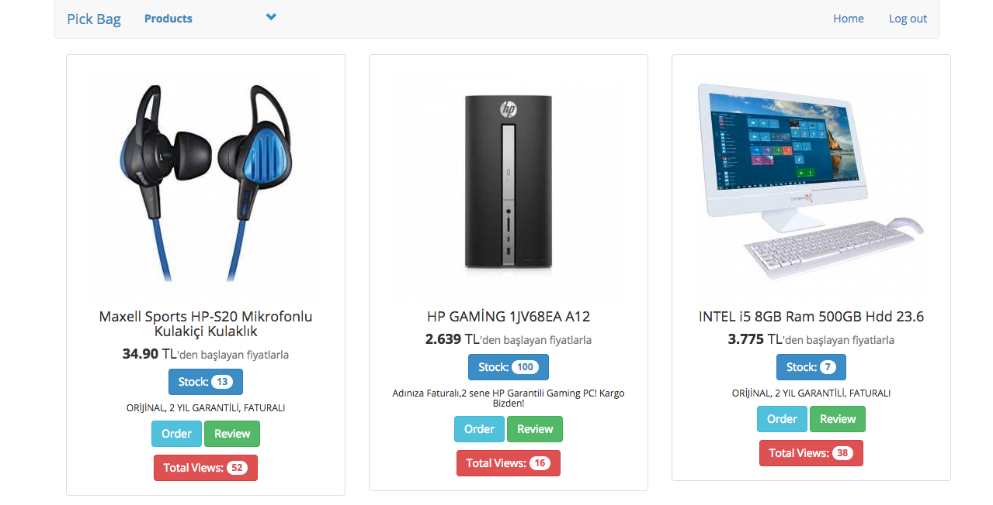

If user want to select different category, it must see in our menu.

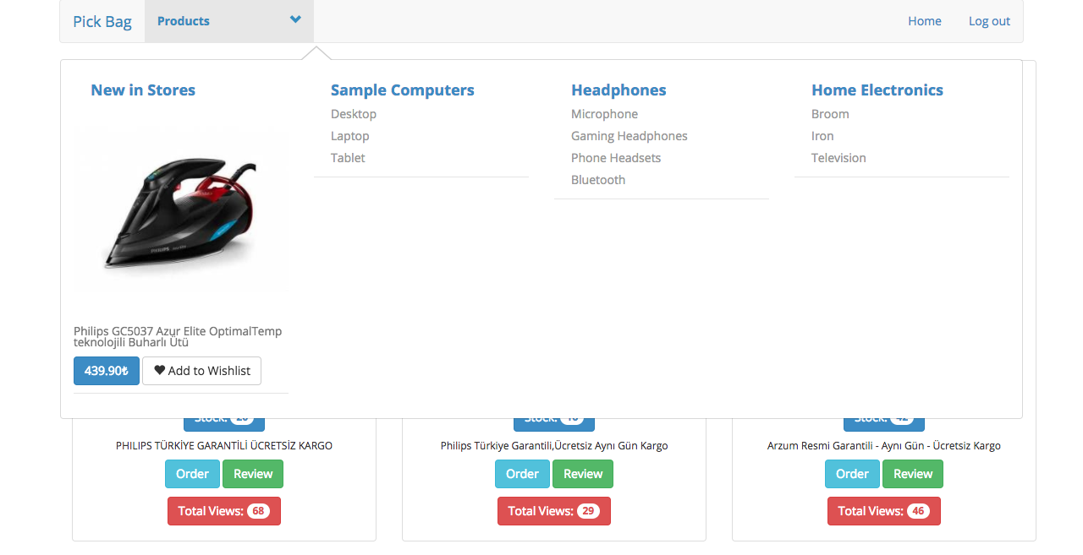

For example, if she clicked desktop.

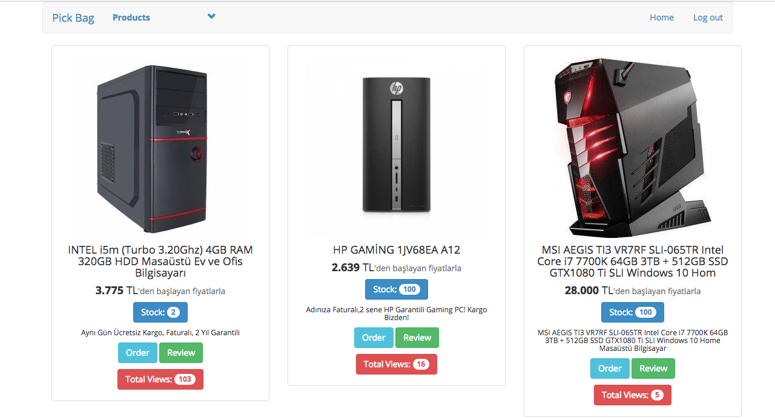

If user want to see detail of its selected product, she have to click review button.

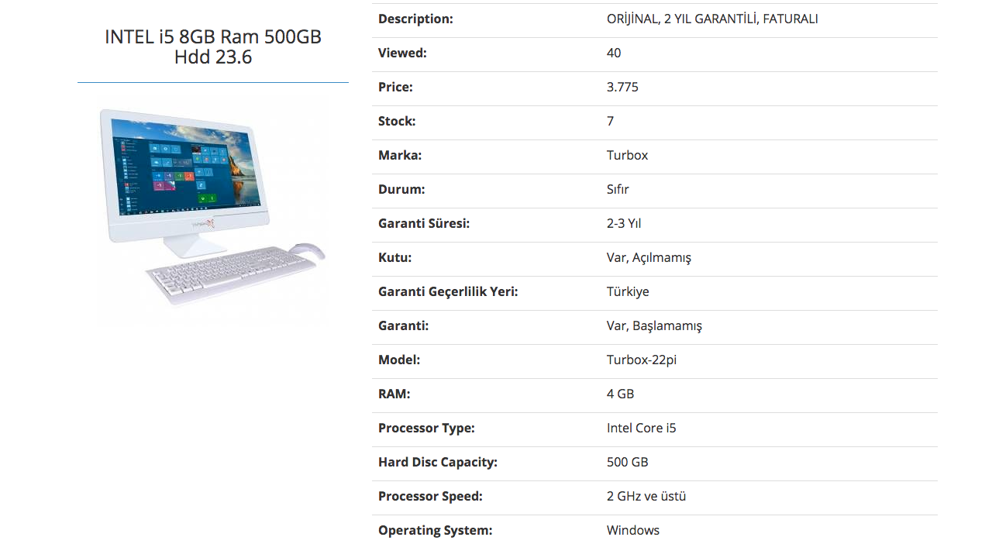

If user want to buy a product she have to click order button.

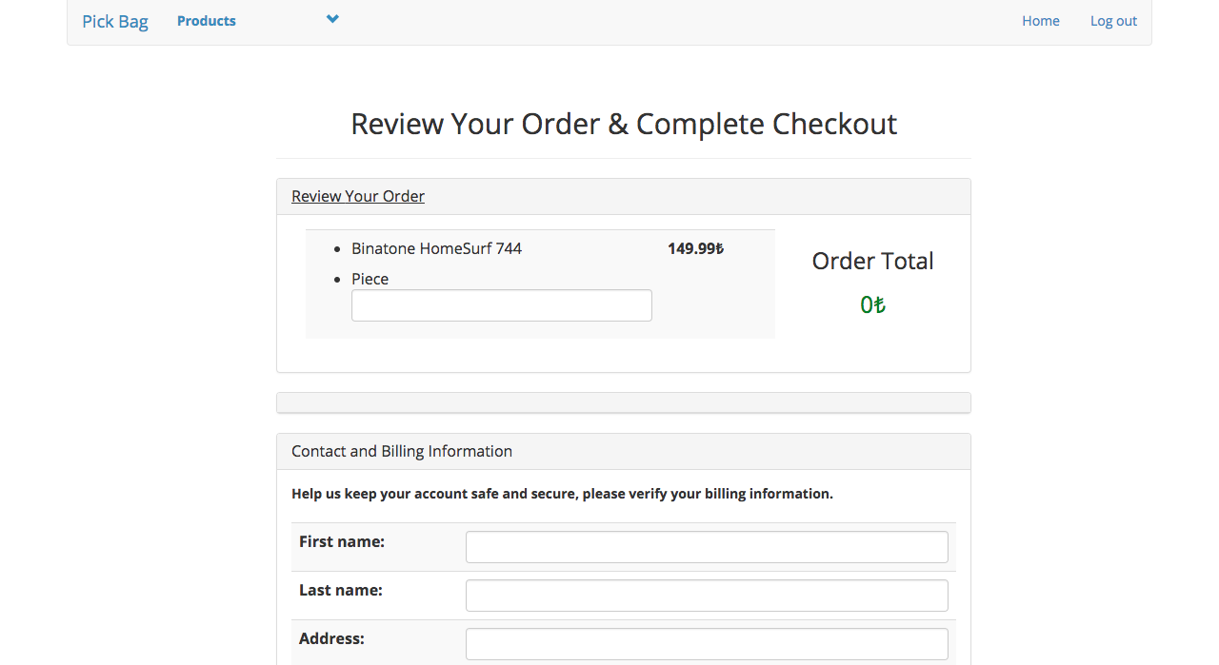

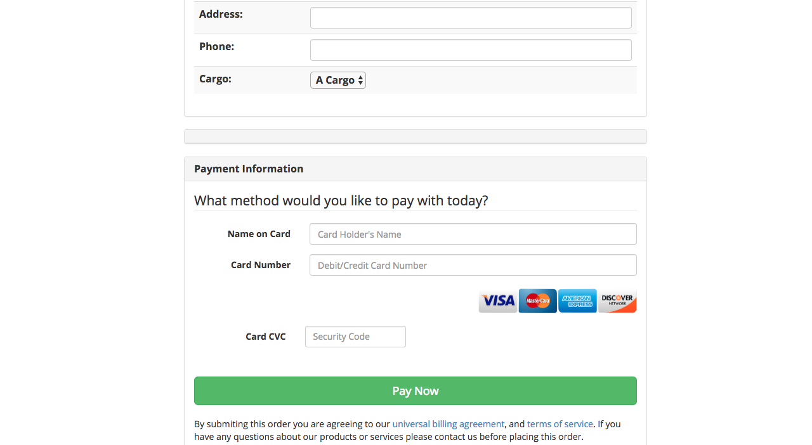

In admin screen,

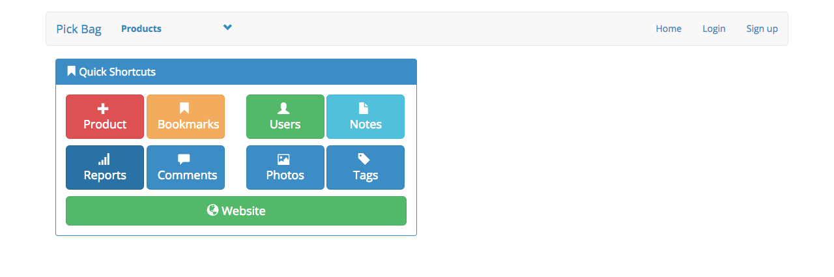

In add product screen via admin screen

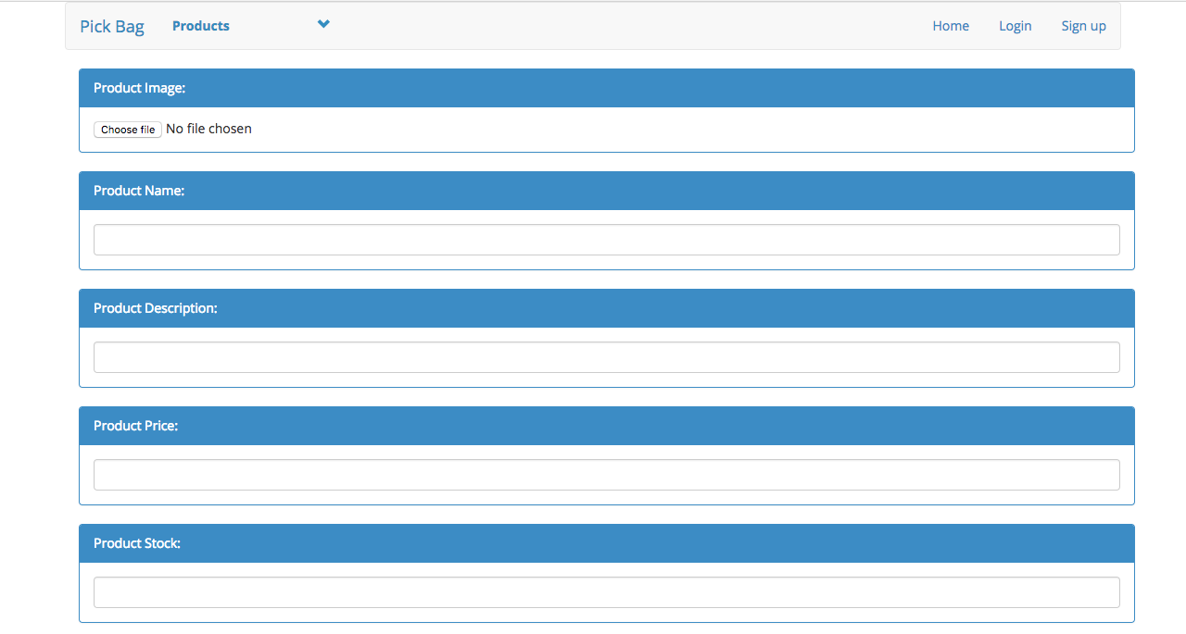

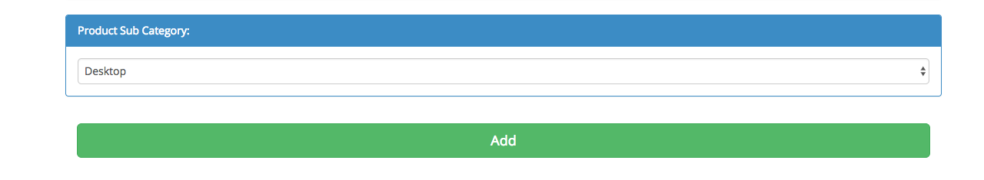

Login and Register screen

