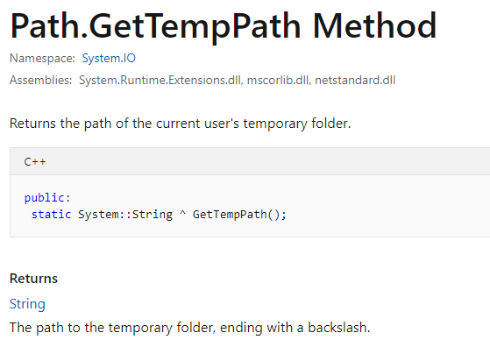

[System.IO](https://docs.microsoft.com/en-us/dotnet/api/system.io?view=netframework-4.8)

Assemblies:

System.Runtime.Extensions.dll, mscorlib.dll, netstandard.dll

Returns the path of the current user's temporary folder.

C++Copy

public:

static System::String ^ GetTempPath();

**Returns**

[String](https://docs.microsoft.com/en-us/dotnet/api/system.string?view=netframework-4.8)

The path to the temporary folder, ending with a backslash.

**Exceptions**

[SecurityException](https://docs.microsoft.com/en-us/dotnet/api/system.security.securityexception?view=netframework-4.8)

The caller does not have the required permissions.

**Examples**

The following code shows how to call the [GetTempPath](https://docs.microsoft.com/en-us/dotnet/api/system.io.path.gettemppath?view=netframework-4.8) method.

VBCopy

Dim result As String = Path.GetTempPath()

Console.WriteLine(result)

This example produces output similar to the following.

Copy

C:\Users\UserName\AppData\Local\Temp\

**Remarks**

This method checks for the existence of environment variables in the following order and uses the first path found:

1. The path specified by the TMP environment variable.
2. The path specified by the TEMP environment variable.
3. The path specified by the USERPROFILE environment variable.
4. The Windows directory.

**Security**

[EnvironmentPermission](https://docs.microsoft.com/en-us/dotnet/api/system.security.permissions.environmentpermission?view=netframework-4.8)  
for unrestricted access to environment variables. Associated enumeration: [Unrestricted](https://docs.microsoft.com/en-us/dotnet/api/system.security.permissions.permissionstate?view=netframework-4.8#System_Security_Permissions_PermissionState_Unrestricted)

**Applies to**

**.NET Core**

3.0 2.2 2.1 2.0 1.1 1.0

**.NET Framework**

4.8 4.7.2 4.7.1 4.7 4.6.2 4.6.1 4.6 4.5.2 4.5.1 4.5 4.0 3.5 3.0 2.0 1.1

**.NET Standard**

2.1 2.0 1.6 1.5 1.4 1.3

**UWP**

10.0

**Xamarin.Android**

7.1

**Xamarin.iOS**

10.8

**Xamarin.Mac**

3.0