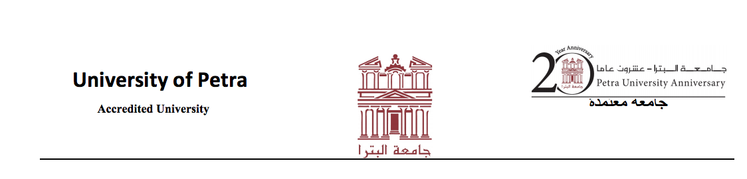

**To Whom It May Concern**

I have known Qusay Samir Hasan ( Shahin Ziadeh ) for two year (2011-2013) as a student in the Faculty of Information Technology. I taught him the following courses: Systems Analysis & Design, Programming By Components and Graduation Project. He was among the top 10% in these courses. Qusay is an intelligent, hardworking and self-motivated person. his English language capabilities both spoken and comprehension is good. He is capable of working in teams and presenting good work. I think Qusay ‘s character and knowledge makes him a very good candidate to continue postgraduate studies.

Mr. Abdulkairm Albanna

Instructor

[abanna@uop.edu.jo](mailto:abanna@uop.edu.jo)

Faculty of Information Technology

University of Petra

Amman, Jordan

www.uop.edu.jo