**What is Anaconda?**

In this course we’ll use Python as the computer language for exploring machine learning. Anaconda is an opens source data science platform that makes using Python much easier. It allows you to run Python programs in an interactive mode using an intuitive interface called a *Jupyter* noteboo*k*. Anaconda comes with most of the packages we’ll need to do machine learning and saves us the time and effort it would take to install these packages individually. We’ll write all our Python code inside Jupyter notebooks.

If you’re an advanced user (have Anaconda installed already and have been using on your computer), skip to the **Advanced Users** section towards the end of this document.

**How to Install Anaconda on Your Computer**

1. Go to <https://www.continuum.io/downloads>

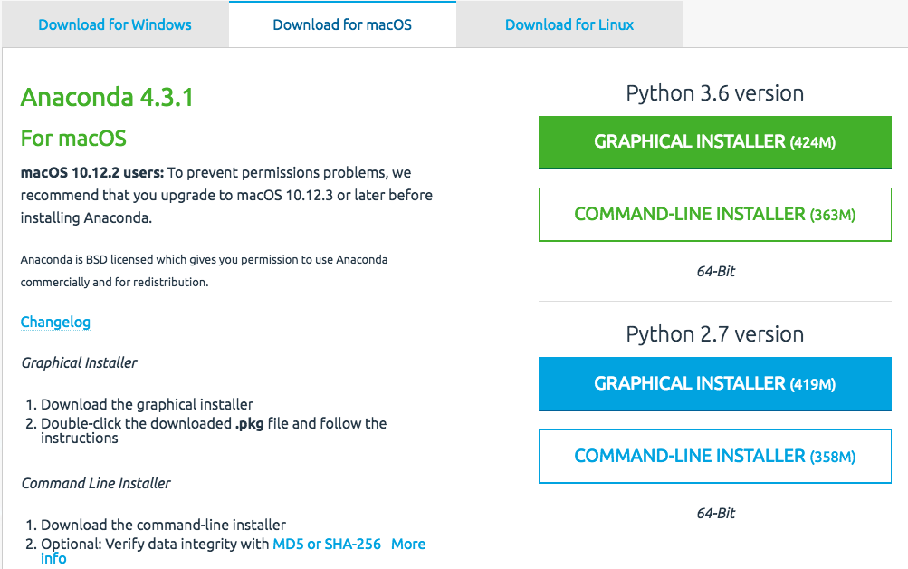

2. Click on the tab for your operating system.

3. Click on the GRAPHICAL INSTALLER for the Python 3.x version. Anaconda will install everything it needs; you shouldn’t have to do anything other than follow the installation prompts. Use Anaconda’s default settings.

4. Once Anaconda is installed, you need to run it from the command prompt. This is not as scary as it sounds and you’ll soon be very used to it. If you haven’t used the command prompt on your computer before, have a look at the resources section below – the links there will help you find it.

5. Once you get to the command line, type “conda info –v” (without the quotes). You’ll see bunch of lines that tell you where Anaconda was installed on your computer and some information about your computer system. Unless you’re an advanced user (see below), you won’t need to change anything – the default installation will work like a dream.

6. Create a directory/folder on your computer for this course. To keep things organized, you’ll keep all the course materials here. You can create any folder structure that makes sense. We suggest keeping all your Jupyter notebooks in one place so that you can access them easily.

7. Use the prompt interface to navigate to the Jupyter folder. Once you’re there, type the following “jupyter notebook” (without the quotes). In a few seconds you’ll see your default browser open a tab and display the content of the (currently empty) folder you just created.

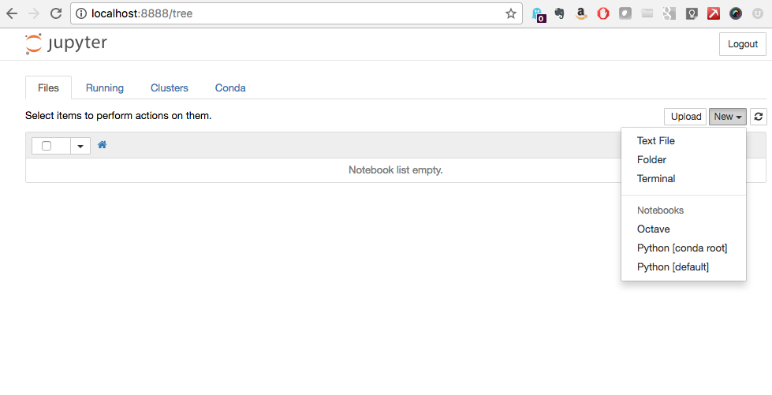

Notice that the web page is running on your computer (not a server on the internet) on port 8888. This is the default location for the root directory for all your Jupyter notebooks. There’s not much to look at initially because there are no notebooks created (or downloaded) so far. New notebooks are easy to create – just click on the New button on the right of the screen and choose Notebooks > Python [conda root]. You’re now up and running with everything you need to work with the Python notebooks for this course!

**Downloading Jupyter Notebooks for this Course**

GitHub repository URL

**Useful Resources**

Opening a Command Prompt

* How to open a command prompt in Windows 10
  + <https://www.youtube.com/watch?v=VyiGZW0fTxk>
  + <https://www.howtogeek.com/235101/10-ways-to-open-the-command-prompt-in-windows-10/>
* How to open a command prompt on Mac OSX
  + <http://blog.teamtreehouse.com/introduction-to-the-mac-os-x-command-line>
* How to open a command line on Linux (just joking – if you’re on Linux, we don’t need to tell you how to do this ☺).

Open, Run, and Shut Down a Jupyter Notebook

* <http://jupyter-notebook-beginner-guide.readthedocs.io/en/latest/execute.html>

**Advanced Users**

If you already have Anaconda installed on your system, we suggest you create a different environment for the files you’ll be creating and using for this course. Please use Python 3.x in this new environment. For complete directions, go to <https://conda.io/docs/test-drive.html>