

**LTE Base Station Conformance Test**

**Band 3 (ZEN) @ BW 10MHz**

1 Introduction 5

1.1 Purpose of Tests 5

1.2 Test Environments 5

1.3 Transmit Characteristics Test Equipment 5

1.4 Receiver Characteristics Test Equipment 5

1.5 Performance Requirement Test Equipment 6

1.6 Reference Documents 6

1.7 Pass Criterion (Home Area BS, Channel Bandwidth 10 MHz) 6

1.8 Pass Criterion (Local Area BS, Channel Bandwidth 10 MHz) 7

1.9 INNO BOX Test Summary (Home Area Criterion) 8

2 Transmitter Characteristics Test 9

2.1 General 9

*Table 2.1-1 Test Model for Transmitter Characteristics* 10

2.2 Base Station Output Power 10

2.2.1 Test Purpose 10

2.2.2 Measurement set-up 10

2.2.3 Test Procedure 10

2.2.4 Test requirement and result 10

2.3 Total Power Dynamic Range 11

2.3.1 RE Power Control Dynamic Range 11

2.3.2 Total Power Dynamic Range 12

2.4 Frequency Error 14

2.4.1 Test Purpose 14

2.4.2 Measurement set-up 14

2.4.3 Test Procedure 14

2.4.4 Test requirement and result 14

2.5 Error Vector Magnitude 16

2.5.1 Test Purpose 16

2.5.2 Measurement set-up 16

2.5.3 Test Procedure 16

2.5.4 Test requirement and result 16

2.6 Time alignment error 19

2.6.1 Test Purpose 19

2.6.2 Measurement set-up 19

2.6.3 Test Procedure 19

2.6.4 Test requirement and result 19

2.7 DL RS Power 19

2.7.1 Test Purpose 20

2.7.2 Measurement set-up 20

2.7.3 Test Procedure 20

2.7.4 Test requirement and result 20

2.8 Occupied Bandwidth 20

2.8.1 Test Purpose 21

2.8.2 Measurement set-up 21

2.8.3 Test Procedure 21

2.8.4 Test requirement and result 21

2.9 Adjacent Channel Leakage Power Ratio (ACLR) 22

2.9.1 Test Purpose 22

2.9.2 Measurement set-up 22

2.9.3 Test Procedure 22

2.9.4 Test requirement and result 22

2.10 Operating Band Unwanted Emissions 24

2.10.1 Test Purpose 24

2.10.2 Measurement set-up 24

2.10.3 Test Procedure 24

2.10.4 Test requirement and result 24

2.11 Transmitter Spurious Emissions 26

2.11.1 Test Purpose 26

2.11.2 Measurement set-up 26

2.11.3 Test Procedure 26

2.11.4 Test requirement and result 26

2.12 Transmitter Intermodulation 28

2.12.1 Test Purpose 28

2.12.2 Measurement set-up 28

2.12.3 Test requirement and result 28

3 Receiver Characteristics Test 31

3.1 General 31

3.2 Reference Sensitivity Level 32

3.2.1 Test Purpose 32

3.2.2 Measurement set-up 32

3.2.3 Test Procedure 32

3.2.4 Test requirement and result 32

3.3 Dynamic Range 33

3.3.1 Test Purpose 34

3.3.2 Measurement set-up 34

3.3.3 Test Procedure 34

3.3.4 Test requirement and result 34

3.4 In-channel Selectivity 35

3.4.1 Test Purpose 35

3.4.2 Measurement set-up 35

3.4.3 Test Procedure 36

3.4.4 Test requirement and result 36

3.5 Adjacent Channel Selectivity and Narrow-band Blocking 37

3.5.1 Test Purpose 37

3.5.2 Measurement set-up 37

Figure 3.5-1 Measuring system Set-up for Adjacent channel selectivity and narrowband blocking 38

3.5.3 Test Procedure 38

3.5.4 Test requirement and result 38

3.6 Blocking 39

3.6.1 Test Purpose 40

3.6.2 Measurement set-up 40

3.6.3 Test Procedure 40

3.6.4 Test requirement and result 40

3.7 Receiver Spurious Emissions 41

3.7.1 Test Purpose 41

3.7.2 Measurement set-up 41

3.7.3 Test Procedure 41

3.7.4 Test requirement and result 42

3.8 Receiver Intermodulation 42

3.8.1 Test Purpose 42

3.8.2 Measurement set-up 43

3.8.3 Test Procedure 43

3.8.4 Test requirement and result 43

4 Performance Requirement Test 44

4.1 General 44

4.2 Performance requirements for PUSCH 45

4.2.1 Performance requirements of PUSCH in multipath fading propagation conditions 45

Table 4.2-3 Test requirements for PUSCH, 10 MHz Channel Bandwidth 46

4.2.2 Performance requirements for UL timing adjustment 46

4.2.3 Performance requirements for HARQ-ACK multiplexed on PUSCH 48

4.2.4 Performance requirements for High Speed Train conditions 50

4.3 Requirements for PUCCH 52

4.3.1 ACK missed detection for single user PUCCH format 1a 52

4.3.2 CQI performance requirements for PUCCH format 2 53

4.3.3 ACK missed detection for multi user PUCCH format 1a 54

4.4 Requirements for PRACH 54

4.4.1 PRACH false alarm probability and missed detection 54

# Introduction

The document defines the different tests that are required to be undergone and also the need to conduct them. The document will reiterate the test requirement for a test to be considered successful if it is within the allowed range as per the 3GPP specification.

## Purpose of Tests

To understand and evaluate the RF characteristics of the board used to test along with the Base station. These tests are defined and conducted based on the 3GPP specs.

## Test Environments

When a normal test environment is specified for a test, the test should be performed within the minimum and maximum limits of the conditions stated in Table 1.1.

Table 1.1: Limits of conditions for Normal Test Environment

|  |  |  |
| --- | --- | --- |
| Condition | Minimum | Maximum |
| Barometric pressure | 86 kPa | 106 kPa |
| Temperature | 15°C | 30°C |
| Relative Humidity | 20 % | 85 % |
| Power supply | Nominal, as declared by the manufacturer | |
| Vibration | Negligible | |

## Transmit Characteristics Test Equipment

|  |  |  |  |
| --- | --- | --- | --- |
|  | **Name and manufacturer** | **Model Number** | **Description** |
| **1** | Signal Analyzer, Keysight | MXA N9020A |  |
| **2** | LTE FDD Software, Keysight | N9080A | LTE FDD Software |
|  |  |  |  |

## Receiver Characteristics Test Equipment

|  |  |  |  |
| --- | --- | --- | --- |
|  | **Name and manufacturer** | **Model Number** | **Description** |
| **1** | Signal Generator, Keysight | N5172B | (Require 3 for intermodulation test) |
| **2** | Calibrated AWGN, Keysight | N5172B - 403 Calibrated AWGN | AWGN Option of N5172B |
| **3** | Signal Studio, Keysight | N7624B | Signal Studio for LTE/LTE-A FDD |

## Performance Requirement Test Equipment

|  |  |  |  |
| --- | --- | --- | --- |
|  | **Name and manufacturer** | **Model Number** | **Description** |
| **1** | Channel Emulator, AZIMUTH | ACE MX | MIMO Channel Emulator |
| **2** | Signal Generator, Keysight | N5172B |  |
| **3** | Signal Analyzer, Keysight | MXA N9020A |  |
| **4** | LTE Test Mobile, Aeroflex | TM500 | LTE Test Mobile |

## Reference Documents

[1] 3GPP TS36.104 V9.11.0 (2012-9): “Evolved Universal Terrestrial Radio Access (E-UTRA); Base station (BS) radio transmission and reception”.

[2] 3GPP TS36.141 V9.11.0 (2012-9): “Evolved Universal Terrestrial Radio Access (E-UTRA); Base station (BS) conformance testing”

## Pass Criterion (Home Area BS, Channel Bandwidth 10 MHz)

|  |  |  |  |
| --- | --- | --- | --- |
|  | **Section** | **Test case** | **Pass criterion** |
| Transmitter | 6.2 | Base station output power | +17 dBm |
| 6.3.1 | RF Power Control dynamic range | Same as item 6.5.2 |
| 6.3.2 | Total power dynamic range | 16.5dB |
| 6.4 | Transmit ON/OFF power | For E-UTRA TDD |
| 6.5.1 | Frequency error | +/-(0.25 ppm + 12Hz) |
| 6.5.2 | Error Vector Magnitude | QPSK : 18.5% 16QAM:13.5% 64QAM : 9% |
| 6.5.3 | Time alignment error | < 90 ns |
| 6.5.4 | DL RS power | +/- 2.9dB |
| 6.6.1 | Occupied bandwidth | within Channel Bandwidth |
| 6.6.2 | Adjacent Channel Leakage power Ratio (ACLR) | 44.2dB |
| 6.6.3 | Operating band unwanted emissions | within each limit range |
| 6.6.4 | Transmitter spurious emissions | within each limit range |
| 6.7 | Transmitter intermodulation | within each limit range |
| Receiver | 7.2 | Reference sensitivity level | Tput ≥ 95% @ -92.8dBm |
| 7.3 | Dynamic range | Tput ≥ 95% @ -25.4dBm |
| 7.4 | In-channel selectivity | Tput ≥ 95% @ -89.1dBm |
| 7.5.4.2 | Adjacent Channel Selectivity (ACS) | Tput ≥ 95% @ -70.8dBm |
| 7.5.4.3 | Narrow-band blocking | Tput ≥ 95% @ -78.8dBm |
| 7.6.5.1 | Blocking (General requirements); (F_ul_low - 20) to (F_ul_high + 20) | Tput ≥ 95% @ -78.8dBm |
| 7.6.5.1 | Blocking, 1 MHz to (F_ul_low - 20) and (F_ul_high + 20) to 12750 MHz | Tput ≥ 95% @ -78.8dBm |
| 7.6.5.2 | Blocking (Co-location with other base stations) | Tput ≥ 95% @ -78.8dBm |
| 7.7 | Receiver spurious emissions | < -57 dBm (30 MHz – 1 GHz)  < -47dBm (1 GHz – 12.75 GHz) |
| 7.8 | Receiver intermodulation | Tput ≥ 95% @ -78.8dBm |
| Performance | 8.2.1 | Performance requirements of PUSCH in multipath fading propagation conditions | [2] subclause 8.2.1.4.2 |
| 8.2.2 | Performance requirements for UL timing adjustment | Tput ≥ 70% @ A7-4 SNR 14.4dB  Tput ≥ 70% @ A8-4 SNR -1.5dB |
| 8.2.3 | Performance requirements for HARQ-ACK multiplexed on PUSCH | < 1% falsely detected ACKs |
| 8.2.4 | Performance requirements for High Speed Train conditions | HST Scenario 3:  - Tput ≥ 30% @ SNR -2.4dB  - Tput ≥ 70% @ SNR 1.5dB  HST Scenario 1:  - Tput ≥ 30% @ SNR -5.1dB  - Tput ≥ 70% @ SNR -1.2dB |
| 8.3.1 | ACK missed detection for single user PUCCH format 1a | < 1% falsely detected ACKs |
| 8.3.2 | CQI missed detection for PUCCH format 2 | BLER of CQI < 1% @ SNR -3.8dB |
| 8.3.3 | ACK missed detection for multi user PUCCH format 1a | < 1% falsely detected ACKs |
| 8.4.1 | PRACH false alarm probability and missed detection | Pfa ≤ 0.1% @ given SNR |

## Pass Criterion (Local Area BS, Channel Bandwidth 10 MHz)

|  |  |  |  |
| --- | --- | --- | --- |
|  | **Section** | **Test case** | **Pass criterion** |
| Transmitter | 6.2 | Base station output power | +24 dBm |
| 6.3.1 | RF Power Control dynamic range | Same as item 6.5.2 |
| 6.3.2 | Total power dynamic range | 16.5dB |
| 6.4 | Transmit ON/OFF power | For E-UTRA TDD |
| 6.5.1 | Frequency error | +/-(0.1 ppm + 12Hz) |
| 6.5.2 | Error Vector Magnitude | QPSK : 18.5% 16QAM:13.5% 64QAM : 9% |
| 6.5.3 | Time alignment error | < 90 ns |
| 6.5.4 | DL RS power | +/- 2.9dB |
| 6.6.1 | Occupied bandwidth | within Channel Bandwidth |
| 6.6.2 | Adjacent Channel Leakage power Ratio (ACLR) | 44.2dB |
| 6.6.3 | Operating band unwanted emissions | within each limit range |
| 6.6.4 | Transmitter spurious emissions | within each limit range |
| 6.7 | Transmitter intermodulation | within each limit range |
| Receiver | 7.2 | Reference sensitivity level | Tput ≥ 95% @ -92.8dBm |
| 7.3 | Dynamic range | Tput ≥ 95% @ -61.9dBm |
| 7.4 | In-channel selectivity | Tput ≥ 95% @ -89.1dBm |
| 7.5.4.2 | Adjacent Channel Selectivity (ACS) | Tput ≥ 95% @ -86.8dBm |
| 7.5.4.3 | Narrow-band blocking | Tput ≥ 95% @ -86.8dBm |
| 7.6.5.1 | Blocking (General requirements); (F_ul_low - 20) to (F_ul_high + 20) | Tput ≥ 95% @ -86.8dBm |
| 7.6.5.1 | Blocking, 1 MHz to (F_ul_low - 20) and (F_ul_high + 20) to 12750 MHz | Tput ≥ 95% @ -86.8dBm |
| 7.6.5.2 | Blocking (Co-location with other base stations) | Tput ≥ 95% @ -86.8dBm |
| 7.7 | Receiver spurious emissions | < -57 dBm (30 MHz – 1 GHz)  < -47dBm (1 GHz – 12.75 GHz) |
| 7.8 | Receiver intermodulation | Tput ≥ 95% @ -86.8dBm |
| Performance | 8.2.1 | Performance requirements of PUSCH in multipath fading propagation conditions | [2] subclause 8.2.1.4.2 |
| 8.2.2 | Performance requirements for UL timing adjustment | Tput ≥ 70% @ A7-4 SNR 14.4dB  Tput ≥ 70% @ A8-4 SNR -1.5dB |
| 8.2.3 | Performance requirements for HARQ-ACK multiplexed on PUSCH | < 1% falsely detected ACKs |
| 8.2.4 | Performance requirements for High Speed Train conditions | HST Scenario 3:  - Tput ≥ 30% @ SNR -2.4dB  - Tput ≥ 70% @ SNR 1.5dB  HST Scenario 1:  - Tput ≥ 30% @ SNR -5.1dB  - Tput ≥ 70% @ SNR -1.2dB |
| 8.3.1 | ACK missed detection for single user PUCCH format 1a | < 1% falsely detected ACKs |
| 8.3.2 | CQI missed detection for PUCCH format 2 | BLER of CQI < 1% @ SNR -3.8dB |
| 8.3.3 | ACK missed detection for multi user PUCCH format 1a | < 1% falsely detected ACKs |
| 8.4.1 | PRACH false alarm probability and missed detection | Pfa ≤ 0.1% @ given SNR |

## Reference Kit One Test Summary (Home Area Criterion)

|  |  |  |  |  |
| --- | --- | --- | --- | --- |
| **Section** | **Test Case** | **Pass Criterion** | **Result** | **Verdict** |
| 6.2 | Base station output power | 17 +/- 2.7 dBm | 21.62 dBm | PASS |
| 6.3.1 | RF Power Control dynamic range | 6.5.2 shall pass | see 6.5.2 | PASS |
| 6.3.2 | Total power dynamic range | > 16.5dB | 17.2dB | PASS |
| 6.5.1 | Frequency error | 472.5Hz @1842Mhz | < 100 Hz @ 1842Mhz | PASS |
| 6.5.2 | EVM | QPSK : 18.5% 16QAM:13.5% 64QAM : 9% | QPSK < 3% 16QAM < 3% 64QAM < 3% | PASS |
| 6.5.3 | Time alignment error | < 90 ns | UNAVAILBLE | TBD |
| 6.5.4 | DL RS power | +/- 2.9dB | -7dB | PASS |
| 6.6.1 | Occupied bandwidth | within channel bandwidth | 10Mhz = 8.92Mhz @ Beta/2 | PASS |
| 6.6.2 | ACLR | > 44.2dB | > 48dB | PASS |
| 6.6.3.5.1 | Operating band unwanted emissions | within each limit range | 5Mhz - 10Mhz < -39dB 10Mhz - 15Mhz <-41dB | PASS |
| 6.6.4.5.1 | Transmitter spurious emissions | within each limit range |  | PASS |
| 6.7 | Transmitter intermodulation | within each limit range |  | PASS |
| 7.2 | Reference sensitivity level | 10Mhz FRC A1-3 @ < -92.8dBm | -100 dBm | PASS |
| 7.3 | Dynamic range | 10Mhz FRC A2-3 @ -25.4dBm | UNAVAILBLE | TBD |
| 7.4 | In-channel selectivity | 10Mhz FRC A1-3 @ -89.1dBm | BLER 0.85% @ -100 dBm | PASS |
| 7.5.4.2 | Adjacent Channel Selectivity (ACS) | 10Mhz FRC A1-3 @ < -70.8 dBm | BLER 0.7% @ -77 dBm | PASS |
| 7.5.4.3 | Narrow-band blocking | 10Mhz FRC A1-3 @ < -78.8 dBm | (m = 0)PER 0.1%@-86dBm | PASS |
| 7.6.5.1 | Blocking (General requirements); (F_ul_low - 20) to (F_ul_high + 20) | 10Mhz FRC A1-3 @ < -78.8 dBm | Psens < -85 dBm in the interfering signal range | PASS |
| 7.6.5.1 | Blocking, 1 MHz to (F_ul_low - 20) and (F_ul_high + 20) to 12750 MHz | 10Mhz FRC A1-3 @ < -78.8 dBm | Psens < -85 dBm in the interfering signal range | PASS |
| 7.6.5.2 | Blocking (Co-location with other base stations) | 10Mhz FRC A1-3 @ < -78.8 dBm | Not Applicable for Home Area | N/A |
| 7.7 | Receiver spurious emissions | < -57 dBm (30 MHz – 1 GHz)  < -47dBm (1 GHz – 12.75 GHz) | Not Applicable (only for separate TX & RX ports) | N/A |
| 7.8 | Receiver intermodulation | 10Mhz FRC A1-3 @ < -78.8 dBm | BLER 0.3% @ -88 dBm | PASS |
| 7.8 | Receiver intermodulation (Narrowband) | 10Mhz FRC A1-3 @ < -78.8 dBm | BLER 0.1% @ -87 dBm | PASS |
| 8.2.1 | Performance requirements of PUSCH in multipath fading propagation conditions | refer to 8.2.1.1-4 | see BLER curve | TBD |
| 8.2.2 | Performance requirements for UL timing adjustment |  | UNAVAILBLE | TBD |
| 8.2.3 | Performance requirements for HARQ-ACK multiplexed on PUSCH | < 1% false alarm | UNAVAILBLE | TBD |
| 8.2.4 | Performance requirements for High Speed Train conditions | < -3.4dB @ BLER 1% | UNAVAILBLE | TBD |
| 8.3.1 | ACK missed detection for single user PUCCH format 1a | Pfa <= 0.1% @ -13.9dB SNR | UNAVAILBLE | TBD |
| 8.3.2 | CQI missed detection for PUCCH format 2 | UNAVAILBLE | UNAVAILBLE | TBD |
| 8.3.3 | ACK missed detection for multi user PUCCH format 1a | UNAVAILBLE | UNAVAILBLE | TBD |
| 8.4.1 | PRACH false alarm probability and missed detection | UNAVAILBLE | UNAVAILBLE | TBD |

# Transmitter Characteristics Test

## General

To conduct the test, Keysight N9020A Signal Analyzer running the software N9080A LTE FDD is used.

The physical channel required for the DL tests are setup using the EUTRA test models ETM1.1, 1.2, 2.0, 3.1, 3.2 and 3.3. The base station under test is designed for Home Base station usage and hence the tests conducted will limit the requirement only to a Home Base station.

The Base station configuration is done such that both the antenna transmits and receives the same signal. Hence all measurements will be made at both the antenna and they will be treated as SISO connection at each of the antenna.

|  |  |  |
| --- | --- | --- |
| **Test Model** | **Modulation Scheme** | **Application** |
| E-TM1.1 | QPSK | BS output power  Unwanted emissions   * Occupied Bandwidth * ACLR * Operating band unwanted emissions * Transmitter spurious emissions   Transmitter intermodulation  RS absolute accuracy |
| E-TM1.2 | QPSK | Unwanted Emissions   * ACLR * Operating band unwanted emissions |
| E-TM2 | 64 QAM 1%  OFF 99% | Total power dynamic range  Frequency error  EVM  (note: at min. power) |
| E-TM3.1 | 64 QAM | Total power dynamic range  Frequency error  EVM  (note: at max. power) |
| E-TM3.2 | 16 QAM 60%  QPSK 40% | Frequency error  EVM |
| E-TM3.3 | 16 QAM 50%  QPSK 50% | Frequency error  EVM |

## *Table 2.1-1 Test Model for Transmitter Characteristics*

## Base Station Output Power

The test mentioned in [2] chapter 6.2 defines the Output power, Pout, as the mean power level per carrier measured at the antenna connector during the transmitter ON period.

### Test Purpose

To verify the maximum output power across the frequency range and under normal and extreme conditions for all transmitters in the base station (Since the Base station under test is meant to be used as home base station – it is tested only in normal conditions across the frequency range).

### Measurement set-up

Measurement equipment

BS under

TX test

TX

**Figure 2.2-1 Measuring system Set-up for base station output power, output power dynamics, transmitted signal quality, Frequency error, EVM, DL RS power, Unwanted emissions**

### Test Procedure

Set the base station as Figure 2.2-1 to transmit a signal according to ETM 1.1 and then measure the mean output power at the RF port.

### Test requirement and result

In normal conditions, the measurement result must within +2.7 dB and -2.7 dB of the manufacturer’s rated output power.

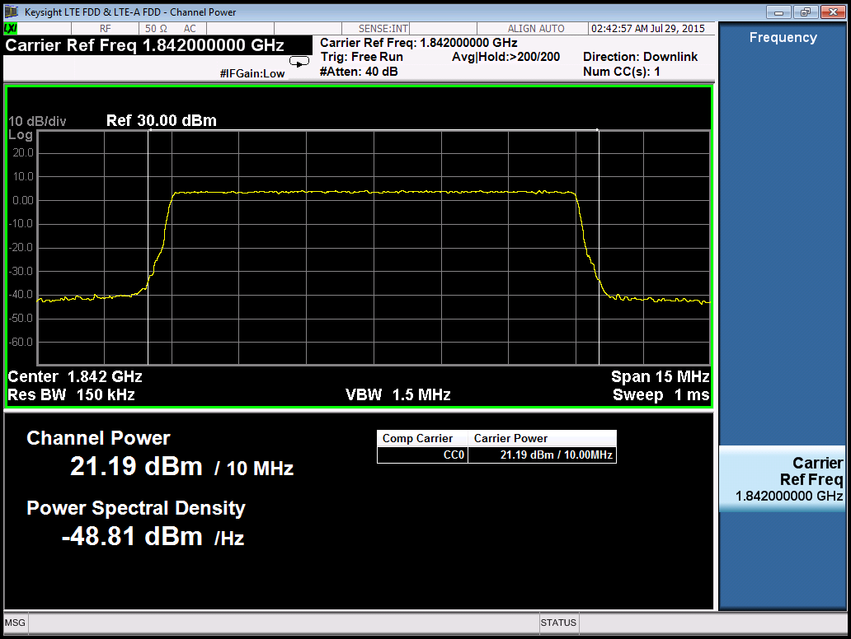

**Figure 2.2-2 Base station output power**

## Total Power Dynamic Range

### RF Power Control Dynamic Range

The RE power control dynamic range is the difference between the power of an RE and the average RE power for a BS at maximum output power. (*Unwanted emissions and Transmit modulation quality shall be maintained within the whole power control dynamic range)

#### Measurement set-up

Connect the measurement device to BS antenna connector as shown in Figure 2.2-1

#### Test Procedure

Set the base station to transmit ETM 2 & 3.1 and measure the OFDM symbol TX power

#### Test requirement and result

|  |  |  |
| --- | --- | --- |
| **Modulation scheme used on the RE** | **RE power control dynamic range (dB)** | |
| **(down)** | **(up)** |
| QPSK (PDCCH) | -6 | +4 |
| QPSK (PDSCH) | -6 | +3 |
| 16QAM (PDSCH) | -3 | +3 |
| 64QAM (PDSCH) | 0 | 0 |
| NOTE 1: Total TX power shall always be less or equal to maximum BS output power. | | |

The EVM test covers the requirement for the test (as per the 36.141 sub-clause 6.3.1.3)

### Total Power Dynamic Range

The total power dynamic range is the difference between maximum and minimum transmit power of an OFDM symbol. The Error Vector Magnitude test provides sufficient test coverage for this requirement.

#### Test Purpose

To verify the total power dynamic range is met the minimum requirement of specification.

#### Measurement set-up

Connect the measurement device to BS antenna connector as shown in Figure 2.2-1.

#### Test Procedure

1. Set the base station to transmit E-TM 3.1 & E-TM 2 and measure the OFDM symbol TX power.
2. Calculate difference between E-TM 3.1 and E-TM 2.

#### Test requirement and result

DL total power dynamic range shall be larger than or equal to the value in the Table 2.3-1.

|  |  |
| --- | --- |
| E-UTRA  channel bandwidth (MHz) | Total power dynamic range (dB) |
| 1.4 | 7.3 |
| 3 | 11.3 |
| 5 | 13.5 |
| **10** | **16.5** |
| 15 | 18.3 |
| 20 | 19.6 |

**Table 2.3-1 BS total power dynamic range, paired spectrum**

The measured dynamic range is about 17.2dB.

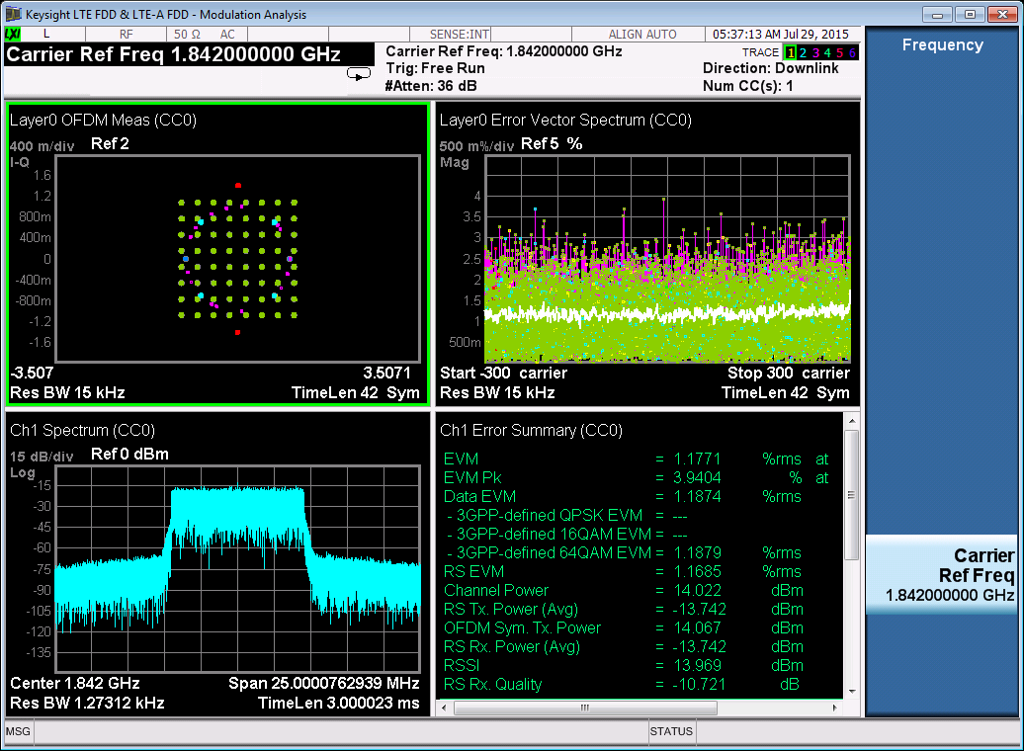

**Figure 2.3-1 OFDM Symbol power of E-TM 3.1**

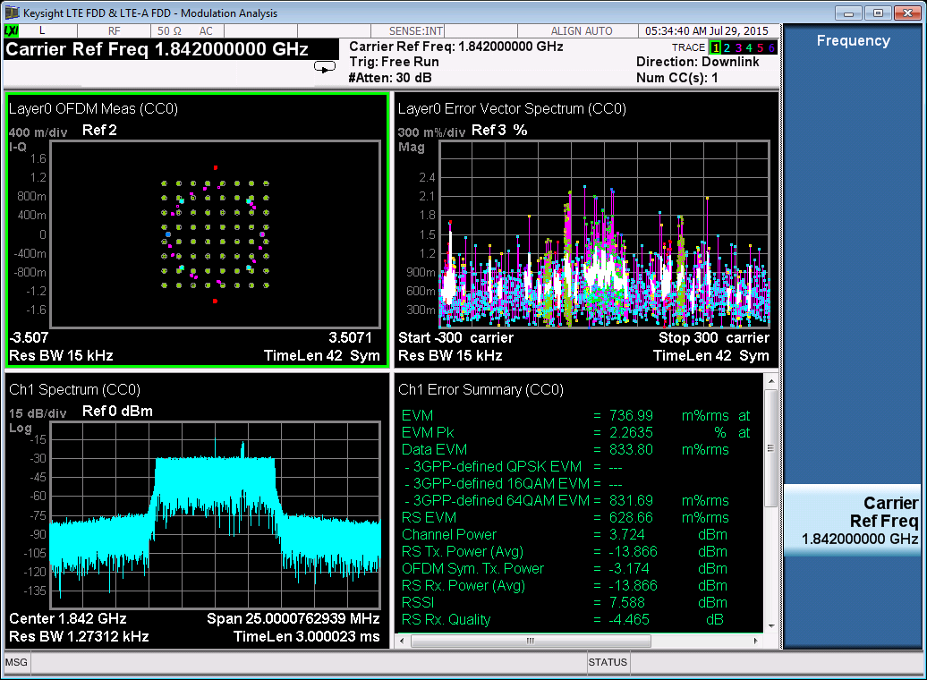

**Figure 2.3-1 OFDM Symbol power of E-TM 2**

## Frequency Error

Frequency error is the measures of the difference between the actual BS transmit frequency and the assigned frequency.

### Test Purpose

Verify the carrier frequency of the BS is within the minimum requirement.

### Measurement set-up

Connect the measurement device to BS antenna connector as shown in Figure 2.2-1.

### Test Procedure

Use ETM 2, 3.1, 3.2 and 3.3 to measure the frequency error as part of the EVM measurement in modulation analysis.

### Test requirement and result

The BS carrier frequency shall be within the range in Table 2.4-1.

|  |  |
| --- | --- |
| **BS class** | **Accuracy** |
| Wide Area BS | ± (0.05 ppm + 12 Hz) |
| Medium Range BS | ± (0.1 ppm + 12 Hz) |
| Local Area BS | ± (0.1 ppm + 12 Hz) |
| Home BS | ± (0.25 ppm + 12 Hz) |

**Table 2.4-1 Frequency error test requirement**

Average Frequency Error for E-TMs is below 100Hz.

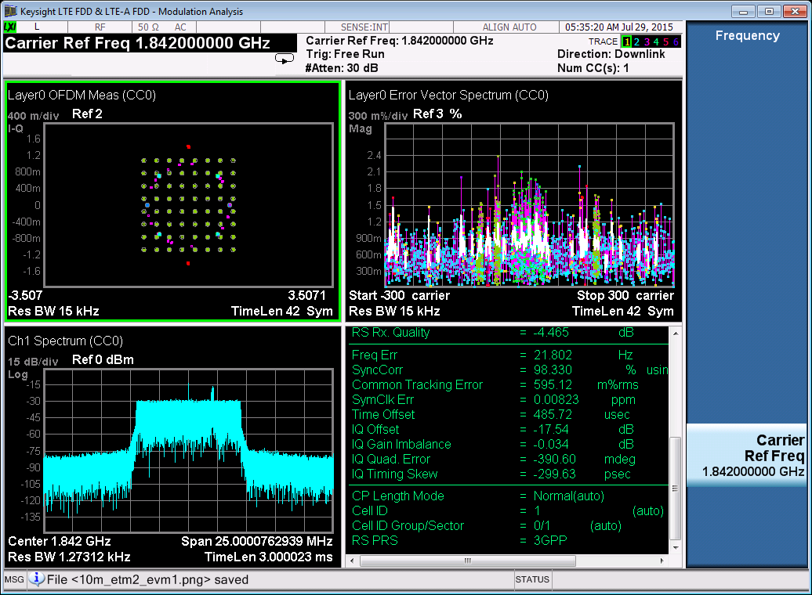

**Figure 2.4-1 Frequency Error of E-TM 2**

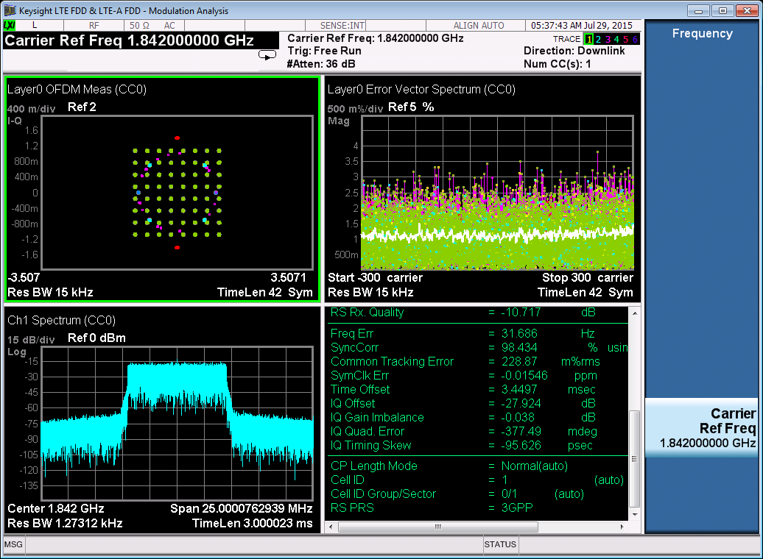

**Figure 2.4-2 Frequency Error of E-TM 3.1**

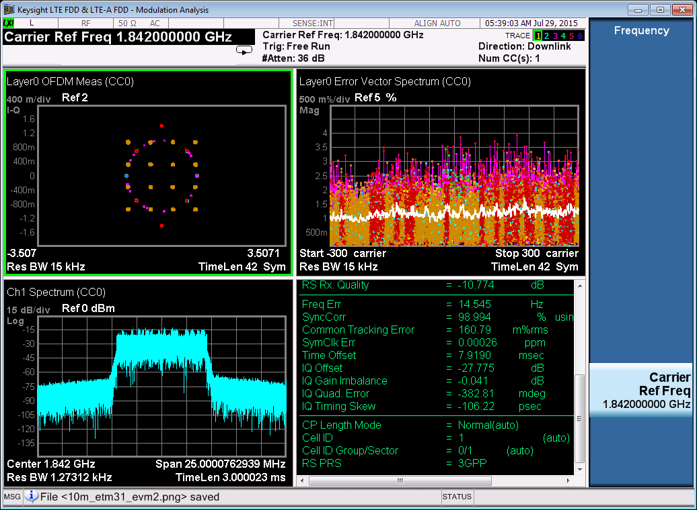

**Figure 2.4-3 Frequency Error of E-TM 3.2**

## Error Vector Magnitude

The Error vector magnitude is a measure of the difference between the ideal symbols and the measure symbols after the equalization. This difference is called the error vector. It is the measure of the amount of distortion in the transmission ultimately affecting the ability of the receiver to decode and process the signal with minimum error.

### Test Purpose

To verify the EVM is within the limit specified by the minimum requirement.

### Measurement set-up

Connect the measurement device to BS antenna connector as shown in Figure 2.2-1

### Test Procedure

Have the eNB transmit the E-TM 2, 3.1, 3.2 and 3.3, and measure the EVM in modulation analysis.

### Test requirement and result

The EVM for different modulation scheme on PDSCH shall be better than the limit in Table 2.5.4-1.

|  |  |
| --- | --- |
| Modulation scheme for PDSCH | Required EVM [%] |
| QPSK | 18.5 % |
| 16QAM | 13.5 % |
| 64QAM | 9 % |

**Table 2.5.4-1 EVM requirement**



**Figure 2.5-1 EVM of E-TM 2**



**Figure 2.5-2 EVM of E-TM 3.1**

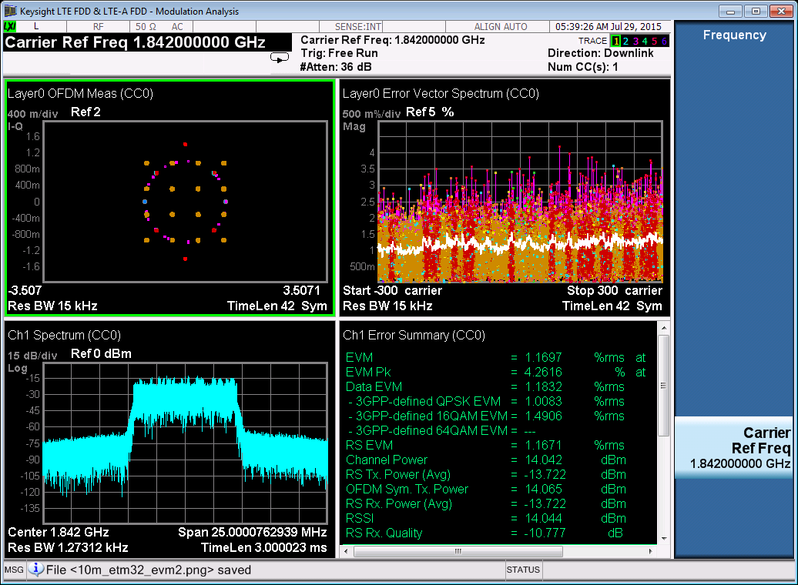

**Figure 2.5-3 EVM of E-TM 3.2**

## Time alignment error

In TX diversity and spatial multiplexing, signals are transmitted from two or more antennas. . The time alignment error in TX Diversity and spatial multiplexing transmission is specified as the delay between the signals from two antennas at the antenna ports.

### Test Purpose

To measure the time delay between the signals from the multiple transmit antennas.

### Measurement set-up

Diversity

Timing

Analyzer

BS under

TX test

TX 1

TX 2

TX 3

TX 4

Termination

Termination

**Figure 2.6-1 Measuring system Set-up for Test of Time alignment between transmitter branches**

### Test Procedure

1. Set BS ETM 1.1 signal and transmit at specified maximum output power.
2. Measure the time alignment error between the reference symbols on the antenna port 1 and the reference symbols on the antenna port 2.

### Test requirement and result

The time alignment error in TX Diversity or spatial multiplexing for any possible configuration of two transmit antennas shall not exceed 90 ns.

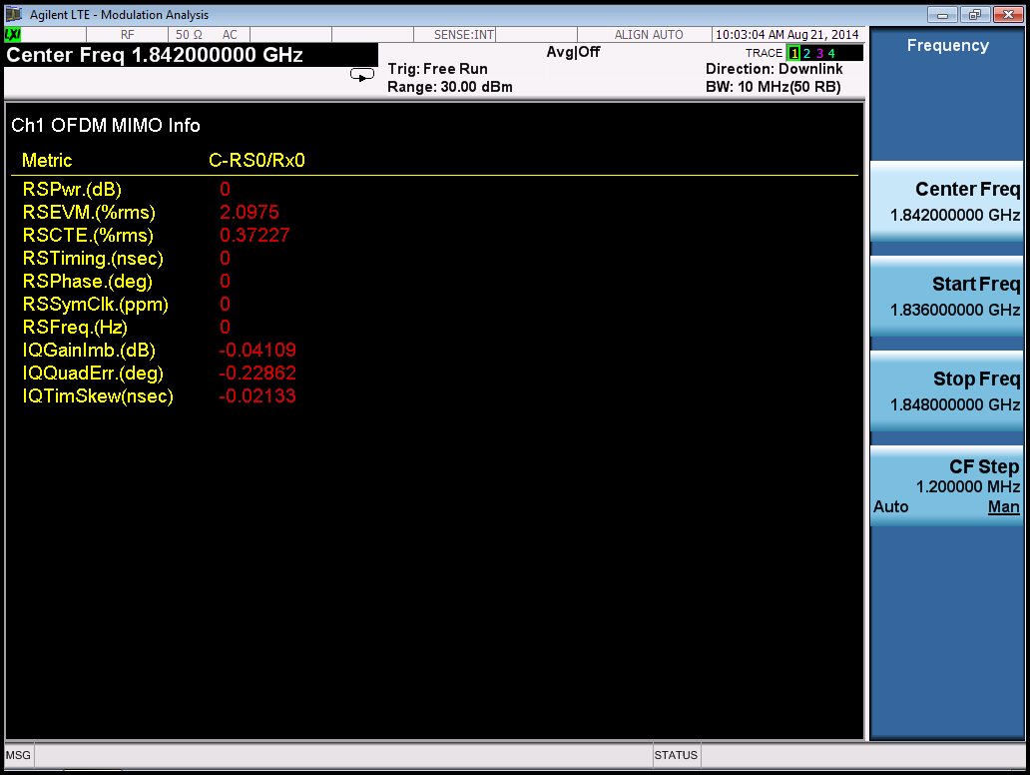

Note: Currently we have not tested TX Diversity or Spatial Multiplexing – right now both antennas transmit the same signal.

## DL RS Power

DL RS power is the resource element power of the DL reference symbol. The absolute accuracy is defined as the maximum deviation between the DL RS power indicated on the DL-SCH and the DL RS power at the BS antenna connector.

### Test Purpose

To measure the accuracy in the signal transmitted by the base station in terms of the accuracy by measuring the maximum deviation between the signaled DL RS power and the actual DL RS power at the eNB antenna connector.

### Measurement set-up

Connect the measurement device to BS antenna connector as shown in Figure 2.2-1.

### Test Procedure

Set up eNB to transmit the ETM model 1.1 at maximum total power and measure the RS TX power.

### Test requirement and result

DL RS power shall be within ± 2.9 dB of the DL RS power indicated on the DL-SCH.

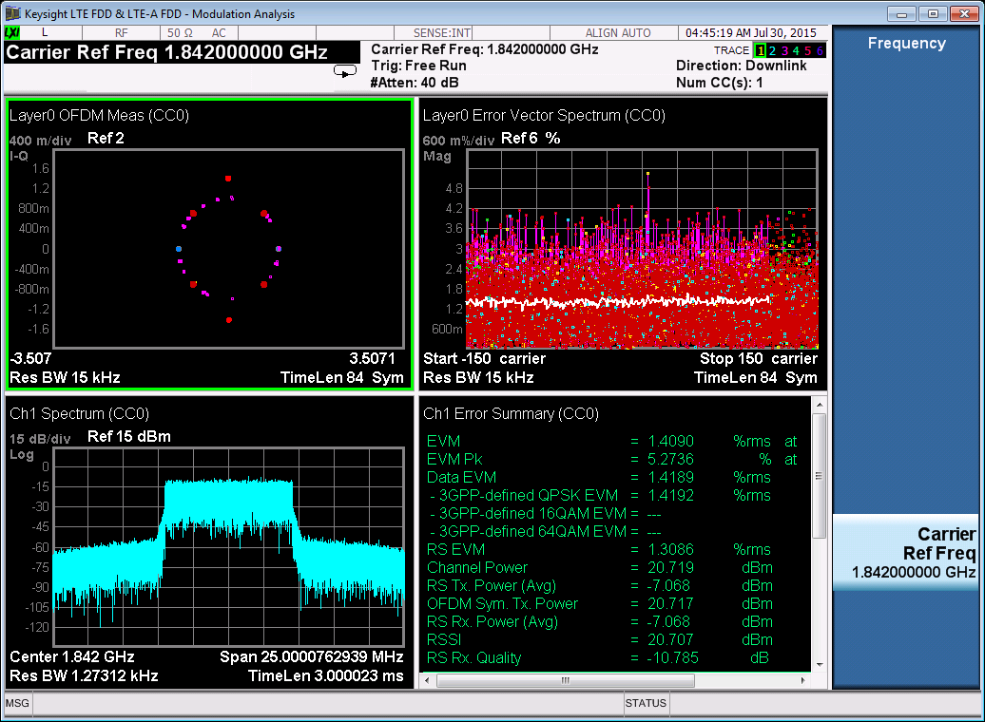

**Figure 2.7-1 DL RS Power of E-TM 1.1**

The measured resource element power is less than setting value -2.9dBm.

## Occupied Bandwidth

The occupied bandwidth is the width of a frequency band such that, below the lower and above the upper frequency limits.

### Test Purpose

To verify that most of the transmitted energy reside within the channel bandwidth. The bandwidth measurement of the signal contains 99% of the channel power.

### Measurement set-up

Connect the measurement device to BS antenna connector as shown in Figure 2.2-1

### Test Procedure

Set up eNB to transmit the ETM model 1.1 and measure the bandwidth.

Note: The selected resolution bandwidth (RBW) filter of the analyzer shall be [30 kHz] or less. The spectrum shall be measured at [400] or more points across the measurement span.

### Test requirement and result

The occupied bandwidth shall be less than the channel bandwidth as Table 2.8-1.

|  |  |  |  |  |  |  |
| --- | --- | --- | --- | --- | --- | --- |
| **Channel Bandwidth [MHz]** | 1.4 | 3.0 | 5 | 10 | 15 | 20 |
| **Occupied Bandwidth [MHZ]** | 1.08  (6 RB) | 2.7 (15 RB) | 4.5 (25 RB) | 9.0 MHz (50 RB) | 13.5 MHz (75 RB) | 18 MHz (100 RB) |

**Table 2.8-1 Occupied Bandwidth**

The measured occupied bandwidth is 8.9MHz.

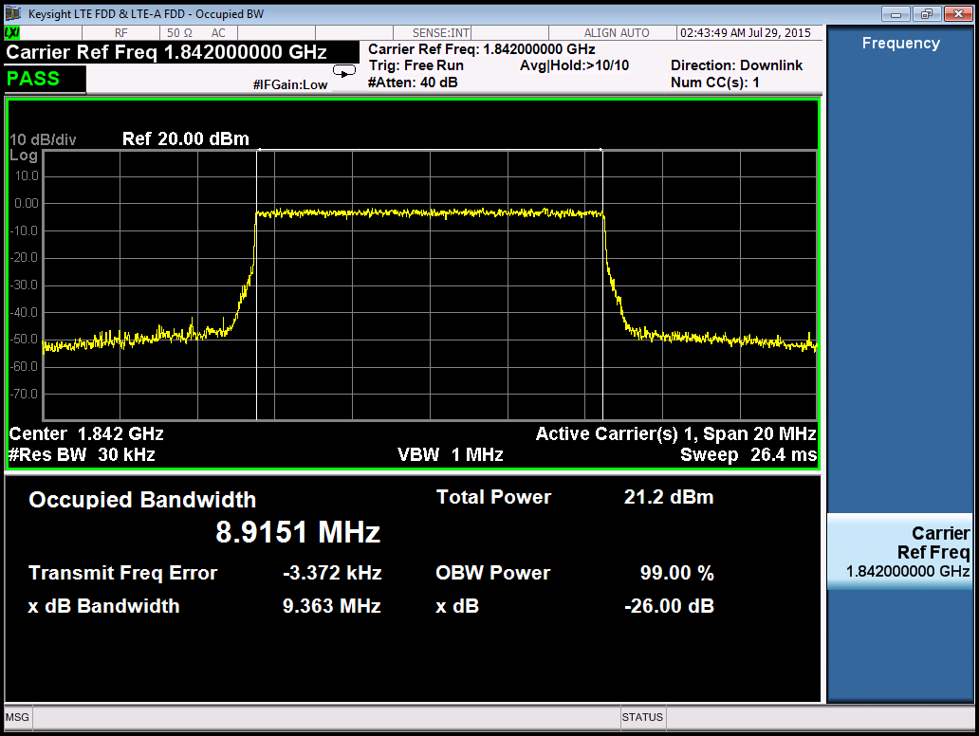

**Figure 2.8-1 Occupied Bandwidth of E-TM 1.1**

## Adjacent Channel Leakage Power Ratio (ACLR)

ACLR is the ratio of the filtered mean power centered on the assigned channel frequency to the filtered mean power centered on an adjacent channel frequency.

### Test Purpose

To verify if the eNB transmits in the adjacent channels is met the minimum requirement.

### Measurement set-up

Connect the measurement device to BS antenna connector as shown in Figure 2.2-1.

### Test Procedure

Set up eNB to transmit the ETM models 1.1 and 1.2, measure the adjacent channel power during these tests.

### Test requirement and result

ACLR is defined with a square filter of bandwidth equal to the transmission bandwidth configuration of the transmitted signal centered on the assigned channel frequency and a filter centered on the adjacent channel frequency as Table 2.9-1.

|  |  |  |  |  |
| --- | --- | --- | --- | --- |
| E-UTRA transmitted signal channel bandwidth BWChannel [MHz] | BS adjacent channel centre frequency offset below the first or above the last carrier centre frequency transmitted | Assumed adjacent channel carrier (informative) | Filter on the adjacent channel frequency and corresponding filter bandwidth | ACLR limit |
| 1.4, 3.0, 5, 10, 15, 20 | BWChannel | E-UTRA of same BW | Square (BWConfig) | 45 dB |
| 2 x BWChannel | E-UTRA of same BW | Square (BWConfig) | 45 dB |
| BWChannel /2 + 2.5 MHz | 3.84 Mcps UTRA | RRC (3.84 Mcps) | 45 dB |
| BWChannel /2 + 7.5 MHz | 3.84 Mcps UTRA | RRC (3.84 Mcps) | 45 dB |
| NOTE 1: BWChannel and BWConfig are the channel bandwidth and transmission bandwidth configuration of the E-UTRA transmitted signal on the assigned channel frequency.  NOTE 2: The RRC filter shall be equivalent to the transmit pulse shape filter defined in TS 25.104 [6], with a chip rate as defined in this table. | | | | |

**Table 2.9-1: Base Station ACLR in paired spectrum**

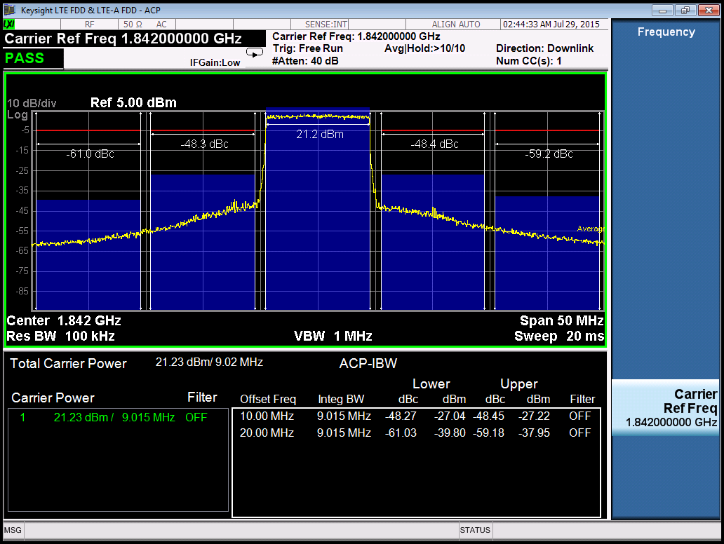

**Figure 2.9-1 ACLR in E-TM 1.1**

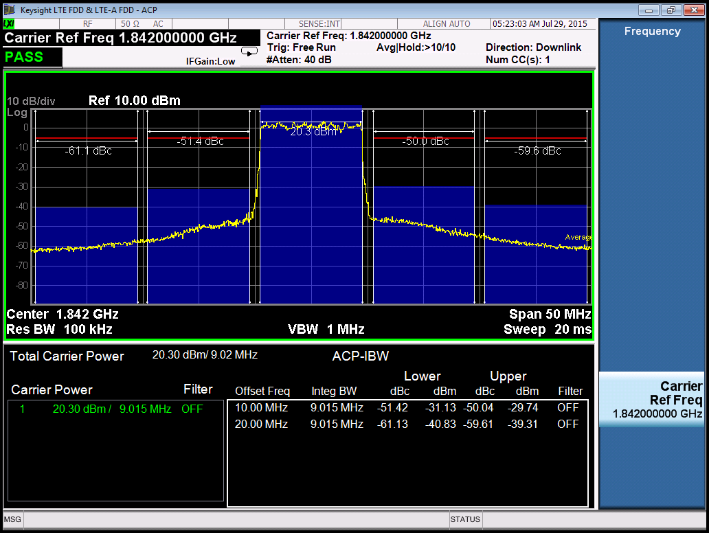

**Figure 2.9-2 ACLR in E-TM 1.2**

## Operating Band Unwanted Emissions

Operating band unwanted emission limits are defined from 10MHz below the lowest frequency of the downlink operating band up to 10MHz above the highest frequency of the downlink operating band.

### Test Purpose

To verify if the eNB leaks RF onto its neighbor channels – it is measured from ±10MHz from the base station transmitter operating band edge

### Measurement set-up

Connect the measurement device to BS antenna connector as shown in Figure 2.2-1.

### Test Procedure

Set up eNB to transmit ETM 1.1 and 1.2 – measure the spectral emission mask during the test.

### Test requirement and result

The measurement results shall not exceed the maximum levels in the Table 2.10.1 below.

|  |  |  |  |
| --- | --- | --- | --- |
| Frequency offset of measurement filter ‑3dB point, Δf | Frequency offset of measurement filter centre frequency, f_offset | Test Requirement | Measurement bandwidth (Note 1) |
| 0 MHz ≤ Δf < 5 MHz | 0.05 MHz ≤ f_offset < 5.05 MHz |  | 100 kHz |
| 5 MHz ≤ Δf <  min(10 MHz, Δfmax) | 5.05 MHz ≤ f_offset <  min(10.05 MHz, f_offsetmax) | -14 dBm | 100 kHz |
| 10 MHz ≤ Δf ≤ Δfmax | 10.5 MHz ≤ f_offset < f_offsetmax | -13 dBm (Note 5) | 1MHz |

**Table 2.10-1: General operating band unwanted emission limits for 5, 10, 15 and 20 MHz channel bandwidth (E-UTRA bands >1GHz) for Category A**

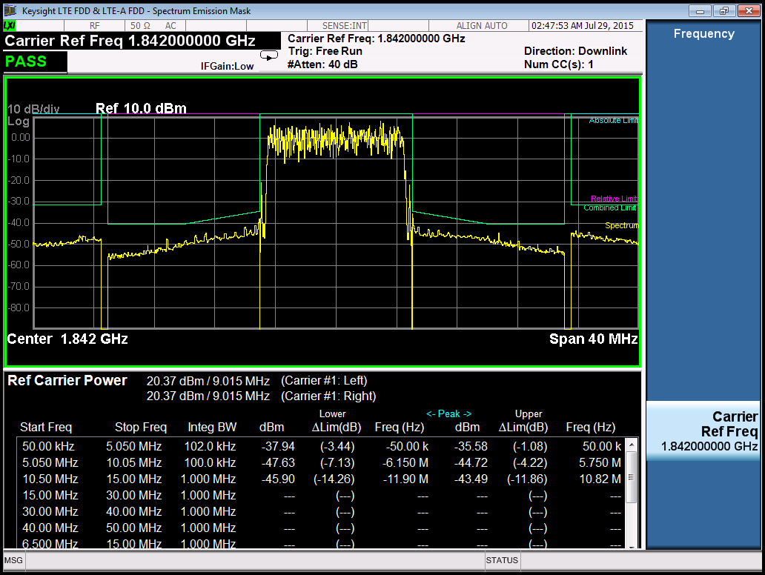

**Figure 2.10-1 Unwanted Emissions in ETM 1.1**

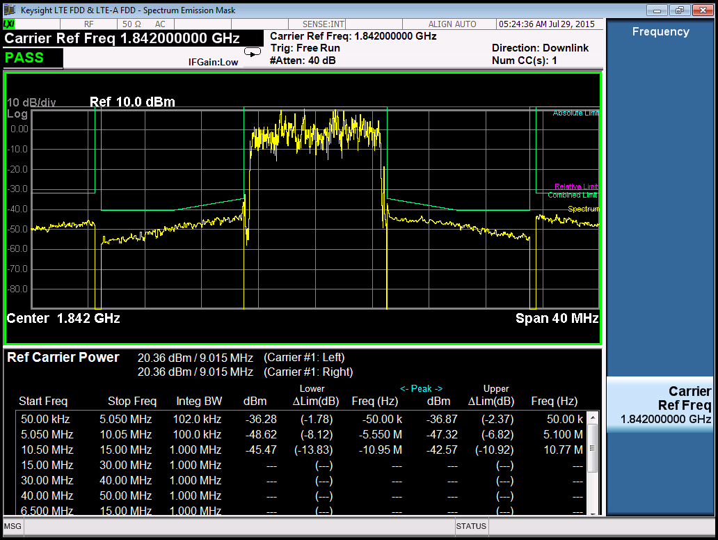

**Figure 2.10-2 Unwanted Emissions ETM 1.2**

## Transmitter Spurious Emissions

The transmitter spurious emission limits apply from 9 kHz to 12.75 GHz excluding the frequency range from 10MHz below the lowest frequency of the downlink operating band up to 10MHz above the highest frequency of the downlink operating band.

### Test Purpose

To verify how much the eNB leaks well beyond its neighboring band – these out of band emissions are regulated to ensure compatibility between different radio systems.

### Measurement set-up

Connect the measurement device to BS antenna connector as shown in Figure 2.2-1.

### Test Procedure

1. Set the BS to transmit a signal according to E-TM 1.1 at the specified maximum output power.
2. Measure the emission at the specified frequencies with specified measurement bandwidth and note that the measured value does not exceed the specified value.

### Test requirement and result

The measurement results shall not exceed the maximum levels in the Table 2.11.1 below.

|  |  |  |  |
| --- | --- | --- | --- |
| Frequency range | Maximum level | Measurement Bandwidth | Note |
| 9kHz ‑ 150kHz | -13 dBm | 1 kHz | Note 1 |
| 150kHz ‑ 30MHz | 10 kHz | Note 1 |
| 30MHz ‑ 1GHz | 100 kHz | Note 1 |
| 1GHz ‑ 12.75 GHz | 1 MHz | Note 2 |
| NOTE 1: Bandwidth as in ITU-R SM.329 [2] , s4.1  NOTE 2: Bandwidth as in ITU-R SM.329 [2] , s4.1. Upper frequency as in ITU-R SM.329 [2] , s2.5 table 1 | | | |

**Table 2.11-1: BS Spurious emission limits, Category A**

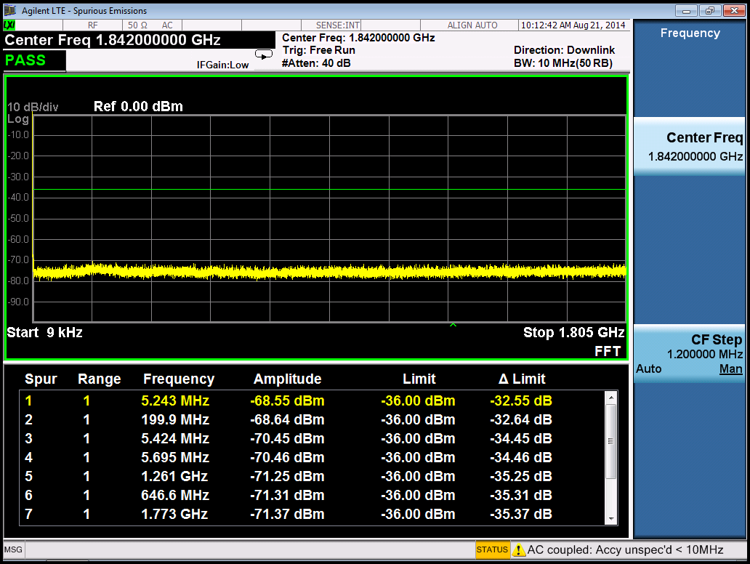

**Figure 2.11-1 Spurious Emissions @ 9kHz to 1.805GHz**

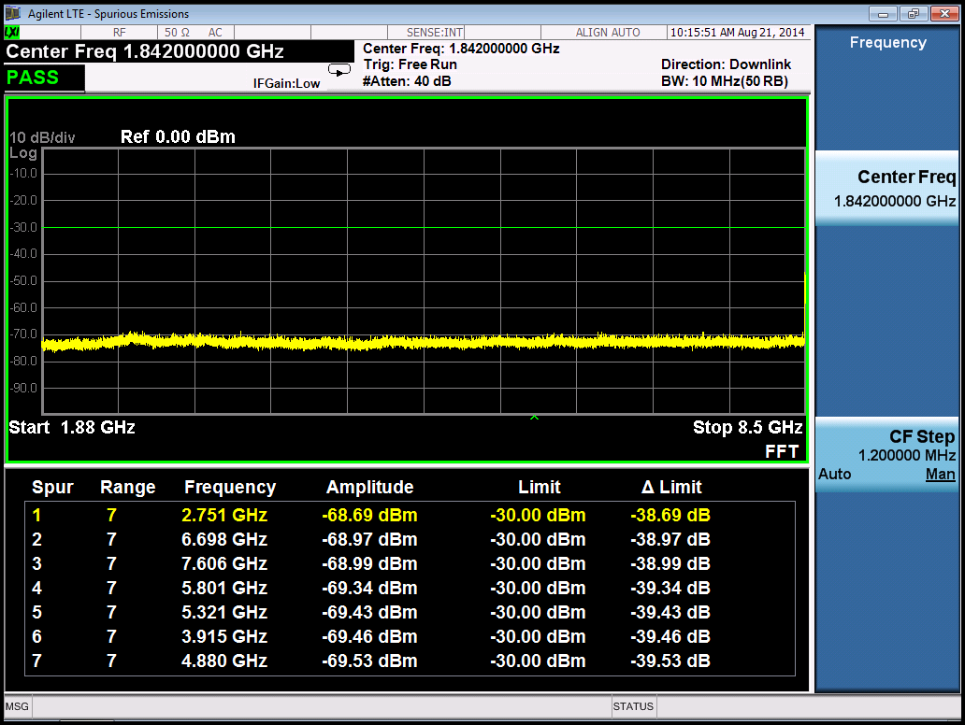

**Figure 2.11-2 Spurious Emissions @ 1.880GHz to 8.5GHz**

## Transmitter Intermodulation

The transmitter intermodulation requirement is a measure of the capability of the transmitter to inhibit the generation of signals in its non-linear elements caused by presence of the own transmit signal and an interfering signal reaching the transmitter via the antenna.

### Test Purpose

The test purpose is to verify the ability of the BS transmitter to restrict the generation of intermodulation products in its non-linear elements caused by presence of the wanted signal and an interfering signal reaching the transmitter via the antenna to below specified levels.

|  |  |
| --- | --- |
| Parameter | Value |
| Interfering signal centre frequency offset from wanted signal carrier centre frequency | -BWChannel /2 - 12.5 MHz  -BWChannel /2 - 7.5 MHz  -BWChannel /2 - 2.5 MHz  BWChannel /2 + 2.5 MHz  BWChannel /2 + 7.5 MHz  BWChannel /2 + 12.5 MHz |
| NOTE 1: Interfering signal positions that are partially or completely outside of the downlink operating band of the base station are excluded from the requirement, unless the interfering signal positions fall within the frequency range of adjacent downlink operating bands in the same geographical area.  NOTE 2: NOTE 1 is not applied in Band 1, 3, 8, 9, 11, 18, 19, 21, 34 in certain regions. | |

**Table 2.12.1 Interfering signal centre frequency offset from wanted signal carrier centre frequency**

### Measurement set-up



**Figure 2.12-1 Measuring system Set-up for Transmitter intermodulation**

### Test requirement and result

In the frequency range relevant to the transmit intermodulation level shall not exceed the out of band emission requirements and transmitter spurious emissions requirement in the presence of a EUTRA modulated interfering signal with a mean power 30dB below the mean power of the wanted signal.

|  |  |
| --- | --- |
|  |  |
| **ACLR @ 1834.5MHz interfering signal** | **ACLR @ 1849.5MHz interfering signal** |

|  |  |
| --- | --- |
|  |  |
| **Unwanted Emissions @ 1834.5MHz interfering signal** | **Unwanted Emissions @ 1849.5MHz interfering signal** |
|  |  |
| **Spurious_A @ 1834.5MHz interfering signal** | **Spurious_B @ 1849.5MHz interfering signal** |
|  |  |
| **Spurious_A @ 1834.5MHz interfering signal** | **Spurious_B @ 1849.5MHz interfering signal** |

# Receiver Characteristics Test

## General

To conduct the test, multiple Keysight EXG N5172B, and CAVIUM logParser software are used.

The eNB software is scripted to comply with the same frequency of the RF card.

The physical channel required for the DL tests are setup using the EUTRA test channel FRC A1-1, A1-2, A1-3, A1-4, A1-5. The base station under test is designed for Home Base station usage and hence the tests conducted will limit the requirement only to a Home Base station.

Unless otherwise stated, the test shall be performed with a lowest and the highest bandwidth supported by the BS. The manufacturer shall declare that the requirements are fulfilled for all other bandwidths supported by the BS which are not tested.

Many tests are performed with appropriate frequencies in the bottom, middle and top channels of the supported frequency range of the BS. These are denoted as RF channels B (bottom), M (middle) and T (top). Unless otherwise stated, the test shall be performed with a single carrier at the RF channels B in the test.

|  |  |  |  |  |  |
| --- | --- | --- | --- | --- | --- |
| **Reference channel** | **A1-1** | **A1-2** | **A1-3** | **A1-4** | **A1-5** |
| Allocated resource blocks | 6 | 15 | 25 | 3 | 9 |
| DFT-OFDM Symbols per subframe | 12 | 12 | 12 | 12 | 12 |
| Modulation | QPSK | QPSK | QPSK | QPSK | QPSK |
| Code rate | 1/3 | 1/3 | 1/3 | 1/3 | 1/3 |
| Payload size (bits) | 600 | 1544 | 2216 | 256 | 936 |
| Transport block CRC (bits) | 24 | 24 | 24 | 24 | 24 |
| Code block CRC size (bits) | 0 | 0 | 0 | 0 | 0 |
| Number of code blocks - C | 1 | 1 | 1 | 1 | 1 |
| Coded block size including 12bits trellis termination (bits) | 1884 | 4716 | 6732 | 852 | 2892 |
| Total number of bits per sub-frame | 1728 | 4320 | 7200 | 864 | 2592 |
| Total symbols per sub-frame | 864 | 2160 | 3600 | 432 | 1296 |

**Table 3.1-1 FRC parameters for reference sensitivity and in-channel selectivity interfering signal**

The interfering signal shall be a PUSCH containing data and reference symbols. Normal cyclic prefix is used. The data content shall be uncorrelated to the wanted signal and modulated according to clause 5 of TS36.211. Mapping of PUSCH modulation to receiver requirement are specified in Table 3.1-2.

|  |  |
| --- | --- |
| **Receiver requirement** | **Modulation** |
| In-channel selectivity | 16QAM |
| Adjacent channel selectivity and narrow-band blocking | QPSK |
| Blocking | QPSK |
| Receiver intermodulation | QPSK |

**Table 3.1-2: Modulation of the interfering signal**

## Reference Sensitivity Level

### Test Purpose

To verify that at the eNB Reference sensitivity level the throughput requirement shall be met for a specified reference measurement channel.

### Measurement set-up

RF signal source

RF out

Termination (If needed)

BS under RX Test

RX1 or RX1/TX

RX2

**Figure 3.2-1 Measuring system Set-up for Base Station Reference sensitivity level Test**

### Test Procedure

1) Set the test signal mean power for Local Area BS

2) Measure the throughput according to [2] Annex E.

### Test requirement and result

The throughput shall be ≥ 95%of the maximum throughput of the reference measurement channel with parameters specified in Table 3.2-1.

|  |  |  |  |
| --- | --- | --- | --- |
| **E-UTRA**  **channel bandwidth [MHz]** | **Reference measurement channel** | **Reference sensitivity power level, Psens [dBm] Requirements** | **Test Results** |
| 10 | FRC A1-3 * | -92.8 | -100 |
| Note*: PREFSENS is the power level of a single instance of the reference measurement channel. This requirement shall be met for each consecutive application of a single instance of FRC A1-3 mapped to disjoint frequency ranges with a width of 25 resource blocks each | | | |

**Table 3.2-1 Local Area BS reference sensitivity levels**

**Figure 3.2-2: Sensitivity level test**

|  |  |  |
| --- | --- | --- |
| Prefsens [dBm] | BLER (%) | Throughput Rate (%) |
| -100 | 0.00 | 1.00 |
| -101 | 0.00 | 1.00 |
| -102 | 4.32 | 0.96 |
| -103 | 17.12 | 0.83 |
| -104 | 61.50 | 0.38 |
| -105 | 100.00 | 0.00 |
| -106 | 100.00 | 0.00 |

**Table 3.2-2 FRC throughput in sensitivity level**

## Dynamic Range

Dynamic range is the measurement of a receiver's ability to process a range of input powers from the antenna in the presence of an interfering signal inside the received channel bandwidth. In this condition a throughput requirement shall be met for a specified reference measurement channel. The interfering signal for the dynamic range requirement is an AWGN signal.

### Test Purpose

Verify the relative throughput if is fulfill the specified limit.

### Measurement set-up



**Figure 3.3-1 Measuring system Set-up for Dynamic range**

### Test Procedure

For each E-UTRA channel BW:

1) Configure the signal generator for the wanted signal as specified in Table 3.3-1 for Local Area BS.

2) Adjust the AWGN generator level as specified in Table 3.3-1 Local Area BS dynamic range for Local Area BS and set the frequency to the same frequency as the tested channel.

3) Measure the throughput according to Annex E in [2] and verify that it is within the specified level.

### Test requirement and result

The throughput shall be ≥ 95% of the maximum throughput of the reference measurement channel with parameters specified in Table 3.3-1 for Local Area BS.

|  |  |  |  |  |
| --- | --- | --- | --- | --- |
| E-UTRA  channel bandwidth [MHz] | Reference measurement channel | Wanted signal mean power [dBm] | Interfering signal mean power [dBm] / BWConfig | Type of interfering signal |
| 1.4 | FRC A2-1 in Annex A.2 | -31.5 | -44.2 | AWGN |
| 3 | FRC A2-2 in Annex A.2 | -27.6 | -40.2 | AWGN |
| 5 | FRC A2-3 in Annex A.2 | -25.4 | -38 | AWGN |
| 10 | FRC A2-3 in Annex A.2* | -25. 4 | -35 | AWGN |
| 15 | FRC A2-3 in Annex A.2* | -25. 4 | -33.2 | AWGN |
| 20 | FRC A2-3 in Annex A.2* | -25. 4 | -31.9 | AWGN |
| Note*: The wanted signal mean power is the power level of a single instance of the reference measurement channel. This requirement shall be met for each consecutive application of a single instance of FRC A2-3 mapped to disjoint frequency ranges with a width of 25 resource blocks each | | | | |

**Table 3.3-1 Home Area BS dynamic range**

## In-channel Selectivity

In-channel selectivity (ICS) is the measurement of a receiver’s ability to receive a wanted signal at its assigned Resource Block locations in the presence of an interfering signal received at a larger power spectral density. In this condition a throughput requirement shall be met for a specified reference measurement channel. The interfering signal shall be an E-UTRA signal as specified in [2] Annex C and shall be time aligned with the wanted signal.

### Test Purpose

Verify the BS receiver’s ability to suppress the IQ leakage.

### Measurement set-up



**Figure 3.4-1 Measuring system Set-up for In-channel selectivity**

### Test Procedure

For each E-UTRA channel BW:

1) Configure the signal generator for the wanted signal as specified in Table 3.4-1 for Local Area BS

2) Adjust the signal generator for the interfering signal as specified in Table 3.4-1 for Local Area BS at opposite side of the FC and adjacent to the wanted signal.

3) Measure the throughput according to [2] Annex E.

4) Repeat the measurement with the wanted signal on the other side of the FC.

### Test requirement and result

The throughput shall be ≥ 95% of the maximum throughput of the reference measurement channel as specified in [2] Annex A with parameters specified in Table 3.4-1.

|  |  |  |  |  |  |
| --- | --- | --- | --- | --- | --- |
| **E-UTRA**  **channel bandwidth (MHz)** | **Reference measurement channel** | **Wanted signal mean power [dBm]** | | **Interfering signal mean power [dBm]** | **Type of interfering signal** |
|  |  | f ≤ 3.0GHz | 3.0GHz < f ≤ 4.2GHz |  |  |
| 1.4 | A1-4 in Annex A.1 | -97.5 | -97.1 | -79 | 1.4 MHz E-UTRA signal, 3 RBs |
| 3 | A1-5 in Annex A.1 | -92.7 | -92.3 | -76 | 3 MHz E-UTRA signal, 6 RBs |
| 5 | A1-2 in Annex A.1 | -90.6 | -90.2 | -73 | 5 MHz E-UTRA signal, 10 RBs |
| **10** | **A1-3 in Annex A.1** | **-89.1** | **-88.7** | **-69** | **10 MHz E-UTRA signal, 25 RBs** |
| 15 | A1-3 in Annex A.1* | -89.1 | -88.7 | -69 | 15 MHz E-UTRA signal, 25 RBs* |
| 20 | A1-3 in Annex A.1* | -89.1 | -88.7 | -69 | 20 MHz E-UTRA signal, 25 RBs* |
| Note*: Wanted and interfering signal are placed adjacently around Fc | | | | | |

**Table 3.4-1 E-UTRA Local/Home Area BS in-channel selectivity**

**Figure 3.4-2 In-channel selectivity test**

## Adjacent Channel Selectivity and Narrow-band Blocking

Adjacent channel selectivity (ACS) is the measurement of a receiver’s ability to receive a wanted signal at its assigned channel frequency in the presence of an adjacent channel signal with a specified center frequency offset of the interfering signal to the band edge of a victim system.

The interfering signal shall be an E-UTRA signal as specified in Annex C in [2].

### Test Purpose

Verify the BS receiver filter’s ability to suppress interfering signals in the channels adjacent to the wanted channel.

### Measurement set-up

BS Under RX Test

RX1

RX2

HYBRID

ATT2

ATT1

Signal Generator for the wanted signal

Signal Generator for the interfering signal

TERMINATION

### Figure 3.5-1 Measuring system Set-up for Adjacent channel selectivity and narrowband blocking

### Test Procedure

For Adjacent Channel Selectivity and narrow band blocking

1. Set interference channel as defined in Table 3.5-2 and Table 3.5-3
2. Measure the throughput according to Annex E in [2].

### Test requirement and result

The throughput shall be ≥ 95% of the maximum throughput of the reference measurement channel.

|  |  |  |  |
| --- | --- | --- | --- |
|  | **Wanted signal mean power [dBm]** | **Interfering signal mean power [dBm]** | **Type of interfering signal** |
| Wide Area BS | PREFSENS + 6dB* | -49 | See Table 7.5-2 |
| Medium Range BS | PREFSENS + 6dB* | -44 | See Table 7.5-2 |
| Local Area BS | PREFSENS +6dB* | -41 | See Table 7.5-2 |
| **Home BS** | **PREFSENS + 14dB\*** | **-33** | **See Table 7.5-2** |
| Note*: PREFSENS depends on the channel bandwidth as specified in TS 36.104 [2] subclause 7.2.1. | | | |

**Table 3.5-1: Narrowband blocking requirement**

|  |  |  |
| --- | --- | --- |
| **E-UTRA**  **Assigned BW [MHz]** | **Interfering RB centre frequency offset to the channel edge of the wanted signal [kHz]** | **Type of interfering signal** |
| 10 | 347.5+m*180,  m=0, 1, 2, 3, 4, 9, 14, 19, 24 | 5 MHz E-UTRA signal, 1 RB* |
| Note*: Interfering signal consisting of one resource block adjacent to the wanted signal, the channel bandwidth of the interfering signal is located adjacently to the channel edge of the wanted signal. | | |

**Table 3.5-2: Interfering signal for Narrowband blocking requirement**

|  |  |  |  |  |  |
| --- | --- | --- | --- | --- | --- |
| **E-UTRA**  **channel bandwidth [MHz]** | **Wanted signal mean power [dBm]** | **Interfering signal mean power [dBm]** | **Interfering signal centre frequency offset from the channel edge of the wanted signal [MHz]** | **Type of interfering signal** | **Measured Wanted signal mean power [dBm]** |
| 10 | PREFSENS + 22dB* | -28 | 2.5075 | 5MHz E-UTRA signal | -61 |
| Note*: PREFSENS depends on the channel bandwidth as specified in TS 36.104 [2] subclause 7.2.1. | | | | | |

**Table 3.5-3: Adjacent channel selectivity for Home Area BS**

**Figure 3.5-2 Adjacent Channel Selectivity test**

**Figure 3.5-3 Narrow-band blocking test (m=0)**

## Blocking

The blocking measurement of the receiver is testing the ability to receive a wanted signal at its assigned channel in the presence of unwanted signals which are a 1.4MHz, 3MHz or 5MHz E-UTRA signal for in-band blocking or a CW signal for out-of-band blocking.

### Test Purpose

Test the ability of the BS receiver to withstand high-level interference from unwanted signals at specified frequency offsets without degradation of its sensitivity.

### Measurement set-up

Signal Generator for  
for the wanted signal

ATT1

Termination

Signal Generator for  
the interfering signal

ATT2

Termination

HYBRID

BS under RX Test

RX1/TX

RX2

**Figure 3.6-1 Measuring system Set-up for blocking characteristics**

### Test Procedure

For Adjacent Channel Selectivity and narrow band blocking

1) Set interfering signal levels and frequency offsets defined in Table 3.6-1 and Table 3.6-2

2) Measure the throughput of the wanted signal at the BS receiver according to [2] Annex E.

### Test requirement and result

The throughput shall be ≥ 95% of the maximum throughput of the reference measurement channel with a wanted and an interfering signal coupled to BS antenna input using the parameters in Table 3.6-1 and 3.6-2.

|  |  |  |  |  |  |  |
| --- | --- | --- | --- | --- | --- | --- |
| **Operating Band** | **Centre Frequency of Interfering Signal [MHz]** | **Interfering Signal mean power [dBm]** | **Wanted Signal mean power [dBm]** | | **Interfering signal center frequency minimum frequency offset from the channel edge of the wanted signal [MHz]** | **Type of Interfering Signal** |
| 8 | (FUL_low -20) to (FUL_high +20) | -27 | PREFSENS +6dB* | See table 7.6-2 | | See table 7.6-2 |
| 1 to (FUL_low -20)  (FUL_high +20) to 12750 | -15 | PREFSENS +6dB* | _ | | CW carrier |
| Note*: PREFSENS depends on the channel bandwidth as specified in TS 36.104 [2] sub-clause 7.2.1. | | | | | | |

**Table 3.6-1: Blocking performance requirement for Home Area BS**

|  |  |  |
| --- | --- | --- |
| **E-UTRA**  **channel BW [MHz]** | **Interfering signal centre frequency minimum offset to the channel edge of the wanted signal [MHz]** | **Type of interfering signal** |
| 10 | 7.5 | 5MHz E-UTRA signal |

**Table 3.6-2: Interfering signals for blocking performance requirement**

|  |  |
| --- | --- |
|  |  |
| **Wanted signal with interfering signal in (FUL_low -20) to (FUL_high +20)** | |
|  |  |
| **Wanted signal with interfering signal in 1 MHz to (FUL_low -20) and (FUL_high +20) to 12750 MHz** | |

The test passed in (FUL_low -20) to (FUL_high +20), and 1 MHz to (FUL_low -20) and (FUL_high +20) to 12750 MHz.

## Receiver Spurious Emissions

The receiver spurious emission is the measurement of the power of emissions which generated or amplified in a receiver that appear at the BS receiver antenna ports. **The requirements apply to all BS with separate RX and TX antenna ports.** The test shall be performed when both TX and RX are on, with the TX port terminated.

### Test Purpose

Verify the ability of the BS to limit the interference caused by receiver spurious emissions to other systems.

### Measurement set-up

BS under RX Test

Termination

Termination

TX notch

Measurement receiver

TX

RX1

RX2

**Figure 3.7-1 Measuring system Set-up for Receiver spurious emission**

### Test Procedure

1) Set BS transmit E-TM 1.1 signal at maximum power.

2) Set signal analyzer as specified in Table 3.7-1.

3) Measure the spurious emissions over each frequency range described in [2] sub-clause 7.7.5.

4) Repeat the test using diversity antenna connector if available.

### Test requirement and result

In addition to the requirements in Table 3.7-1, the power of any spurious emission shall not exceed the levels specified for Protection of the E-UTRA FDD BS receiver of own or different BS in [2] Clause 6.6.4.5.3 and for Co-existence with other systems in the same geographical area in [2] Clause 6.6.4.5.4. In addition, the co-existence requirements for co-located base stations specified in [2] sub-clause 6.6.4.5.5 may also be applied.

|  |  |  |
| --- | --- | --- |
| **Frequency range** | **Maximum level** | **Measurement Bandwidth** |
| 1 GHz - 12.75 GHz | -47 dBm | 1 MHz |
| NOTE: The frequency range between 2.5 * BWChannel below the first carrier frequency and 2.5 * BWChannel above the last carrier frequency transmitted by the BS, where BWChannel is the channel bandwidth according to Table 5.6-1, may be excluded from the requirement. However, frequencies that are more than 10 MHz below the lowest frequency of the BS downlink operating band or more than 10 MHz above the highest frequency of the BS downlink operating band shall not be excluded from the requirement. | | |

**Table 3.7-1: General spurious emission test requirement**

## Receiver Intermodulation

Intermodulation response rejection is a measure of the capability of the receiver to receive a wanted signal on its assigned channel frequency in the presence of two interfering signals which have a specific frequency relationship to the wanted signal. Interfering signals shall be a CW signal and an E-UTRA signal as specified in [2] Annex C.

### Test Purpose

Test the ability of the BS receiver to inhibit the generation of intermodulation products in its non-linear elements caused by the presence of two high-level interfering signals at frequencies with a specific relationship to the frequency of the wanted signal.

### Measurement set-up

Signal Generator for the wanted signal

Termination

HYBRID

BS under RX Test

Signal Generator for the CW interfering signal

Signal Generator for the E-UTRA interfering signal

ATT1

ATT2

ATT3

HYBRID

RX1

RX2

**Figure 3.8-1 Measuring system Set-up for intermodulation characteristics**

### Test Procedure

1) Generate the wanted signal and adjust the signal level to the BS under test to the level specified in Table 3.8-2.

2) Adjust the signal generators to the type of interfering signals, levels and the frequency offsets as specified in Table 3.8-2 for intermodulation requirement in Table 3.8-2 for narrowband intermodulation requirement.

3) Adjust the signal generators to obtain the specified level of interfering signal at the BS input.

4) Measure the throughput according to Annex E in [2].

### Test requirement and result

The throughput shall be ≥ 95% of the maximum throughput of the reference measurement channel, with a wanted signal in Table 3.7-1 Table 3.8-2

|  |  |  |  |  |
| --- | --- | --- | --- | --- |
| **BS type** | **Wanted signal mean power [dBm]** | **Interfering signal mean power [dBm]** | **Type of interfering signal** | **Margin** |
| Wide Area BS | PREFSENS + 6dB* | -52 | See Table 5.8.4-2 |  |
| Local Area BS | PREFSENS + 6dB* | -44 | 4.8dB |
| **Home BS** | **PREFSENS + 14dB\*** | **-36** |  |
| Note*: PREFSENS depends on the channel bandwidth as specified in TS 36.104 [2] subclause 7.2.1. For E-UTRA channel bandwidths 10, 15 and 20 MHz this requirement shall apply only for a FRC A1-3 mapped to the frequency range at the channel edge adjacent to the interfering signals. | | | | |

**Table 3.8-1: Intermodulation performance requirement**

|  |  |  |
| --- | --- | --- |
| **E-UTRA**  **channel bandwidth [MHz]** | **Interfering signal centre frequency offset from the channel edge of the wanted signal [MHz]** | **Type of interfering signal** |
| 10 | 7. 375 | CW |
| 17.5 | 5MHz E-UTRA signal |

**Table 3.8-2: Interfering signal for Intermodulation performance requirement**

|  |  |  |  |  |  |
| --- | --- | --- | --- | --- | --- |
| **E-UTRA**  **channel bandwidth [MHz]** | **Wanted signal mean power [dBm]** | **Interfering signal mean power [dBm]** | **Interfering RB centre frequency offset from the channel edge of the wanted signal**  **[kHz]** | **Type of interfering signal** | **Margin** |
| 10 | PREFSENS + 6dB*  (***) | -36 | 325 | CW | 4.8dB |
| -36 | 1245 | 5 MHz E-UTRA signal, 1 RB** |  |

**Table 3.8-4: Narrowband intermodulation performance requirement for Home Area BS**

**Figure 3.8-2 RX Inter-modulation**

**Figure 3.8-2 RX Inter-modulation (narrow band)**

# Performance Requirement Test

## General

The requirements only apply to those measurement channels that are supported by the base station. Therefore ETU channel shall not be applied to local and home area base station which might be our base station type.

For BS with receiver antenna diversity the required SNR shall be applied separately at each antenna port. BS with more receiving antenna has an advantage over these requirements test. In PUSCH test cases, the number of antenna is specified.

## Performance requirements for PUSCH

### Performance requirements of PUSCH in multipath fading propagation conditions

#### Test Purpose

Verify the receiver’s ability to achieve throughput under multipath fading propagation conditions for a given SNR.

#### Measurement set-up

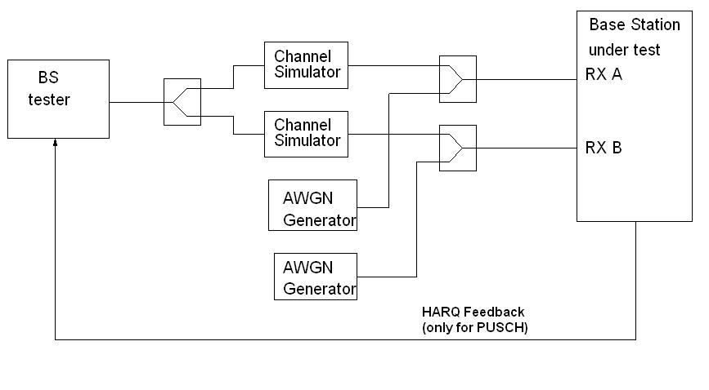

**Figure 4.2-1: Functional set-up for performance requirements for PUSCH, PRACH, single user PUCCH in multipath fading conditions and for High Speed Train conditions for BS with Rx diversity**

Test environment: Normal, see sub-clause D.2 in ref. [2].

RF channels to be tested: M; see sub-clause 4.7 in ref. [2]

#### Test Procedure

1. Adjust the AWGN generator, according to the channel bandwidth, defined in Table 4.2-1

|  |  |
| --- | --- |
| **Channel bandwidth [MHz]** | **AWGN power level** |
| 1.4 | -92.7dBm / 1.08MHz |
| 3 | -88.7dBm / 2.7MHz |
| 5 | -86.5dBm / 4.5MHz |
| 10 | -83.5dBm / 9MHz |
| 15 | -81.7dBm / 13.5MHz |
| 20 | -80.4dBm / 18MHz |

**Table 4.2-1 AWGN power level at the BS input**

|  |  |
| --- | --- |
| **Parameter** | **Value** |
| Maximum number of HARQ transmissions | 4 |
| RV sequence | 0, 2, 3, 1, 0, 2, 3, 1 |
| Uplink-downlink allocation for TDD | Configuration 1 (2:2) |

**Table 4.2-2 Test parameters for testing PUSCH**

1. The multipath fading emulators shall be configured according to the corresponding channel model.
2. Adjust the equipment so that required SNR specified in Table 4.2-3 is achieved at the BS input.
3. For each of the reference channels in Table 4.2-3 applicable for the base station, measure the throughput.

#### Test requirement and result

The measured throughput should not below the limits for the SNR levels specified in Table 4.2-3.

|  |  |  |  |  |  |  |  |
| --- | --- | --- | --- | --- | --- | --- | --- |
| **Number of RX antennas** | **Cyclic prefix** | **Propagation conditions (Annex B)** | **FRC (Annex A)** | **Fraction of maximum throughput** | **SNR [dB]** | **Measured**  **SNR** | **Margin** |
| 2 | Normal | EPA 5Hz | A3-5 | 30% | -3.6 | -4.0 | 0.4 |
| 70% | 0.2 | -0.4 | 0.6 |
| A4-6 | 70% | 11.4 | 10.8 | 0.6 |
| A5-5 | 70% | 18.9 |  |  |
| EVA 5Hz | A3-1 | 30% | -2.1 | -2.8 | 0.7 |
| 70% | 2.5 | 1.4 | 1.1 |
| A4-1 | 30% | 4.9 | 3.7 | 1.2 |
| 70% | 12.0 | 12.7 | -0.7 |
| A5-1 | 70% | 19.4 |  |  |
| EVA 70Hz | A3-5 | 30% | -3.5 | -3.3 | 0.2 |
| 70% | 0.7 | 0.7 | 0.0 |
| A4-6 | 30% | 5.1 | 4.5 | 0.6 |
| 70% | 13.2 | 12.1 | 1.1 |
| ETU 70Hz* | A3-1 | 30% | -1.9 |  |  |
| 70% | 3.0 |  |  |
| ETU 300Hz* | A3-1 | 30% | -1.6 |  |  |
| 70% | 3.5 |  |  |
| Extended | ETU 70Hz* | A4-2 | 30% | 5.4 |  |  |
| 70% | 14.2 |  |  |
| Note*: Not applicable for Local Area BS and Home BS | | | | | |  |  |

### Table 4.2-3 Test requirements for PUSCH, 10 MHz Channel Bandwidth

### Performance requirements for UL timing adjustment

#### Test Purpose

Verify receiver’s ability to achieve throughput for the moving UE at given SNR under moving propagation conditions.

#### Measurement set-up

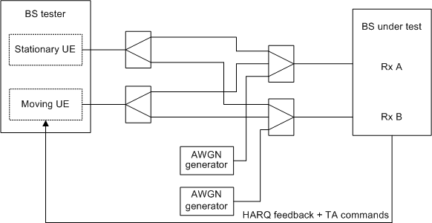

**Figure 4.2.2-1 Functional set-up for performance requirement for UL timing adjustment**

#### Test Procedure

1. Adjust signal generator’s AWGN power level to -83.5 dBm and noise bandwidth 9 MHz. Set channel bandwidth to 10 MHz
2. Configure the wanted signal of signal generator as Annex A in ref. [2], UL reference measurement channel. The test parameters is as Table 4.2.2-1

|  |  |
| --- | --- |
| **Parameter** | **Value** |
| Maximum number of HARQ transmissions | 4 |
| RV sequence | 0, 2, 3, 1, 0, 2, 3, 1 |
| Uplink-downlink allocation for TDD | Configuration 1 (2:2) |
| Subframes in which PUSCH is transmitted | For FDD:  subframe #0, #2, #4, #6, and #8 in radio frames  For TDD:  Subframe #2, #3, #7, #8 in each radio frame |
| Subframes in which sounding RS is transmitted (Note 1) | For FDD:  subframe #1 in radio frames  For TDD:  UpPTS in each radio frame |
| Note 1. The transmission of SRS is optional. | |

**Table 4.2.2-1 Test parameters for testing UL timing adjustment**

1. Configure multipath fading emulator to the corresponding channel model defined in [2] Annex B.
2. Adjust the SNR as Table 4.2.2-2

|  |  |  |  |  |  |
| --- | --- | --- | --- | --- | --- |
| **Number of RX antennas** | **Cyclic prefix** | **Channel Bandwidth [MHz]** | **Moving propagation conditions (Annex B)** | **FRC (Annex A)** | **SNR**  **[dB]** |
| 2 | Normal | 1.4 | Scenario 1 | A7-1 | 13.7 |
| Scenario 2 | A8-1 | -1.6 |
| 3 | Scenario 1 | A7-2 | 14.0 |
| Scenario 2 | A8-2 | -1.2 |
| 5 | Scenario 1 | A7-3 | 13.8 |
| Scenario 2 | A8-3 | -1.3 |
| 10 | Scenario 1 | A7-4 | 14.4 |
| Scenario 2 | A8-4 | -1.5 |
| 15 | Scenario 1 | A7-5 | 14.6 |
| Scenario 2 | A8-5 | -1.5 |
| 20 | Scenario 1 | A7-6 | 14.5 |
| Scenario 2 | A8-6 | -1.5 |

**Table 4.2.2-2 Test requirement for UL timing adjustment**

1. Measure the throughput for each reference channel in Table 4.2.2-2.

#### Test requirement and result

In channel bandwidth 10 MHz test, the required throughput is expressed as 70% of maximum throughput for scenario 1 A7-4 SNR 14.4dB, and scenario A8-4 SNR -1.5dB.

### Performance requirements for HARQ-ACK multiplexed on PUSCH

#### Test Purpose

Verify the receiver’s ability to detect HARQ-ACK information multiplexed on PUSCH under multipath fading propagation condition for a given SNR.

#### Measurement set-up



**Figure 4.2.3-1 Functional set-up for performance requirements for PUSCH, PRACH, single user PUCCH in multipath fading conditions and for High Speed Train conditions for BS with Rx diversity**

#### Test Procedure

1. Adjust signal generator’s AWGN power level to -83.5 dBm and noise bandwidth 9 MHz. Set channel bandwidth to 10 MHz
2. Set wanted signal as [2] chapter 8.2.3.1. For reference channels using 1 resource block in the middle of the channel bandwidth.
3. Configure multipath fading emulator according to ETU70 channel model.
4. Adjust SNR as specified in Table 4.2.3-1 during the ACK transmissions.

|  |  |  |  |  |  |  |
| --- | --- | --- | --- | --- | --- | --- |
| **Number of**  **RX antennas** | **Cyclic Prefix** | **Propagation**  **conditions**  **(Annex B)** | **Channel Bandwidth**  **[MHz]** | **FRC**  **(Annex A)** |  | **SNR [dB]** |
| 2 | Normal | ETU70 | 1.4 | A.3-1 | 8 | 7.2 |
| A.4-3 | 5 | 14.4 |
| 3 | A.3-1 | 8 | 7.2 |
| A.4-4 | 5 | 13.5 |
| 5 | A.3-1 | 8 | 7.1 |
| A.4-5 | 5 | 13.1 |
| 10 | A.3-1 | 8 | 7.2 |
| A.4-6 | 5 | 12.9 |
| 15 | A.3-1 | 8 | 7.3 |
| A.4-7 | 5 | 12.7 |
| 20 | A.3-1 | 8 | 7.1 |
| A.4-8 | 5 | 12.6 |

**Table 4.2.3-1 Test requirement for HARQ-ACK multiplexed on PUSCH**

1. The number of ACKs detected during data only transmissions and the numbers of missed ACKs during PUSCH with ACK transmission are kept for statistics.

#### Test requirement and result

The fraction of falsely detected ACKs measured shall be less than 1%.

### Performance requirements for High Speed Train conditions

#### Test Purpose

Verify the receiver’s ability to achieve throughput under High Speed Train conditions for a given SNR.

#### Measurement set-up

As shown in sub-clause 4.2.3.2

#### Test Procedure

1. Adjust signal generator’s AWGN power level according to Table 4.2.4-1.

|  |  |
| --- | --- |
| **Channel bandwidth [MHz]** | **AWGN power level** |
| 1.4 | -92.7 dBm / 1.08MHz |
| 3 | -88.7 dBm / 2.7MHz |
| 5 | -86.5 dBm / 4.5MHz |
| 10 | -83.5 dBm / 9MHz |
| 15 | -81.7 dBm / 13.5MHz |
| 20 | -80.4 dBm / 18MHz |

**Table 4.2.4-1: AWGN power level at the BS input**

1. Configure the wanted signal to the corresponding UL reference measurement channel in Table 4.2.4-2.

|  |  |
| --- | --- |
| ***Parameter*** | ***Value*** |
| *Maximum number of HARQ transmissions* | *4* |
| *RV sequence* | *0, 2, 3, 1, 0, 2, 3, 1* |
| *Subframes in which PUSCH is transmitted* | *For FDD:*  *subframe #0 and #8 in radio frames for which SFN mod 4 = 0*  *subframe #6 in radio frames for which SFN mod 4 = 1*  *subframe #4 in radio frames for which SFN mod 4 = 2*  *subframe #2 in radio frames for which SFN mod 4 = 3* |
| *Subframes in which PUCCH is transmitted (Note1, Note 2)* | *For FDD:*  *subframe #5 in radio frames* |
| *Note 1. The configuration of PUCCH (format 2) is optional.*  *Note 2. The SNR values per antenna shall be set to [-4.5 dB and -1.5 dB] for Scenario 1 and 3, respectively.* | |

**Table 4.2.4-2 Test parameters for High Speed Train conditions**

1. Configure channel simulator according to the corresponding channel model defined in [2] Annex B.3
2. Adjust the equipment to the required SNR specified in Table 4.2.4-3.
3. For each of the reference channels in Table 4.2.4-3 applicable for the base station, measure the throughput, according to [2] Annex E.

#### Test requirement and result

The throughput measured according to sub-clause 4.2.4.3 shall not be below the limits in Table 4.2.4-3.

|  |  |  |  |  |  |
| --- | --- | --- | --- | --- | --- |
| **Channel Bandwidth [MHz]** | **FRC (Annex A)** | **Number of RX antennas** | **Propagation conditions (Annex B)** | **Fraction of maximum throughput** | **SNR**  **[dB]** |
| 1.4 | A3-2 | 1 | HST Scenario 3 | 30% | -1.2 |
| 70% | 2.2 |
| 2 | HST Scenario 1 | 30% | -3.6 |
| 70% | -0.3 |
| 3 | A3-3 | 1 | HST Scenario 3 | 30% | -1.8 |
| 70% | 1.9 |
| 2 | HST Scenario 1 | 30% | -4.2 |
| 70% | -0.7 |
| 5 | A3-4 | 1 | HST Scenario 3 | 30% | -2.3 |
| 70% | 1.6 |
| 2 | HST Scenario 1 | 30% | -4.8 |
| 70% | -1.1 |
| 10 | A3-5 | 1 | HST Scenario 3 | 30% | -2.4 |
| 70% | 1.5 |
| 2 | HST Scenario 1 | 30% | -5.1 |
| 70% | -1.2 |
| 15 | A3-6 | 1 | HST Scenario 3 | 30% | -2.4 |
| 70% | 1.5 |
| 2 | HST Scenario 1 | 30% | -4.9 |
| 70% | -1.1 |
| 20 | A3-7 | 1 | HST Scenario 3 | 30% | -2.4 |
| 70% | 1.5 |
| 2 | HST Scenario 1 | 30% | -5.0 |
| 70% | -1.1 |

**Table 4.2.4-3 Test requirements for High Speed Train conditions**

## Requirements for PUCCH

### ACK missed detection for single user PUCCH format 1a

#### Test Purpose

Verify the receiver’s ability to detect ACK under multipath fading propagation conditions for a given SNR.

#### Measurement set-up

As shown in sub-clause 4.2.3.2

#### Test Procedure

Connect the BS tester generating the wanted signal, multipath fading simulators and AWGN generators to all BS antenna connectors for diversity reception via a combining network as shown in Figure 4.2.3-1

1. Adjust the AWGN generator, according to the channel bandwidth defined in Table 4.3.1-1

|  |  |
| --- | --- |
| **Channel bandwidth [MHz]** | **AWGN power level** |
| 1.4 | -89.7 dBm / 1.08MHz |
| 3 | -85.7 dBm / 2.7MHz |
| 5 | -83.5 dBm / 4.5MHz |
| 10 | -80.5 dBm / 9MHz |
| 15 | -78.7 dBm / 13.5MHz |
| 20 | -77.4 dBm / 18MHz |

**Table 4.3.1-1: AWGN power level at the BS input**

1. The characteristics of the wanted signal shall be configured according to TS 36.211.
2. The multipath fading emulators shall be configured according to the corresponding channel model
3. Adjust the equipment so that the SNR specified in Table 4.3.1-1 is achieved at the BS input during the ACK transmissions.

#### Test requirement and result

False alarm requirement: 1% or less and the fraction of correctly detected ACKs shall be larger than 99% for the SNR listed in Table 4.3.1-2.

|  |  |  |  |  |  |  |  |  |
| --- | --- | --- | --- | --- | --- | --- | --- | --- |
| **Number of RX antennas** | **Cyclic Prefix** | **Propagation Conditions (Annex B)** | **Channel Bandwidth / SNR [dB]** | | | | | |
| **1.4 MHz** | **3 MHz** | **5 MHz** | **10 MHz** | **15 MHz** | **20 MHz** |
| 2 | Normal | EPA 5 | -1.9 | -3.3 | -4.2 | -4.8 | -4.7 | -4.5 |
| EVA 5 | -3.9 | -4.5 | -4.5 | -4.4 | -4.5 | -4.5 |
| EVA 70 | -4.3 | -4.6 | -4.6 | -4.5 | -4.6 | -4.5 |
| ETU 300 | -4.4 | -4.5 | -4.3 | -4.4 | -4.6 | -4.6 |
| Extended | ETU 70 | -3.6 | -3.7 | -3.5 | -3.7 | -3.6 | -3.7 |
| 4 | Normal | EPA 5 | -7.3 | -7.8 | -8.1 | -8.3 | -8.3 | -8.4 |
| EVA 5 | -8.2 | -8.5 | -8.5 | -8.2 | -8.3 | -8.3 |
| EVA 70 | -8.3 | -8.4 | -8.4 | -8.2 | -8.4 | -8.2 |
| ETU 300 | -8.1 | -8.3 | -8.1 | -8.1 | -8.3 | -8.2 |
| Extended | ETU 70 | -7.3 | -7.5 | -7.3 | -7.5 | -7.4 | -7.4 |

**Table 4.3.1-2 Required SNR for single user PUCCH format 1a demodulation tests**

### CQI performance requirements for PUCCH format 2

#### Test Purpose

The test evaluates the performance of CQI decoding ability under multipath fading propagation conditions for a given SNR.

#### Measurement set-up

As shown in sub-clause 4.2.3.2

#### Test Procedure

1. Adjust AWGN noise level and channel bandwidth as shown in Table 4.3.2-1

|  |  |
| --- | --- |
| **Channel bandwidth [MHz]** | **AWGN power level** |
| 1.4 | -89.7 dBm / 1.08MHz |
| 3 | -85.7 dBm / 2.7MHz |
| 5 | -83.5 dBm / 4.5MHz |
| 10 | -80.5 dBm / 9MHz |
| 15 | -78.7 dBm / 13.5MHz |
| 20 | -77.4 dBm / 18MHz |

**Table 4.3.2-1: AWGN power level at the BS input**

1. Configure the wanted signal according to TS 36.211. The CQI information bit payload per sub-frame is equal to 4 bits.
2. Set channel emulator to the corresponding channel model defined in [2] Annex B.
3. Send CQI test patterns.

#### Test requirement and result

Incorrectly decoded CQIs shall be less than 1% for the SNR listed in Table 4.3.2-2.

|  |  |  |  |  |  |  |  |  |
| --- | --- | --- | --- | --- | --- | --- | --- | --- |
| **Number of RX antennas** | **Cyclic Prefix** | **Propagation Conditions (Annex B)** | **Channel Bandwidth / SNR [dB]** | | | | | |
| **1.4 MHz** | **3 MHz** | **5 MHz** | **10 MHz** | **15 MHz** | **20 MHz** |
| 2 | Normal | EVA 5* | -3.1 | -3.5 | -3.8 | -3.4 | -3.6 | -3.6 |
| ETU 70** | -3.3 | -3.8 | -3.6 | -3.8 | -3.8 | -3.8 |
| Note*: Not applicable for Wide Area BS.  Note**: Not applicable for Local Area BS and Home BS. | | | | | | | | |

**Table 4.3.2-2 Required SNR for PUCCH format 2 demodulation tests**

### ACK missed detection for multi user PUCCH format 1a

Multi-UE scenarios require for using the TM500 which is needed to be studied yet. So this experiment will be done later when the problem of single user case is solved.

## Requirements for PRACH

### PRACH false alarm probability and missed detection

#### Test Purpose

Verify the receiver’s ability to detect PRACH preamble under multipath fading propagation conditions for a given SNR.

#### Measurement set-up



**Figure 4.4.1-1: Functional set-up for performance requirements for PRACH in static conditions for BS with Rx diversity**

#### Test Procedure

1. Adjust the AWGN generator, according to the channel bandwidth.

|  |  |
| --- | --- |
| **Channel bandwidth [MHz]** | **AWGN power level** |
| 1.4 | -89.7 dBm / 1.08MHz |
| 3 | -85.7 dBm / 2.7MHz |
| 5 | -83.5 dBm / 4.5MHz |
| 10 | -80.5 dBm / 9MHz |
| 15 | -78.7 dBm / 13.5MHz |
| 20 | -77.4 dBm / 18MHz |

**Table 4.4.1-1: AWGN power level at the BS input**

1. The characteristics of the wanted signal shall be configured according to the corresponding UL reference measurement channel defined in [2] Annex A.
2. The multipath fading emulators shall be configured according to the corresponding channel model defined in [2] Annex B.
3. Adjust the frequency offset of the test signal according to Table 4.4.1-1.
4. Adjust the equipment so that the SNR specified in Table 4.4.1-1 is achieved at the BS input during the PRACH preambles.
5. The test signal generator sends a preamble and the receiver tries to detect the preamble. This pattern is repeated as illustrated in figure 4.4.1-1. The preambles are sent with certain timing offsets as described in [2]. The following statistics are kept: the number of preambles detected in the idle period and the number of missed preambles.

#### Test requirement and result

Pfa shall not exceed 0.1%. Pd shall not be below 99% for the SNRs in Table 4.4.1-2 and 4.4.1-3.

|  |  |  |  |  |  |  |  |
| --- | --- | --- | --- | --- | --- | --- | --- |
| Number of RX antennas | Propagation conditions (Annex B) | Frequency offset | SNR [dB] | | | | |
| Burst format 0 | Burst format 1 | Burst format 2 | Burst format 3 | Burst format 4 |
| 2 | AWGN | 0 | -13.9 | -13.9 | -16.1 | -16.2 | -6.9 |
| ETU 70 | 270 Hz | -7.4 | -7.2 | -9.4 | -9.5 | 0.5 |
| 4 | AWGN | 0 | -16.6 | -16.4 | -18.7 | -18.5 | -9.5 |
| ETU 70 | 270 Hz | -11.5 | -11.1 | -13.5 | -13.3 | -4.5 |

Table 4.4.1-2 PRACH missed detection test requirements for Normal Mode

|  |  |  |  |  |  |  |
| --- | --- | --- | --- | --- | --- | --- |
| Number of RX antennas | Propagation conditions (Annex B) | Frequency offset | SNR [dB] | | | |
| Burst format 0 | Burst format 1 | Burst format 2 | Burst format 3 |
| 2 | AWGN | 0 | -13.8 | -13.9 | -16.0 | -16.3 |
| ETU 70 | 270 Hz | -6.8 | -6.7 | -8.7 | -8.9 |
| AWGN | 625 Hz | -12.1 | -12.0 | -14.1 | -14.1 |
| AWGN | 1340 Hz | -13.1 | -13.2 | -15.2 | -15.4 |
| 4 | AWGN | 0 | -16.6 | -16.3 | -18.6 | -18.5 |
| ETU 70 | 270 Hz | -11.2 | -10.8 | -13.1 | -13.1 |
| AWGN | 625 Hz | -14.6 | -14.3 | -16.5 | -16.5 |
| AWGN | 1340 Hz | -15.6 | -15.2 | -17.5 | -17.5 |

**Table 4.4.1-3 PRACH missed detection test requirements for High speed Mode**