**使用说明**

1. **界面及说明：**

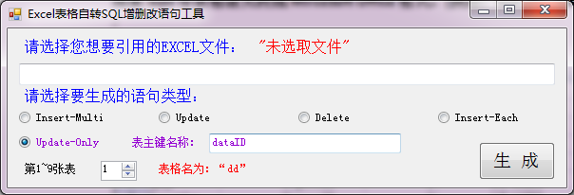

**支持EXCEL表格格式为(*.xls、*.xlsx)，即Office2003及以上所有版本EXCEL表格。**

**如果wps等表格请先转成MircoSoft Office格式。(例如：test.xls、testing.xlsx)**

1. **测试数据如下：**

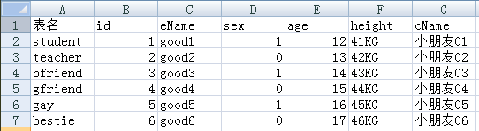

1. **数据库修改结果：[Update]**

UPDATE student SET eName='good1',sex='1',age='12',height='41KG',cName='小朋友01' WHERE id='1';

UPDATE teacher SET eName='good2',sex='0',age='13',height='42KG',cName='小朋友02' WHERE id='2';

UPDATE bfriend SET eName='good3',sex='1',age='14',height='43KG',cName='小朋友03' WHERE id='3';

UPDATE gfriend SET eName='good4',sex='0',age='15',height='44KG',cName='小朋友04' WHERE id='4';

UPDATE gay SET eName='good5',sex='1',age='16',height='45KG',cName='小朋友05' WHERE id='5';

UPDATE bestie SET eName='good6',sex='0',age='17',height='46KG',cName='小朋友06' WHERE id='6';

1. **数据库删除结果：[Delete]**

DELETE FROM student where id='1' AND eName='good1';

DELETE FROM teacher where id='2' AND eName='good2';

DELETE FROM bfriend where id='3' AND eName='good3';

DELETE FROM gfriend where id='4' AND eName='good4';

DELETE FROM gay where id='5' AND eName='good5';

DELETE FROM bestie where id='6' AND eName='good6';

1. **数据库新增插入结果：[Insert-Multi]**

INSERT INTO student (id,eName,sex,age,height,cName) VALUES

('1','good1','1','12','41KG','小朋友01'),

('2','good2','0','13','42KG','小朋友02'),

('3','good3','1','14','43KG','小朋友03'),

('4','good4','0','15','44KG','小朋友04'),

('5','good5','1','16','45KG','小朋友05'),

('6','good6','0','17','46KG','小朋友06');

1. **数据库新增插入结果：[Insert-Each]**

INSERT INTO student (id,eName,sex,age,height,cName) VALUES ('1','good1','1','12','41KG','小朋友01');

INSERT INTO student (id,eName,sex,age,height,cName) VALUES ('2','good2','0','13','42KG','小朋友02');

INSERT INTO student (id,eName,sex,age,height,cName) VALUES ('3','good3','1','14','43KG','小朋友03');

INSERT INTO student (id,eName,sex,age,height,cName) VALUES ('4','good4','0','15','44KG','小朋友04');

INSERT INTO student (id,eName,sex,age,height,cName) VALUES ('5','good5','1','16','45KG','小朋友05');

INSERT INTO student (id,eName,sex,age,height,cName) VALUES ('6','good6','0','17','46KG','小朋友06');

1. **数据库判定更新结果：[Update-Only]**

UPDATE student SET eName='good1',sex='1',age='12',height='41KG',cName='小朋友01' WHERE 'dataID'=(SELECT 'dataID' FROM 'student' WHERE 'id'='4');

UPDATE teacher SET eName='good2',sex='0',age='13',height='42KG',cName='小朋友02' WHERE 'dataID'=(SELECT 'dataID' FROM 'teacher' WHERE 'id'='4');

UPDATE bfriend SET eName='good3',sex='1',age='14',height='43KG',cName='小朋友03' WHERE 'dataID'=(SELECT 'dataID' FROM 'bfriend' WHERE 'id'='4');

UPDATE gfriend SET eName='good4',sex='0',age='15',height='44KG',cName='小朋友04' WHERE 'dataID'=(SELECT 'dataID' FROM 'gfriend' WHERE 'id'='4');

UPDATE gay SET eName='good5',sex='1',age='16',height='45KG',cName='小朋友05' WHERE 'dataID'=(SELECT 'dataID' FROM 'gay' WHERE 'id'='5');

UPDATE bestie SET eName='good6',sex='0',age='17',height='46KG',cName='小朋友06' WHERE 'dataID'=(SELECT 'dataID' FROM 'bestie' WHERE 'id'='6');

1. **帮助说明**
2. 程序适用于向已有数据库表中增删改大量数据；
3. 您可以先将数据有序的加入到EXCEL表中，软件自动生成语句；
4. 支持2003/2007版EXCEL后缀名*.xls/*.xlsx!。
5. 默认支持生成SHEET1表格的内容，表格中不要有间隙单元或不整齐非空单元格（如H1格非空）。
6. 手动输入数字0或1均表示第一张表，最大允许输入99，超出实际表格数字会有提示！
7. 表名尽量使用英文；表名排序可能根据首字拼音排序！所以并非第一位置就是第一张表！