

**Turkcell Login SDK**

**Android Integration Document**

Author: Semih Gökyer

Document Status : Draft

Document Version : 0.1

1. Prerequirements

Minimum deployment target for Login SDK is Anroid 10(GINGERBREAD)

If your app supports lower versions than 10 you can’t integrate your app.

1. Flow

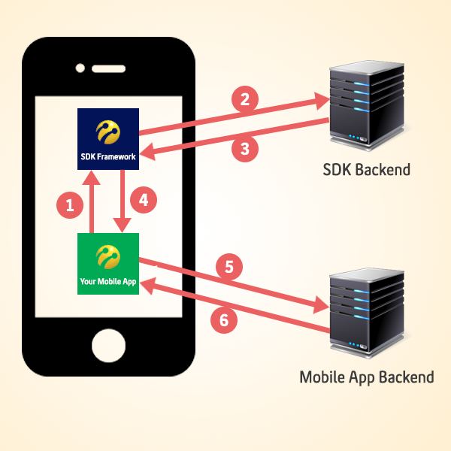

1. Your app start LoginSDKMainActivity to start login process with following mandatory extras:

Intent intent = new Intent(this, com.turkcell.loginsdk.activity.LoginSDKMainActivity.class);

intent.putExtra("appId", "123);//Application unique id

intent.putExtra("dll", "false");//If dll is true,Disable light login(skip 3g login)

intent.putExtra("loginForce", "false");//if loginForce is true,client try 3g login.if it fails, open wifi login screen

startActivityForResult(intent, 100);

1. SDK makes rest call to SDK Server*
2. SDK Server returns login result to SDK Client*
3. SDK returns login result and authtoken (if result is success) to onActivityResult:

@Override

protected void onActivityResult(int requestCode, int resultCode, Intent data) {

String resultMessage = data.getStringExtra("authToken") == null ? data.getStringExtra("code") + "_" + data.getStringExtra("message") : data.getStringExtra("authToken");

if (100 == requestCode) {

if (resultCode == Activity.RESULT_OK) {

Toast.makeText(this, resultMessage, Toast.LENGTH_LONG).show();

}

}

*Added just for information. App developer shouldn’t care about these steps.

1. App sends token its backend to validate it
2. App backend calls validateAuthToken to retrieve msisdn, then starts session and performs app related tasks.
3. Integration
4. Integration for library project

You need to check out LibraryProject in github and import project(LoginSDK) into workspace.if you want to try example project,import also LoginSDKTest project and add library project to main project.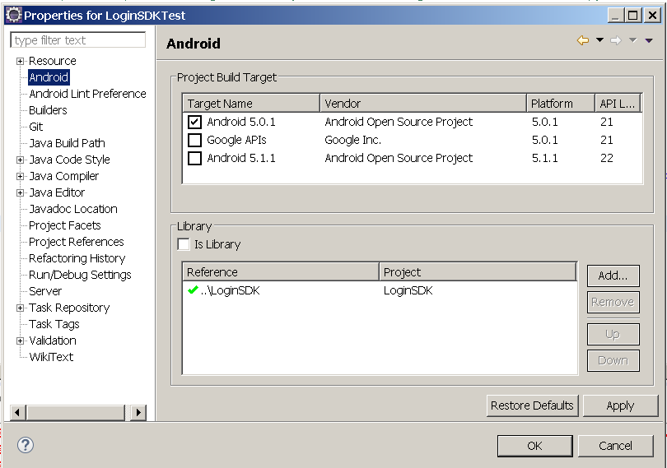

1. Integration for android studio

You need to check out AndroidStudioProject in github.There is an aar file in this example project.

AndroidStudioProject/app/libs/app-debug.aar

Add this aar file into libs folder that is in main project and add these following dependencies into build.gradle file.

compile(name: 'app-debug', ext: 'aar')

compile 'com.android.support:support-v4:22.2.0'

compile 'com.mcxiaoke.volley:library:1.0.17@aar'

compile 'com.android.support:appcompat-v7:22.2.0'

1. Configuration for your project

You need add following permission to manifest.

<uses-permission android:name="android.permission.INTERNET" />

<uses-permission android:name="android.permission.READ_PHONE_STATE" />

<uses-permission android:name="android.permission.ACCESS_NETWORK_STATE" />

Then,you need add following declaration to manifest(into application tag).

<activity android:name="com.turkcell.login_sdk.activity.LoginSDKMainActivity"></activity>

SDK Functionality

There is only one Activity in LoginSDK(LoginSDKMainActivity) but 2 functionality in this activity.(Login,Logout)

intent.putExtra("dll", "false");//If dll is true,Disable light login(skip 3g login)

intent.putExtra("loginForce", "false");//if loginForce is true,client try 3g login.if it fails, open wifi login screen

* 1. Login

Calling login intent

Intent intent = new Intent(this, com.turkcell.login_sdk.activity.LoginSDKMainActivity.class);

intent.putExtra("fontPath","fonts/LDFComicSans.ttf");

intent.putExtra("Env", "PROD");//Default environment is test

intent.putExtra("appId", "123");//Application unique id

intent.putExtra("dll", "false");//If dll is true,Disable light login(skip 3g login)

intent.putExtra("loginForce", "false");//if loginForce is true,client try 3g login.if it fails, open wifi login screen

intent.putExtra("isDirectLogin", "false");//opens wifi screen directly

intent.putExtra("pageBackgroundColor", R.color.white);

intent.putExtra("pageTextColor", R.color.lsdk_gray1);

intent.putExtra("headerBackgroundColor", R.color.flatBlue);

intent.putExtra("headerTextBackgroundColor", R.color.flatBlue);

intent.putExtra("headerTextColor", R.color.white);

intent.putExtra("headerTitle", "Turkcell Platinum");

intent.putExtra("positiveButtonColor", R.color.flatBlue);

intent.putExtra("positiveButtonTextColor", R.color.white);

intent.putExtra("negativeButtonColor", R.color.white);

intent.putExtra("negativeButtonTextColor", R.color.lsdk_gray1);

intent.putExtra("inputBackgroundColor", R.color.lsdk_gray_background);

intent.putExtra("showFreeText", "true");

intent.putExtra("freeText", "bla blab blab bla bla bla");

intent.putExtra("exitButtonDrawable", com.turkcell.loginsdktest.R.drawable.a);

intent.putExtra("backButtonDrawable", com.turkcell.loginsdktest.R.drawable.b);

intent.putExtra("checkedCheckBoxButtonDrawable", com.turkcell.loginsdktest.R.drawable.custom_icon);

intent.putExtra("turkcellLogoDrawable", com.turkcell.loginsdktest.R.drawable.d);

intent.putExtra("hidePreloader", "true");//if true,hide loginsdk preloader

intent.putExtra("hintTextColor", R.color.lsdk_yellow1);

intent.putExtra("captchaButtonDrawable", R.drawable.lsdk_icon_refresh);

startActivityForResult(intent, 100);

Result login intent

@Override

protected void onActivityResult(int requestCode, int resultCode, Intent data) {

String resultMessage = data.getStringExtra("authToken") == null ? data.getStringExtra("code") + "_" + data.getStringExtra("message") : data.getStringExtra("authToken");

if (100 == requestCode) {

if (resultCode == Activity.RESULT_OK) {

Toast.makeText(this, resultMessage, Toast.LENGTH_LONG).show();

}

}

* 1. Logout

Calling logout intent

Intent intent = new Intent(this, com.turkcell.login_sdk.activity.LoginSDKMainActivity.class);

intent.putExtra("isLogout", "true");

intent.putExtra("appId", "123");//Application unique id

startActivityForResult(intent, 200);

Result logout intent

@Override

protected void onActivityResult(int requestCode, int resultCode, Intent data) {

if (200 == requestCode) {

if (resultCode == Activity.RESULT_OK) {

//Your logout logic comes here

}

}

1. Account Manager Sharing

You need to sign application with same keys and to add same application chain.You may want to contact with Osman Kara(osman.kara@turkcellteknoloji.com.tr) for information about signing application with same keys and adding application to chain.

1. Customizing Theme

intent.putExtra("fontPath","fonts/LDFComicSans.ttf");//Text Font in page

intent.putExtra("pageBackgroundColor", R.color. lsdk_green1);//page background color

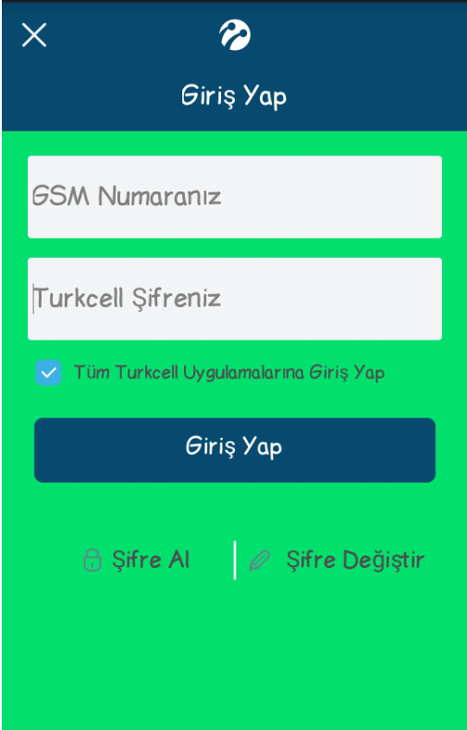

intent.putExtra("pageTextColor", R.color.lsdk_gray1);//Text Color in page

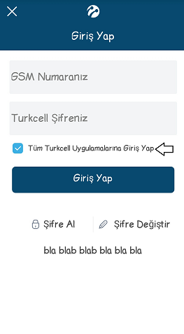

intent.putExtra("headerBackgroundColor", R.color.flatBlue);//Header Background color

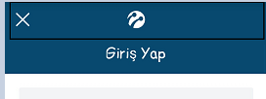

intent.putExtra("headerTextBackgroundColor", R.color.flatBlue);//Header background color on text

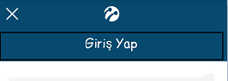

intent.putExtra("headerTextColor", R.color.white);//Header text color

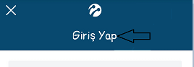

intent.putExtra("headerTitle", "Turkcell Platinum");//Text in header



intent.putExtra("positiveButtonColor", R.color.flatBlue);//Positive button color

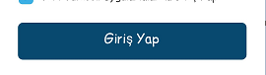

intent.putExtra("positiveButtonTextColor", R.color.white);//Positive button text color



intent.putExtra("negativeButtonColor", R.color.lsdk_gray8);//Negative button color

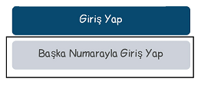

intent.putExtra("negativeButtonTextColor", R.color.lsdk_gray1);//Negative button text color

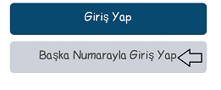

intent.putExtra("inputBackgroundColor", R.color.lsdk_gray_background);//bg color for edittext

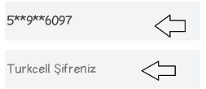

intent.putExtra("showFreeText", "true");//Show Free Text

intent.putExtra("freeText", "bla blab blab bla bla bla");//Text in free text



intent.putExtra("exitButtonDrawable", com.turkcell.loginsdktest.R.drawable.a);



intent.putExtra("backButtonDrawable", com.turkcell.loginsdktest.R.drawable.b);



intent.putExtra("checkedCheckBoxButtonDrawable", com.turkcell.loginsdktest.R.drawable.custom_icon);



intent.putExtra("turkcellLogoDrawable", com.turkcell.loginsdktest.R.drawable.d);

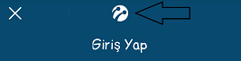

intent.putExtra("hintTextColor", R.color.lsdk_yellow1);

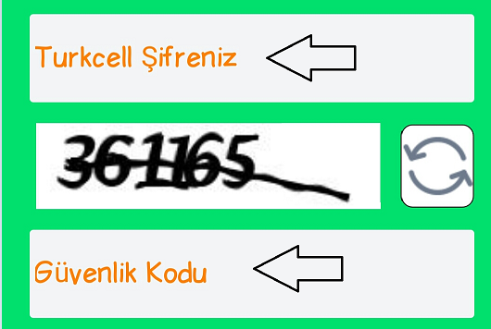

intent.putExtra("captchaButtonDrawable", R.drawable.lsdk_icon_refresh);

