

**KASTAMONU ÜNİVERSİTESİ**

**BİLGİSAYAR MÜHENDİSLİĞİ BÖLÜMÜ**

**ROBOTİK TEKNOLOJİLERİ**

**SERVO MOTOR KONTROLÜ**

**Raporu Yazan Öğrenciler:**

RAMAZAN ŞAHİN(134410008)

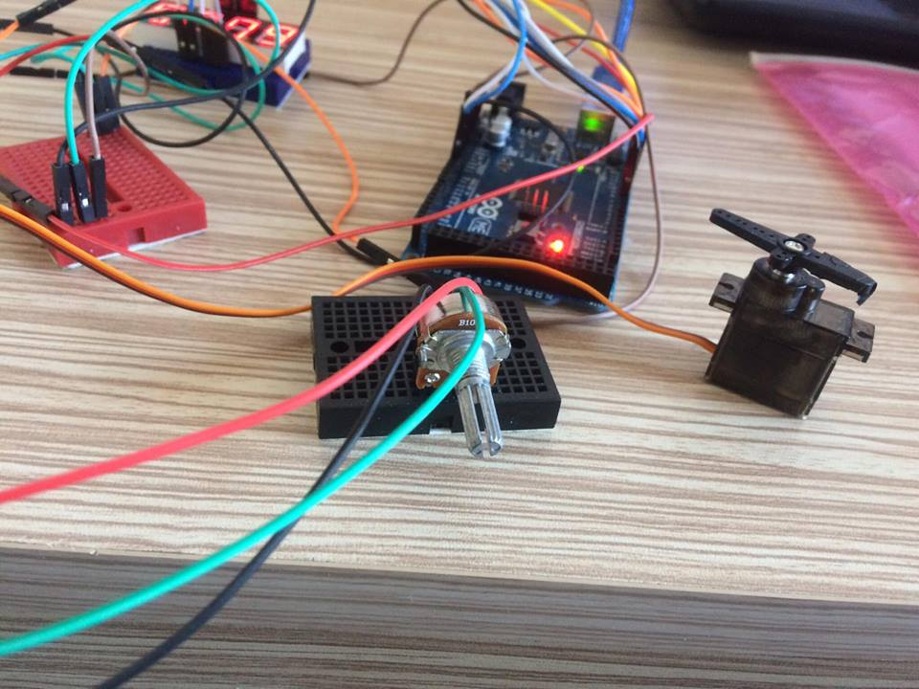

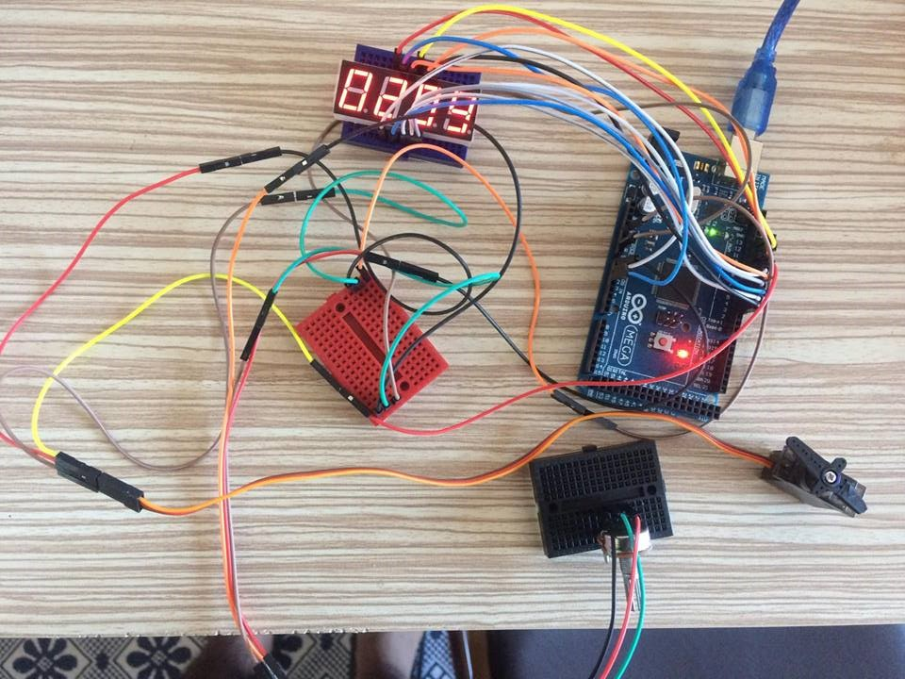

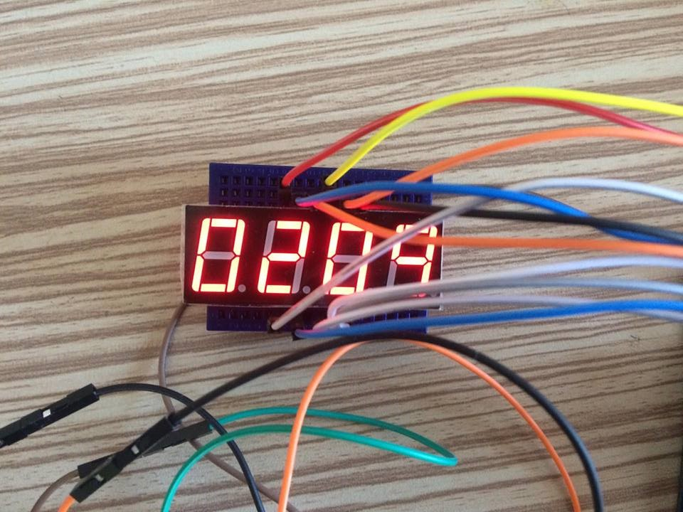

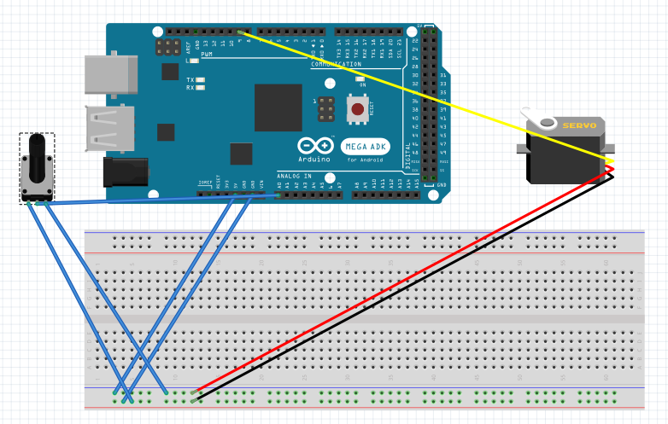

Bu devrede display hariç devre şeması. Fritzing kullanılarak yapılmıştır.

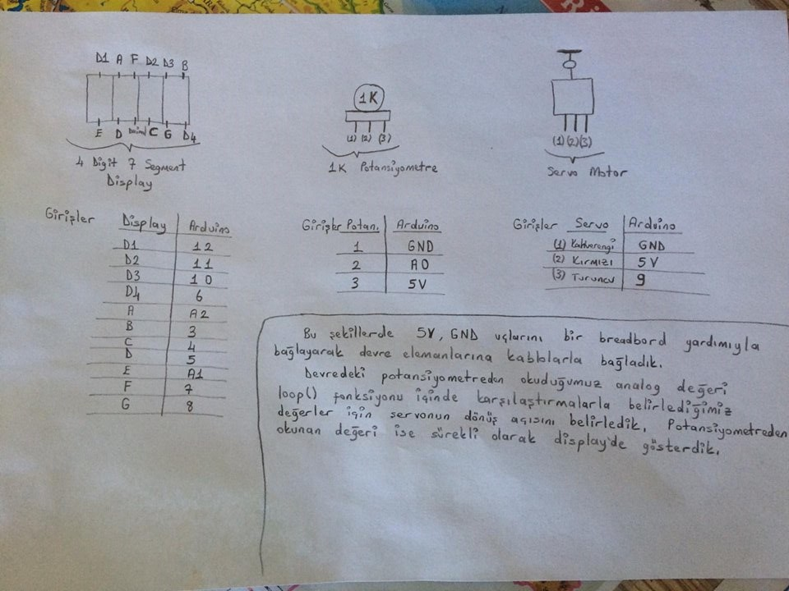

#include <LiquidCrystal.h>

LiquidCrystal lcd(38,39,36,37,34,35);//

#include <Servo.h> /* Servo kutuphanesi projeye dahil edildi */

Servo servoNesnesi; /* servo motor nesnesi yaratildi */

//Display Girisler

int digit1 = 12;

int digit2 = 11;

int digit3 = 10;

int digit4 = 6;

int segA = A2;

int segB = 3;

int segC = 4;

int segD = 5;

int segE = A1;

int segF = 7;

int segG = 8;

**void setup()**

{

//Display Giris Tanımları

pinMode(segA, OUTPUT);

pinMode(segB, OUTPUT);

pinMode(segC, OUTPUT);

pinMode(segD, OUTPUT);

pinMode(segE, OUTPUT);

pinMode(segF, OUTPUT);

pinMode(segG, OUTPUT);

pinMode(digit1, OUTPUT);

pinMode(digit2, OUTPUT);

pinMode(digit3, OUTPUT);

pinMode(digit4, OUTPUT);

pinMode(A0,INPUT);

Serial.begin(9600);

servoNesnesi.attach(9); /* Servo motor 9 numarali pine baglandi */

}

**void loop()**

{

int smoke=analogRead(A0);//Potansiyometreden okuduğumuz değeri smoke değişkenine aktarıyoruz

Serial.println(smoke);//okuduğumuz değeri serial ekrana yazdırıyoruz

if(smoke>=0 && smoke<150)

{

servoNesnesi.write(0); /* Motorun mili 100. dereceye donuyor */

}

else if(smoke>100 && smoke<350)

{

servoNesnesi.write(50); /* Motorun mili 100. dereceye donuyor */

}

else if(smoke>350 && smoke<600)

{

servoNesnesi.write(100); /* Motorun mili 100. dereceye donuyor */

}

else if(smoke>600 && smoke<800)

{

servoNesnesi.write(150); /* Motorun mili 100. dereceye donuyor */

}

else

{

servoNesnesi.write(180); /* Motorun mili 100. dereceye donuyor */

}

displayNumber(smoke);//okuduğumuz değeri display'de gösteriyoruz

}

//Display'de gösterilen değerlerin yazdırılma komutları

**void displayNumber(int toDisplay)** {

#define DISPLAY_BRIGHTNESS 500

#define DIGIT_ON HIGH

#define DIGIT_OFF LOW

long beginTime = millis();

for(int digit = 4 ; digit > 0 ; digit--) {

//Turn on a digit for a short amount of time

switch(digit) {

case 1:

digitalWrite(digit1, DIGIT_ON);

break;

case 2:

digitalWrite(digit2, DIGIT_ON);

break;

case 3:

digitalWrite(digit3, DIGIT_ON);

break;

case 4:

digitalWrite(digit4, DIGIT_ON);

break;

}

//Turn on the right segments for this digit

lightNumber(toDisplay % 10);

toDisplay /= 10;

delayMicroseconds(DISPLAY_BRIGHTNESS);

//Display digit for fraction of a second (1us to 5000us, 500 is pretty good)

//Turn off all segments

lightNumber(10);

//Turn off all digits

digitalWrite(digit1, DIGIT_OFF);

digitalWrite(digit2, DIGIT_OFF);

digitalWrite(digit3, DIGIT_OFF);

digitalWrite(digit4, DIGIT_OFF);

}

while( (millis() - beginTime) < 10) ;

//Wait for 20ms to pass before we paint the display again

}

//Given a number, turns on those segments

//If number == 10, then turn off number

**void lightNumber(int numberToDisplay)** {

#define SEGMENT_ON LOW

#define SEGMENT_OFF HIGH

switch (numberToDisplay){

case 0:

digitalWrite(segA, SEGMENT_ON);

digitalWrite(segB, SEGMENT_ON);

digitalWrite(segC, SEGMENT_ON);

digitalWrite(segD, SEGMENT_ON);

digitalWrite(segE, SEGMENT_ON);

digitalWrite(segF, SEGMENT_ON);

digitalWrite(segG, SEGMENT_OFF);

break;

case 1:

digitalWrite(segA, SEGMENT_OFF);

digitalWrite(segB, SEGMENT_ON);

digitalWrite(segC, SEGMENT_ON);

digitalWrite(segD, SEGMENT_OFF);

digitalWrite(segE, SEGMENT_OFF);

digitalWrite(segF, SEGMENT_OFF);

digitalWrite(segG, SEGMENT_OFF);

break;

case 2:

digitalWrite(segA, SEGMENT_ON);

digitalWrite(segB, SEGMENT_ON);

digitalWrite(segC, SEGMENT_OFF);

digitalWrite(segD, SEGMENT_ON);

digitalWrite(segE, SEGMENT_ON);

digitalWrite(segF, SEGMENT_OFF);

digitalWrite(segG, SEGMENT_ON);

break;

case 3:

digitalWrite(segA, SEGMENT_ON);

digitalWrite(segB, SEGMENT_ON);

digitalWrite(segC, SEGMENT_ON);

digitalWrite(segD, SEGMENT_ON);

digitalWrite(segE, SEGMENT_OFF);

digitalWrite(segF, SEGMENT_OFF);

digitalWrite(segG, SEGMENT_ON);

break;

case 4:

digitalWrite(segA, SEGMENT_OFF);

digitalWrite(segB, SEGMENT_ON);

digitalWrite(segC, SEGMENT_ON);

digitalWrite(segD, SEGMENT_OFF);

digitalWrite(segE, SEGMENT_OFF);

digitalWrite(segF, SEGMENT_ON);

digitalWrite(segG, SEGMENT_ON);

break;

case 5:

digitalWrite(segA, SEGMENT_ON);

digitalWrite(segB, SEGMENT_OFF);

digitalWrite(segC, SEGMENT_ON);

digitalWrite(segD, SEGMENT_ON);

digitalWrite(segE, SEGMENT_OFF);

digitalWrite(segF, SEGMENT_ON);

digitalWrite(segG, SEGMENT_ON);

break;

case 6:

digitalWrite(segA, SEGMENT_ON);

digitalWrite(segB, SEGMENT_OFF);

digitalWrite(segC, SEGMENT_ON);

digitalWrite(segD, SEGMENT_ON);

digitalWrite(segE, SEGMENT_ON);

digitalWrite(segF, SEGMENT_ON);

digitalWrite(segG, SEGMENT_ON);

break;

case 7:

digitalWrite(segA, SEGMENT_ON);

digitalWrite(segB, SEGMENT_ON);

digitalWrite(segC, SEGMENT_ON);

digitalWrite(segD, SEGMENT_OFF);

digitalWrite(segE, SEGMENT_OFF);

digitalWrite(segF, SEGMENT_OFF);

digitalWrite(segG, SEGMENT_OFF);

break;

case 8:

digitalWrite(segA, SEGMENT_ON);

digitalWrite(segB, SEGMENT_ON);

digitalWrite(segC, SEGMENT_ON);

digitalWrite(segD, SEGMENT_ON);

digitalWrite(segE, SEGMENT_ON);

digitalWrite(segF, SEGMENT_ON);

digitalWrite(segG, SEGMENT_ON);

break;

case 9:

digitalWrite(segA, SEGMENT_ON);

digitalWrite(segB, SEGMENT_ON);

digitalWrite(segC, SEGMENT_ON);

digitalWrite(segD, SEGMENT_ON);

digitalWrite(segE, SEGMENT_OFF);

digitalWrite(segF, SEGMENT_ON);

digitalWrite(segG, SEGMENT_ON);

break;

case 10:

digitalWrite(segA, SEGMENT_OFF);

digitalWrite(segB, SEGMENT_OFF);

digitalWrite(segC, SEGMENT_OFF);

digitalWrite(segD, SEGMENT_OFF);

digitalWrite(segE, SEGMENT_OFF);

digitalWrite(segF, SEGMENT_OFF);

digitalWrite(segG, SEGMENT_OFF);

break;

}

}