**The package contains:-**

1] **infIP.py [ This is the main python script.]**

2] **BeautifulSoup.py** [Beautiful Soup is a Python HTML/XML parser designed for quick turnaround projects like screen-scraping]

BeautifulSoup Also available @ <http://www.crummy.com/software/BeautifulSoup/>

**This script is tested with Python 2.7.**

**Instructions:-**

1] Download Python from http://www.python.org/ftp/python/2.7/python-2.7.msi

2] Install python2.7. [Installation Directory by Default C:\Python27].

3] Copy the "BeautifulSoup.py" file into "C:\Python27\Lib" directory.

To check if the module is installed properly or not Open python shell and type

import BeautifulSoup

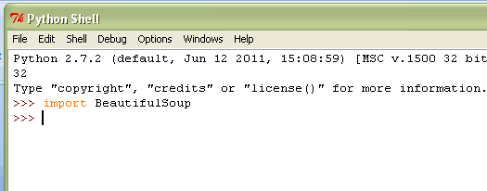

4] Execute "infIP.py"

5] Let the script complete initial lookup process after completions it will open an html report in your default browser with all the hosts and their details. Click on the hosts to go to details.

**Command line run POC:-**

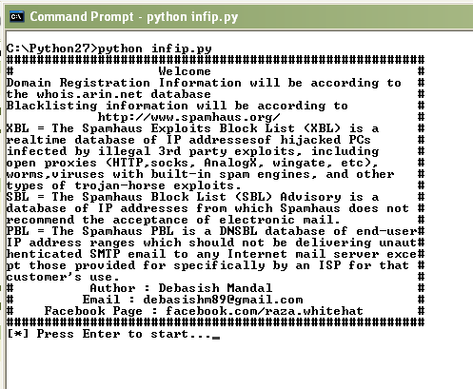

**Report Format POC:-**

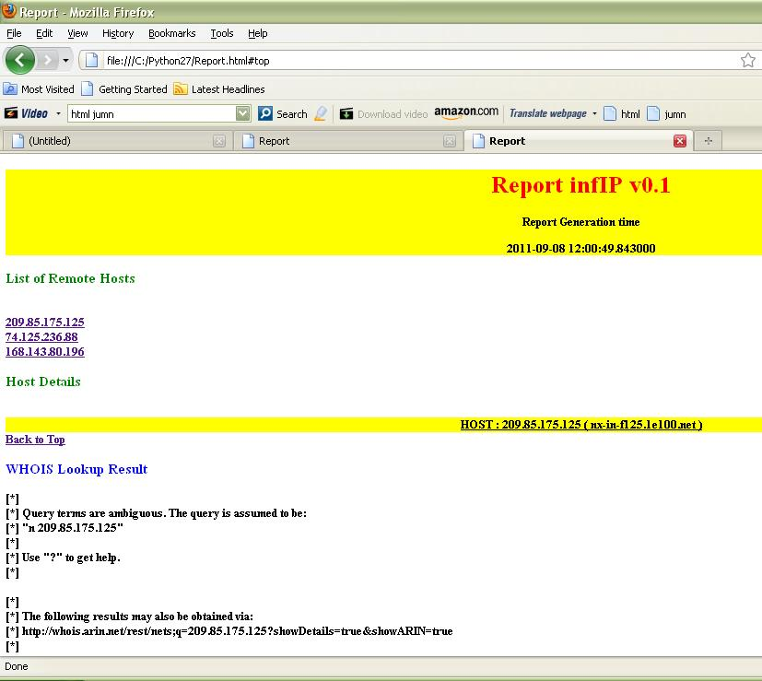

**About Me:**

I’m Debasish Mandal (21)aka Raza from India. Working as a penetration tester @ iViZ Security.( http://www.ivizsecurity.com/)