**Scenester a Small Tool for Cross-Platform review**

A quick post to announce NCC Group’s new tool has been pushed to our Github repo at <https://github.com/nccgroup/>.

**So what is Scenester?**

It is a simple java application to test how web application renders on different devices. It achieves this by using different User-Agents string.

**What can Scenester do?**

* It can request web application using different User-Agents strings
* Take a screen shots to see the difference visually
* Emulate different browsers
* Can make HTTP and HTTPS requests

**Where do I get the code?**

https://github.com/nccgroup/Scenester

**Where do I get the binaries?**

https://github.com/nccgroup/Scenester/XXXXXXXXXXXXXXXXXXXXXXXXXXX

**How about a screenshot?**

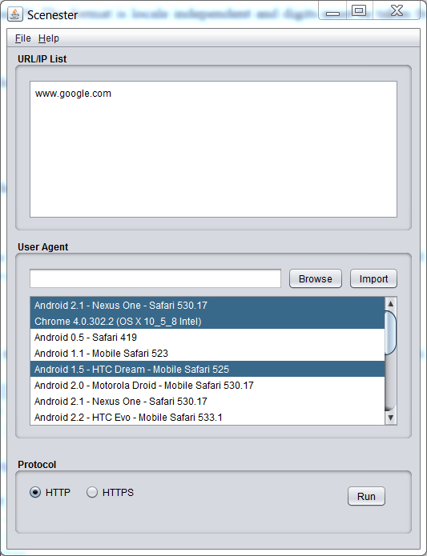

**Future development plan**

* Report rendering
* Post request
* Custom request (allow you modify all request headers)
* Define browser dimensions(e.g iPhone screen size for iPhone useragent string)

Please let me know if you have any suggestion, I will try to develop it

**Want more open source tools for NCC Group companies?**

* <https://github.com/isecpartners> - iSec Partners
* <https://bitbucket.org/IntrepidusGroup> - Intrepidus Group