# Deleterious synonymous mutations hitchhike to high frequency in HIV env evolution

Fabio Zanini, Richard A. Neher

## Abstract

Intra-patient HIV evolution is dominated by selection on the protein level in the arms race with the adaptive immune system. When cytotoxic CD8+ T-cells or neutralizing antibodies target a new epitope, the virus often escapes via nonsynonymous mutations that impair recognition. Synonymous mutations do not affect this interplay and are often assumed to be neutral. We analyze longitudinal intrapatient data from the C2-V5 part of the envelope gene (env) and observe that synonymous derived alleles rarely fix even though they often reach high frequencies in the viral population. We find that synonymous mutations that disrupt base pairs in RNA stems flanking the variable loops of gp120 are more likely to be lost than other synonymous changes, hinting at a direct fitness effect of these stem-loop structures in the HIV RNA. Computational modeling indicates that these synonymous mutations have a (Malthusian) selection coefficient of the order of −0.002, and that they are brought up to high frequency by hitchhiking on neighboring beneficial nonsynonymous alleles. Besides, the patterns of fixation of nonsynonymous mutations estimated from the longitudinal data and comparisons with computer models suggest that escape mutations in C2-V5 are only transiently beneficial, either because the immune system is catching up or because of competition between equivalent escapes.

## Introduction

HIV evolves rapidly within a single host during the course of the infection. This evolution is driven by strong selection imposed by the host immune system via killer T cells (CTLs) and neutralizing antibodies (nAbs) (Rambaut et al., 2004) and facilitated by the high mutation rate of HIV (Abram et al., 2010; Mansky and Temin, 1995). When the host develops a CTL or nAb response against a particular HIV epitope, mutations in the viral genome that reduce or prevent recognition of the epitope frequently emerge. Escape mutations in epitopes targeted by CTLs typically evolve during early infection and spread rapidly through the population (McMichael et al., 2009). During chronic infection, the most rapidly evolving part of the HIV genome are the variable loops V1-V5 in the envelope protein gp120, which change to avoid recognition by neutralizing ABs. Mutations in env, the gene encoding gp120, spread through the population within a few months (see Figure 1B). Consistent with this time scale, it is found that serum from a particular time typically neutralizes virus extracted more than 3-6 month earlier, but not contemporary viruses (Richman et al., 2003).

These escape mutations are selected for their effect on the amino acid sequence of the viral proteins. Conversely, synonymous mutations are commonly used as approximately neutral markers in studies of viral evolution. Neutral markers are very useful since their dynamics can be compared to that of putatively functional sites to detect purifying or directional selection (Bhatt et al., 2011; Chen et al., 2004; Hurst, 2002). In addition to maintaining protein function and avoiding the adaptive immune recognition, however, the HIV genome has to ensure efficient processing and translation, nuclear export, and packaging into the viral capsid: all these processes operate at the RNA level and are sensitive to synonymous changes since these processes often depend on RNA folding. For example, the HIV rev response element (RRE) in env enhances nuclear export of full length or partially spliced viral transcripts via a complex stem-loop RNA structure (Fernandes et al., 2012). Another well studied case is the interaction between viral reverse transcriptase, viral ssRNA, and the host tRNALys3 : the latter is required for priming reverse transcription (RT) and is bound by a pseudoknotted RNA structure in the viral 5’ untranslated region (Barat et al., 1991; Paillart et al., 2002).

Even in absence of important RNA structures, synonymous codons do not evolve completely neutrally. Some codons are favored over others in many species (Plotkin and Kudla, 2011). Recent studies have shown that genetically engineered HIV strains with altered codon usage can in some cases produce more viral protein, but in general replicate less efficiently (Keating et al., 2009; Li et al., 2012; Ngumbela et al., 2008). Codon deoptimization has been suggested as attenuation strategy for polio and influenza (Coleman et al., 2008; Mueller et al., 2010). Purifying selection beyond the protein sequence is therefore expected (Forsdyke, 1995; Snoeck et al., 2011) and it has been shown that rates of evolution at synonymous sites vary along the HIV genome (Mayrose et al., 2007). Positive selection through the host adaptive immune system, however, is restricted to changes in the amino acid sequence.

In this paper, we characterize the dynamics of synonymous mutations in env and show that a substantial fraction of these mutations is deleterious. We argue that synonymous mutations reach high frequencies via genetic hitchhiking due to the small recombination rate of HIV (Batorsky et al., 2011; Neher and Leitner, 2010). We then compare our observations to computational models of HIV evolution and derive estimates for the effect synonymous mutations on fitness. Extending the analysis of fixation probabilities to the nonsynonymous mutations, we show that time dependent selection or strong competition of escape mutations inside the same epitope are necessary to explain the observed patterns of fixation and loss.

## Results

The central quantity we investigate is the probability of fixation of a mutation, conditional on its population frequency. A neutral mutation segregating at frequency ν has a probability Pfix (ν) = ν to spread through the population and fix; in the rest of the cases, i.e. with probability 1 − ν, it goes extinct. As illustrated in the inset of Fig. 1A, this is a simple consequence of the fact that (i) exactly one individual in the current population will be the common ancestor of the entire future population at a particular locus and (ii) this ancestor has a probability ν of carrying the mutation (assuming the neutral mutation is not preferentially associated with genomes of high or low fitness). Deleterious or beneficial mutations fix less or more often than neutral ones, respectively. Fig. 1 shows the time course the frequencies of all synonymous and nonsynonymous mutations observed env, C2-V5, in patient p10 (Shankarappa et al., 1999), respectively. Despite many synonymous mutations reaching high frequency, few fix (panel 1A); in constrast, many nonsynonymous mutations fix (panel 1B).

### Synonymous polymorphisms in env, C2-V5, are mostly deleterious

We study the dynamics and fate of synonymous mutations more quantitatively by analyzing data from seven patients from Liu et al. (2006); Shankarappa et al. (1999) and three patients from Bunnik et al. (2008) (patients whose viral population was structured were excluded from the analysis; see methods and Figure S1). The former data set from is restricted to the C2-V5 region of env, while the data from Bunnik et al. (2008) covers the majority of env. Considering all mutations in a frequency interval around ν0 at some time t, we calculate the fraction that is found at frequency 1, at frequency 0, or at intermediate frequency at later times t + ∆t. Plotting these fixed, lost, and polymorphic fraction against the time interval ∆t, we see that most synonymous mutations segregate for roughly one year and are lost much more frequently than expected (panel 2A). The long-time probability of fixation versus extinction of synonymous mutations is shown as a function of the initial frequency ν0 in panel 2B (red line). Restricted to the region C2-V5, we find that Pfix of synonymous mutations is far below the neutral expectation. Outside of C2-V5, using data from Bunnik et al. (2008) only, no such reduction in Pfix is found. Restricted to the C2-V5 region, the sequence samples from Bunnik et al. (2008) are fully compatible with data from Shankarappa et al. (1999). The nonsynonymous mutations seem to follow more or less the neutral expectation (blue line) – a point to which we will come back below.

When interpreting these results for the fixation probabilities, it is important to distinguish between random mutations and polymorphisms observed at a certain frequency since the latter have already been filtered by selection. A polymorphism could be beneficial to the virus and on its way to fixation. In this case, we expect that it fixes almost surely given that we see it at high frequency. If, on the other hand, the polymorphism is deleterious it must have reached a high frequency by chance (genetic drift or hitchhiking), and we expect that selection drives it out of the population again. Hence our observations suggest that many of the synonymous polymorphisms at intermediate frequencies in the C2-V5 part of env that includes the hypervariable regions are deleterious, while outside this region most polymorphisms are roughly neutral. Note that this does not imply that all synonymous mutations in outside C2-V5 are neutral – only those mutations observed at high frequencies, which have been experiencing selection for some time already, tend to be neutral.

### Synonymous mutations in C2-V5 tend to disrupt conserved RNA stems

One possible explanation for lack of fixation of synonymous mutations in C2-V5 are secondary structures in the viral RNA, the disruption of which is deleterious to the virus (Forsdyke, 1995; Sanjuan and Borderia, 2011; Snoeck et al., 2011).

The propensity of nucleotides in the HIV genome to form base pairs has been measured using the SHAPE assay, a biochemical reaction preferentially altering unpaired bases (the HIV genome is a single stranded RNA) (Watts et al., 2009). The SHAPE assay has shown that the variable regions V1-V5 tend to be unpaired, while the conserved regions between those variable regions form stems. We partition all synonymous alleles observed at intermediate frequencies above 15% depending on their final destiny (fixation or extinction). Subsequently, we align our sequences to the reference NL4-3 strain used in ref. (Watts et al., 2009) and assign them SHAPE reactivities. As shown in Fig. 3A, the reactivities of fixed alleles (red histogram) are systematically larger than of alleles that are lost (blue) (Kolmogorov-Smirnov test on the cumulative distribution, p ≈ 0.002). In other words, alleles that are likely to break RNA helices are also more likely to revert and finally be lost from the population. The average over all mutations that are not observed (green) lies between those that fix and those that get lost. Note that this analysis will be sensitive only at positions where the base pairing pattern of NL4-3 agrees with that of each patient’s initial consensus sequence (it is thus statistically conservative).

To test the hypothesis that mutations in C2-V5 are lost because they break stems in the conserved stretches between the variable loops, we consider mutations in variable loops and conserved parts separately. The biggest depression in fixation probability is observed in the conserved stems, while the variable loops show little deviation from the neutral signature, see Fig. 3B. This is consistent with important stem structures in conserved regions between loops.

In addition to RNA secondary structure, we have considered other possible explanations for a fitness cost of some synonymous mutations, in particular codon usage bias (CUB). HIV is known to prefer A-rich codons over highly expressed human codons (Jenkins and Holmes, 2003; Kuyl and Berkhout, 2012). We do not find, however, any evidence for a contribution of average CUB to the ultimate fate of synonymous alleles; consistently, HIV does not seem to adapt its codon usage to its human host cells at the macroevolutionary level (Kuyl and Berkhout, 2012).

### Deleterious mutations are brought to high frequency by hitchhiking

While the observation that some fraction of synonymous mutations is deleterious is not unexpected, it seems odd that we observe them at high population frequency and that the fixation probability is reduced only in parts of the genome. These regions, however, undergo frequent adaptive changes to evade recognition by neutralizing antibodies (Richman et al., 2003; Williamson, 2003). Due to the limited amount of recombination in HIV (Batorsky et al., 2011; Neher and Leitner, 2010), deleterious mutations that are linked to adaptive variants can reach high frequency. This process is known as hitchhiking (Smith and Haigh, 1974) or genetic draft (Gillespie, 2000; Neher and Shraiman, 2011). Hitchhiking is apparent in Fig. 1, which shows that many mutations change rapidly in frequency as a flock.

The approximate magnitude of the deleterious effects can be estimated from Fig. 2A, which shows the distribution of times for synonymous alleles to reach the fix or get lost starting from intermediate frequencies. The typical time to loss is of the order of 500 days. If this loss is driven by the deleterious effect of the mutation, this corresponds to deleterious effects of roughly sd ∼ −0.002 per day.

To get a better idea of the range of parameters that are compatible with the observations and our interpretation, we performed computer simulations of evolving viral populations assuming a mix of positive and purifying selection and rare recombination. For this purpose, we use the simulation package FFPopSim, which includes a module dedicated to intra-patient HIV evolution (Zanini and Neher, 2012). For each simulation run, we specify the deleterious effect of synonymous mutations, the fraction of synonymous mutations that are deleterious, the escape rate of adaptive nonsynonymous mutations and the frequency of new escapes. Note that the escape rate is the sum of two factors: (i) the beneficial effect due to the ability to evade the immune system minus (ii) the fitness cost of the mutation in terms of structure, stability, etc. Net escape rates in chronic infections have been estimated to be on the order of ε = 0.01 per day (Asquith et al., 2006; Neher and Leitner, 2010).

Fig. 4A shows simulations results for the fixation probability and the synonymous diversity for different deleterious effects of synonymous mutations. We quantify synonymous diversity via Pinterm , the fraction of sites with an allele at frequency 0.25 < ν < 0.75. The synonymous diversity observed in patient data is indicated in the figure. To quantify the depression of the fixation probability, we calculate the area between the measured fixation probability and the diagonal, which is the neutral expectation (Fig. 4A, lower inset). If no fixation happens, the area will be −0.5; if every mutation fixes, the area will be +0.5. In HIV infected patients, we find Asyn ≈ −0.2 for synonymous changes and Anonsyn ≈ 0 for nonsynonymous changes. In the three simulations shown in Fig. 4A, the fixation probability of synonymous alleles decreases from the neutral expectation (Asyn ∼ 0) to zero (Asyn ∼ −0.5) as their fitness cost increases; the synonymous diversity plummets as well, as deleterious mutations are selected against.

To map the parameter range of the model that is compatible with the data, we repeatedly simulated the evolution with random choices for the parameters in certain bounds, see Fig. 4B. Among all simulations, we select the ones that show Asyn and Pinterm as observed in the data, i.e., a large depression in fixation probability of synonymous mutations but, simultaneously, a moderately high synonymous diversity. Specifically, Fig. 4B shows parameter combinations for which we found Asyn < −0.15 and 0.0025 < Pinterm < 0.010. These conditions indicate that a high fraction (0.8) of sites has to be deleterious with effect size |sd | ∼ 0.002. This result fits well the expectation based on the fixation/extinction times above (see Fig. 2A). The results are plausible: (i) a substantial depression in Pfix requires pervasive deleterious mutations, otherwise the majority of observed polymorphisms are neutral and no depression is observed; (ii) in order to hitchhike, the deleterious effect size has to be much smaller than the escape rate, otherwise the double mutant has little or no fitness advantage. Consistent with this argument, larger deleterious effects in Fig. 4 correspond to larger escapes rates. (iii) mutations with a deleterious effect smaller than approximately 0.001 behave neutrally consistent with the typical coalescent times observed in HIV.

The above simulation shows that hitchhiking can explain the observation of deleterious mutations that rarely fix. However, in a simple model where nonsynonymous escape mutations are unconditionally beneficial, they almost always fix once they reach high frequencies – Anonsyn is well above zero. This is incompatible with the blue line in Fig. 2: in an HIV infection, nonsynonymous mutations at high frequency often disappear again, even though many are at least transiently beneficial. Inspecting the trajectories of nonsynonymous mutations suggests the rapid rise and fall of many alleles. We test two possible mechanisms that are biologically sound and could explain the transient rise of nonsynonymous mutations: time-dependent selection and within-epitope competition.

The former hypothesis can be formulated as follows: if the immune system recognizes the escape mutant before its fixation, the mutant might cease to be beneficial and disappear soon, despite its quick initial rise in frequency. In support of this idea, Bunnik et al. (2008); Richman et al. (2003) report antibody responses to escape mutants. These responses are delayed by a few months, roughly matching the average time needed by an escape mutant to rise from low to high frequency. To model this type of behavior, we assume that antibody responses against escape mutations arise with a rate proportional to the frequency against the escape mutation and abolish the benefit of the escape mutations. As expected, this type of time-dependent fixation retains the potential for hitchhiking, but reduces fixation of nonsynonymous mutations. Figure S3 shows that Pfix of synonymous mutations is not affected by this chance, while Pfix of nonsynonymous mutations approaches the diagonal as the rate of recognition of escape mutants is increased.

In the alternative hypothesis, several different escape mutations within the same epitope might arise almost simultaneously and start to spread. Their benefits are not additive, because each of them is essentially sufficient to escape. As a consequence, several escape mutations rise to high frequency rapidly, while the one with the smallest cost in terms of replication, packaging, etc. is most likely to eventually fix. The emergence of multiple sweeping nonsynonymous mutations in real HIV infections has been shown (Bar et al., 2012; Moore et al., 2009). Within epitope competition can be implemented in the model through epistasis between escape mutations. While each mutation is individually beneficial, combining the mutations is deleterious (no extra benefit, but additional costs). Again, we find that the potential for hitchhiking is little affected by within epitope competition, but that the fixation probability of nonsynonymous polymorphisms is reduced. With roughly six mutations per epitope, the simulation data is compatible with observations; see Figure S4. The two scenarios are not exclusive and possibly both important in HIV evolution.

## Discussion

By analyzing the fate of mutations in longitudinal data of HIV env evolution, we demonstrate selection against synonymous substitutions in the comparatively conserved regions C2-C5 of the env gene. Comparison with biochemical studies of base pairing propensity of bases in RNA genome of HIV indicates that these mutations are deleterious, at least in part, because they disrupt stems in RNA secondary structures. Computational modeling shows that these mutations have deleterious effects on the order of 0.002 and that they are brought to high frequency through linkage to adaptive mutations.

The fixation and extinction times and probabilities represent a rich and simple summary statistics useful to characterize longitudinal sequence data and compare to models via computer simulations. A method that is similar to ours in spiritu has been recently used in a longitudinal study of influenza evolution (Strelkowa and Laessig, 2012). The propagators suggested in that article, however, represent ratios between nonsynonymous and synonymous mutations. The latter is used as an approximately neutral control; this method can therefore not be used to investigate synonymous changes themselves. More generally, evolutionary rates at synonymous sites are often used as a baseline to detect purifying or diversifying selection at the protein level (Hurst, 2002). It has been pointed out, however, that the rate of evolution at synonymous sites varies considerable along the HIV genome (Mayrose et al., 2007) and that this variation can confound estimates of selection on proteins substantially (Ngandu et al., 2008).

A functional significance of the insulating RNA structure stems between the hypervariable loops has also been proposed previously (Sanjuan and Borderia, 2011; Watts et al., 2009) and conserved RNA structures exist in different parts of the HIV genome. Our analysis is able to quantify the fitness effect of RNA structure within single infections and demonstrates how selection at synonymous sites can alter genetic diversity and dynamics. The observed hitchhiking highlights the importance of linkage due to infrequent recombination for the evolution of HIV (Batorsky et al., 2011; Josefsson et al., 2011; Neher and Leitner, 2010). The recombination rate has been estimated to be on the order of ρ = 10−5 per base and day. It takes roughly tsw = ε−1 log ν0 generations for escape mutation with escape rate ε to rise from an initially low frequency ν0 ∼ μ to frequency one. This implies that a region of length l = (ρtsw ) 1 = ε/ρ log ν0 remains linked to the adaptive mutation. With ε = 0.01, we have l ≈ 100 bases. Hence we expect strong linkage between the variable loops and the flanking sequences, but none far beyond the variable regions, consistent with the lack of signal outside of C2-V5. In case of much stronger selection – such as observed during early CTL escape or drug resistance evolution – the linked region is of course much larger (Nijhuis et al., 1998).

While classical population genetics assumes that the dominant stochastic force is genetic drift, i.e. nonheritable fluctuations in offspring number, our results show that stochasticity due to linked selection is much more important. Such fluctuations have been termed genetic draft by Gillespie (2000). Genetic draft in facultatively sexual population such as HIV has been characterized in (Neher and Shraiman, 2011). Importantly, large population sizes are compatible with low diversity and fast coalescence when draft dominates over drift.

Contrary to na ̈ıve expectations, the adaptive escape mutations do not seem to be unconditionally beneficial. Otherwise we would observe almost sure fixation of nonsynonymous mutations once they reach intermediate frequencies. Instead, we find that the fixation probability of nonsynonymous mutations is roughly given by its frequency. There are several possible explanations for this observation. Similar to synonymous mutations, the majority of nonsynonymous mutations could be weakly deleterious and the adaptive and deleterious parts conspire to yield a more neutral-like averaged fixation probability. We consider this possibility implausible since the amino acid sequence outside the variable loops is much more conserved that the synonymous positions, suggesting that the majority of the nonsynonymous mutations is much more deleterious.

Alternatively, the lack of fixation could be due to time-dependent environment through an immune system that is catching up, or competition between mutations that mediate escape within the same epitope. We explore both of these possibilities and find that both produce the desired effect. Furthermore, there is experimental evidence in support of both of these hypotheses. Serum from HIV infected individuals typically neutralizes the virus that dominated the population a few (3-6) months earlier (Richman et al., 2003). This suggests that escape mutations cease to be beneficial after a few months and might revert if they come with a fitness cost. Deep sequencing of regions of env after antibody escape have revealed multiple escape mutations in the same epitope (Bar et al., 2012; Moore et al., 2009). Presumably, each one of these mutations is sufficient for escape but most combinations of them do not provide any additional benefit to the virus. Hence only one mutation will spread and the others will be driven out of the population although they transiently reach high frequencies. The rapid emergence of multiple escape mutations in the same epitope implies a large effective population size that explores all necessary point mutations rapidly. A similar point has been made recently by Boltz et al. in the context of preexisting drug resistance mutations (Boltz et al., 2012).

Our results emphasize the inadequacy of independent site models of HIV evolution and the common assumption that selection is time-independent or additive. If genetic variation is only transiently beneficial, existing estimates of the strength of selection (Batorsky et al., 2011; Neher and Leitner, 2010) could be substantial underestimates.

## Methods

### Sequence data collection

Longitudinal intrapatient viral RNA sequences were collected from published studies (Bunnik et al., 2008; Liu et al., 2006; Shankarappa et al., 1999) and downloaded from the Los Alamos National Laboratory (LANL) HIV sequence database (Kuiken et al., 2012). The samples from some patients show substantial population structure and were discarded (see Figure S); a total of 11 patients with 4-23 time points each and approximately 10 sequences per time point were analyzed. The time intervals between two consecutive sequences ranged from 1 to 34 months, most of them between 6 and 10 months.

### Sequence analysis

The sequences were translated and the resulting amino acid sequences aligned using Muscle (Edgar, 2004) to each other and the NL4-3 reference sequences separately for each patient. Within each patient, the consensus nucleotide sequence at the first time point was used to classify alleles as “ancestral” or “derived” at all sites. Sites that include large frequencies of gaps were excluded from the analysis to avoid artifactual substitutions due to alignment errors. Allele frequencies at different time points were extracted from the multiple sequence alignment.

A mutation was considered synonymous if it did not change the amino acid corresponding to the codon, and if the rest of the codon was in the ancestral state. Codons with more than one mutation were discarded. Slightly different criteria for synonymous/nonsynonymous discrimination yielded similar results.

### Fixation probability and secondary structure

For the estimate of times to fixation/extinction, polymorphisms were binned by frequency and the time to first reaching either fixation or extinction was stored. The fixation probability was determined as the long-time limit of the resulting curves. Mutations that reached high frequency but neither fixed nor got extinct were classified as “floating”, with one exception: if they first reached high frequencies within 3 years of the last time point, it was assumed they had not had sufficient time to settle, so they were discarded.

### Computer simulations

Computer simulations were performed using FFPopSim (Zanini and Neher, 2012). Briefly, FFPopSim enables individual- based simulations where each site in the genome is represented by one bit that can be in one of two states. Outcrossing rates, crossover rates, mutations rates and arbitrary fitness functions can be specified. We used a generation time of 1 day, an outcrossing rate of r = 0.01 per day (Batorsky et al., 2011; Neher and Leitner, 2010), a mutation rate of μ = 10−5 (Abram et al., 2010; Mansky and Temin, 1995) and simulated intrapatient evolution for 6000 days. For simplicity, all third position in a codon where deemed synonymous and assigned either a selection coefficient 0 with probability 1 − α or a deleterious effect sd with probability α. First and second positions have strongly deleterious fitness effects 0.02. At at rate kA , a random place in the genome is designated an epitope that can escape by one or several mutations with an exponentially distributed escape rate with mean ε. Both full-length HIV genomes and env-only simulations were performed and yielded comparable results.

The simulations were repeated 2400 times with random choices for the following parameters: the fraction of deleterious sites α was sampled uniformly between 0.75 and 1.0; the average deleterious effect sd was sampled such that its logarithm is uniformly distributed between 10−4 and 10−2 ; the average escape rate ε of escape mutation such that its logarithm is uniform between 10−2.5 and 10−1.5 ; the rate kA of new antibody challenges such that its logarithm is uniform between 10−3 and 10−2 per generation. Populations were initialized with a homogenous founder population and were kept at an average size of N = 10000 throughout the simulation. After 30 generations of burn-in to create genetic diversity, new epitopes were introduced at a constant rate kA .

For the models with competition within epitopes, a complex epistatic fitness landscape was designed such that each single mutant is sufficient for full escape. In particular, each mutation had a linear effect equal to the escape, but a negative epistatic effect of the same magnitude between each pair of sites was included. Higher order terms compensated each other to make sure that not only double, but all k-mutants with k ≥ 1 had the same fitness (see supplementary materials). To model recognition of escape variants by the immune system that is catching up, the beneficial effect of an escape mutation was set to its previous cost of -0.02 with a probability per generation proportional to the frequency of the escape variant.

For each set of parameters, fixation probabilities and probabilities of synonymous polymorphisms Pinterm were calculated as averages over 100 repetitions (with different random seeds).

The areas below or above the neutral fixation probability (diagonal line) were estimated from the binned fixation probabilities using linear interpolation between the bin centers. This measure is sufficiently precise for our purposes. In 10 runs out of 2400, the highest frequency bin was empty so the fixation probability could not be calculated; those runs were excluded from Fig. 4B.

### Methods availability

All analysis and computer simulation scripts, as well as the sequence alignments used, are available for download.

### Acknowledgements

We are grateful for stimulating discussions with Jan Albert and Trevor Bedford. This work is supported by the ERC starting grant HIVEVO 260686.

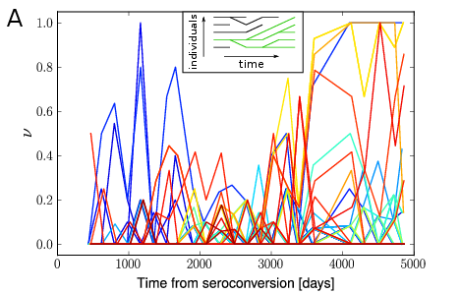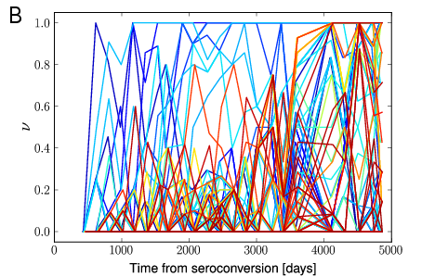

Figure 1 Time series of frequencies of synonymous (A) and nonsynonymous (B) derived alleles in env, C2-V5, from patient 10 (Shankarappa et al., 1999). While many nonsynonymous mutations fix, few synonymous mutations do even though they are frequently observed at intermediate frequencies. Colors indicate the position of the site along the C2-V5 region (blue to red). Inset: the fixation probability Pfix of a neutral mutation is simply the likelihood that the future common ancestor is currently carrying it, i.e., its frequency ν.

Figure 2 Fixation and loss of synonymous mutations. Panel A) shows the fraction of polymorphisms that have fixed (lower curves), are lost (distances between upper curves and 1), or remain polymorphic a time ∆t later for different initial allele frequencies (colors, indicated as shaded area). In each frequency interval, the fraction of synonymous mutations that ultimately fix is the fixation probability conditional on the initial frequency. Panel B) shows the fixation probability of derived synonymous alleles as a function of ν0 . Polymorphisms within C2-V5 fix less often than expected for neutral mutations indicated by the diagonal line. This suppression is not observed in other parts of env or for nonsynonymous mutations. The horizontal error bars on the abscissa are bin sizes, the vertical ones the standard deviation after 100 patient bootstraps of the data. Data from refs. (Bunnik et al., 2008; Liu et al., 2006; Shankarappa et al., 1999).

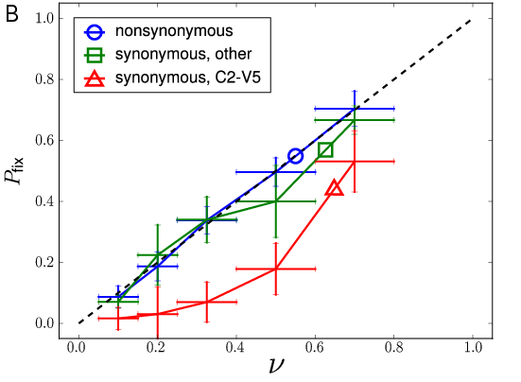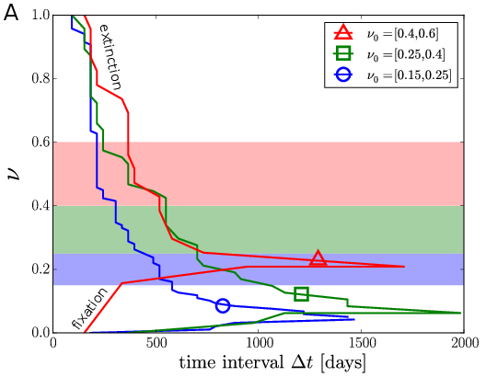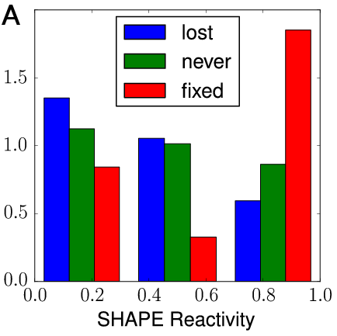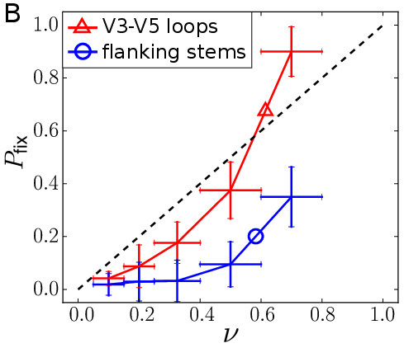

Figure 3 Permissible synonymous mutations tend to be unpaired. Panel A) shows the distribution of SHAPE reactivities among synonymous mutations that fix, mutations that reach frequencies above 15%, but are susequently lost, and random mutations (all categories are restricted to the regions V1-V5±100bp). Fixed mutations tend to have higher higher SHAPE reactivities, corresponding to less base pairing. Mutations that are never observed show an intermediate distribution of SHAPE values. Panel B) shows the fixation probability of synonymous mutations in C2-V5 separately for variable loops and the connecting conserved regions that harbor RNA stems. As expected, the fixation probability is lower inside the conserved regions. Data from Refs. (Bunnik et al., 2008; Liu et al., 2006; Shankarappa et al., 1999).

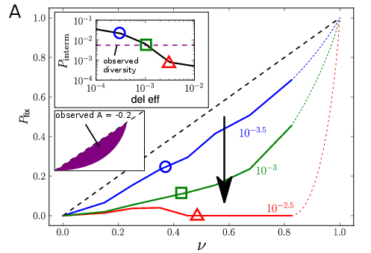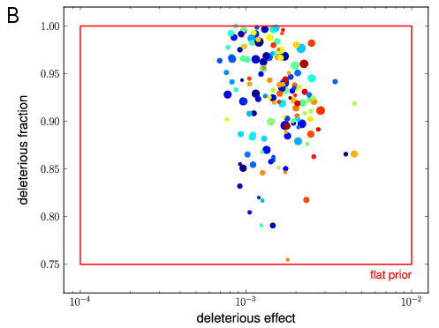

Figure 4 Distribution of selection coefficients on synonymous sites. Panel A) The depression in Pfix depends on the deleterious effect size of the synonymous alleles. This parameter also reduces synonymous diversity, measured by the probability of a derived allele to be found at intermediate frequencies Pinterm (first inset). Panel B) To assess the parameter space that affects synonymous fixation and diversity, we run 2400 simulations with random parameters for deleterious effect size, fraction of deleterious synonymous sites, average size of escape mutations (color, blue (10−2.5 ) to red (10−1.5 )), and rate of introduction of new epitopes (marker size, from 10−3 to 10−2 per generation).

Mostly simulations with small deleterious effects and relatively high deleterious fractions of synonymous mutations reproduce synonymous the fixation probability and diversity observed in patients. Parameters are chosen from uniform prior distributions as indicated by the red box (see methods).