**МИНОБРНАУКИ РОССИИ**

**Санкт-Петербургский государственный**

**электротехнический университет**

**«ЛЭТИ» им. В.И. Ульянова (Ленина)**

**Кафедра ЭТПТ**

отчет

**по лабораторной работе №5**

**по дисциплине «Электротехническое проектирование»**

Тема: Моделирование трехмерных объектов.

Самостоятельное создание 3D модели детали.

|  |  |  |
| --- | --- | --- |
| Студент гр. 9491 |  | Лобазев Н.А. |
| Преподаватель |  | Козулина Т.П. |

Санкт-Петербург

2023

**Цель работы.**

Закрепить навыки моделирования трехмерных объектов. Самостоятельно сделать 3D модель детали.

**Обработка результатов эксперимента.**

*Command: PLINE*

*Specify start point: 0,-15*

*Current line-width is 0.0000*

*Specify next point or [Arc/Halfwidth/Length/Undo/Width]: 0,15*

*Specify next point or [Arc/Close/Halfwidth/Length/Undo/Width]: 80,15*

*Specify next point or [Arc/Close/Halfwidth/Length/Undo/Width]: A*

*Specify endpoint of arc (hold Ctrl to switch direction) or*

*[Angle/CEnter/CLose/Direction/Halfwidth/Line/Radius/Second pt/Undo/Width]: CE*

*Specify center point of arc: 80,0*

*Specify endpoint of arc (hold Ctrl to switch direction) or [Angle/Length]: A*

*Specify included angle (hold Ctrl to switch direction): -180*

*Specify endpoint of arc (hold Ctrl to switch direction) or*

*[Angle/CEnter/CLose/Direction/Halfwidth/Line/Radius/Second pt/Undo/Width]: CL*

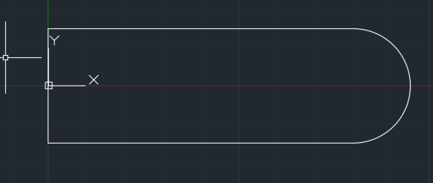

*Command: MIRROR*

*Select objects: 1 found*

*Select objects:*

*Specify first point of mirror line: 0,15*

*Specify second point of mirror line: 0,-15*

*Erase source objects? [Yes/No] <No>: N*

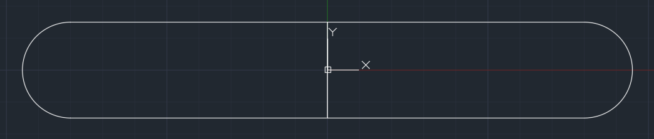

*Command: CIRCLE*

*Specify center point for circle or [3P/2P/Ttr (tan tan radius)]: 80,0*

*Specify radius of circle or [Diameter]: D*

*Specify diameter of circle: 15*

*Command: CIRCLE*

*Specify center point for circle or [3P/2P/Ttr (tan tan radius)]: -80,0*

*Specify radius of circle or [Diameter] <7.5000>: D*

*Specify diameter of circle <15.0000>: 15*

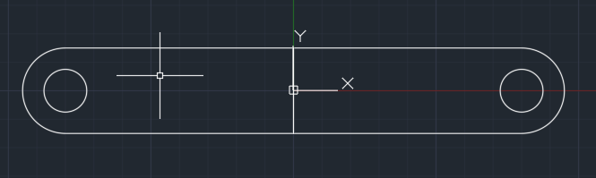

*Command: REGION*

*Select objects: 1 found*

*Select objects: 1 found, 2 total*

*Select objects:*

*2 loops extracted.*

*2 Regions created.*

*Command: REGION*

*Select objects: 1 found*

*Select objects: 1 found, 2 total*

*Select objects:*

*2 loops extracted.*

*2 Regions created.*

*Command: EXTRUDE*

*Current wire frame density: ISOLINES=4, Closed profiles creation mode = Solid*

*Select objects to extrude or [MOde]: 1 found*

*Select objects to extrude or [MOde]: 1 found, 2 total*

*Select objects to extrude or [MOde]:*

*Specify height of extrusion or [Direction/Path/Taper angle/Expression]: 10*

*Command: EXTRUDE*

*Current wire frame density: ISOLINES=4, Closed profiles creation mode = Solid*

*Select objects to extrude or [MOde]: 1 found*

*Select objects to extrude or [MOde]: 1 found, 2 total*

*Select objects to extrude or [MOde]:*

*Specify height of extrusion or [Direction/Path/Taper angle/Expression] <10.0000>: 30*

*Command: SUBTRACT*

*Select solids, surfaces, and regions to subtract from ..*

*Select objects: 1 found*

*Select objects:*

*Select solids, surfaces, and regions to subtract ..*

*Select objects: 1 found*

*Select objects:*

*Command: SUBTRACT*

*Select solids, surfaces, and regions to subtract from ..*

*Select objects: 1 found*

*Select objects:*

*Select solids, surfaces, and regions to subtract ..*

*Select objects: 1 found*

*Select objects:*

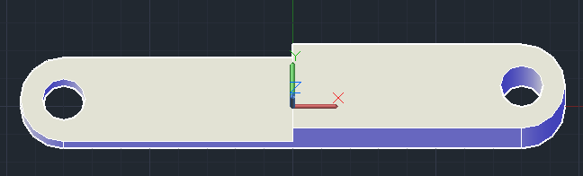

*Command: PLINE*

*Specify start point: 65,-15,10*

*Current line-width is 0.0000*

*Specify next point or [Arc/Halfwidth/Length/Undo/Width]: 95,-15*

*Specify next point or [Arc/Close/Halfwidth/Length/Undo/Width]: 95,15*

*Specify next point or [Arc/Close/Halfwidth/Length/Undo/Width]: 65,15*

*Specify next point or [Arc/Close/Halfwidth/Length/Undo/Width]: C*

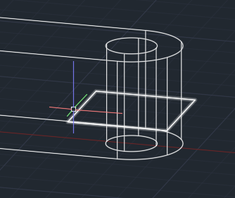

*EXTRUDE*

*Current wire frame density: ISOLINES=4, Closed profiles creation mode = Solid*

*Select objects to extrude or [MOde]: 1 found*

*Select objects to extrude or [MOde]:*

*Specify height of extrusion or [Direction/Path/Taper angle/Expression] <30.0000>: 10*

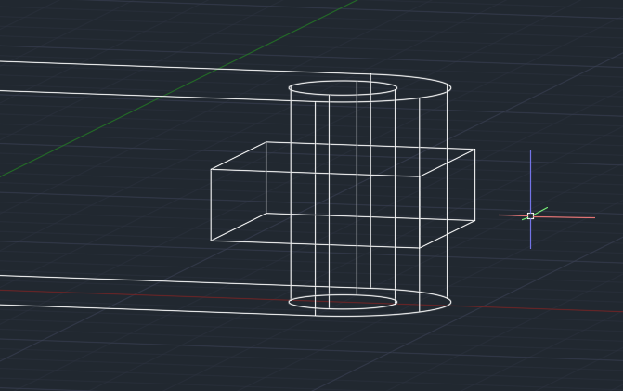

*Command: SUBTRACT*

*Select solids, surfaces, and regions to subtract from ..*

*Select objects: 1 found*

*Select objects:*

*Select solids, surfaces, and regions to subtract ..*

*Select objects: 1 found*

*Select objects:*

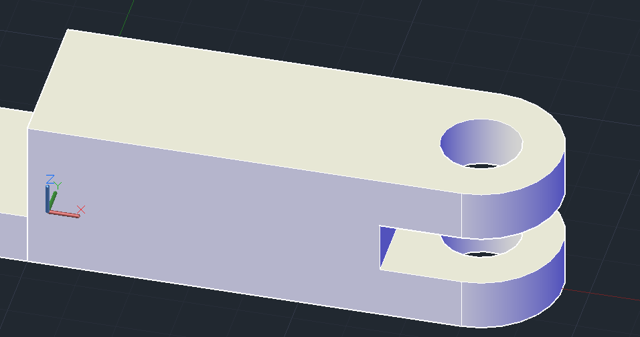

*Command: PLINE*

*Specify start point: 55,-15,10*

*Current line-width is 0.0000*

*Specify next point or [Arc/Halfwidth/Length/Undo/Width]: 0,-15,10*

*2D point or option keyword required.*

*Specify next point or [Arc/Halfwidth/Length/Undo/Width]: 55,15*

*Specify next point or [Arc/Close/Halfwidth/Length/Undo/Width]: 0,15*

*Specify next point or [Arc/Close/Halfwidth/Length/Undo/Width]: 0,-15*

*Specify next point or [Arc/Close/Halfwidth/Length/Undo/Width]: C*

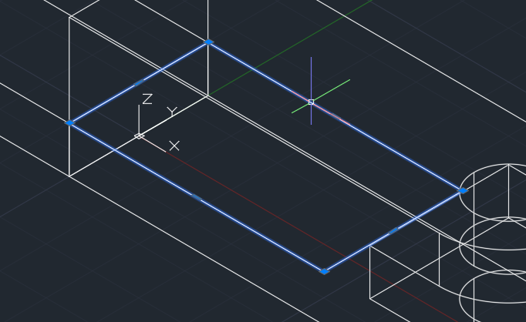

*EXTRUDE*

*Current wire frame density: ISOLINES=4, Closed profiles creation mode = Solid*

*1 found*

*Specify height of extrusion or [Direction/Path/Taper angle/Expression] <10.0000>: 80*

*Command: Regenerating model.*

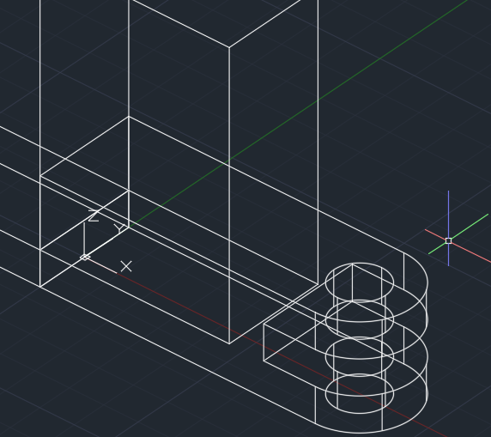

*Command: SUBTRACT*

*Select solids, surfaces, and regions to subtract from ..*

*Select objects: 1 found*

*Select objects:*

*Select solids, surfaces, and regions to subtract ..*

*Select objects: 1 found*

*Select objects:*

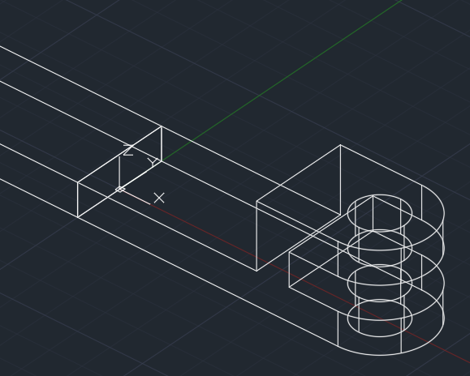

*Command: 3DPOLY*

*Specify start point of polyline: 0,-6,10*

*Specify endpoint of line or [Undo]: 55,-6,10*

*Specify endpoint of line or [Undo]: 55,-6,30*

*Specify endpoint of line or [Close/Undo]: 5,-6,110*

*Specify endpoint of line or [Close/Undo]: 0,-6,110*

*Specify endpoint of line or [Close/Undo]: C*

*Command: EXT*

*EXTRUDE*

*Current wire frame density: ISOLINES=4, Closed profiles creation mode = Solid*

*Select objects to extrude or [MOde]: 1 found*

*Select objects to extrude or [MOde]:*

*Specify height of extrusion or [Direction/Path/Taper angle/Expression]: 12*

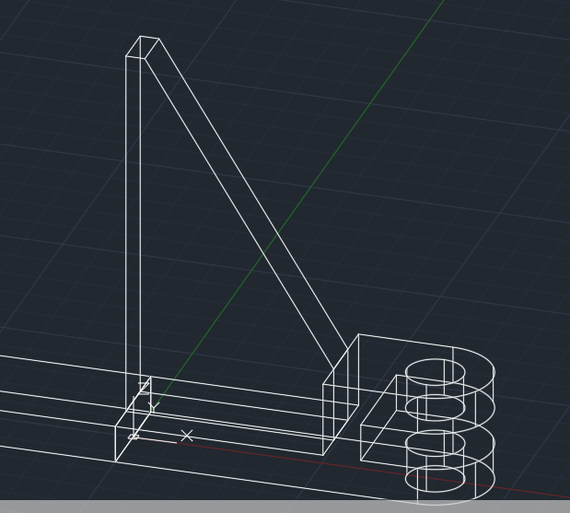

*Command: 3DPOLY*

*Specify start point of polyline: 0,-6,10*

*Specify endpoint of line or [Undo]: -70,-6,10*

*Specify endpoint of line or [Undo]: -10,-6,100*

*Specify endpoint of line or [Close/Undo]: 0,-6,100*

*Specify endpoint of line or [Close/Undo]: C*

*Command: EXTRUDE*

*Current wire frame density: ISOLINES=4, Closed profiles creation mode = Solid*

*Select objects to extrude or [MOde]: 1 found*

*Select objects to extrude or [MOde]:*

*Specify height of extrusion or [Direction/Path/Taper angle/Expression] <12.0000>: 12*

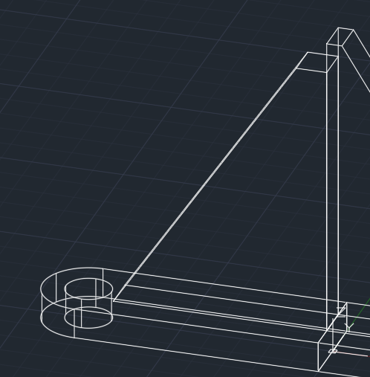

*Command: ROTATE3D*

*Current positive angle: ANGDIR=counterclockwise ANGBASE=0*

*Select objects: 1 found*

*Select objects: 1 found, 2 total*

*Select objects:*

*Specify first point on axis or define axis by*

*[Object/Last/View/Xaxis/Yaxis/Zaxis/2points]: Z*

*Specify a point on the Z axis <0,0,0>:*

*Specify rotation angle or [Reference]: 15*

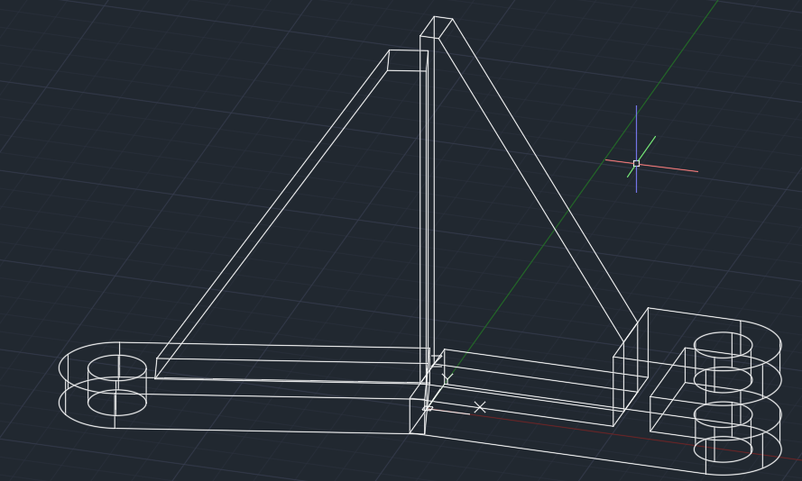

*Command: CIRCLE*

*Specify center point for circle or [3P/2P/Ttr (tan tan radius)]: 0,0,0*

*Specify radius of circle or [Diameter]: D*

*Specify diameter of circle: 60*

*EXTRUDE*

*Current wire frame density: ISOLINES=4, Closed profiles creation mode = Solid*

*Select objects to extrude or [MOde]: 1 found*

*Select objects to extrude or [MOde]:*

*Specify height of extrusion or [Direction/Path/Taper angle/Expression] <12.0000>: 90*

*CIRCLE*

*Specify center point for circle or [3P/2P/Ttr (tan tan radius)]: 0,0,0*

*Specify radius of circle or [Diameter] <30.0000>: D*

*Specify diameter of circle <60.0000>: 40*

*Command: EXTRUDE*

*Current wire frame density: ISOLINES=4, Closed profiles creation mode = Solid*

*Select objects to extrude or [MOde]: 1 found*

*Select objects to extrude or [MOde]:*

*Specify height of extrusion or [Direction/Path/Taper angle/Expression] <90.0000>: 150*

*Command: Regenerating model.*

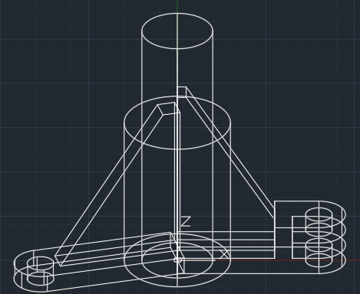

*UNION*

*Select objects: 1 found*

*Select objects: 1 found, 2 total*

*Select objects: 1 found, 3 total*

*Select objects: 1 found, 4 total*

*Select objects: 1 found, 5 total*

*Select objects:*

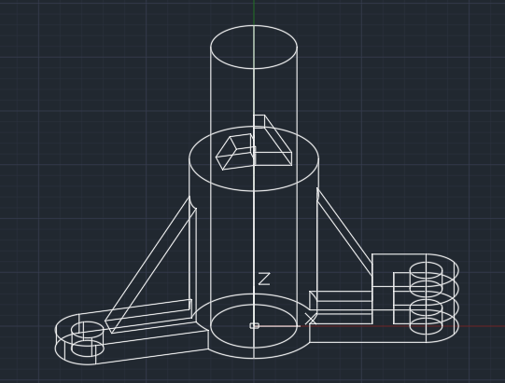

*Command: SUBTRACT*

*Select solids, surfaces, and regions to subtract from ..*

*Select objects: 1 found*

*Select objects:*

*Select solids, surfaces, and regions to subtract ..*

*Select objects: 1 found*

*Select objects:*

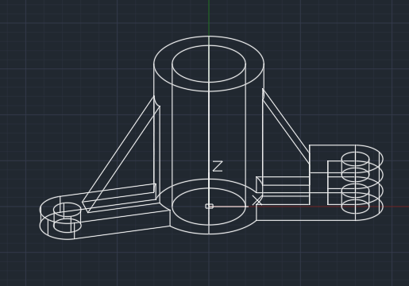

*Command: ROTATE3D*

*Current positive angle: ANGDIR=counterclockwise ANGBASE=0*

*Select objects: 1 found*

*Select objects:*

*Specify first point on axis or define axis by*

*[Object/Last/View/Xaxis/Yaxis/Zaxis/2points]: X*

*Specify a point on the X axis <0,0,0>:*

*Specify rotation angle or [Reference]: -90*

*Command: ROTATE3D*

*Current positive angle: ANGDIR=counterclockwise ANGBASE=0*

*Select objects: 1 found*

*Select objects:*

*Specify first point on axis or define axis by*

*[Object/Last/View/Xaxis/Yaxis/Zaxis/2points]: Y*

*Specify a point on the Y axis <0,0,0>:*

*Specify rotation angle or [Reference]: -90*

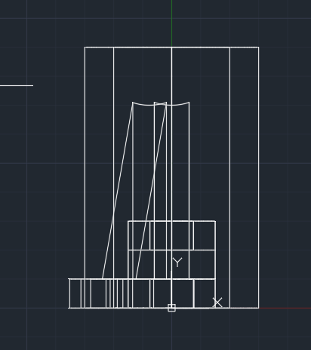

*Command: CIRCLE*

*Specify center point for circle or [3P/2P/Ttr (tan tan radius)]: 0,75*

*Specify radius of circle or [Diameter]: D*

*Specify diameter of circle: 10*

*Current wire frame density: ISOLINES=4, Closed profiles creation mode = Solid*

*Select objects to extrude or [MOde]: 1 found*

*Select objects to extrude or [MOde]:*

*Specify height of extrusion or [Direction/Path/Taper angle/Expression]: Regenerating model.*

*Resuming EXTRUDE command.*

*Specify height of extrusion or [Direction/Path/Taper angle/Expression]: Regenerating model.*

*Resuming EXTRUDE command.*

*Specify height of extrusion or [Direction/Path/Taper angle/Expression]: 100*

*Command: SUBTRACT*

*Select solids, surfaces, and regions to subtract from ..*

*Select objects: 1 found*

*Select objects:*

*Select solids, surfaces, and regions to subtract ..*

*Select objects: 1 found*

*Select objects:*

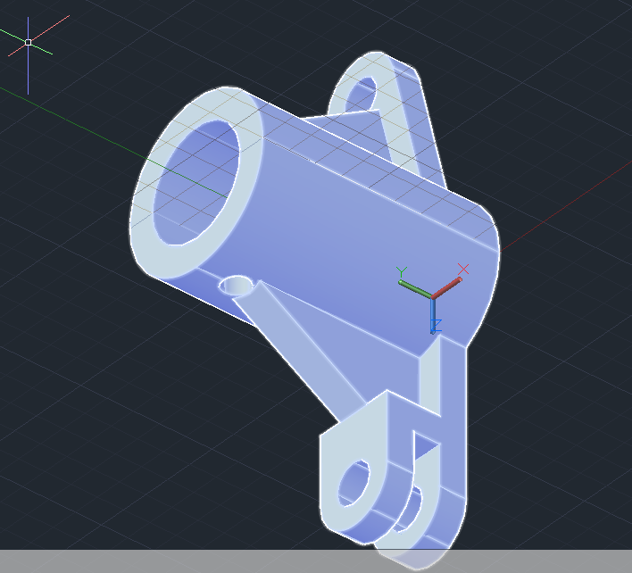

*Command: ROTATE3D*

*Current positive angle: ANGDIR=counterclockwise ANGBASE=0*

*Select objects: 1 found*

*Select objects:*

*Specify first point on axis or define axis by*

*[Object/Last/View/Xaxis/Yaxis/Zaxis/2points]: X*

*Specify a point on the X axis <0,0,0>:*

*Specify rotation angle or [Reference]: -90*

*Command: POLYLINE*

*PLINE*

*Specify start point: 15,5*

*Current line-width is 0.0000*

*Specify next point or [Arc/Halfwidth/Length/Undo/Width]: 25,5*

*Specify next point or [Arc/Close/Halfwidth/Length/Undo/Width]: 25,-5*

*Specify next point or [Arc/Close/Halfwidth/Length/Undo/Width]: 15,-5*

*Specify next point or [Arc/Close/Halfwidth/Length/Undo/Width]: C*

*EXTRUDE*

*Command: EXTRUDE*

*Current wire frame density: ISOLINES=4, Closed profiles creation mode = Solid*

*Select objects to extrude or [MOde]: 1 found*

*Select objects to extrude or [MOde]:*

*Specify height of extrusion or [Direction/Path/Taper angle/Expression] <90.0000>: -90*

*Command: SUBTRACT*

*Select solids, surfaces, and regions to subtract from ..*

*Select objects: 1 found*

*Select objects:*

*Select solids, surfaces, and regions to subtract ..*

*Select objects: 1 found*

*Select objects:*

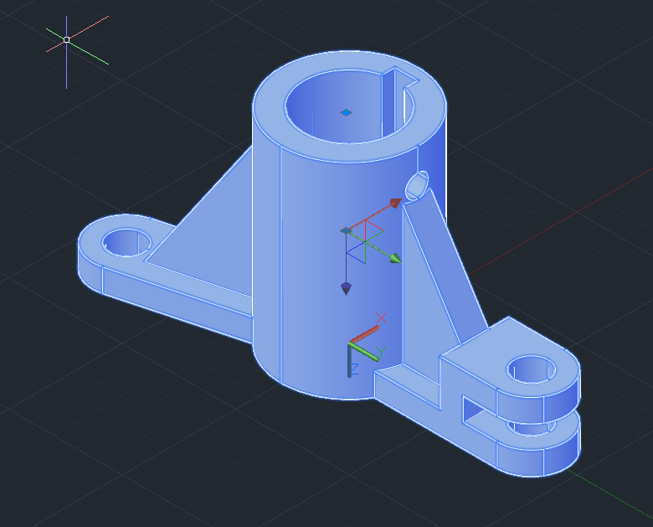

**Выводы**

В результате лабораторной работы были закреплены навыки моделирования трехмерных объектов; самостоятельно сделана 3D модель детали.