TABLE OF CONTENTS

PROJECT CHARTER…………………………………………………………………..1

WORK BREAKDOWN STRUCTURE…………………………………………….3

GANTT CHART………………………………………………………………………….4

FIVE LONGEST TASK…………………………………………………………………5

PERT TABLE…………………………………………………………………………….6

Project Title: Online Doctor Appointment System using python
Project Start Date: 6th of February 2023
Project End Date: 5th of August 2023
Key Schedule Milestones:
First Prototype of the Software by 6th May 2023
Functional working Software by 10th July 2023
Final documentation ready for submission by 5th August 2023

Budget Information: This Project is economically feasible and the budget depends upon the capacity of server, cost of front end theme as well as the features available.

Project Manager: Pradip Raut , Phone: 07307608280
Email: Raut-p@ulster.ac.uk

Project Objectives:
The primary objectives of the project are:
- To build the web-based application which manages appointment in the front-end section and store data in the back-end section, and have analysis and design for the Online doctor appointment system.
Secondary objectives are: -
To check the previous appointment history and medical records.
- To have uplift the healthcare system through the help of E-medicine.
0
- To get information of the patient and doctor as well as information real time availability of doctor.
Main Project Success Criteria: It should book an appointment with Doctors based on the symptoms and should store reports on back end for future use.

Approaches:
• It will be determined which needs are functional and which are not.
• A risk table will be created, and a risk mitigation strategy will be executed to manage risk.
• A work breakdown structure (WBS) and a Gantt chart will be created.
• The risk management approach will be thoroughly checked to ensure that none of the obstacles listed are encountered, and it will be regularly updated if new ones develop.
• To ensure that no problems are identified, the project will be tested and debugged towards the end of development, followed by final documentation.

Roles and Responsibilities
Name | position | roles | Contact
Pradip Raut | Manager | Project Manager | Raut-p@ulster.ac.uk
Iftikhar Afridi | Supervisor | Project Supervisor | i.afridi@qa.com

1

Work Breakdown Structure(WBS)
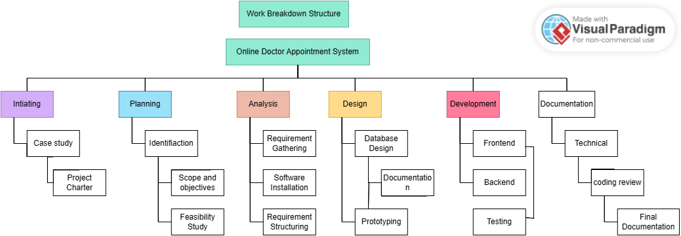

2
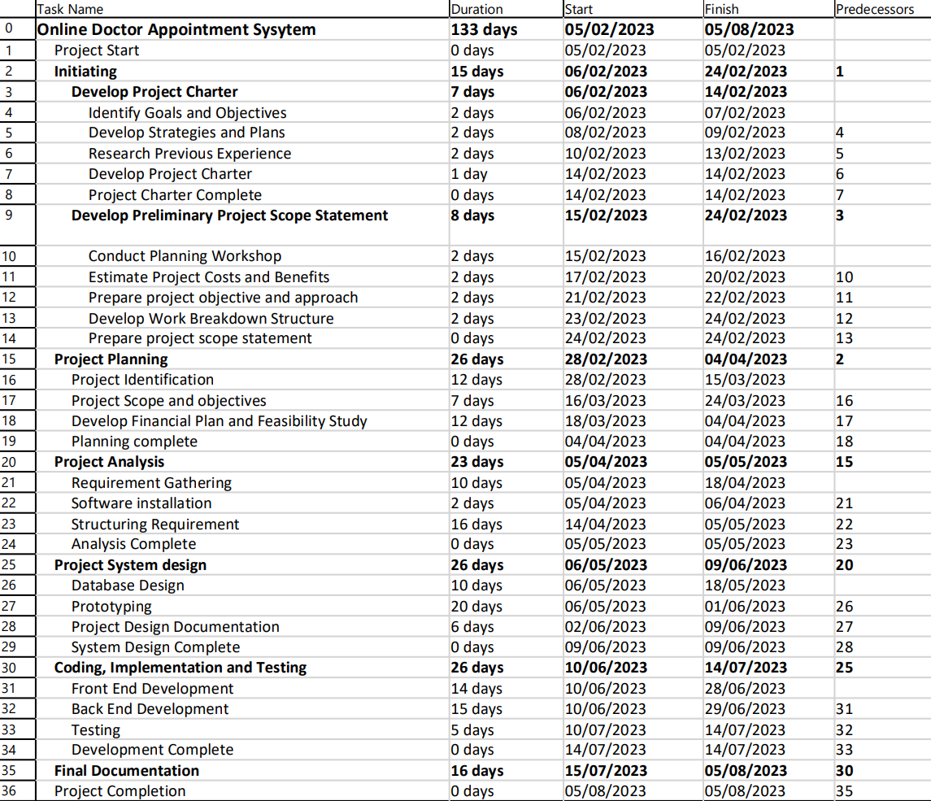
Task schedule and Gantt chart

3

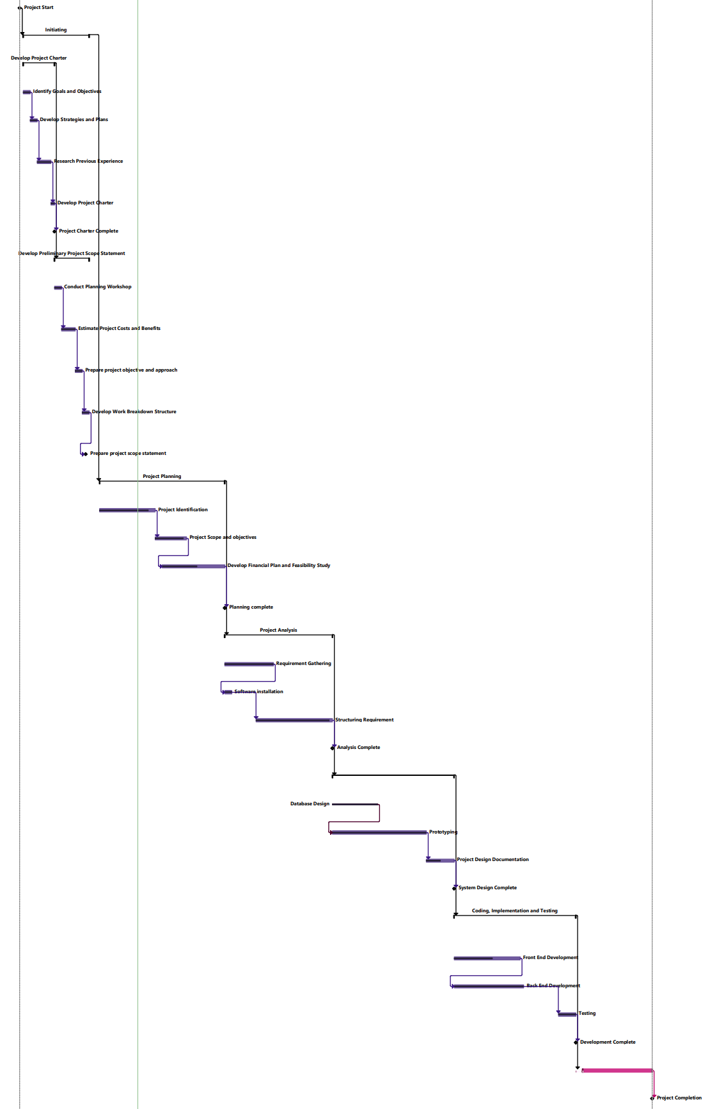

4

Five Longest Tasks
- Project Planning(22 days)
This task is one of the longest tasks in my project. In this task of 232days, I have several steps to do such as identifying the project as well as it’s scopes and objectives. This took a total of 16 days. Developing the Financial plan took 10 days as I needed to study the ecomonic, technical and operational feasibility of the project.
- Project Analysis (30 days)
This is the important task in my project as analysis about the whole project will be done on this one. From gathering and structuring requirement to analyzing the software installation process , every task will be done in this phase. This phase is divided into 3 sub phases - Requirement gathering ( 10 days), software installation (10 days) and structuring requirement (15 days).
3) System Design (22 days)
While designing a online software it is important to design a proper system including efficient database The sub-tasks under this are Database Design (10 days), Prototyping(20 days) and Design Documentation(2 days) .As Design is a vital phase collaborating with QA is important. Thus, the design needs to be documented in this phase for QA to review the system.

4) Development (26 days)
Development of application after system design will be started and almost 26 days is required to complete this task. This is due to various sub-tasks I have in this process. Front-end development will require 14 days and Back-end will take 15 days.we will test individual module in this phase. Both front and back end development will be simultaneous . After the development is complete the overall will be tested and integrated which will take 5 days.
- Documentation (16 days)
Creating and finalizing the document will take 16 days for this project. It will include technical documentation and review of the documentation . After that final documentation will be developed.

5
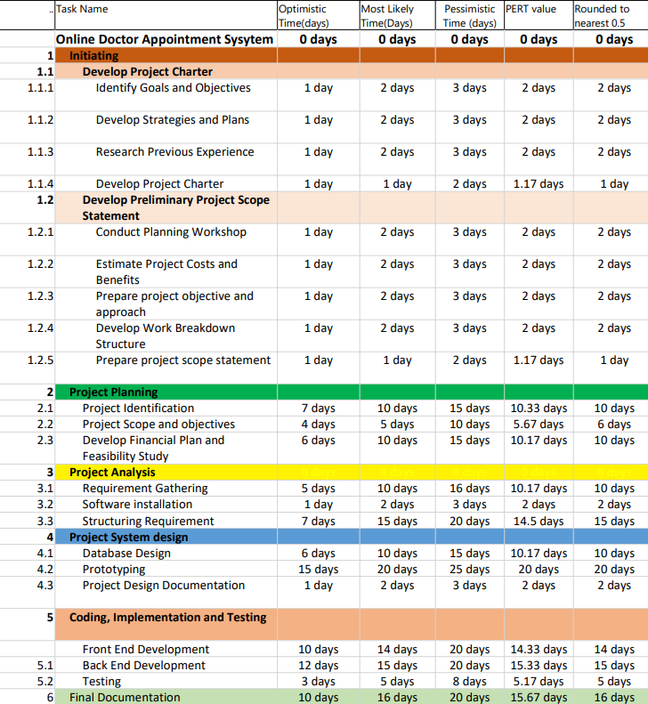
PERT Table

6

