LEARNING BASICS OF HC05 BT MODULE.

1. we connect it to arduino and thereby control a device. eg: wireless gamepad

2. Coming to the pins.

a. EN pin: it has 2 modes, first is the data mode which helps to transfer data between two devices. Second is the command mode in which it executes the AT commands.

b. VCC pin: we have to give it 5v so we connect it directly to the 5v pin in the arduino board.

c. GND pin: gets connected to the ground pin of the arduino.

d. RX and TX pin: recieve and transfer pin. Should be strictly connected to 3.3v

e. STATE pin: tells whether the device is connected to the bluetooth or not.

3. There is a red LED pin on the HC05 which blinks every 1 sec when not connected and blinks every two secs when connected. There is also a reset button which helps in starting the code again.

4. the HC05 can take up to 3.3-5v, it runs on 2.4ghz ism band, operating temp:-20 to 75 degree celcius.

5. has the ability to work in both slave and master mode.

NOTE: we can use fritzing wwebsite to run online circuit simulators.

EXAMPLE CIRCUIT DEMONSTRATION:

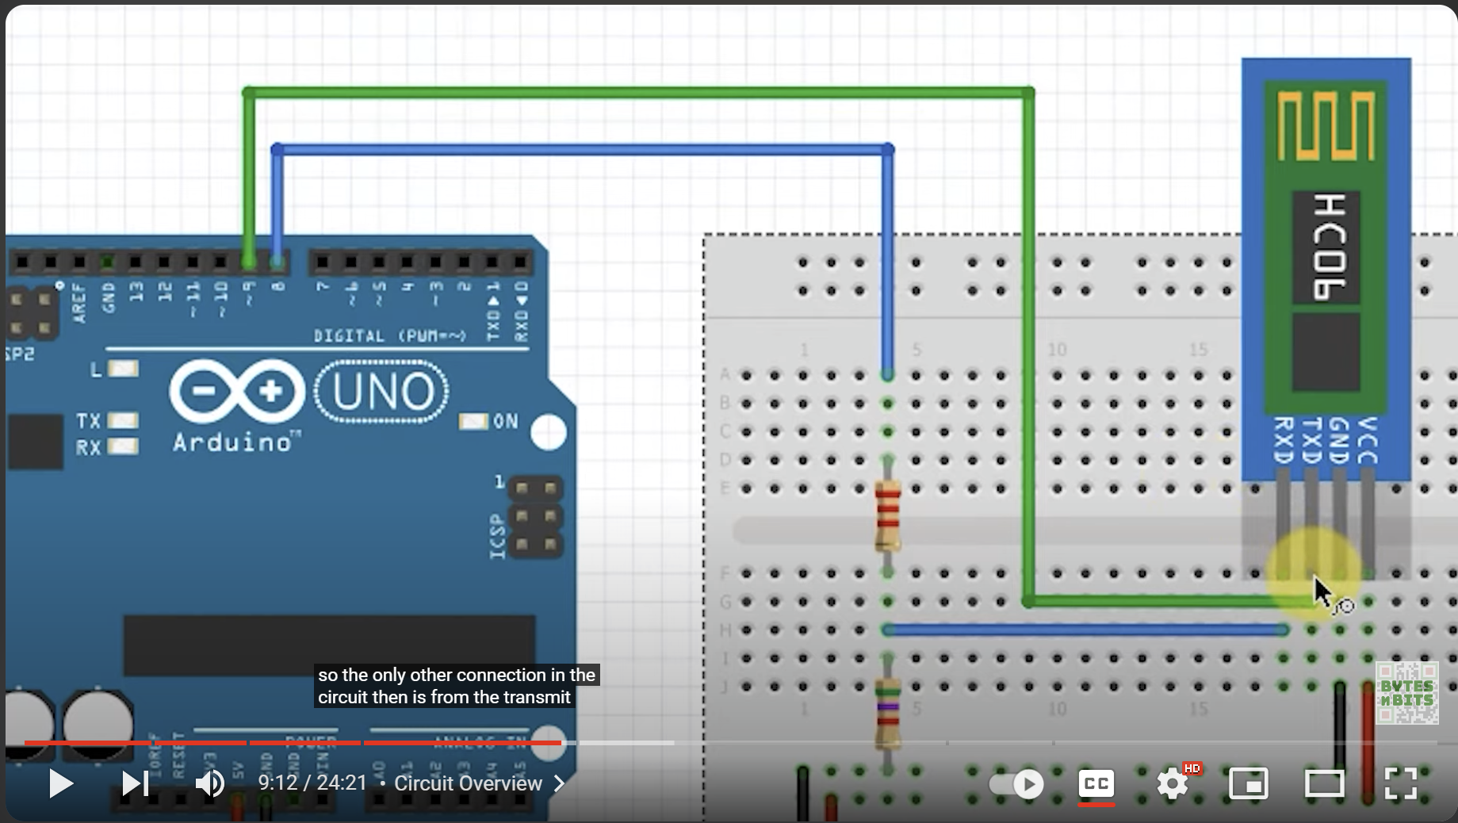

THINGS TO NOTE:

The transfer pin of HC06 is connected to the receive pin 9 of Arduino

The receiver pin of HC06 is connected to the transfer pin 8 of Arduino

The resistance is present in the breadboard to keep the voltage almost 3.3v

