**SHRUBS**

# **Viburnum**

Good luck finding a more diverse group of shrubs for the garden. Viburnums offer something for everyone. Whether you plant them for their colorful berries, showy flowers, wonderful fragrance, or brilliant foliage and stem color, viburnum options are seemingly endless.

Genus name: Viburnum

Height: 3 to 8 feet, 8 to 20 feet

Sunlight: part sun, sun

Plant features: low maintenance, attracts birds, fragrance, cut flowers

Plant seasons: spring bloom, colorful fall foliage, winter interest

Plant region: native to North America, but their range extends to Southeast Asia and South America

Plant info: **Viburnum,** (genus Viburnum), any of about 175 shrubs and small trees belonging to the family Adoxaceae, native to temperate and subtropical Eurasia and [North America](https://www.britannica.com/place/North-America), with about 16 species native to Malaysia. Many species are [cultivated](https://www.merriam-webster.com/dictionary/cultivated) for their ornamental foliage, fragrant clusters of usually white flowers, and colourful blue-black fruits.

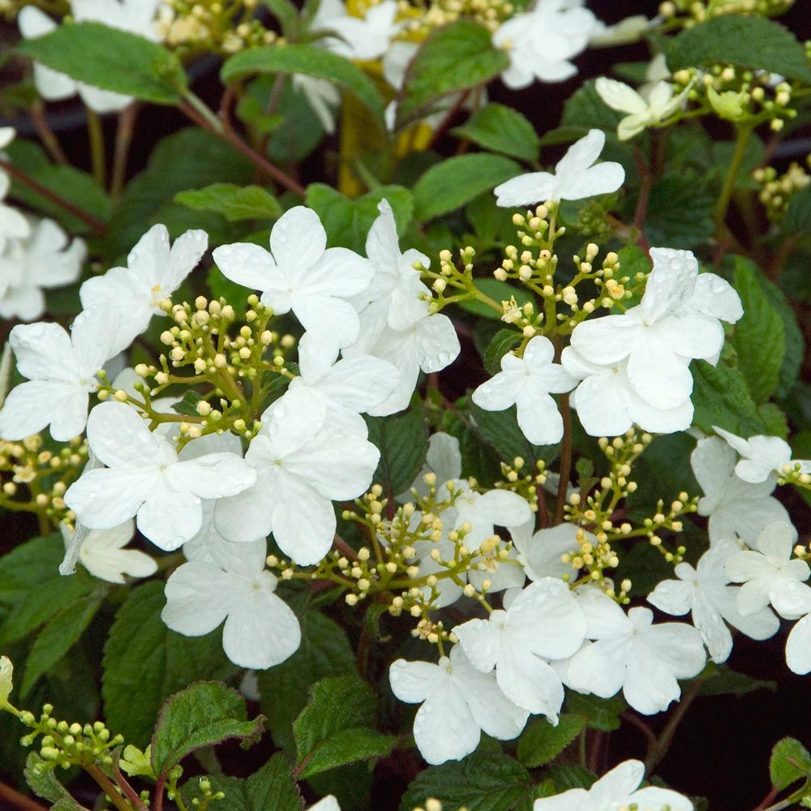

# **Shrub Rose**

The classic rose has long been loved for its aroma and looks. However, it can be quite a diva when it comes to care, demanding plenty of fertilizer, water, and sunlight. Not so for the shrub rose. It combines all of the best characteristics of roses into a beautiful, low-maintenance plant.

Genus name: Rosa

Height: 1 to 3 feet, 3 to 8 feet, 8 to 20 feet

Sunlight: sun

Plant features: low maintenance, attracts birds, fragrance, cut flowers, good for containers

Plant seasons: spring bloom, fall bloom, summer bloom, winter interest

Plant region: native to [Asia](https://en.wikipedia.org/wiki/Asia), with smaller numbers native to [Europe](https://en.wikipedia.org/wiki/Europe), [North America](https://en.wikipedia.org/wiki/North_America), and northwestern [Africa](https://en.wikipedia.org/wiki/Africa)

Plant info: **Rose**, (genus Rosa), [genus](https://www.britannica.com/science/genus-taxon) of some 100 species of [perennial](https://www.britannica.com/science/perennial) [shrubs](https://www.britannica.com/plant/shrub) in the rose family ([Rosaceae](https://www.britannica.com/plant/Rosaceae)). Roses are native primarily to the temperate regions of the Northern Hemisphere. Many roses are [cultivated](https://www.merriam-webster.com/dictionary/cultivated) for their beautiful flowers, which range in colour from white through various tones of yellow and [pink](https://www.britannica.com/plant/pink-plant) to dark crimson and maroon, and most have a delightful fragrance, which varies according to the variety and to climatic conditions.

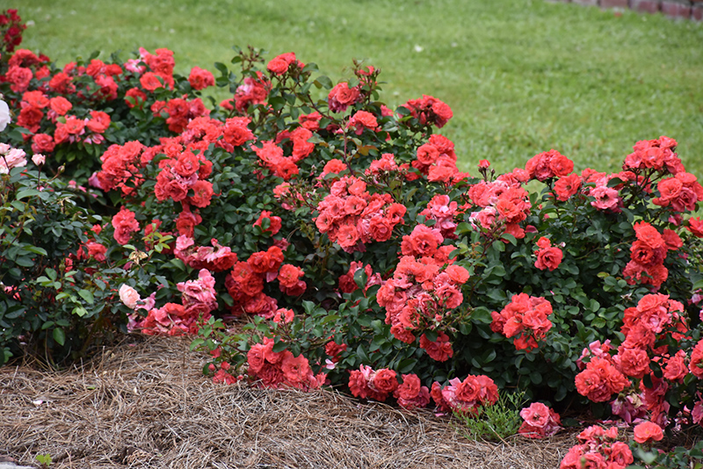

# **St. John’s Wort**

A landscape workhorse, St. John’s wort is a champion at providing food and shelter to wildlife—especially pollinators—as well as adding blossoms, colorful foliage, and great texture to entry gardens, foundation plantings, perennial beds, and mixed shrub borders. This North American native all-star shrub is easy to grow and a cinch to incorporate into almost any landscape. You’re sure to delight in its sunny yellow flowers in summer and low-maintenance habit year-round. Seldom browsed by deer and rabbits, it is a great plant for landscape plagued by these munching pests.

Genus name: hypericum spp.

Height: 1 to 3 feet, 3 to 8 feet

Sunlight: part sun, sun

Plant features: low maintenance, attracts birds, cut flowers,

Plant seasons: summer bloom

Plant region: native to parts of Europe, Asia, and northern Africa

Plant info: **Saint-John’s-wort**, (genus Hypericum), [genus](https://www.britannica.com/science/genus-taxon) of nearly 500 species of herbs or low shrubs in the family Hypericaceae that are native to temperate and tropical areas. Several species are [cultivated](https://www.merriam-webster.com/dictionary/cultivated) for their attractive flowers, and at least one, [common Saint-John’s-wort](https://www.britannica.com/plant/Saint-Johns-wort) (Hypericum perforatum), is important in herbalism. The common name stems from the fact that various European species [flower](https://www.britannica.com/science/flower) around June 24, which is the feast day of [St. John the Baptist](https://www.britannica.com/biography/Saint-John-the-Baptist); “wort” derives from an [Old English](https://www.britannica.com/topic/Old-English-language) word for herb or [plant](https://www.britannica.com/plant/plant).

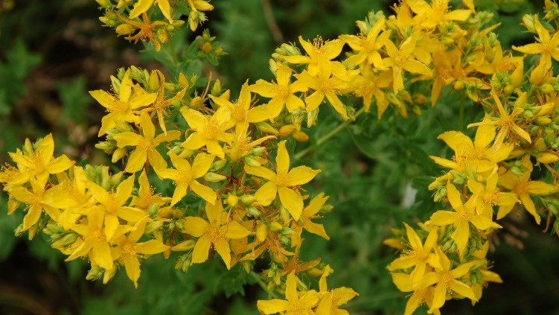

# **Banana Shrub**

Banana shrub sports thick, glossy dark green leaves (similar to those of magnolia) and  flower buds cupped by six petals each that bloom from spring to summer. Its common name refers to the intense bananalike fragrance of those creamy yellow blossoms. This broadleaf evergreen, which has multiple stems and a rounded habit, grows 6 to 10 feet tall and wide if left unpruned. But don’t worry; it tolerates pruning well and is easily maintained at 4 to 5 feet tall.

Genus name: magnolia figo

Height: 3 to 8 feet, 8 to 20 feet

Sunlight: part sun, sun

Plant features: low maintenance, fragrance

Plant seasons: summer bloom, spring bloom

Plant region: native to china

Plant info: This evergreen shrub is like a classic Southern lady—both sweet and tough. Its flowers are incredibly fragrant, and the plant itself is easy to take care of. Gardeners can think of it as a miniature Southern magnolia whose flowers smell like bananas instead of lemons.

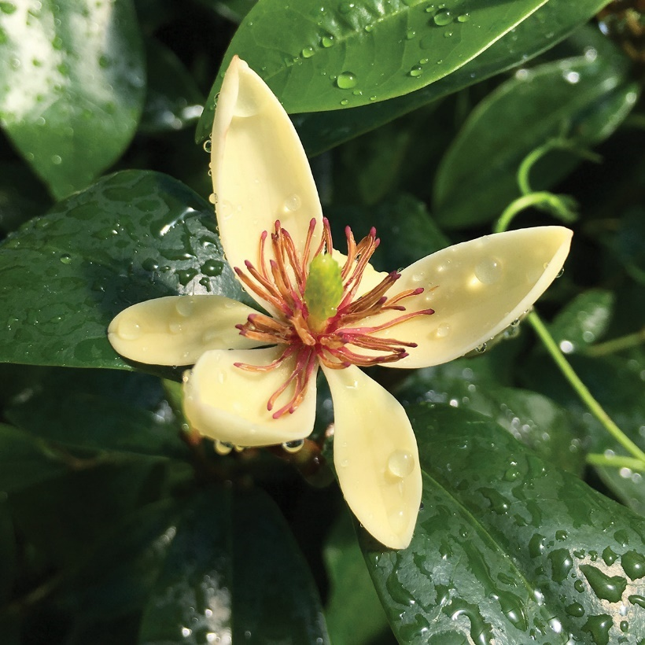

# **Lily-of-the-Valley**

This is a plant with many names. Commonly known as lily-of-the-valley bush, it is sometimes called andromeda or Japanese pieris. This plant showcases pendulous chains of puckered flowers closely resembling the perennial lily of the valley. Though it may not be as fragrant as the groundcover perennial, lily-of-the-valley bush has a sweet, light scent. If the bountiful flowers aren’t enough, its new growth emerges in shades of orange and red.

Genus name: pieris

Height: 3 to 8 feet, 8 to 20 feet

Sunlight: part sun, sun

Plant features: low maintenance, fragrance, good for containers

Plant seasons: spring bloom, winter interest

Plant region: native throughout the cool temperate [Northern Hemisphere](https://en.wikipedia.org/wiki/Northern_Hemisphere) in Asia and Europe.

Plant info: **Lily of the valley**, (Convallaria majalis), fragrant [perennial](https://www.merriam-webster.com/dictionary/perennial) herb and only species of the genus Convallaria in the asparagus family (Asparagaceae). Native to Eurasia and eastern [North America](https://www.britannica.com/place/North-America), lily of the valley is [cultivated](https://www.merriam-webster.com/dictionary/cultivated) in shaded garden areas in many temperate parts of the world. The plants often grow closely together, forming a dense mat, and are sometimes used as ground cover.

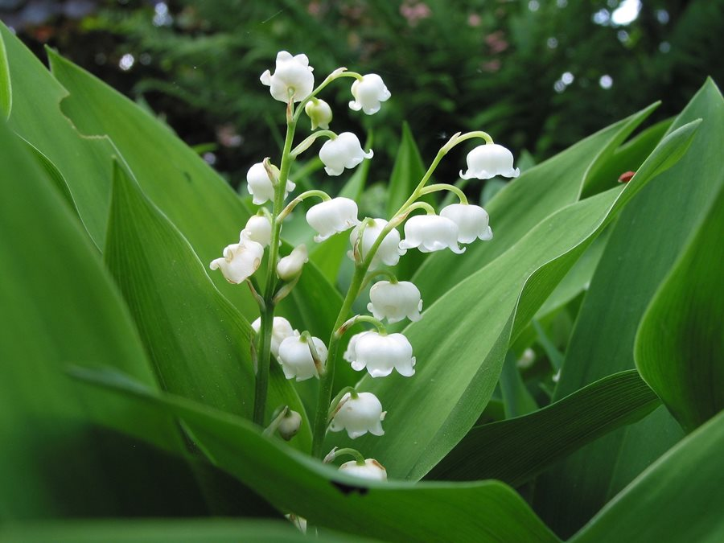

# **Orange**

Orange trees are a popular selection for gardeners in citrus-friendly climates. While grapefruits, mandarins, and acid fruits are also favored, sweet and juicy oranges are the most popular. In addition to producing tasty fruit, the trees have ornamental value, too. When in bloom they will perfume a landscape and a well-maintained tree makes a striking focal point. Plant an orange tree where it can be enjoyed from outdoor living spaces but far enough removed that any falling fruit will not create a messy problem.

Genus name: citrus spp.

Height: 8 to 20 feet, 20 feet or more

Sunlight: sun

Plant features: fragrance

Plant seasons: spring bloom, winter bloom

Plant region: **native** to the tropical regions of Asia, especially the Malay Archipelago; along with other citrus species, they have been cultivated from remote ages

Plant info: **Orange**, any of several species of small trees or shrubs of the [genus](https://www.britannica.com/science/genus-taxon) [Citrus](https://www.britannica.com/plant/Citrus) of the family [Rutaceae](https://www.britannica.com/plant/Rutaceae) and their nearly round fruits, which have leathery and oily rinds and edible, juicy inner flesh. A number of species and varieties of orange are economically important, namely the [China](https://www.britannica.com/place/China) orange, also called the sweet, or common, orange (Citrus ×sinensis); the mandarin orange (C. reticulata), some varieties of which are called [tangerines](https://www.britannica.com/plant/tangerine-fruit); and the sour, or Seville, orange (C. ×aurantium), which is less extensively grown. Common varieties of the sweet orange include the Jaffa, from Israel, the seedless navel, and the Maltese, or blood, orange.

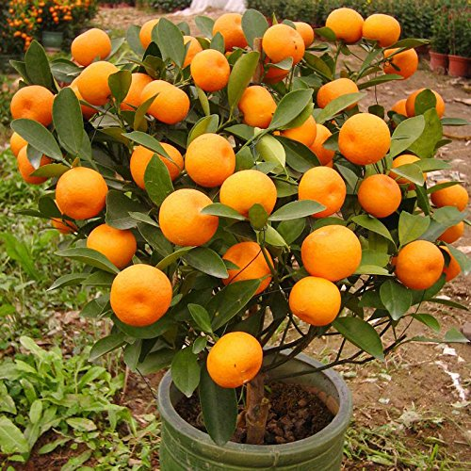

**WATER PLANTS**

# **Lotus**

the lotus is considered sacred by the Buddhist and Hindu religions. It’s also prized by water gardeners because it’s both beautiful and easy to grow. Lotus stalks start out in muddy soil and water, and end in sweetly fragrant white-to-pink flowers that can grow as large as 12 inches across. Although spectacular, the flowers are short-lived—appearing for only a few days followed by large ornamental seed pods. Also intriguing to observe, the plant’s canopy of waxy blue-green leaves can reach two to three feet in diameter—either lying flat on the water or rising up several feet above the water line.

Genus name: nelumbo

Height: 3 to 8 feet

Sunlight: sun

Plant features: fragrance, good for containers, cut flowers

Plant seasons: summer bloom

Plant region: Native to Asia and Australia

Plant info: **Lotus**, any of several different plants. The lotus of the Greeks was the species Ziziphus lotus of the buckthorn family (Rhamnaceae), a bush native to southern Europe. It has large fruits containing a mealy substance that can be used for making bread and fermented drinks. In ancient times the fruits were an article of food among the poor, and a wine made from the fruit was thought to produce contentment and forgetfulness.

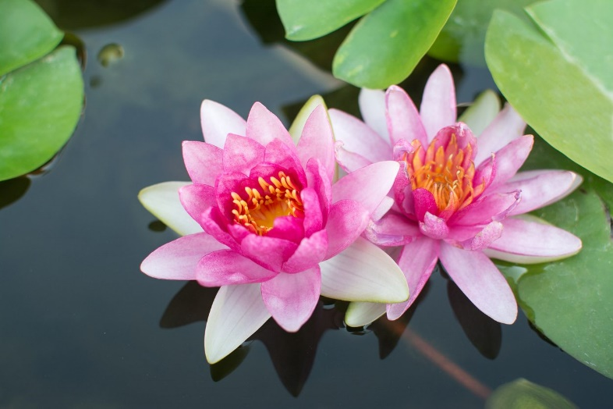

# **Sorrel**

Sorrel begins growth in early spring, providing salad greens when few other edibles are available. The plant thrives in full sun or partial shade, and it prefers moist soil. Some types can be grown in shallow water. Sorrel develops a mound of foliage that grows 12-18 inches tall, and it sends up a flower stalk with green flowers that mature to reddish-brown seeds. Remove seed stalks to prevent the plant from self-sowing.

Genus name: Rumex spp.

Height: under 6 inches, 6 to 12 inches, 1 to 3 feet

Sunlight: part sun, sun

Plant features: fragrance, good for containers, cut flowers

Plant seasons: summer bloom

Plant region: Distribution. Rumex acetosa occurs in grassland habitats throughout Europe from the northern Mediterranean coast to the north of Scandinavia and in parts of Central Asia. It occurs as an introduced species in parts of New Zealand, Australia and North America.

Plant info: **Sorrel**, any of several hardy [perennial](https://www.britannica.com/science/perennial) herbs of the Polygonaceae, or [buckwheat](https://www.britannica.com/plant/buckwheat), family that are widely distributed in temperate regions. Sheep sorrel (Rumex acetosella) is a weed that is native to [Europe](https://www.britannica.com/place/Europe) and has become widespread in [North America](https://www.britannica.com/place/North-America). It is an attractive but troublesome invader that occurs in lawns and gardens as well as meadows and grassy slopes. It sprouts from spreading rootstocks and has acid-tasting, slender triangular leaves and tiny yellow or reddish flowers.

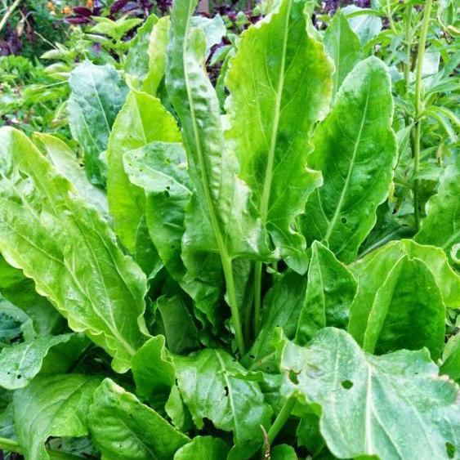

# **Water Hyacinth**

Water hyacinth is a friend or foe, depending on where it is growing. A vigorous water plant, water hyacinth is invasive and is illegal to plant in many states. Water hyacinth plays a helpful role in water gardens, where it provides shelter and spawning area for small fish. The dense foliage also inhibits algae growth and helps keep water clear.

Genus name: Eichhornia crassipes

Height: under 6 inches

Sunlight: part sun, sun

Plant features: fragrance, good for containers

Plant seasons: summer bloom

Plant region: native to the [Amazon basin](https://en.wikipedia.org/wiki/Amazon_basin)

Plant info: **Water hyacinth**, any aquatic [plant](https://www.britannica.com/plant/plant) of the genus Eichhornia of the [pickerelweed](https://www.britannica.com/plant/pickerelweed) family (Pontederiaceae), consisting of about five species, native primarily to tropical [America](https://www.britannica.com/place/United-States). Some species float in shallow water; others are rooted in muddy stream banks and lakeshores. All have slender rootstocks, feathery roots, rosettes of stalked leaves, and few to many flowers arranged in spikes or clusters in the [leaf](https://www.britannica.com/science/leaf-plant-anatomy) axils.

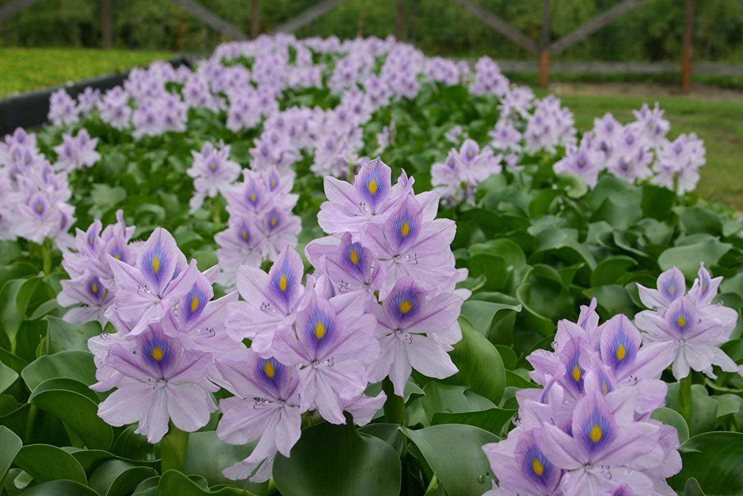

# **Pitcher Plant**

Pitcher plant has a Dr. Seuss-like quality that draws onlookers to its unique leaves and whimsical, upright habit. At home in soggy soil, pitcher plant has exacting growing requirements. In nature it grows in full sun and moist but not watery soil, from Minnesota to Florida. Mimic its native environment and you’ll have success with pitcher plant, too.

Genus name: sarracenio

Height: under 6 inches, 6 to 12 inches, 1 to 3 feet, 3 to 8 feet

Sunlight: part sun, sun

Plant features: good for containers, cut flowers

Plant seasons: spring bloom

Plant region: native to Madagascar, Southeast Asia, and Australia

Plant info: **Pitcher plant**, any [carnivorous plant](https://www.britannica.com/plant/carnivorous-plant) with [pitcher](https://www.britannica.com/science/pitcher-plant-structure)-shaped [leaves](https://www.britannica.com/science/leaf-plant-anatomy) that form a passive pitfall [trap](https://www.britannica.com/science/trapping-mechanism-botany). Old World pitcher plants are members of the family [Nepenthaceae](https://www.britannica.com/plant/Nepenthes) (order [Caryophyllales](https://www.britannica.com/plant/Caryophyllales)), while those of the New World belong to the family [Sarraceniaceae](https://www.britannica.com/plant/Sarraceniaceae) (order [Ericales](https://www.britannica.com/plant/Ericales)). The [Western Australian pitcher plant](https://www.britannica.com/plant/Western-Australian-pitcher-plant) (Cephalotus follicularis) is the only species of the family Cephalotaceae (order [Oxalidales](https://www.britannica.com/plant/Oxalidales)). Pitcher plants are found in a wide range of [habitats](https://www.britannica.com/science/habitat-biology) with poor [soil](https://www.britannica.com/science/soil) conditions, from pine barrens to sandy coastal [swamps](https://www.britannica.com/science/swamp), and rely on carnivory to obtain nutrients such as [nitrogen](https://www.britannica.com/science/nitrogen) and [phosphorus](https://www.britannica.com/science/phosphorus-chemical-element).

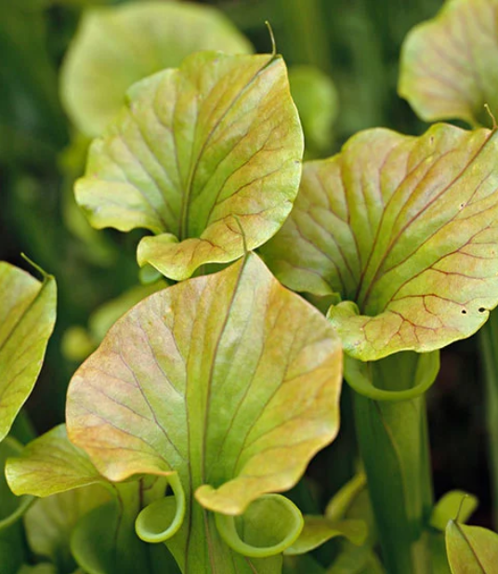

# **Pickerel Weed**

Quiet ponds and wetlands are excellent growing places for low-maintenance and easy-to-grow pickerel weed. Its blue-green, heart-shape leaves have a waxy feel and provide a backdrop for the plant’s purple-blue flower spikes. The 6-inch-long flowers bloom from the bottom up and decorate the plant nonstop from summer through fall. A valuable source of nectar for bees and butterflies, pickerel weed beckons winged visitors to the garden. Fish often take shelter in pickerel weed and dragonflies and damselflies often lay their eggs on the plant stems near the water.

Genus name: Pontederia cordata

Height: 1 to 2 feet

Sunlight: sun

Plant features: low maintenance, attracts birds

Plant seasons: fall bloom, summer bloom

Plant region: **native** to the American continent.  It grows in a variety of [wetlands](https://en.wikipedia.org/wiki/Wetlands), including pond and lake margins across an extremely large range from eastern Canada south to Argentina.

Plant info: The species grows as an [emergent plant](https://en.wikipedia.org/wiki/Emergent_plant), that is, in flooded conditions, so the plant is generally dependent upon [aerenchyma](https://en.wikipedia.org/wiki/Aerenchyma) in the [stem](https://en.wikipedia.org/wiki/Plant_stem) to carry oxygen into the roots. Its [metabolism](https://en.wikipedia.org/wiki/Metabolism), is, however, also tolerant of low soil oxygen. It is often found in areas where water levels fluctuate naturally, with spring flooding and later summer emergence. Apart from flooding, the species is also influenced by soil fertility, tending to grow in the more fertile bays of large lakes, for example. Like many aquatic plants, it is negatively affected by salinity and grazing. It is also negatively affected by competition from other wetland plants. Like many wetland plants, it can survive unfavorable conditions as buried seeds in the soil

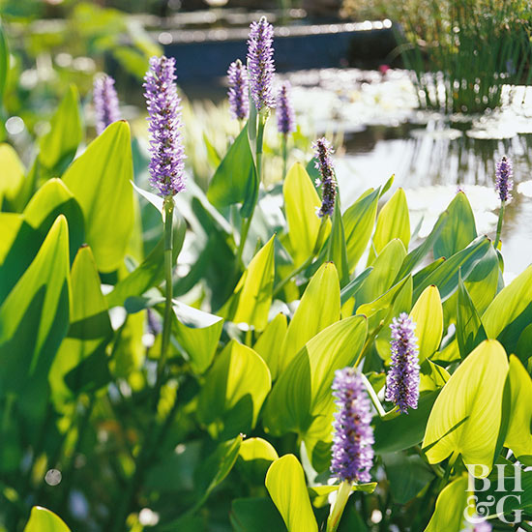

# **Papyrus**

Papyrus is an easy-to-grow water plant with a rich, long history. Native to areas of Africa, the plant has been used for thousands of years to make a paperlike material. But papyrus is also loved in gardens. Papyrus sends out grassy sprays of leaves that jut out from the stems like a fireworks display. The leafy clusters may form plantlets that you can separate and grown individually. Grow papyrus in a weighted pot so that the stems rise above the water surface in a pond, or grow it in moist soil at water's edge.

Genus name: Cyperus papyrus

Height: 3 to 8 feet, 8 to 20 feet

Sunlight: sun

Plant features: low maintenance, good for containers, cut flowers

Plant seasons: fall bloom, summer bloom, Reblooming

Plant region:  [native](https://en.wikipedia.org/wiki/Native_plant) to Africa, and forms tall stands of reed-like swamp vegetation in shallow water

Plant-info: **Papyrus**, writing material of ancient times and also the [plant](https://www.britannica.com/plant/papyrus-plant) from which it was derived, Cyperus papyrus (family Cyperaceae), also called paper plant. The papyrus plant was long [cultivated](https://www.merriam-webster.com/dictionary/cultivated) in the Nile delta region in [Egypt](https://www.britannica.com/place/Egypt) and was collected for its stalk or stem, whose central pith was cut into thin strips, pressed together, and dried to form a smooth thin writing surface.

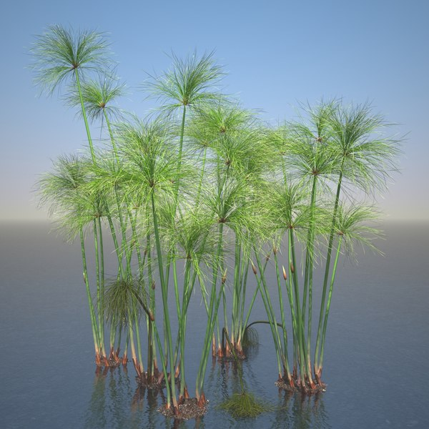

**Vegetables**

# **Corn salad**

This cool-season green has spoon-shape leaves with a mild nutty flavor. Also called mache, it's a gourmet salad green that fetches top dollar at the supermarket. But you can save money by growing it yourself to enjoy its mild nutty flavor right from your garden.

Genus name: Volerianella locusta

Height: under 6 inches

Sunlight: part sun, sun

Plant features: grows in a low rosette, spatulate leaves, hardy plant

Plant seasons: summer bloom

Plant region:  grows wild in parts of [Europe](https://en.wikipedia.org/wiki/Europe), northern [Africa](https://en.wikipedia.org/wiki/Africa) and western [Asia](https://en.wikipedia.org/wiki/Asia).

Plant-info: **Lamb’s lettuce**, (Valerianella locusta), also called **Lewiston corn salad**or **mâche**, weedy [plant](https://www.britannica.com/plant/plant) of the family [Caprifoliaceae](https://www.britannica.com/plant/Caprifoliaceae), native to southern [Europe](https://www.britannica.com/place/Europe) but widespread in grainfields in Europe and [North America](https://www.britannica.com/place/North-America). It has been used locally as a salad green and as an herb with a nutty tangy flavour.

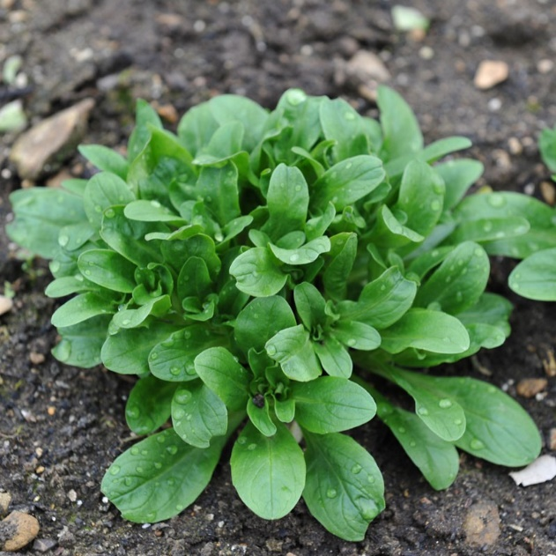

# **Sweet potato**

Sweet potatoes are undergoing a renaissance. Once a sticky, frumpy food eaten only at Thanksgiving, a renewed appreciation for this root vegetable's powerful nutritional value has made it popular once again. Go ahead and mash sweet potatoes with maple syrup or use them in a marshmallow-studded casserole, but also try baking them like regular potatoes or cutting them into strips, tossing it with oil, and roasting at a high heat for sweet potato oven fries.

Genus name: Ipomoea batatas

Height: 1 to 3 feet

Sunlight: sun

Plant features: starchy, sweet-tasting root vegetable, thin, brown skin on the outside with coloured flesh inside

Plant seasons: fall bloom

Plant region:  **native** to tropical South America

Plant-info: **Sweet potato**, (Ipomoea batatas), [food](https://www.britannica.com/topic/food) [plant](https://www.britannica.com/plant/plant) of the morning glory family ([Convolvulaceae](https://www.britannica.com/plant/Convolvulaceae)), native to tropical America. The [sweet potato](https://www.britannica.com/art/ocarina) is widely [cultivated](https://www.merriam-webster.com/dictionary/cultivated) in tropical and warm temperate climates and is an important food crop in the southern United States, tropical America and the Caribbean, the warmer islands of the Pacific, Japan, and parts of Russia. The fleshy roots are served as a cooked [vegetable](https://www.britannica.com/topic/vegetable), in whole or mashed form, and are used as pie filling. In Japan the crop has long been grown for drying and for manufacture of [starch](https://www.britannica.com/science/starch) and [alcohol](https://www.britannica.com/science/alcohol).

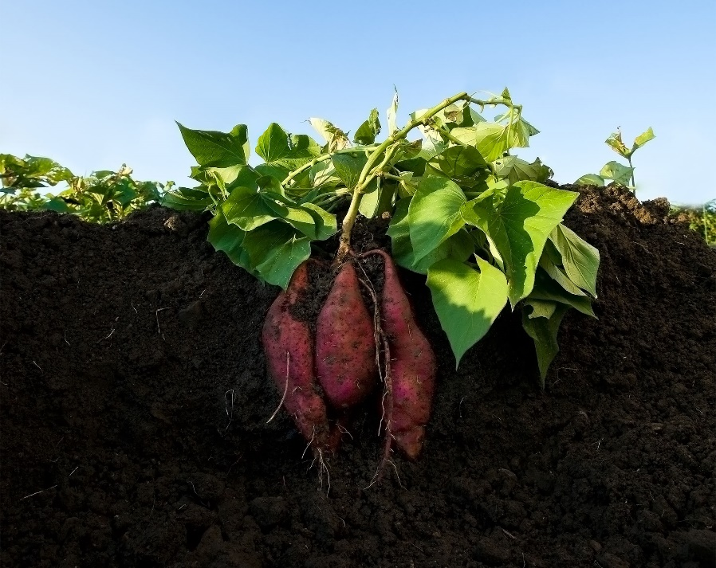

# **Broccoli Raab**

Broccoli raab resembles its close cousin broccoli, but it develops multiple clusters of buds instead of one big head and it has a more pronounced flavor. Thankfully, it’s just as easy to grow as broccoli. Plus, it’s ready for harvest much sooner after planting.

Genus name: Brassica rapa

Height: 6 to 12 inches

Sunlight: part sun, sun

Plant features: distinctively bitter, peppery flavor

Plant seasons: spring bloom, fall bloom

Plant region: native to China as well as the Mediterranean

Plant-info: A green leafed vegetable or cooking green, often used in Italian cooking, that is related to both the broccoli and turnip family of vegetables. The shoots of the flower buds and the stems of the Broccoli-raab are typically added as an ingredient to pasta or chicken dishes, or mixed into soups and salads, or served as a vegetable dish garnished with cheese and garlic. This vegetable can also be added to other foods with strong flavors such as sausages, seasoned meats, olives, or hot peppers to add a tangy or spicy enhancement to the flavors.

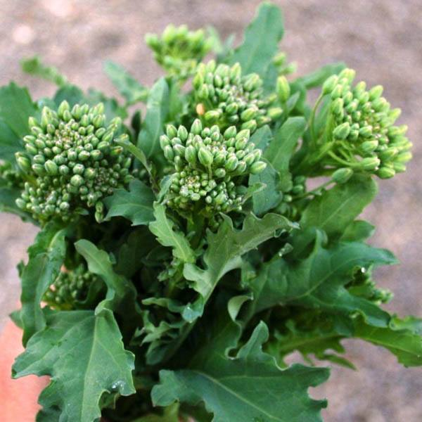

# **Winter Squash**

Winter squash are all known for the hard skins that protect them through the fall, winter, and sometimes even spring, depending on the variety. Every type of winter squash is edible, but the amount of flesh on the inside varies. If you love roasted squash or pumpkin pie, then these are the plants for you.

Genus name: [*Cucurbita moschata*](https://en.wikipedia.org/wiki/Cucurbita_moschata)

Height: 12 to 15 inches

Sunlight: part sun, sun

Plant features: uniquely beautiful with ribbed or bumpy skins, irregular shapes, and vibrant colors ranging from yellow to orange to dark green or even multi-toned

Plant seasons: spring bloom, fall bloom

Plant region:  native to Mexico and Central America

Plant-info: Winter squash is an annual fruit representing several [squash](https://en.wikipedia.org/wiki/Squash_(plant)) species within the genus [*Cucurbita*](https://en.wikipedia.org/wiki/Cucurbita). It differs from [summer squash](https://en.wikipedia.org/wiki/Summer_squash) in that it is harvested and eaten in the mature fruit stage when the seeds within have matured fully and the skin has hardened into a tough rind. At this stage, most varieties of this fruit can be stored for use during the winter. Winter squash is generally cooked before being eaten, and the skin or rind is not usually eaten as it is with summer squash.

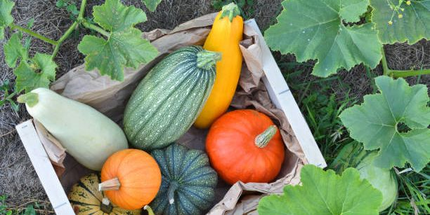

# **Bell Pepper**

bell peppers are much more than the classic green bell these days. It is a little more challenging to grow purple, red, and some orange peppers at home as they require an exceptionally long growing season. Green fruits are actually immature peppers. If you leave them on the plant, they eventually will develop one of the other colors, most commonly red, and become sweeter.

Genus name: Capsicum annuum

Height: 6 to 12 inches, 1 to 3 feet

Sunlight: sun

Plant features: Inside the thick flesh is an inner cavity with edible bitter seeds and a white spongy core

Plant seasons: spring bloom, fall bloom

Plant region:  originated in Mexico, Central America, and South America

Plant-info: **Bell pepper**, (Capsicum annuum), also called **sweet pepper**or **capsicum**, [pepper](https://www.britannica.com/plant/pepper-plant-Capsicum-genus) [cultivar](https://www.britannica.com/science/cultivar) in the nightshade family ([Solanaceae](https://www.britannica.com/plant/Solanaceae)), grown for its thick, mild fruits. Bell peppers are used in salads and in cooked dishes and are high in [vitamin A](https://www.britannica.com/science/vitamin-A) and [vitamin C](https://www.britannica.com/science/vitamin-C). The large furrowed fruits are technically [berries](https://www.britannica.com/science/berry-plant-reproductive-body) and can be green, red, yellow, or orange. Bell pepper plants are grown as [annuals](https://www.britannica.com/science/annual), and the green varieties are harvested before the appearance of red or yellow pigment—generally about 60–80 days after transplanting.

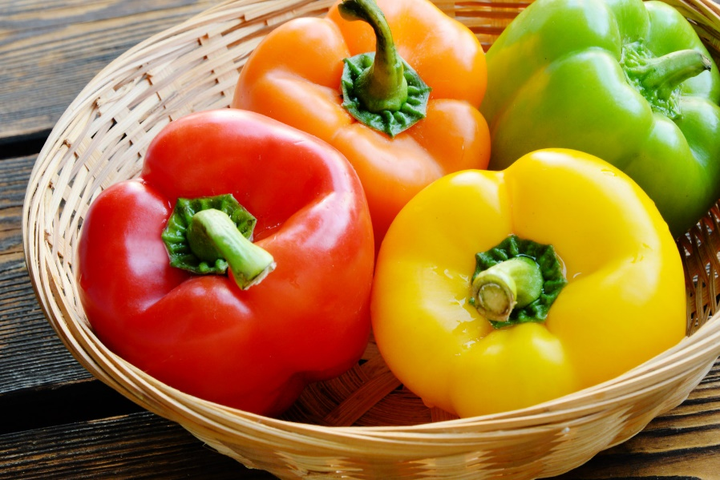

# **Pea**

Peas are a spring garden staple, loved for their easy-to-grow nature, delicious seeds, and nutritional value. There’s something magical about harvesting peas fresh from the garden and tasting their sweet, fresh flavor.

Genus name: Pisum Sativum

Height: 1 to 3 feet

Sunlight: sun

Plant features: Good for containers

Plant seasons: spring bloom

Plant region: native to the Mediterranean region, and ancient remains dating to the late Neolithic Period have been found in the Middle East

Plant-info: **Pea**, (Pisum sativum), also called **garden pea**, herbaceous annual plant in the family [Fabaceae](https://www.britannica.com/plant/Fabaceae), grown virtually worldwide for its edible seeds. Peas can be bought fresh, canned, or frozen, and dried peas are commonly used in soups. Some varieties, including sugar peas and snow peas, produce pods that are edible and are eaten raw or cooked like green beans; they are popular in East Asian cuisines. The plants are fairly easy to grow, and the seeds are a good source of [protein](https://www.britannica.com/science/protein) and [dietary fibre](https://www.britannica.com/science/dietary-fiber).

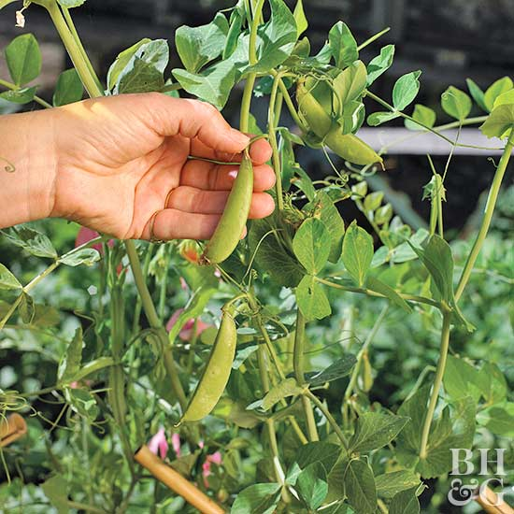

**HOUSE PLANTS**

[Pilea](https://www.bhg.com/gardening/plant-dictionary/houseplant/pilea/)

A symphony of leaf shapes, colors, and textures gives this diverse group of houseplants great character. It’s challenging to choose a favorite, as each displays the intricate beauty of nature with colorful veining and texture-rich leaves that beckon you to reach out and touch them. Also called friendship plant, pilea is easy to grow in medium light, making it perfect for everywhere: desktops, nightstands, sunny tabletops, and more.

GENUS:Pilea

HEIGHT: under 6 inches,6 to 12 inches

SUNLIGHT: sun,part sun

FEATURES:Low maintenance

SEASON: spring bloom,winter bloom

REGION:  [Cang Mountain](https://en.wikipedia.org/wiki/Cang_Mountain" \o "Cang Mountain) range in [Yunnan Province](https://en.wikipedia.org/wiki/Yunnan).

PROPAGATION: stem cutting

DESCRIPTION

Pilea peperomioides is an Asiatic perennial herb that is native to Yunnan Province in Southern China at the foot of the Himalayas. Pileas are a part of the stinging-nettle family, Urticaceae. Plants in this family usually have stinging hairs filled with irritating histamines. Achoo! Inflorescences consist of clusters of highly-reduced (missing more than one whorl), unshowy, unisexual flowers. Many plants in this family are considered weedy. Some Urtica are used as an herbal tea for various blood and menstrual ailments.

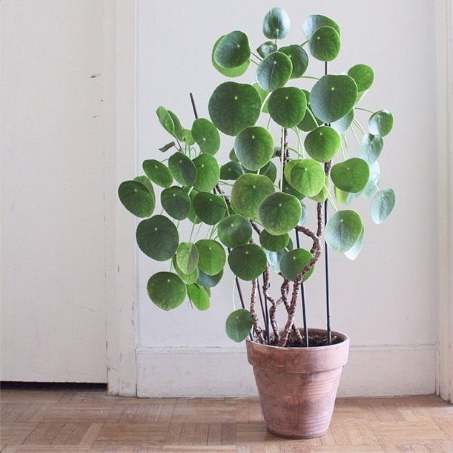

**African Violet**

Blooming off and on from January through December, African violets unfurl pretty flowers in shades of white, pink, and blue. The individual flowers last for a week or more. Count on the plants to be in bloom for about a month before taking a short break and erupting in a profusion of flowers again.

GENUS: *Saintpaulia ionantha*

HEIGHT: under 6 inches,6 to 12 inches

SUNLIGHT: sun

FEATURES:Low maintenance

SEASON: reblomming,summer bloom,spring bloom,winter bloom ,fall bloom

REGION:  . native to Tanzania and adjacent southeastern Kenya in eastern tropical Africa.

PROPAGATION: leaf cutting

DESCRIPTION

**African violet**, (genus Saintpaulia), any of the six [species](https://www.britannica.com/science/species-taxon) of flowering plants in the genus Saintpaulia (family [Gesneriaceae](https://www.britannica.com/plant/Gesneriaceae)). Native to higher elevations in tropical eastern Africa, African violets are widely grown horticulturally, especially S. ionantha. The members of Saintpaulia are small [perennial](https://www.britannica.com/science/perennial) herbs with thick, hairy, ovate [leaves](https://www.britannica.com/science/leaf-plant-anatomy). These dark green leaves have long petioles (leaf stems) and are arranged in a basal cluster at the base of the [plant](https://www.britannica.com/plant/plant). The violet-like [flowers](https://www.britannica.com/science/flower) are bilaterally symmetric with five petals and can be violet, white, or pink in colour. The tiny seeds are produced in a [capsule](https://www.britannica.com/science/capsule-plant).

**Geranium**

A truly classic garden plant, geraniums have been a gardener's favorite for well over a century. The old-fashioned standard for beds, borders, and containers, geranium is still one of the most popular plants today. Traditional bedding types love hot weather and hold up well in dry conditions. Though most geraniums are grown as annuals, they are perennials in Zones 10–11. Bring them indoors to overwinter, if you like, then replant outdoors in spring. (Or they can bloom indoors all year long if they get enough light.)

GENUS:pelargonium

HEIGHT: under 6 inches,6 to 12 inches

SUNLIGHT: sun

FEATURES : Low maintenance , good for containers

SEASON: reblooming ,summer bloom ,spring bloom ,winter bloom ,fall bloom

REGION:  .temperate regions of the world and the mountains of the tropics, but mostly in the eastern part of the  Mediterranean Sea

PROPAGATION: leaf cutting , seed

DESCRIPTION:

Geranium is a [genus](https://en.wikipedia.org/wiki/Genus) of 422 [species](https://en.wikipedia.org/wiki/Species) of [annual](https://en.wikipedia.org/wiki/Annual_plant), [biennial](https://en.wikipedia.org/wiki/Biennial_plant), and [perennial](https://en.wikipedia.org/wiki/Perennial_plant) [plants](https://en.wikipedia.org/wiki/Plant) that are commonly known as geraniums or cranesbills**.** The palmately cleft [leaves](https://en.wikipedia.org/wiki/Leaf) are broadly circular in form. The flowers have five petals and are coloured white, pink, purple or blue, often with distinctive veining. Geraniums will grow in any soil as long as it is not waterlogged. [Propagation](https://en.wikipedia.org/wiki/Plant_propagation) is by semiripe cuttings in summer, by seed, or by division in autumn or spring.

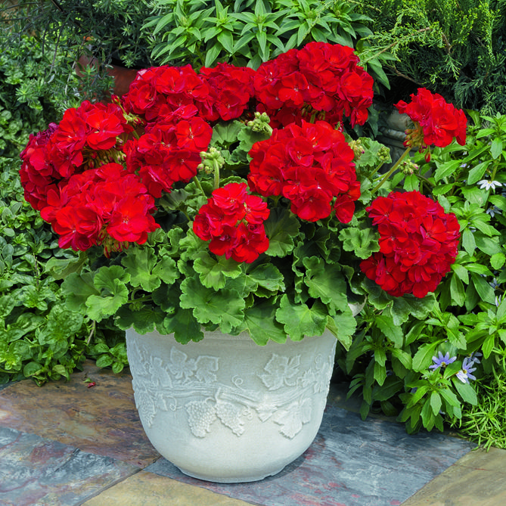

# Dieffenbachia

Dieffenbachia (also known as dumb cane) is a popular houseplant grown for its large, showy leaves. They are generally green with splashes or blotches of creamy white, although cultivars have expanded the palette to include yellow. This plant can grow quite large in the right setting (6 to 10 feet tall in its native Brazil, for example), but offers smaller sizes, too. As lower leaves naturally drop off over time, the plant’s cane-like stems become visible.

GENUS: Dieffenbachia sanguine

HEIGHT : 1 to 3 feet ,3 to 8 feet, 8 to 20 feet

SUNLIGHT : part sun, shade

FEATURES : Low maintenance , good for containers

SEASON: summer bloom

REGION:  Native to Central and South America

PROPAGATION: stem cutting

DESCRIPTION:

Dieffenbachia, otherwise known as dumb cane, comes in a lot of varieties, all of which make great houseplants. This is a houseplant that can live and thrive easily, but it's known for some toxicity to human and pets.

# Croton

Croton, a perennial with hard, woody stems and roots, features leathery, smooth-edge, oval- or lance-shape leaves in bright colors. These colors are often combined in patterns involving blotching and striping, and sometimes the color changes as the plant ages. Native to Malaysia, the Pacific Islands, and northern Australia, crotons are most often grown as houseplants, but they can be planted in containers outdoors for season-long color.

GENUS:codieum

HEIGHT: 1 to 3 feet , 3 to 8 feet, 8 to 20 feet

SUNLIGHT: sun, part sun

FEATURES : Low maintenance , good for containers

SEASON:

REGION:  native to Malaysia, India and some of the South Pacific Islands  
PROPAGATION: stem cutting

DESCRIPTION:

Croton plants are incredibly varied plants that are often grown as houseplants. The croton indoor plant has a reputation for being fussy, but in reality, if you know about caring for a croton houseplant properly, it can make for a resilient and hard-to-kill plant.

**OXALIS**

This diverse genus is comprised of hundreds of species. There's a wide range of annuals, perennials, and even tropical types of oxalis. Many oxalis are bulb-forming plants while others form vigorous spreading plants that can create dense colonies. Several species can also make wonderful, easy-to-grow houseplants. GENUS: Oxalis

HEIGHT : under 6 inches,6 to 12 inches

SUNLIGHT : part sun, shade

FEATURES : Low maintenance , good for containers

SEASON: summer bloom , winter bloom , fall bloom , spring bloom

REGION:  Native to Central and South America

PROPAGATION: stem cutting , seed ,division

DESCRIPTION:

***Oxalis*** [/ˈɒksəlɪs/](https://en.wikipedia.org/wiki/Help:IPA/English) (American English)[[1]](https://en.wikipedia.org/wiki/Oxalis#cite_note-1) or [/ɒksˈɑːlɪs/](https://en.wikipedia.org/wiki/Help:IPA/English) (British English)[[2]](https://en.wikipedia.org/wiki/Oxalis#cite_note-2) is a large [genus](https://en.wikipedia.org/wiki/Genus) of [flowering plants](https://en.wikipedia.org/wiki/Flowering_plants) in the wood-sorrel family [Oxalidaceae](https://en.wikipedia.org/wiki/Oxalidaceae" \o "Oxalidaceae) comprising about 570 [species](https://en.wikipedia.org/wiki/Species).[[3]](https://en.wikipedia.org/wiki/Oxalis#cite_note-Christenhusz-Byng2016-3) The genus occurs throughout most of the world, except for the [polar](https://en.wikipedia.org/wiki/Polar_region) areas; species diversity is particularly rich in tropical [Brazil](https://en.wikipedia.org/wiki/Brazil), [Mexico](https://en.wikipedia.org/wiki/Mexico) and [South Africa](https://en.wikipedia.org/wiki/South_Africa).

Many of the species are known as **wood sorrels** (sometimes written "woodsorrels" or "wood-sorrels") as they have an acidic taste reminiscent of the sorrel proper ([*Rumex acetosa*](https://en.wikipedia.org/wiki/Rumex_acetosa)), which is only distantly related. Some species are called **yellow sorrels** or **pink sorrels** after the color of their flowers instead. Other species are colloquially known as **false**[shamrocks](https://en.wikipedia.org/wiki/Shamrock), and some called [sourgrasses](https://en.wikipedia.org/wiki/Sourgrass" \o "Sourgrass). For the genus as a whole, the term **oxalises** is also used.

**Bay**

A culinary classic, bay's glossy green foliage is a flavor favorite in soups, stews, and meat dishes. Bay only survives to 25 degrees, so it's commonly grown in containers, sounding a steady evergreen note on patios during the growing season and gracing sunny interior windows after frost. In the landscape, established trees are fuss-free and drought tolerant. Potted bay is susceptible to scale insects; hand-pick any offenders. Protect potted bay from intense sunlight in hottest zones. If you love to cook, keep dried leaves on hand; they're an essential herb for bouquet garni.

GENUS: Lourus nobilis

HEIGHT : under 6 inches, 1 to 3 feet , 3 to to 8 feet, 8 to 20 feet

SUNLIGHT : part sun, sun

FEATURES : good for containers

SEASON: summer bloom , winter inerest , spring bloom

REGION:  Native to Mediterranean Region

PROPAGATION: stem cutting

DESCRIPTION:

**Bay tree**, also known as **bay** laurel belongs to the laurel family. It originates from Mediterranean region, but it can be found around the world today. **Bay tree** grows in ravines, woodlands and thickets. It prefers fertile, well-drained soil (sandy soil, loam and clay) and areas that provide partial shade or full sun.

**TREES**

Bradford pear

Snowy early-spring blossoms and a tall pyramidal shape make flowering pear the ideal lawn tree for home landscapes. It also tolerates urban conditions such as air pollution. Select smaller, narrower varieties such 'Chanticleer' and 'Valiant' for street-side tree planting. A bonus is the fall color; 'Redspire' is a good choice for deep purple-red fall foliage. The tiny fruits appeal to summer birds.

GENUS: Pyrus calleryana

HEIGHT : 20 feet or more

SUNLIGHT : part sun, sun

FEATURES : good for containers , attract birds , low maintenanace

SEASON: colorful fall foliage , spring bloom

REGION:  Native to China and Vietnam

PROPAGATION: stem cutting

DESCRIPTION:

Bradford pear (Pyrus calleryana ‘Bradford’) is a spring-flowering tree that has been widely planted throughout the eastern U.S. in the last few decades. It is a popular tree that is frequently seen in nearly every city within its growing range. The species is a native of China, Taiwan, Japan, and Vietnam; the cultivar ‘Bradford’ is the most commonly planted in South Carolina.

# Maple

Maples are the premier trees for providing shade and dramatic fall color. And happily, there's a maple tree for just about every size landscape—from smaller varieties that stay below 20 feet tall to large species that can reach 100 feet or more. And if you think maples are only showy for their leaves, think again. Some types (such as the paperbark maple and coral bark Japanese maple) display intriguing branch color and texture. Other species, such as the red maple, display brightly colored flower clusters.

GENUS:Acer spp

HEIGHT : 20 feet or more

SUNLIGHT : part sun, sun

FEATURES : good for containers , attract birds , low maintenanace

SEASON: colorful fall foliage , spring bloom , winter interest

REGION:

PROPAGATION: stem cutting , seed , grafting

DESCRIPTION:

***Acer*** [/ˈeɪsər/](https://en.wikipedia.org/wiki/Help:IPA/English) is a [genus](https://en.wikipedia.org/wiki/Genus) of trees and shrubs commonly known as **maples**. The [genus](https://en.wikipedia.org/wiki/Genus) is placed in the family [Sapindaceae](https://en.wikipedia.org/wiki/Sapindaceae" \o "Sapindaceae).[[1]](https://en.wikipedia.org/wiki/Maple#cite_note-1) There are approximately 128 [species](https://en.wikipedia.org/wiki/Species), most of which are native to [Asia](https://en.wikipedia.org/wiki/Asia),[[2]](https://en.wikipedia.org/wiki/Maple#cite_note-2) with a number also appearing in [Europe](https://en.wikipedia.org/wiki/Europe), northern [Africa](https://en.wikipedia.org/wiki/Africa), and [North America](https://en.wikipedia.org/wiki/North_America). Only one species, [*Acer laurinum*](https://en.wikipedia.org/wiki/Acer_laurinum), extends to the [Southern Hemisphere](https://en.wikipedia.org/wiki/Southern_Hemisphere).[[3]](https://en.wikipedia.org/wiki/Maple#cite_note-The_Red_List_of_Maples-3) The [type species](https://en.wikipedia.org/wiki/Type_species) of the genus is the sycamore maple, [*Acer pseudoplatanus*](https://en.wikipedia.org/wiki/Acer_pseudoplatanus), the most common maple species in Europe.[[4]](https://en.wikipedia.org/wiki/Maple#cite_note-gelderen-4) The maples usually have easily recognizable [palmate](https://en.wikipedia.org/wiki/Palmate) leaves ([Acer negundo](https://en.wikipedia.org/wiki/Acer_negundo) is an exception) and distinctive [winged fruits](https://en.wikipedia.org/wiki/Samara_(fruit)). The closest relatives of the maples are the [horse chestnuts](https://en.wikipedia.org/wiki/Horse_chestnuts). [Maple syrup](https://en.wikipedia.org/wiki/Maple_syrup) is made from the sap of some maple species.

American Hornbeam

A North American native tree boasting a kaleidoscope of color, American hornbeam unfurls striking reddish purple leaves in spring. The leaves turn dark green in summer and then come ablaze with shades of yellow and orange-red in fall. This tree brings interest to the winter landscape, too, by displaying blue-gray bark with a slightly rippled appearance that earned the common name musclewood. At 20–35 feet tall and wide, the American hornbeam tree suits most residential landscapes. It’s also notably pest- and disease-resistant.

GENUS:Carpinus caroliniana

HEIGHT : 20 feet or more

SUNLIGHT : part sun, sun

FEATURES : low maintenanace

SEASON: colorful fall foliage , winter interest

REGION:  America

PROPAGATION: seed

DESCRIPTION:

The American hornbeam is a native forest understory tree in the Chicago area, making it useful for shady landscapes and naturalized or woodland gardens. New leaves emerge reddish-purple, changing to dark green, then turn yellow to orange-red in the fall, offering a kaleidoscope of color throughout the year. Even in winter, the tree's fluted blue-gray bark with long, sinewy ridges make it a special addition to the landscape. This plant has some cultivated varieties.

Katsura Tree

Katsura is classified as a shade tree and is a standout in this large category of plants. A slow grower with a pleasing pyramidal form when young, katsura is a great plant for a front-yard or backyard planting or for lining a driveway or planting street-side. Unlike many common shade trees, katsura’s heart-shape leaves present a rainbow of foliage colors beginning with bronzy young leaves in spring, followed by blue-green summer foliage that turns to warm shades of orange and golden yellow in fall. The leaves are reminiscent of redbud foliage and are a pleasing contrast to angular leaves of maple and oaks.

GENUS:Cercidiphyllum japonicum

HEIGHT : 20 feet or more

SUNLIGHT : sun

FEATURES : low maintenanace

SEASON: colorful fall foliage

REGION:  Katsura  is a neighborhood in Nishikyo-ku, in the western part of the city of Kyoto, in Japan.

PROPAGATION: seed

DESCRIPTION:

**Katsura** is a neighborhood in [Nishikyo-ku](https://en.wikipedia.org/wiki/Nishikyo-ku,_Kyoto), in the western part of the city of [Kyoto](https://en.wikipedia.org/wiki/Kyoto), in [Japan](https://en.wikipedia.org/wiki/Japan). It is also a particularly wealthy area, with most residents owning large, free-standing houses. The center includes an *[onsen](https://en.wikipedia.org/wiki/Onsen)*, numerous restaurants and shops, and ubiquitous [*pachinko*](https://en.wikipedia.org/wiki/Pachinko) parlors. In the residential area, there is also an [Izumiya](https://en.wikipedia.org/wiki/Izumiya) supermarket, one of the few in the Kyoto area.