CSC1020

Group E

Student Name | Student ID | Contributions | Contribution Percentage
Uvidu Vihan DeSilva | 23101016 | - Sections 3.4 to 3.8  - Made Use Case tables (Ride Request and Cancel Ride)  - Fixing all formatting issues  - Checking consistency throughout document | 20%
Uchenna King | 24522 | - Domain Model (Associations + Multiplicities + Diagram)  - Completed Sections 3.1 and 3.2 and 3.3 and made use case overview diagram and use case tables (login, view ride history, gps location, add payment method) | 20%
Lucero Dafne Sangueza Espinoza | 23100952 | - Sections sections 1.1 to 1.2  - System Vision/rich picture (Operational environment, Business environment Actors),  - Onion model  - Non-Functional Quality Requirements | 20%
Petra Sartori | 23324986 | - Sections 2.1.6 to 2.5  - Including constraints  - Goal Model Diagram (Stakeholders, Goals and Subgoals) | 20%
Josh Sheridan | 31301 | - Sections 2.1.1 to 2.1.5  - Stakeholders  - Stakeholder Matrix  - Domain Classes (class, attributes, and operations only)  - Explanation of the use of domain class model | 20%

Software Requirements Specification

Document

Version: (2) Date: (23/11/2025)

Table of Contents

1. Introduction
1.1 Purpose
1.2 Scope
1.3 Definitions, Acronyms, and Abbreviations
1.4 References
1.5 Overview

2. The Overall Description
2.1 Product Perspective
2.1.1 System Interfaces
2.1.2 Interfaces
2.1.3 Hardware Interfaces
2.1.4 Software Interfaces
2.1.5 Communications Interfaces
2.1.6 Memory Constraints
2.1.7 Operations
2.1.8 Site Adaptation Requirements
2.2 Product Functions
2.3 User Characteristics
2.4 Constraints
2.5 Assumptions and Dependencies
2.6 Apportioning of Requirements

3. Specific Requirements
3.1 External interfaces
3.2 Functions
3.3 Performance Requirements
3.4 Logical Database Requirements
3.5 Design Constraints
3.6 Software System Attributes
3.6.1 Reliability
3.6.2 Availability
3.6.3 Security
3.6.4 Maintainability
3.6.5 Portability
3.7 Organizing the Specific Requirements
3.8 Additional Comments

1. Introduction

1.1 Purpose
The purpose of this Software Requirements Specification (SRS) document is to define and examine the requirements for the Uber Ride Service System. This service is a client-server system that provides a mobile interface for passengers to request private transportation by specifying customisable pickup locations and destinations.
The following sections present an in-depth overview of the system’s purpose, features, stakeholders and goals. The document is primarily directed for all individuals involved in the development of the system, such as systems analysts, developers and testers that require a comprehensive understanding of the system’s components, requirements and functions.

1.2 Scope
The system defined in this SRS is Uber Ride Service System, which focuses only on the driver-passenger environment and excludes all additional multi-services that Uber platform provides. Therefore, additional branches of the platform such as Uber Eats, Uber freight are beyond the scope of this SRS.
The system is built on a digital interface where passengers can request rides and drivers can accept them. Functionalities such as booking rides, passenger - driver matching, real-time vehicle location tracking, cashless in-app payments and trip rating submissions are the core functions of the system.
As opposed to traditional taxis, Uber Ride Service System is designed to encourage individual private mobility by providing a more accessible, safe, and efficient transportation alternative. The system aims to lower passenger waiting times, increase demand availability, enhance safety of passengers while providing secure cashless transactions.
These features not only benefit passengers by offering a convenient access to means of transportation but also benefit drivers by providing flexible earning opportunities while optimising and streamlining demand and supply coordination through an integrated mobile interface.

1.3 Definitions, Acronyms, and Abbreviations.
This section defines the terms, acronyms, and abbreviations. Below are the key terms used throughout this document to ensure clarity.
1.3.1 SRS: Software Requirements Specification. It is a crucial document used to build software that meets both business needs and user expectations.
1.3.2 GPS: Global Positioning System. It is a technology that uses communication with a constellation of satellites in space to pinpoint precise locations on Earth.
1.3.3 UI: User Interface. It is the platform of interaction between a machine and a human, it involves visual, tactile and auditory elements that allow people to interact with and control a system on a device.
1.3.4 ETA: Estimated Time of Arrival
1.3.5 API: Application Programming Interface. A collection of rules that allow interaction and communication between a wide range of different systems.
1.3.6 App: Mobile Application.
1.3.7 UAT: User Acceptance Testing. Actual end users test the software in real-world settings to ensure that it satisfies all requirements before a system’s deployment.
1.3.8 QR: Quality Requirement. Quantifiable criteria for the quality of the system. Based on a quality model such as ISO 25010 or Gravin’s 8 Dimensions.

1.4 References

- Engineers, I. of E. and E. (1998) IEEE recommended practice for software Requirements Specifications
- IEEE (1998). IEEE Recommended Practice for Software Requirements Specifications. IEEE Std 830-1998, [online] pp.1–40. doi:https://doi.org/10.1109/IEEESTD.1998.88286.
- ⁠Apple (2024). App Store Review Guidelines - Apple Developer. [online] Apple.com. Available at: https://developer.apple.com/app-store/review/guidelines/.
- ⁠play.google.com. (n.d.). Release | Google Play Console. [online] Available at: https://play.google.com/console/about/guides/releasewithconfidence/.
- Uber’s community guidelines: Safety and respect for all Uber. Available at: https://www.uber.com/gb/en/safety/uber-community-guidelines/ (Accessed: 24 October 2025).
- Safety Uber. Available at: https://www.uber.com/ie/en/safety/ (Accessed: 24 October 2025).
- What’s in your data download? | Riders | Uber Help (2025). https://help.uber.com/en/riders/article/whats-in-your-data-download?nodeId=3d476006-87a4-4404-ac1e-216825414e05 (Accessed: October 24, 2025).
- Uber Privacy Notice: Riders & Order Recipients (2025). https://www.uber.com/global/en/privacy-notice-riders-order-recipients/ (Accessed: October 22, 2025).
- Setting up MFA using Authenticator App | Uber for Business | Uber Help (2025). https://help.uber.com/business/article/setting-up-mfa-using-authenticator-app?nodeId=96191bd5-1613-4157-908f-a3b27738ea33 (Accessed: October 25, 2025).
- Lastovetska, A. (2021) Explaining Uber API: why to integrate it and how | MLSDev. https://mlsdev.com/blog/uber-api.
- Improving Driver Communication through One-Click Chat, Uber’s Smart Reply System | Uber Blog (2018). https://www.uber.com/en-IN/blog/one-click-chat/.
- Oireachtas.ie. (2025). Taxi Regulations. [online] Available at: https://www.oireachtas.ie/en/debates/question/2025-03-19/302/ [Accessed 25 Oct. 2025].
- Uber (2021). The Architecture of Uber’s API gateway. [online] Uber Blog. Available at: https://www.uber.com/en-IE/blog/architecture-api-gateway/ [Accessed 24 Oct. 2025].
- Uber (2025). Downloading the rider app. [online] Uber Help. Available at: https://help.uber.com/riders/article/downloading-the-rider-app-?nodeId=bd546eae-73e0-49e3-a2da-0dbfa2a1d526 [Accessed 24 Oct. 2025].
- Uber (2025). Robust Database Backup Recovery at Uber. [online] Uber Blog. Available at: https://www.uber.com/en-IE/blog/robust-database-backup-recovery-at-uber/ [Accessed 24 Oct. 2025].
- Scientiamobile.com. (2022). How Much RAM is in Smartphones? – ScientiaMobile. [online] Available at:
- How Much RAM is in Smartphones? (2025). https://scientiamobile.com/how-much-ram-is-in-smartphones/.
- Chawla, P. (2024) 'How Uber Conquered UX Design,' Medium. https://blog.prototypr.io/how-uber-conquered-ux-design-1d9c56788a41 (Accessed: October 11, 2025).
- Features for deaf and hard of hearing drivers | Driving & Delivering | Uber Help (no date). https://help.uber.com/driving-and-delivering/article/features-for-deaf-and-hard-of-hearing-drivers/?nodeId=d1d88d1f-0dcf-4ce8-a3a9-c3955d14c2ff&uclick_id=b0a016bb-0037-47e2-b503-f997ec9edde0.
- Request a ride with TalkBack | Riders | Uber Help (no date). https://help.uber.com/en/riders/article/request-a-ride-with-talkback?nodeId=5a9ca82e-f92a-4237-bb2d-5547e0c86fbb.
- Uber Privacy notice: Drivers and delivery people (no date). https://www.uber.com/global/en/privacy-notice-drivers-delivery-people/.
- Explore the Uber platform | Earn & Ride | Uber (no date). https://www.uber.com/us/en/safety/rider-verification/.
- Explore the Uber platform | Earn & Ride | Uber (no date b). https://www.uber.com/us/en/drive/product-updates/summer-2024/.
- Medisetty, U.K. (2020) Uber’s Real-Time push platform | Uber Blog. https://www.uber.com/en-IE/blog/real-time-push-platform/.
- Chandrasekar, A. (2025) 'The Story of Uber’s Journey: From REST to gRPC to Domain-Driven Architecture,' Medium. https://medium.com/@archanachandrasekar563/the-story-of-ubers-journey-from-rest-to-grpc-to-domain-driven-architecture-bfa458940c25.
- Uber built a great ridesharing experience with SMS & Voice | Twilio (no date). https://customers.twilio.com/en-us/uber.

1.5 Overview
This document is organised into three main sections. Section 1 provides an introduction alongside general information about what Uber Ride Service System is. The remainder of the document includes Section 2 and Section 3. Section 2 offers a thorough overview of the system’s environment, primary functions, technical interfaces, constraints, stakeholders and operational assumptions, providing the overall context of the system for users. Section 3 outlines functional and non-functional requirements, in conjunction with the use cases and performance expectations of the system and is of major interest for the system development team. Together, Section 2 and Section 3 offer an exhaustive understanding of the system from both user and developer standpoint.

2. The Overall Description
The system is a mobile and web-based app. When a passenger makes a request, they enter their collection and destination locations with the size of the car they require. The system proceeds to identify nearby drivers in the passenger’s area. This process requires backend servers that match requests with drivers.
Once a driver receives a request with the passenger’s information (pick up location and estimated fare) and accepts it, the system confirms the match and it provides real-time navigation. When reaching the destination, the trip ends and fare is automatically recalculated and the passenger is charged through the in-app payment system.
After payment completion, both driver and passenger can rate each other. The trip information such as payment data and feedback rating is then stored in the system’s backend servers.
This entire process requires the system to store and organise information about passengers, drivers, rides, and payments. The data must be linked accurately such that both user and driver have access to history rides and are able to identify what payments belong to each ride. All this information has to be protected from any unauthorised access.
Interactions such as driver ride acceptance or payment receipt have to be updated in real-time for both parties to be informed. Past ride records have to be saved and displayed in the UI for a period of time. The system then moves older records when they are no longer needed by users.
The system is required to display different functions for different primary users. Passengers should be able to book rides and track their driver’s location. Drivers must have access to accept ride requests or mark rides completed. Admins should be able to manage users (drivers and passengers) and monitor the entire system to ensure its proper functioning.

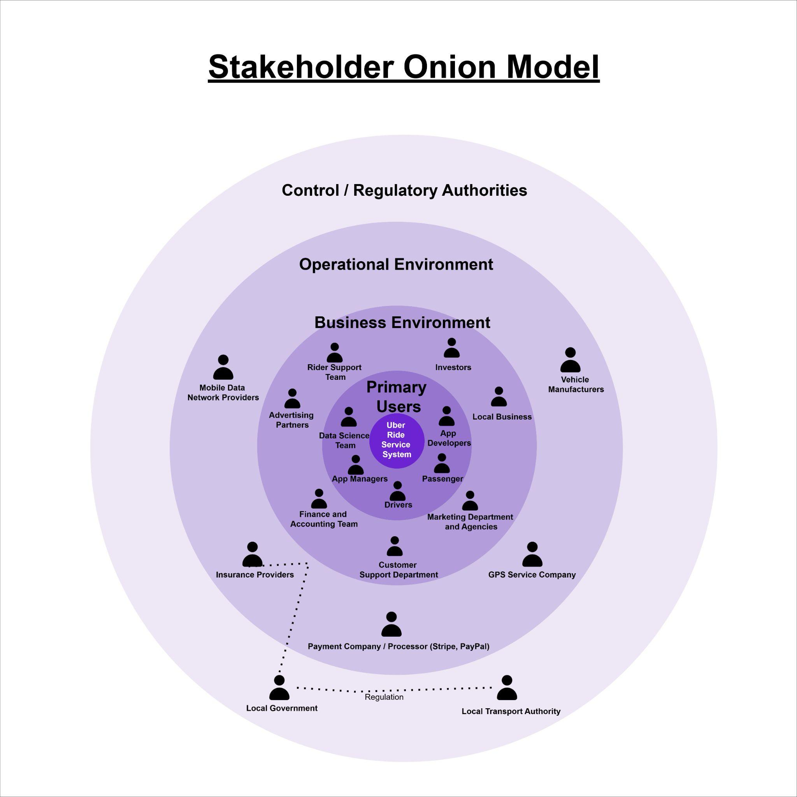
Fig. 2.1 Stakeholder Onion Model
Table 2.1 Stakeholder Matrix

Stakeholder Role | Stakeholder | Necessary Involvement | Business Goals | Technical Constraints | Look and Feel | Functionality | Usability | Performance
Primary Users | Passengers | Continuous involvement as active users | Customer satisfaction, repeat usage | App must support multiple device types and OS | Simple user- friendly interface | Booking rides, payments | Easy to use for ride booking | Fast response, quick ride confirmation
Primary Users  Business Environment Stakeholders | App Managers  Customer Support Department | Constantly overseeing app function and performance  Customer interactions and troubleshooting | Ensure app runs smoothly and meets customer needs  Resolve customer issues | Backend infrastructure, app stability  Access to customer data systems | Organized backend management  Clear interface for customer support | System maintenance, updates, bug fixes  Tools for handling questions, complaints, refunds | User experience should be consistent  Access to user data for problem- solving | Uptime and performance under heavy traffic  Fast resolutions
Business Environment Stakeholders | Marketing and Sales Team | Involvement in campaigns and promotions | Increase sales, acquire new customers | Integration with marketing platforms (emails, instagram etc etc) | Branding, attractive offers | Tools for promotions | Accessible promotional content and offers to users | Quick turnaround on ads
Business Environment Stakeholders | Investors/Shareholders | Quarterly decision-making and strategy | Financial growth, profits | N/A | Simple visuals for financial presentations | Reporting and real-time analytics | Easily understandable financial reports | Fast and accurate reports
Business Environment Stakeholders | Advertising Partners | Occasional help in creating ad campaigns | Attract new customers | App must support ad integration | Ads that fit within the app style | Targeted ads | Access to ad campaigns and stats for partners | Ads load quickly, integration with app
Operational Environment (External System)  Operational Environment (External  System) | Payment and Accounting Team  GPS/Mapping Service Providers | Constantly processing payments/transact ions  Occasional route optimisation and location tracking | Secure transactions, track profits  Accurate navigation for drivers | Secure payment integration, works with payments processors  Integration with mapping services,  real-time location data | Payment gateways are easy to use  Navigation screens must be clear, with accurate data | Payment processing, invoicing, track profits  Real-time routing and location tracking for rides | Simple interface for payments  Easy navigation, clear directions for drivers | Transactions processed quickly and securely  Real-time updates on routes and locations
Operational Environment (External System) | Mobile Data Network Providers | Continuous involvement for ensuring network connectivity | Ensure uninterrupted service | High bandwidth, low latency for real-time data syncing | Understandable network status information for users | Ensure data transmission doesn’t harm ride functionality | Maintain stable data connections | Minimal delay or service interruptions
Control Authority  Control Authority | Local Transport Authorities (Local Governments)  Regulatory Authorities (Local Government) | Periodically check for compliance with local transport laws Involvement as required for ensuring compliance with transport  regulations | Abiding law in all operating regions  Maintain law in transport sector | Must ensure compliance with local laws regarding ride- sharing  Must meet all regional transportation laws | Legal terms should be clearly visible | Monitoring operations, compliance checks  Ensure the app complies with legal standards e.  g. ADA | Transparent pricing and service policies for riders and drivers  Easy access to laws, clear understanding of rights | Fast updates on regulatory changes  Enforcement of new legal requirements
Operational Environment (External System) | Insurance Providers | Periodic checkins to ensure protection of passengers/driver s | Reduce risks, cover incidents | Insurance data integration, incident reporting capabilities | Understandable insurance coverage/claims process | Fast incident reports and insurance claims | Insurance information easily accessible within the app | Fast claim processing
Operational Environment (External System)  Operational Environment (External System)  Primary Users | Vehicle Manufacturers  Rider Support Team  App Developers | Occasionally checking vehicles are safely made  Continuous involvement for resolving rider concerns  Continuously doing system updates, improving app,  bug fixes | Ensure vehicle safety standards  Ensure quality of service  Ensure app is optimised and no bugs | App must support vehicle type  Support integration with comms methods  Compatibility across devices | Clear vehicle condition and safety status info  Support contacts, live chat, etc.  Intuitive designs and interfaces for updates | Making adequately constructed vehicles  Troubleshooting tools  System updates, bug fixes, new features | Access to vehicle specs for users/stakeholders  Access to help desk, FAQ, live chat  Clean, thought out development (SRS, dev cycles, etc) | Access to vehicle info, maintenance tracking, alert to defects  Good response time for user questions  Fast implementation of features and bug fixes
Primary Users | Drivers | Continuous taking ride assignments | Earn a wage | Integration with nav systems and payment processors | Simple interface for easy ride management and feedback | Real-time ride requests, location tracking, payment processor | Understandable interface for drivers to accept, and rate rides | Fast response to ride requests
Primary Users  Operational Environment (External System) | Data Science Team  Local Businesses | Constantly looking at data to look for improvements  Occasional benefits from riders using Uber  app to patronise business | Optimise business functions  Improve patron numbers, boost local economy | Data science tools, expensive software licences  N/A | Understandable graphs of business performance data  Compelling promotional materials | Analysis of business strengths and weaknesses, data collections  Support for local businesses, mutual benefit | Readable good data for easy use by team  N/A | Identify ways for business improvement based on data  Local promotions, increased  patronage (bars, clubs etc)
Business Environment Stakeholders | Marketing Agencies | Regular involvement in promoting Uber’s services | Increase userbase | App must support advertising campaigns | Compelling marketing content in app | Advertising, promotions, customer acquisition | Simple and accessible marketing content | Fast ad load times, user outreach

2.1 Product Perspective
The larger Uber app system is a transportation service platform that encompasses other digital services such as food delivery (Uber Eats) and logistics (Uber freight). Within this broader ecosystem, the Uber Ride Service System is in charge of providing individuals with on-demand, efficient, and safe transportation. Certain features such as payment gateways, user authentication, GPS tracking and rating feedback are shared among Uber business units.
However, while Uber Eats and Uber freight share similar functionalities, the Uber Ride Service System uniquely manages human passengers requesting immediate transportation with sequential route guidance, real-time rerouting and fare estimation while ensuring passengers safety during travel.
Uber Ride Service System provides functionalities that include but are not limited to:
1. User accounts creation, login and security maintenance
2. Ride requests handling
3. ⁠Driver matching and accepting rides
4. ⁠GPS navigation tracking
5. ⁠Passenger - driver communication
6. ⁠Payment processing
7. ⁠Ratings submissions
8. ⁠Trip history
9. ⁠Admin management
10. ⁠Scheduling rides
To perform these functions, the system is required to interact with additional external components such as Google maps API for GPS navigation tracking, route calculation and ETA which uses passengers pick up and destination location data to estimate arrival time and fare.
Stripe/PayPal are used for payment receival and processing that securely stores passengers payment details. Twilio for passenger - driver communication to allow passenger and driver locate each other accurately or in case of last minute changes.
While the system depends on the external services described above, every functionality is controlled entirely by the system’s backend infrastructure, managing the overall system’s logic.
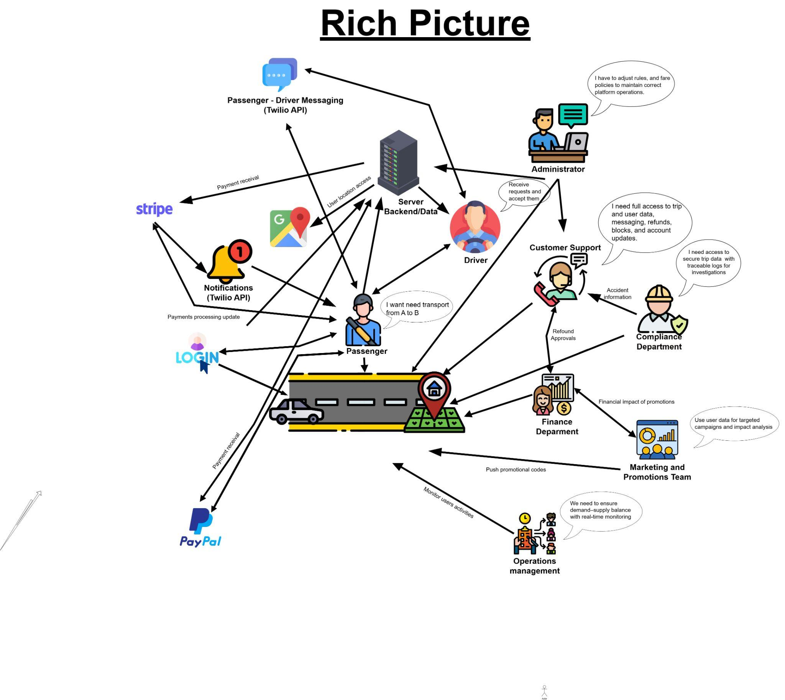
Fig. 2.2 System Vision
The purpose of the System Vision above is to help any stakeholder visually comprehend the system components, interactions and functions. It illustrates the passenger transportation as the core of the system and provides the operational environment where the system interacts with third-party services such as specific APIs for pushing notifications, Stripe and PayPal for payment processing with live updates through server communication and secure login authentication.

Internally, the business environment is constituted of business departments that interact with the system such as Customer Support, Finance, Compliance, Marketing, Operations, and Administration. These departments require access to data for monitoring, promotional campaigns, decision-making and user management. The primary users/actors are the passenger, driver and administrator.

All these components form the system’s operational and business environment, ensuring proper and efficient overall business functioning, ride processing and tracking.

2.1.1 System Interfaces

The main system interface of the Uber app must be the Uber API. It allows for connection to other internal and external services, such as ride requests, navigation, and transactions, among others. It is also known as REST API, allowing for HTTP keyword methods, and interaction with other systems. It is used to integrate with other services and APIs, e.g. Google Maps for navigation and Stripe (or whatever other payment processors).

It must interface with various systems:
- Payment gateways
- Map services
- SMS notification systems
- ID verification systems (e.g. OAuth 2.0, referenced later)
- GPS services
- Driver ratings
- Surge pricing
Some of these are contained in Uber’s backend services, while others are external APIs that Uber links to.

2.1.2 Interfaces

The primary interface for users of the Uber app is the mobile application interface, employing a Graphical User Interface (GUI) for user interaction. The key components include: the passenger interface and the driver interface. The passenger interface includes:
- Map showing current location
- Ride request buttons, ride options
- Ride tracking, estimated times of arrival
- Payment and rating page
The driver interface contains:
- Map showing current location
- Trip request notifications
- Navigation to pick-up and drop-off points
- Real-time earnings display

The Uber app must optimize for user interfacing in several ways. The interface is designed with the intention of being compliant with the ADA (Americans with Disabilities Act). The app supports voice over capabilities for visually impaired users, using VoiceOver on iOS systems and TalkBack on Android systems. Additionally, the driver interface must be optimised for the hard of hearing, with flashing for trip requests. Aside from that, the app should be optimised for simplicity by using large, contrasting buttons and minimalist colours, namely black and white. This is done in an effort to reduce user cognitive load, and lessen distractions to drivers. Finally, multiple languages are supported for global user base interaction.

2.1.3 Hardware Interfaces

The Uber app must interact with the passenger’s mobile device, the driver’s mobile device, and optionally the driver’s vehicle hardware. In terms of mobile devices, it supports both iOS and Android systems. Hardware interfacing for the app is essentially the same for both driver and passenger mobile devices. The app should interact with the mobile devices’ GPS, display, microphone, and camera. GPS is for the purpose of location tracking and maps, and the display is of course for the purpose of showing the user the GUI. The camera is used for selfie identity verification, and the microphone is for various purposes, including passenger-driver communication and accessibility functionality via voice commands. The app accesses the GPS and network communications, by communicating with the smartphone OS API, via Wi-Fi or cellular.

Additionally, the Uber app may interface with a driver’s vehicle technology, connecting the app on the driver’s phone to the vehicle dashboard using either Apple CarPlay or Android Auto. This may be done using Bluetooth protocol, or USB.

2.1.4 Software Interfaces

Firstly,
- Name: Google Maps API
- Mnemonic: Google Maps
- Specification Number: 2.0 (example, not public)
- Version Number: Latest version used by Uber (not public)
- Source: Google LLC
The purpose of this API is for the sake of providing mapping functionality, providing users map visualisations for pickup/drop-off points or driver location, estimating ride durations, and finding the best route from point A to point B.
The message content is coordinates of passenger/driver locations, and other parameters like destination, route, ETA and such. The format is JSON, via the RESTful architecture.

Secondly,
- Name: Stripe API
- Mnemonic: Stripe
- Specification Number: 2.0 (example, not public)
- Version Number: Latest version used by Uber (not public)
- Source: Strip Inc.
The Uber app must interface with Stripe in order to process payments for services rendered. For instance, processing card payments, processing refunds, and securely storing payment details.
The message content is card information, payment method information, amount and the like. The format is JSON, via the RESTful architecture.

Thirdly,
- Name: Twilio SMS API
- Mnemonic: Twilio
- Specification Number: not public
- Version Number: Latest version used by Uber (not public)
- Source: Twilio Inc.
The Uber app must use the Twilio API for SMS based notifications, such as ride confirmations, or location updates.
Message content is the SMS text content, and the phone numbers of participants. The format is JSON, via the REST API architecture.

2.1.5 Communications Interfaces

The Uber app largely relies on standard protocols. The app must use TCP/IP for data transfer to the Uber backend, over mobile data networks or Wi-Fi, using the standard HTTP/HTTPS protocols interacting with REST APIs. These protocols are documented as RFC 2616 and RFC 2818 respectively. The HTTP/HTTPS requests made by the app/backend must be encrypted using SSL/TLS, and OAuth 2.0 (RFC 6749) must be used for token based authentication.

The Uber app must also use WebSocket, to facilitate real-time updates between the app and Uber backend, in order to allow for location tracking, surge pricing, and status updates. This protocol is documented in RFC 6455.

2.1.6 Memory Constraints

Uber app is primarily a mobile app, so the memory constraints are related to the primary and secondary memory capacities of an average user’s mobile device. Market research done in the Mobile Overview Report by ScientiaMobile shows us that the most common primary memory capacity (RAM) is 4 gigabytes. A simple individual app typically uses between 40MB and 1GB of primary memory, which means that the Uber app must run within that range to achieve optimal functionality. When it comes to secondary memory, an average user will have 128GB of storage on their phone. The app must not surpass 35MB in size for iOS, and 12MB for Androids.

2.1.7 Operations

Uber includes multiple modes of operation depending on the type of user. The first mode is the Rider mode, which is used by passengers who request rides. The second mode is the Driver mode, which is used by drivers who accept rides, and the third mode is administrative one, which is used by employees of Uber who monitor and upkeep the system.

The app supports interactive operations done by the user such as requesting and accepting rides, giving a review, sending messages etc., and unattended operations which are done automatically without the input from the user like determining a price range, real-time GPS tracking etc.

The app contains functions that process data, such as a function that matches drivers to passengers based on passenger’s preferences that were set in the app and their proximity, a function that calculates the rating average based on previous rides and a function that generates the best route to take based on the distance and traffic. The user data that these functions use is stored on the company servers, but can be viewed by users in the app as well. Storing and processing this information makes the matches more efficient and accurate.

There are also operations that continuously back up data previously mentioned to decrease the app downtime, but full backups are done outside of the typical peak hours (e.g. weekday nights). To ensure that these backups are restored properly in the case of a system failure, there are recovery functions, which also contain tests that the developers periodically use to check the quality of the backup.

2.1.8 Site Adaptation Requirements

The app requires minimal adaptations on the client side as it is meant to be downloaded on an average smartphone. Users must make sure they have enough RAM and storage space on their devices to download and run the app smoothly. They must also connect to the internet and enable GPS on their devices so that the app can track their whereabouts. If a user owns an Android smartphone, their operating system must be 8.0 or higher, and iOS users must make sure that their device runs on iOS 15.0 or higher.

Servers of the system must be in adequate physical conditions to run consistently and have enough storage to keep user data, location data, payment information, etc. The database must support constant and quick data updates. Servers must be able to communicate with external services like maps and online payment processors.

2.2 Product Functions

Major product functions of the system are:
- Users create and modify their account, including adding a home address, uploading a profile picture and setting preferences.
- Passengers request rides.
- The system finds the best driver match for a ride request based on proximity and preferences.
- Drivers accept ride requests from passengers.
- The system determines the locations of drivers and passengers, and generates the best route for the driver to take using GPS navigation.
- Users communicate with each other, drivers can call and text passengers and vice versa.
- The system processes online payments through external payment service.
- Users provide ratings after the completed ride.
- The system records and stores a trip history for every user account.

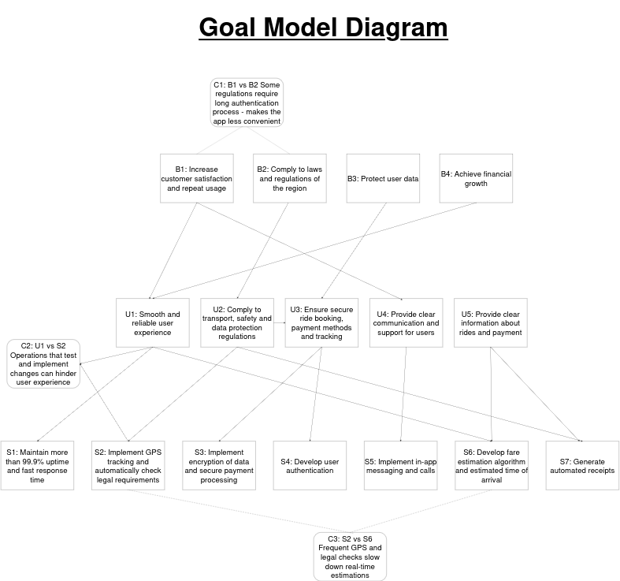
Fig. 2.3 Goal Model Diagram
The goal model diagram above shows relationships between major goals of the system which implements all of the product functions, each goal being issued by different stakeholders. A visual representation like this helps determine conflicts early on. It shows us connections between goals that need to be considered before any implementation. Stakeholders need to be aware of these connections to make decisions about the system.

This diagram is implemented by GSN (Goal Structuring Notation), and has a hierarchical structure:
Goals are represented by rectangles, sub-goals by circles, and conflicts by rounded rectangles
- B1, B2, B3 and B4 represent business goals - high-level outcomes the system is aiming for.
- U1, U2, U3, U4 and U5 represent usage goals - the functionality of the system that achieves the business goal.
- S1, S2, S3, S4, S5, S6 and S7 represent system goals - technical aspects that can be implemented to support the usage goal.

C1, C2 and C3 represent potential conflicts and trade-offs that occur between two specific goals.

Arrows pointing from one goal to another represent a connection between them, for example, B1: “Increase customer satisfaction and repeat usage” is pointing to U1: “Smooth and reliable user experience” because a reliable user experience increases user satisfaction and compels the user to use the system again. In other words, U1 contributes to B1’s existence.

One goal can have multiple contributions, an example of a case like this can be seen in the connection between B3: “Protect user data” with U2: “Comply to transport, safety and data protection regulations” and U3: “Ensure secure ride booking, payment methods and tracking”. To protect the data of a user, the system should be compliant to regulations of a region, but it can also implement its own methods to ensure secure payment.

Conflicts are connected to two opposing goals by dashed lines. They have to be included in the diagram for stakeholders to manage trade-offs between them. Two examples of conflicts are:
B1 vs. B2: Customer satisfaction can be negatively impacted by lengthy authentication and security processes required by laws and regulations in that region, but those regulations cannot be ignored.
U1 vs. S2: Implementing new features or tweaking the system to fit new legal requirements can cause disruption or temporary problems in the app which would hinder a smooth user experience.
S2 vs. S6: During the process of implementation of new rules, regulations or updates, GPS tracking and ETA can be impacted as their accuracy depends on real-time algorithms, which are disrupted during downtime of the app.

Stakeholders have a direct relationship with these goals as they are ones issuing them.
This list specifies which goal is issued by which stakeholder:
B1: Passengers, Marketing Department, Customer Support Department, App Manager
B2: Regulatory Authorities, Local Transport Authority, App Manager
B3: Regulatory Authorities, Payment Company, App Developers, Data Science Team, Passengers
B4: Investors/Shareholders, Marketing Department

U1: Passengers, Drivers, Rider Support Team
U2: Regulatory Authorities, Local Transport Authorities
U3: Payment Company, App Manager, Passengers, Regulatory Authorities
U4: Customer Support Department, Passengers
U5: Passengers, Drivers

S1: App Manager, Mobile Data Network Providers, App Developers
S2: Map/GPS Service Company, App Manager, Regulatory Authorities, App Developers
S3: Payment Company, App Manager, App Developers, Regulatory Authorities
S4: App Developers, App Manager
S5: Passengers, Drivers, Customer Support Department, App Developers, App Manager
S6: Passengers, Driver, GPS/Mapping Service Providers, App Developers, App Manager
S7: Passengers, Regulatory Authorities, Drivers, Payment Company, App Developers, App Manager

2.3 User Characteristics

User roles derived from the stakeholder analysis that interact with the system the most are primary users, which include drivers, passengers, administrators and developers, as well as some business environment stakeholders, which include customer support.

The intended users of the app are at different levels of experience with smartphones. Primary end-users, such as passengers and drivers, have a basic knowledge of setting up an account, a payment method, connecting to the internet, enabling GPS tracking, and navigating a simple user interface. These actions do not require high level technical expertise.

Primary internal users, such as administrators and developers, have a strong educational background and high technical skills to monitor the system and resolve any issues that occur efficiently.

Business environment users, such as customer support staff, have a similar skillset to administrators and developers, but with less technical knowledge of the system implementation. Their role focuses on helping primary end-users and resolving simple issues.

2.4 Constraints

There are various limitations in the system development which impact the final product. Developers must be mindful of these limitations in the development process to avoid both technical and legal errors.

(1) Regulatory policies
The app must adhere to local laws and regulations. In Ireland, it must adhere to the same regulations as all SPSVs. This includes privacy laws like the General Data Protection Regulation (GDPR), as well as transportation service laws, like displaying “appropriate insurance in place, driver who has been vetted by An Garda Siochana and a verified charging system”.

(2) Hardware limitations
The app must be compatible with both Android and iOS phones, and it must be of
appropriate size to achieve optimal performance. This is important because the aim is to
cover compatibility with as many different mobile devices as possible so that the Uber
service can be used by a large number of customers.

(3) Interface to other applications
The system depends on other services like the GPS navigation service and payment
processors. The app must map external APIs of services like Apple Maps to
determine the location of a user. It also must interact with various secure
third-party payment processing services depending on passenger preference.
For users to communicate, app has to interact with third-party telecommunication
services in the area.

(4) Audit functions
The app heavily relies on audit functions because it processes personal user
information and payment methods. These functions include safely tracking and
storing important information, logging user history and flagging suspicious
behaviour for both users and administrators.

(5) Control functions
The system processes sensitive information, so control functions must be in place
to ensure that no fraudulent activity occurs. This includes passenger and driver
authentication to secure safety for both parties. If a user does not adhere to app
terms of service, their accounts can be restricted, and they can be banned from
using the service.

(6) Higher-order language requirements
The app must include all languages and currencies of the countries it is available
in. For some languages, it has to support special characters and different alphabets.

(7) Safety and security considerations
It is essential that drivers are authorized in the app before entering the service,
and the location of the vehicle must be present at all times for safety of both drivers and
passengers.

2.5 Assumptions and Dependencies

The system assumes that users have smartphones meeting appropriate hardware requirements, internet connection and GPS navigation enabled. Users are assumed to have made an account and set up a payment method before using the service. The system also assumes that all of the external resources are in normal operation (navigation services, payment processing services, telecommunication and notification services etc.) Any changes can greatly affect app functionality.

It is assumed that all the regulations the app has to follow are remaining the same, and if they change, it would affect the software requirements specification of the app.
It is also assumed that backups and recovery testing is done regularly and that servers have reliable resources to work with and enough storage to keep the system data.

2.6 Apportioning of Requirements
Not Applicable.

3.1 External Interfaces:

3.1.1 (Input) Account information:

Input 1. Account information - Purpose: Used to separate each user's ride history allows them to access the app on an individual basis allowing for easier response to support tickets. Source of input: Entered by the user via the pick-up point tab on the apps home screen. Valid range/and tolerance: Valid email address or valid phone number or valid Apple account. Units of measurement: Account tokens. Timing - Recorded once but can be updated whenever the user wishes Relation to other inputs/outputs - Recorded once

3.1.2 (Input) Payment Method:

Purpose - Allows for the drivers to be paid through the app and allows for riders to pay for their app. Source of input - Entered by the user via Account > Wallet > Add payment method. Valid range/ tolerance - Valid credit or debit card or valid uber gift card if not paying via cash. Unit of measurement - Currency(Dollars, Euros, Pesos etc). Timing - Recorded once but can be updated whenever the user wishes to. Relation to other inputs/outputs - Payment method, GPS location. Screen formats - Account. Window formats- Wallet. Data formats - Longitude and latitude. Command formats - Tap screen, PaymentMethod(Card information). End messages - “{Last digits of payment method}”

3.1.3 (Input) GPS location:

Purpose - Allows driver and rider to know where each other are and be aware of destination and pickup location etc. Source of input - entered via “Rides” -> pick-up point. Valid range/ tolerance - valid address that exists within the city. Units of measurement - degrees and seconds (gps location). Timing - Recorded continuously
Relating to other inputs - pickup location, ride destination. Screen formats - “ “. Window formats- “ “. Data formats - “ Longitude and latitude “. Command formats -
Accountinformation.GPSlocation(GPSlocation). End messages - There are no end messages for this.

3.1.4 (Input) Pickup location:

Purpose - Allows the driver to know the pickup location of the rider. Source of input - entered via Rides -> Enter pickup location. Valid range/tolerance - Valid address that exists in the city. Units of measurement - Degrees and seconds. Timing - recorded once on ride request. Relating to other inputs - GPS location, Ride request. Screen formats - Rides. Window formats- Enter pick up location. Data formats - Longitude and latitude. Command formats - Ride.Pickuplocation(PickupLocation). End messages - There are none.

3.1.5 (Input) Ride destination:

Purpose - Allows the driver to know the intended destination of the rider. Source of input - Rides > Trip/Rides > Reserve. Valid range/tolerance - Valid address that exists in the city. Units of measurement - Degrees and seconds. Timing - recorded on ride request. Relating to other inputs - GPS location, Ride request, Pickup location. Screen formats - Plan your trip. Window formats- “Where to”. Data formats - Longitude and latitude. Command formats - Ride.Ride_Destination(Ride destination). End messages - There are none.

3.1.6 (Input) Ride request:

Purpose - Sends a ride request to available drivers to carry the rider to the destination. Source of input - Rides > Trip or Rides > Reserve. Valid range/tolerance - Only valid if valid location and destination are given and payment method selected. Units of measurement - Not really measured in any way. Timing - recorded once when the ride information is filled out. Relating to other inputs - Pickup location, ride destination, payment method. Screen formats - Rides. Window formats- Enter pickup point . Data formats - Boolean value. Command formats - Account.RideRequest[n]. End messages - “Ride status”.

3.1.7 (Input) Ride cancel:

Purpose - Allows a driver or rider to cancel a ride. Source of input - Ride details > Cancel rides. Valid range/tolerance - There are none . Unit of measurement - Not really measured in any way. Timing - recorded once whenever the user wants to cancel a ride. Relating to other inputs - Ride request. Screen formats - Ride status. Window formats- Cancel trip. Data formats - Boolean value. Command formats - Account.RideRequest[n].cancel() End messages - Ride cancelled.

3.1.8 (Output) Driver earnings:
Purpose - Allows a driver to see how much they have earned. Source of output - Driver app > fare icon / Earnings tab. Valid range/tolerance - “”. Unit of measurement - currency. Timing - updated once after every ride. Relating to other methods - Payment methods. Screen formats - “Earnings tab”. Window formats- “statements” tab. Data formats - Integer. Command formats - “ “. End messages - “{input drivers earnings}” to be displayed

3.2 Functions

3.2.1 The system shall process inputs such as the pickup location, ride destination and GPS location, payment method, account information such as google play account, apple account, email account, phone number. In the scenario that an incorrect payment method is provided the system will request for a valid payment method to be attached. In the case of an invalid phone number being attached the system shall request for a valid phone number.

3.2.2 The system shall first require users to register/login with their account information then the system shall check if the user has 2 factor authentication enabled and will then proceed to email the user with a verification code to their chosen two factor authentication medium This is related to the inputs of account information. User_Inputed_password == Account_information.password()

3.2.3 The system shall then proceed to ask the user to enable location services on their device so that they can get their geolocation. If geolocation is not turned on the system will not proceed unless the user has enabled their location.

3.2.4 The system shall then ask. The system shall then give the user the option of selecting a pickup location and a destination. If the pick up location is not valid then the system will not proceed to make a ride request unless the pick up location and ride destination are valid.

3.2.5 The system shall then give the user the option of selecting the vehicle for their ride. There shall be no abnormal activity with this as it is not an open ended input it is a choice from a list of inputs.Calculated as Account_information.RideRequest[n].vehicle(User_input)

3.2.6 The system shall then ask the user whether or not they are paying by cash or by an attached payment method. If a user does not have an attached payment method then the system will not carry out the ride request unless pay in cash is available in that user's country.
Calculated as User_Input = Account_information.card(User_input).

3.2.7 The system shall send drive requests to the drivers who are the closest to the rider. This is related to the inputs of geolocation and pickup location and ride destination.

3.2.8 The system shall then assign the ride to the driver who accepts the ride request first.

3.2.9 The system shall then send a notification to the rider when the driver is close to the pickup location.

3.2.10 The system shall track the users GPS location constantly throughout the ride. The system shall use the user's GPS location constantly to access the most efficient route in the case that the user's GPS location is off and the app will tell the user to turn it on. This is related to the input of GPS location.

3.2.11 The system shall track the distance of your ride actively in kilometers.

3.2.12 The system shall notify the user when the ride is complete. Calculated as Account_information.GPS_location == Account_RideRequest[n].destination. This will be outputted through trip status using interactive ui.

3.2.13 The system shall then charge the rider through their preferred payment method. This function is again related to the payment method input. Calculated as Account_information.card.charge(fare, preferred payment method). The fare amount decides how much the rider is charged.

3.2.14 The system shall then pay the driver through their payment information. This function is related to the payment method input, Calculated as Account_information.card.payout(fare, preferred payment method). The fare amount decides how much that the driver is paid. Amount will be outputted into drivers earnings.

Use Case Model
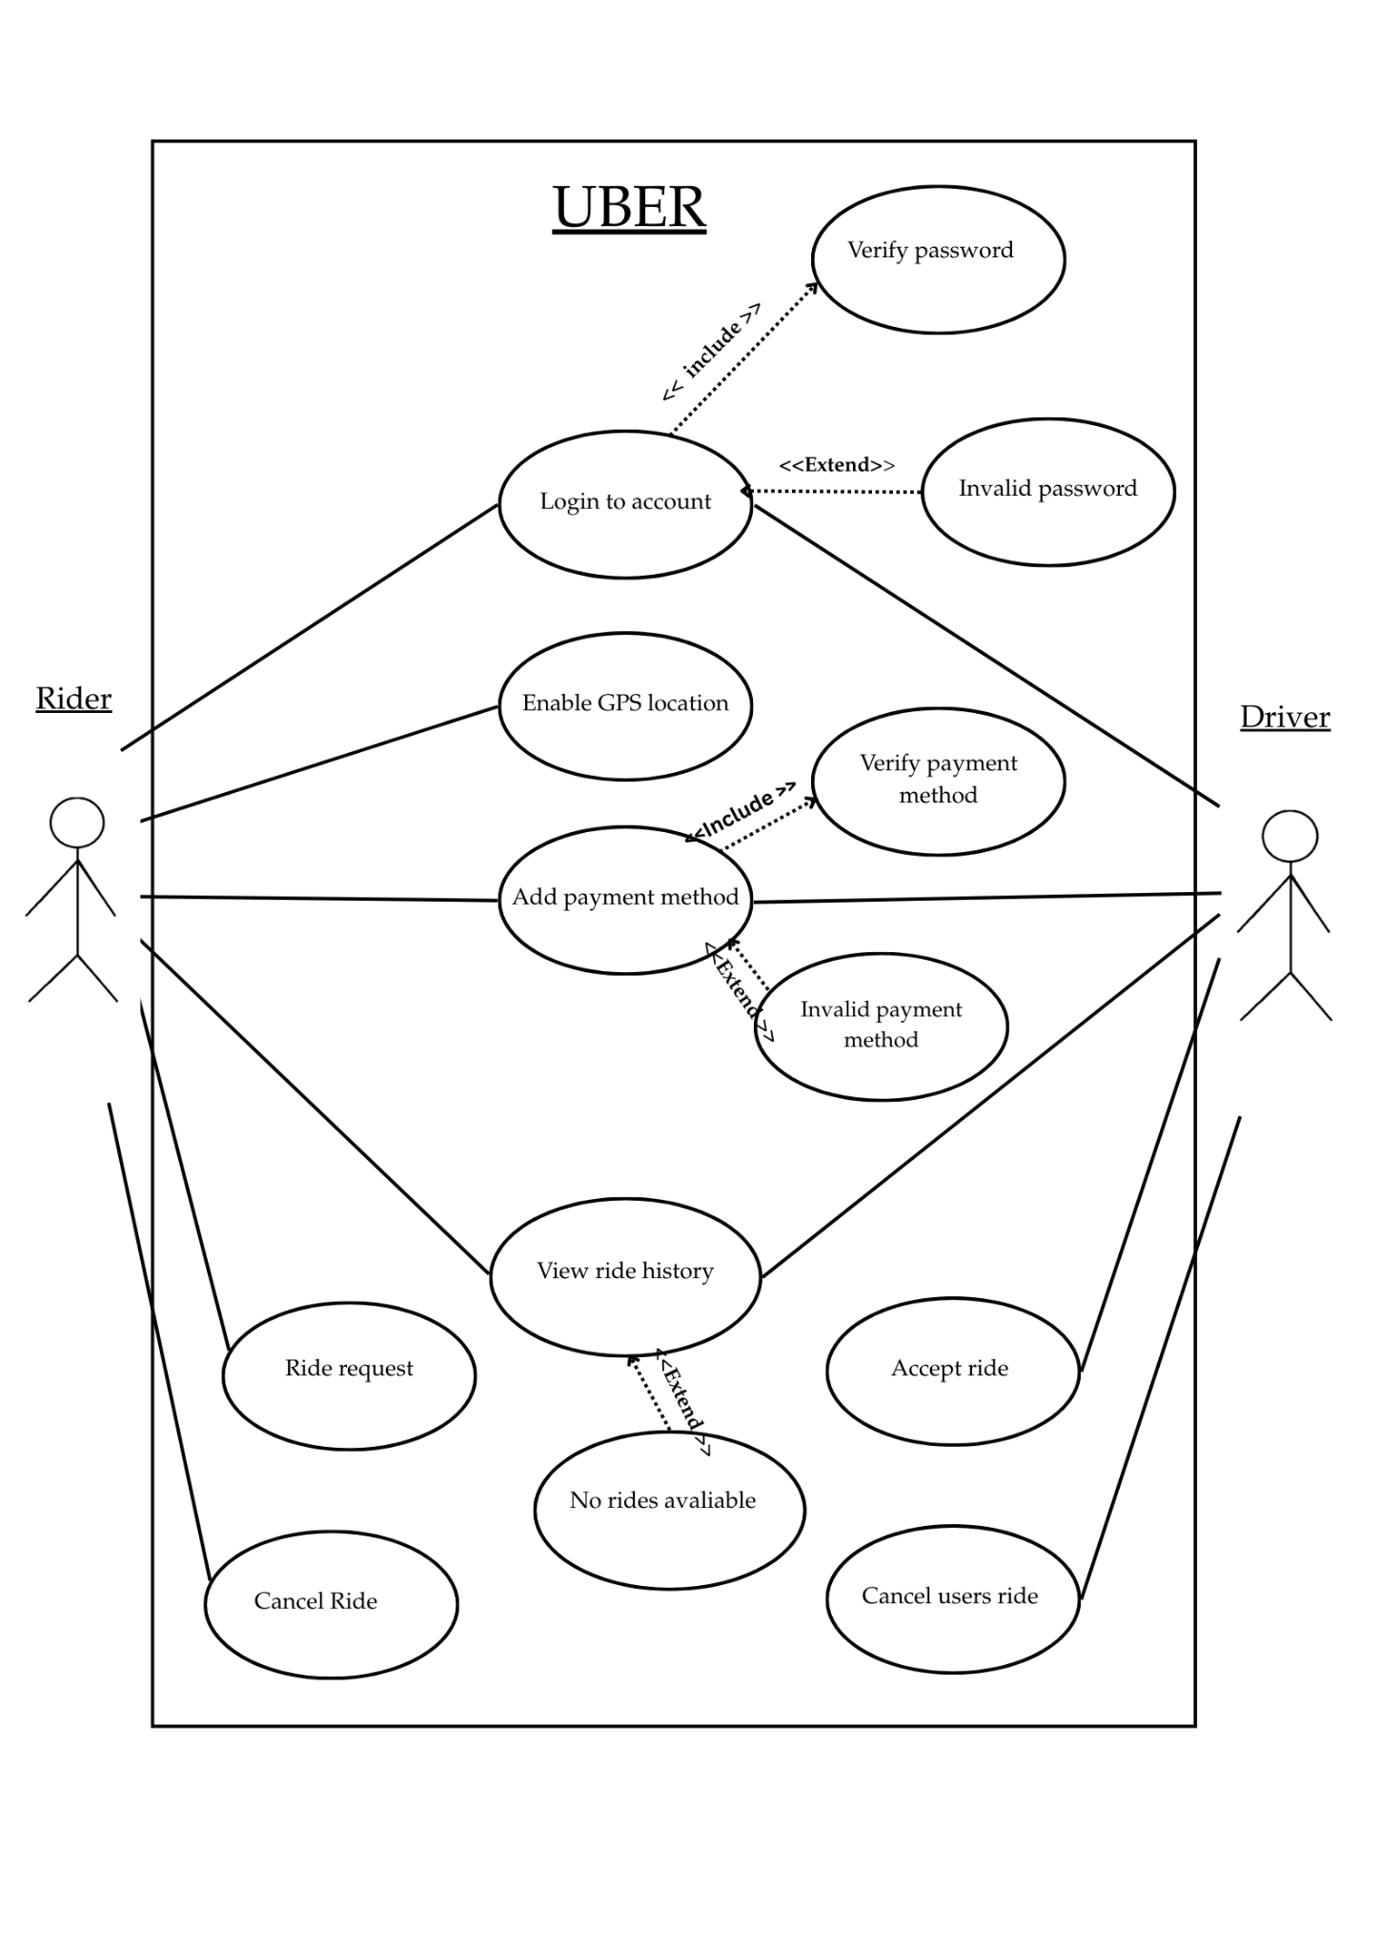
Fig. 3.2 Use Case Model

Use case table 1.

Use Case | Login to account
Primary Actors | Rider, Driver
Description | Allows the user to access uber on an individual basis
Preconditions | - User has registered with uber before in the past
Scenario | 1. Uber displays login screen  2. User inputs their login details  3. System logs user in using account tokens
Result | User is logged into their account and can book rides etc
Extensions | Invalid password

Use case table 2.

Use Case | Add Payment method
Primary Actors | Rider, Driver
Description | Allows user to pay their driver and for the driver to be paid for their work
Preconditions | - User has to be registered with Uber  - User has to have a valid payment method such as a debit/credit card or valid giftcard
Scenario | - Uber displays home screen  - User goes to Account page  - User goes to Wallet  - User taps add payment method  - User can add their payment method
Result | User adds a valid payment method to be paid through or to be
Extensions | Invalid payment method

Use case table 3.

Use Case | View Ride history
Primary Actors | Rider, Driver
Description | Allows the user to view their previous rides
Preconditions | - Users must have a stable internet connection.  - Users must have a registered Uber account.
Scenario | - Uber displays home screen  - User goes to Account page  - User goes to Activity page
Result | Users should be able to see past rides that they have gone on.
Extensions | No rides available

Use case table 4.

Use Case | Enable GPS location
Primary Actors | Rider, Driver
Description | Geolocation of devices to allow
Preconditions | - User must have a stable internet connection  - Users must have a registered Uber account.  - Users must have location services turned on.  - User must enable GPS location in the Uber app
Scenario | - User opens home screen  - Users must then enable location services via the prompt that will appear on screen.
Result | Users' geolocation will be available for the driver to see so they can know the rider's exact location, drivers' geolocation will be available to riders so they can know the exact location.
Extensions | None

Use case table 5.

Use Case | Ride Request
Primary Actors | Rider, Driver
Description | Allows for a rider (user) to request for transportation through a nearby driver from their pickup point.
Preconditions | - Users must have a registered Uber account.  - User must have a stable internet connection  - User must have GPS enabled  - User must have a payment method
Scenario | - The rider opens the Uber application  - The rider puts in their pickup and drop-off location.  - The application shows the estimated price  - The rider confirms the request  - The system then selects the nearest driver for the service.
Result | A ride would be created and both, rider and driver, can view the trip details.
Extensions | - If no drivers are selected then the application would display “No drivers nearby”  - If there is a network problem then the request would not work.

Use case table 6.

Use Case | Cancel Ride
Primary Actors | Rider, Driver
Description | Allows the rider or the driver to cancel a ride request before or after it is accepted.
Preconditions | - User must have requested for a ride  - A stable internet connection
Scenario | - The rider/driver opens the application and goes to the current ride.  - The rider/driver selects the “Cancel Ride” option.  - The application would ask for a reason for cancellation.  - The system would confirm the cancellation and notify the rider/driver.
Result | The ride is then cancelled. Both rider and driver would be notified.
Extensions | - A cancellation fee might be applied if the ride is cancelled too late.

3.3 Performance Requirements

A large scale ride share app such as Uber must be able to support billions of accounts for riders and drivers. The app must load the login screen to input account information in less than 3 seconds. After pickup location and destination have been chosen the app must display the list of vehicles in less than 2 seconds. The app must process a ride request in less than 10 seconds. The app must display ride requests to closest Uber drivers for 10 seconds.

The app must be able to handle around 149 million monthly users globally smoothly without any noticeable latency. The app must be able to safely store account information for 149 million users. The app must display the final fare around 10 seconds after the ride has been completed. 99% of transactions shall be processed in under 5 seconds. The app must update the riders GPS location for the driver every 0.04 seconds. The app must display the trip status constantly and should update it in less than 5 seconds whenever the trip's progress advances.

- Non-Functional Quality Requirement - Model: ISO 25010

QR 1: Request and Response Times
NFR | The system's responsiveness shall be quick, loading key displayable information within a maximum of 3 seconds under regular operating conditions.
Dimension | Performance
Rationale | Derived from goals U1, S1, Sn1. Efficiency and fast responsiveness are crucial for proper functioning and improve user experience. Slow screens make the system less engaging, increasing cancellations, ultimately decreasing user preference.
Satisfaction criterion | The system’s sign-up/login screens, request confirmations and booking acceptance must load in at most 3 seconds.
Measurement | Latency measurement with automated internal analytics tools across different devices and networks.

QR 2: Real-time Status Updates
NFR | The system is required to provide live GPS location information to drivers and passengers with trip status information with low latency.
Dimension | Performance
Rationale | Derived from goals U1, S2, Sn2. Accurate and reliable information for users is mandatory for safety reasons and high performance. Latency can result in navigation miscalculations and user confusion leading to loss of trust.
Satisfaction criterion | At least 90% of GPS updates must happen within 0 to 1 milliseconds (≤ 1). Trip status updates have to appear in ≤ 5 seconds after GPS update
Measurement | Timestamp logs will be carried out in simulated trips from different client-server devices to calculate point to point update latency

Section 3.4 Logical Database Requirements
This system would maintain data structures such as Users, Drivers, Rides, Vehicles, Payments and Ratings
- Each User has elements: user_id, name, email, phone_number, payment_method
- Each Driver has elements: driver_id, license_number, vehicle_id, status
- Each Ride record includes: ride_id, pickup_location, dropoff_location, time_duration, fare_amount, status.
Every ride must have an authorized user and drive and the database would help provide a referential integrity between users and rides.
The data must be available in real-time for ride status updates, with a maximum latency of two seconds.
Previous rides will be stored for 365 days before it gets archived.
The domain class model of the Uber App represents the important classes, along with their attributes and operations, as well as the relationships, connections, and interactions between those classes, in order to make a blueprint for the logical operation of the system. The classes can represent people, things, or concepts, which should show how the system must be organised so that stakeholders will understand the system, as well as its required functions.

Generalisations:
User->Rider, User->Driver,
Trip->Ride Trip->Route,
Ratings->Drivers rating, rider rating,
Location->Drivers location, Location->Route, Location->Destination,

 |  | Role names
Rider rates driver | (1- Rider….0..* Rating…..1 - Driver) | ratingsGiven
Rider cancels ride | (1- Rider …0..* - Ride) | rideCancelled
Driver rates driver | (1- Driver.. 0..* Rating .. 1 Rider) | ratingsGiven
Driver has vehicle | (1- Driver - 1- Vehicle) | assignedVehicle
Rider has location | (1- Rider - 1 - location) | assignedLocation
Driver has location | (1- Driver - 0..1 - location) | locationSent
Driver receives ride request | (1- Driver - 0..*- Ride request) | assignedDriver
The Rider creates/sends a payment | (1- Rider, 0..*-Payment) | paymentsMade
Driver receives payment | (1-Driver, 0..*-Payment) | routeSet
Ride matches one driver with one rider, | (1- Ride, 1-Driver, 1-Rider) | currentRide

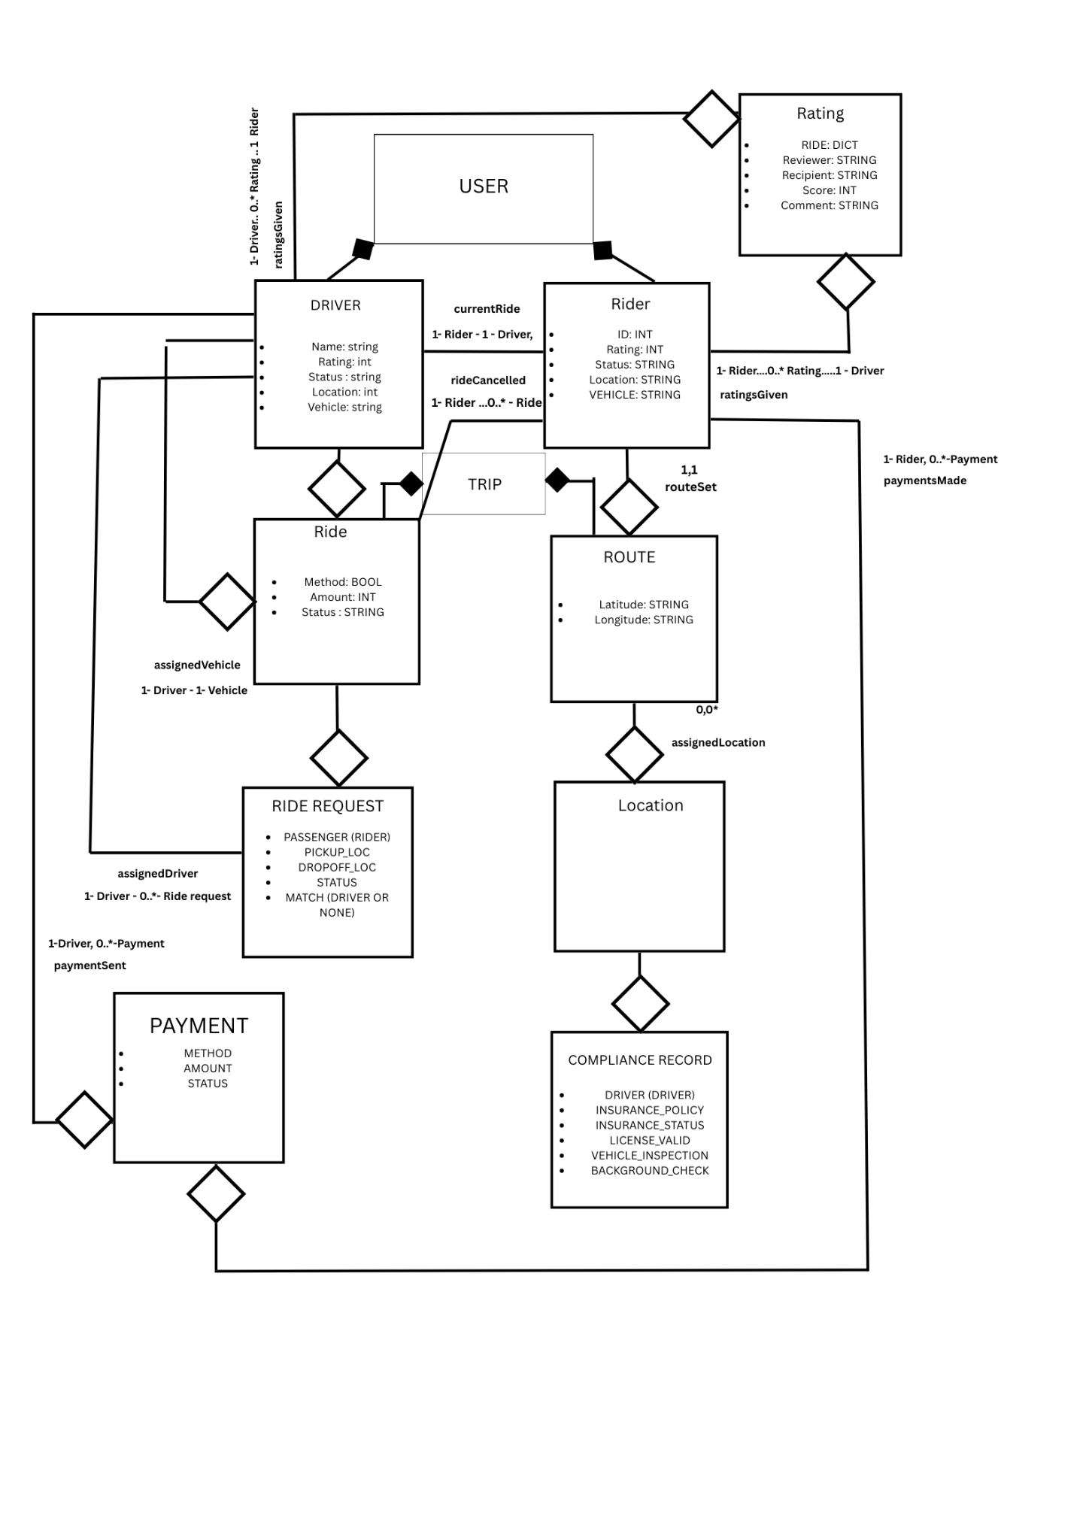
Domain model graph:
Fig. 3.4 Domain Model Graph
Section 3.5 Design Constraints
1- Mobile Platforms:
a. The Uber app needs to work smoothly on both IOS and Android smartphones as these are the most common systems used by Users.
2- GPS Requirement:
a. The GPS feature must be available in order to find the Users current location and to show where the driver is in real-time.
3- Internet Connection:
a. A stable internet connection needs to be present to function. Without the internet, users cannot book rides or track drivers.
4- App Store Rules:
a. The design of the application needs to follow Google Play and Apple App Store rules so that the application can be uploaded successfully
5- Battery Usage:
a. The app mustn’t use too much battery when tracking rides or using the GPS.
Section 3.6 Software System Attributes
Section 3.6.1 Reliability
The application needs to work properly without crashing or freezing. Additionally, it should be able to handle an overload of users, using the application, at once without causing any major problem.

Section 3.6.2 Availability
The Uber app must be available to use all the time (24/7) in order for users to book riders whenever they require a service. If there is any maintenance with the app, users must get a message saying or notice regarding when the app will be back.
- Non-Functional Quality Requirement - Model: ISO 25010
QR 3: Availability and Reliability
NFR | The system must be robust, handling high-demand times efficiently. It has to be available 99.5% year-round.
Dimension | Reliability
Rationale | Derived from goals B1, U1, S1. Availability and robustness ensures global reach and user satisfaction. System crashes hinders users from using the system causing losses in revenue and increasing negative feedback/dissatisfaction.
Satisfaction criterion | The system shall not exceed a maximum reliability failure mean of 0.1 per month. Additionally, it is required to maintain operations availability ≥ 99.5% year-round.
Measurement | Crash analytics with automatic close monitoring tools that track stability and crash frequency.
Section 3.6.3 Security
All user details like passwords, phone numbers, and payment info must be kept safe and private. Only the user should be able to access any private info of their own. Drivers would also have to log in safely to protect their data.
- Non-Functional Quality Requirement - Model: ISO 25010
QR 4: Payment Data and User Protection
NFR | The system shall provide a fully secure data storage and data handling. Sensitive information is stored and transmitted safely and must be protected against data leaks and cyberattacks.
Dimension | Security
Rationale | Derived from goals B3, U3, S3. Users have to be provided with robust and reliable personal data security. Failure to provide such, results in legal repercussions.
Satisfaction criterion | 100% Fully reliable hashed passwords with encrypted data payment process and protected tokens for APIs
Measurement | Automated vulnerability scanning, penetration testing performed by ethical hackers and security compliance random checks

Section 3.6.4 Maintainability
If there is a bug or a new feature that has to be added, the developers should be able to do it without causing problems to the other parts of the application.
- Non-Functional Quality Requirement - Model: ISO 25010
QR 5: Safe Refinement and Updates
NFR | The system shall be structured in a way that incremental improvements are manageable and do not break logic or interfere with system’s performance.
Dimension | Maintainability
Rationale | Derived from U1, C2, S1. Maintainability ensures the system can evolve and improve over time. Poor practices and uncontrolled changes can harm performance and cause setbacks.
Satisfaction criterion | At least 95% of releases shall not cause strong setbacks, and any critical damage to the system such as newly introduced bugs must be fixed in at most 48 hours
Measurement | Internal control and analyse Release Regression Rate, which should not exceed 2%
Section 3.6.5 Portability
The app should run smoothly on both Android and iPhone. It must also work on devices of different sizes and newer versions of the mobile OS.
- Non-Functional Quality Requirement - Model: ISO 25010
QR 6: Available Across Different Platforms
NFR | The system is required to run seamlessly across different OS (Android and iOS) and their updates without requiring UI or functionality modifications.
Dimension | Portability
Rationale | Derived from B1, U1, S1. The system is aimed to reach a large user base. Failure to provide a system that adapts to different operating systems can lead to users being unable to use the app, experiencing broken layouts and poor performance.
Satisfaction criterion | The system passes monthly test for UI in a variety of operating systems with a success rate of 97%
Measurement | Perform device compatibility testing on emulators and real devices with a device matrix that tracks most used OS and most used device models.

The 6 tables describing the Non-functional Quality Requirements above indicate the performance level that Uber Ride Service System requires in order to meet goals defined in sections 2.2. These quality requirements guarantee the system’s high performance by ensuring speed, reliability, security, maintainability and availability across different operating systems and devices, supporting the performance expectations described in sections 3.3 to 3.6. Each quality requirement is directly linked to the system’s Goal Model demonstrating that the system’s technical behaviour meets user needs while also supporting regulatory expectations. Overall, these quality requirements ensure satisfactory user experience, secure data protection and enable secure maintainability and scalability while outlining how the system has to operate to achieve its goals.
Section 3.7 Organizing Specific Requirements
The requirements for the Uber Taxi App are split based on who’s using the application:
- Passenger Requirements:
o Includes – Booking a ride, making payments, checking driver details and tracking the ride.
- Driver Requirements:
o Includes – Accepting rides, using GPS to find passengers, seeing trip details and checking the earnings.
- Admin Requirements:
o Includes: Handling user accounts, approving new drivers, viewing reports and ensuring that everything runs smoothly.
Section 3.8 Additional Comments
In the future, developers could add features such as voice booking or tracking carbon emissions. The app would also use Google Maps or Apple Maps to give more accurate directions in order to cut ride time. Before it is released, the system would go through testing using sample ride data ensuring that everything works as expected.

