**Observations for fault predictions**

**Overview**

Dataset:

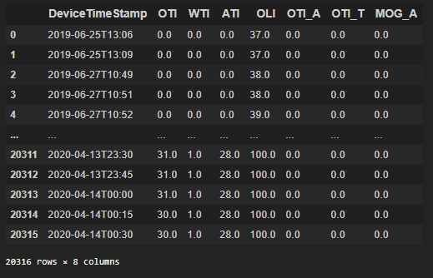

OTI Varying with time:

There are few abnormal increases.

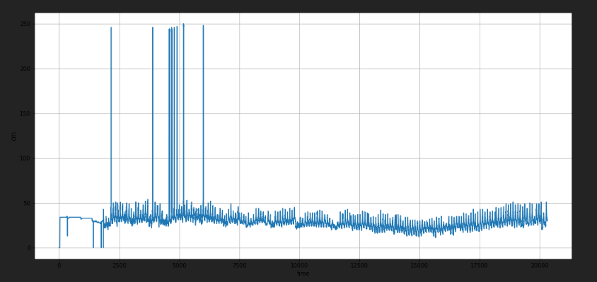

OTI_A with time:

There are sudden changes occuring.

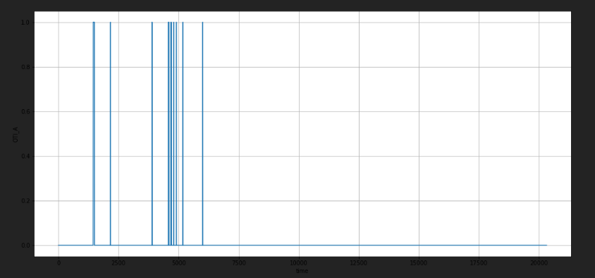

ATI with time:

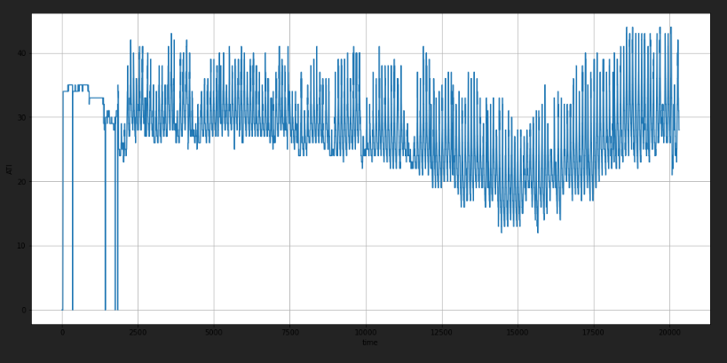

OLI with time:

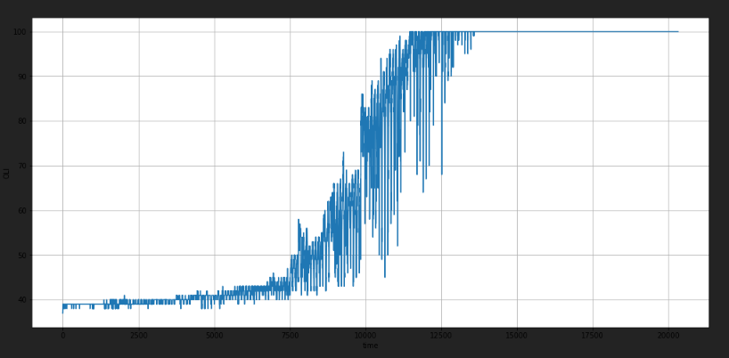

1. OTI reached above 65 47 times.

2. OTI_A went off 101 times.

3. ATI was normal even when OTI increased abnormally.

4. There are 1720 cases when OLI is below 40.

5. There are rapid variations in OLI.

**Current Voltage**

Dataset:

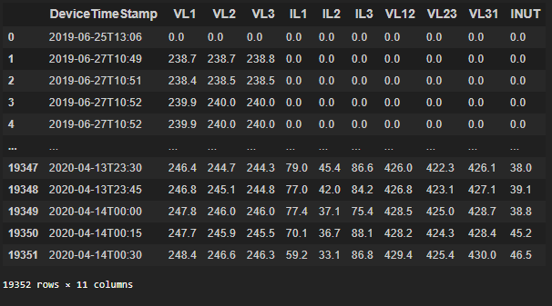

INUT with time:(neutral current)

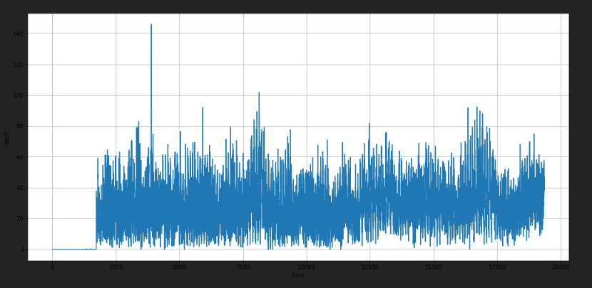

VL1, VL2, VL3 with time:

(VL1 - Blue line

VL2 - Orange Line

VL3 - Green line)

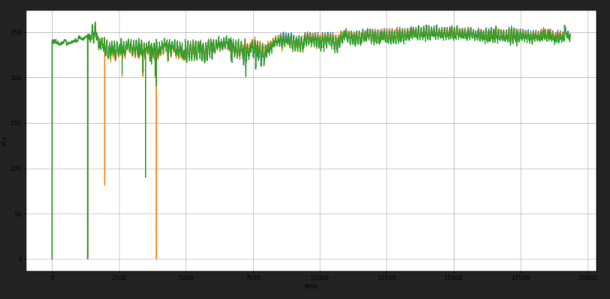

VL1 with time:

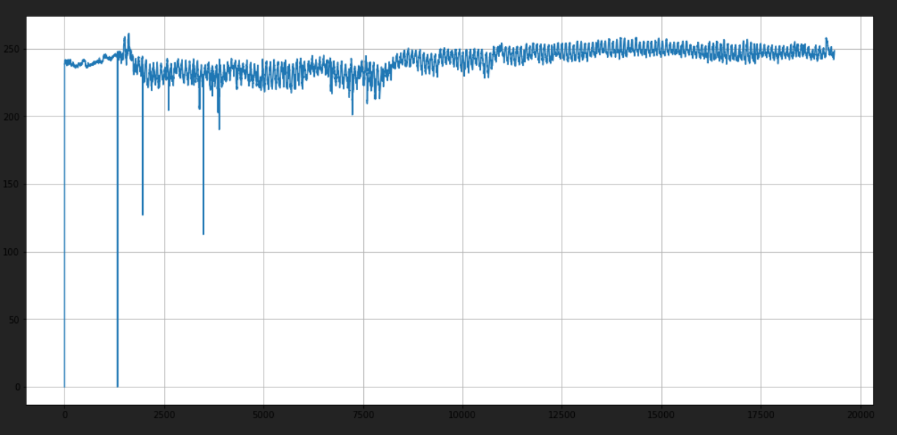

VL1<200:(for sudden drops)

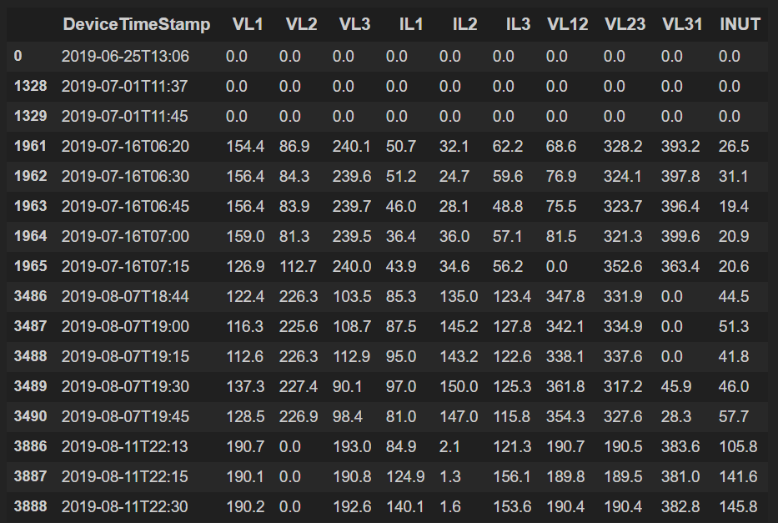

VL2 with time:(for sudden drops)

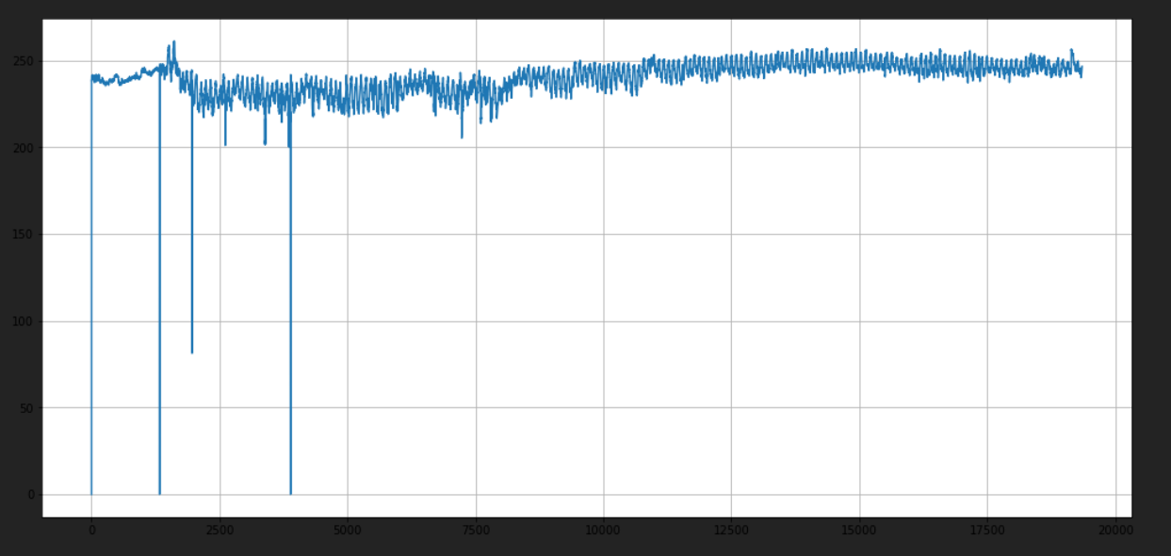

VL2<200:(for sudden drops)

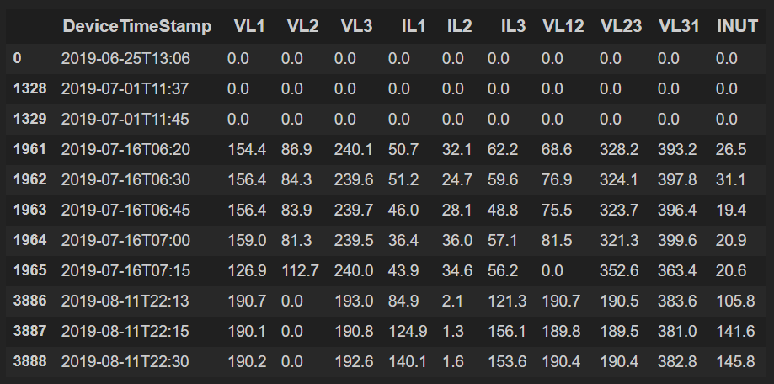

VL3 with time:

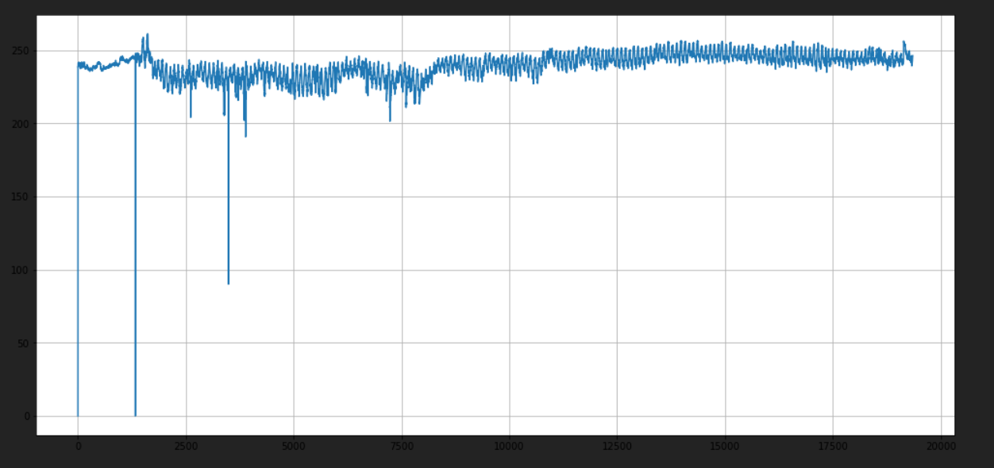

VL3<200:(for sudden drops)

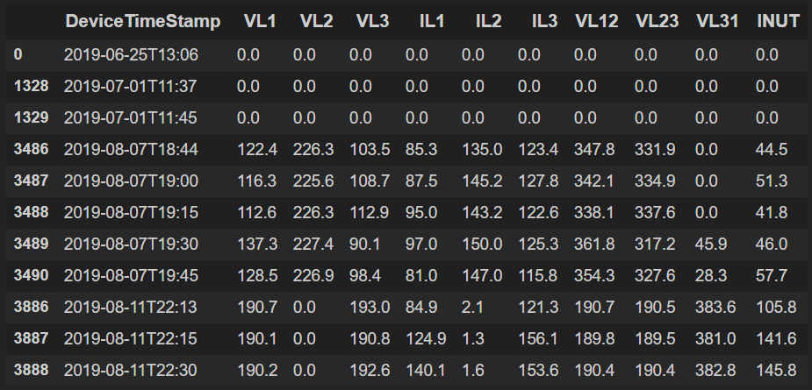

High differences between Phase Voltages leads to fault in transformer.

IL1, IL2, IL3 with time:

(IL1 - Blue line

IL2 - Orange Line

IL3 - Green line)

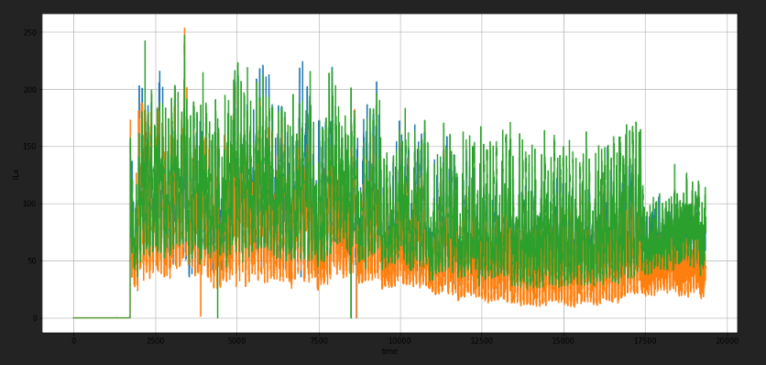

VL12, VL23, VL31 with time:

(VL12 - Blue line

VL23 - Orange Line

VL31 - Green line)

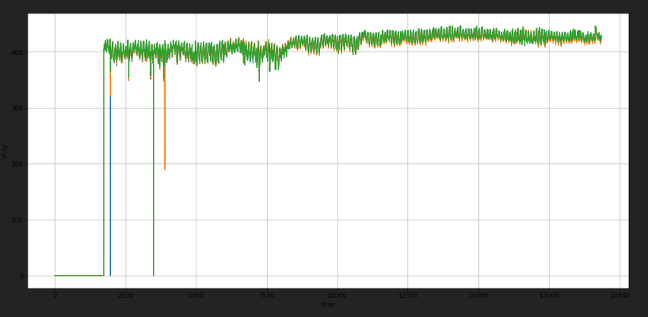

VL12 with time:

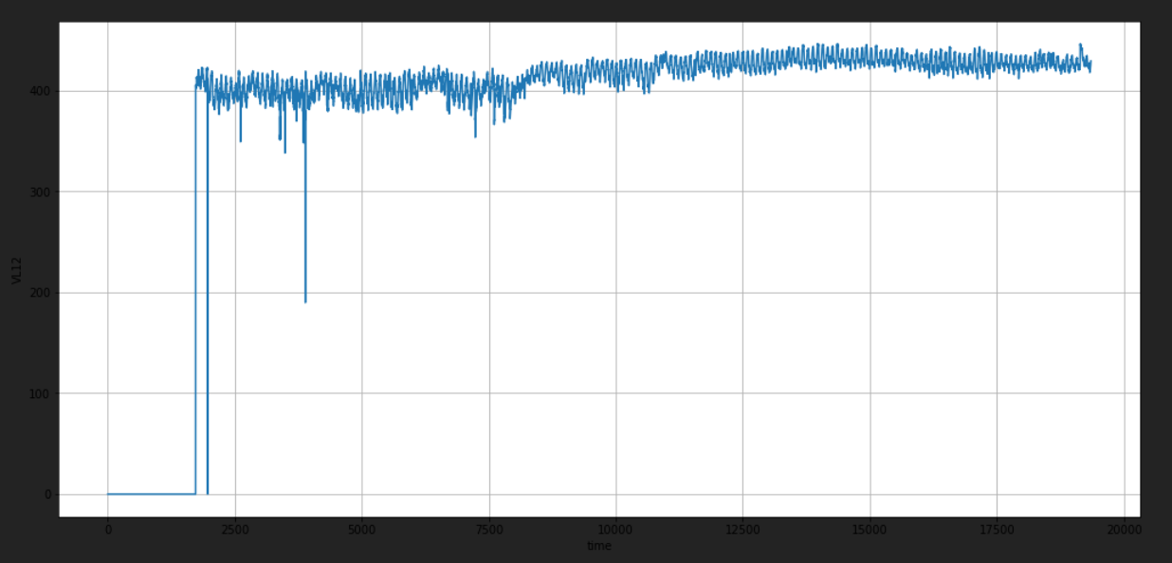

VL12<350:(For sudden drops)

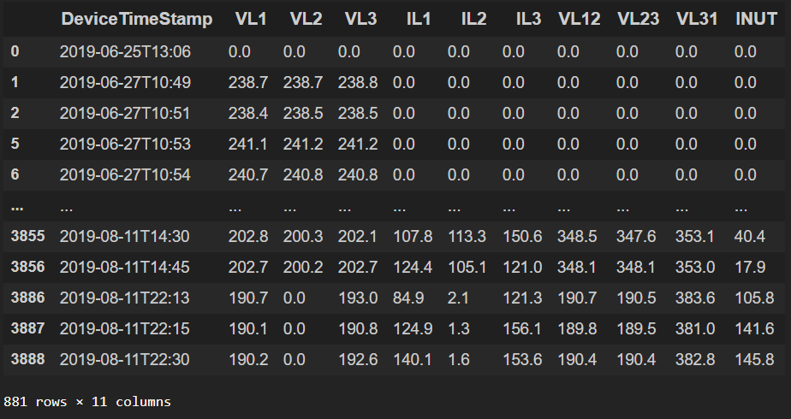

Fault may occur at row 3886, 3887, 3888- because at VL2 There sudden change in load.

VL23 with time:

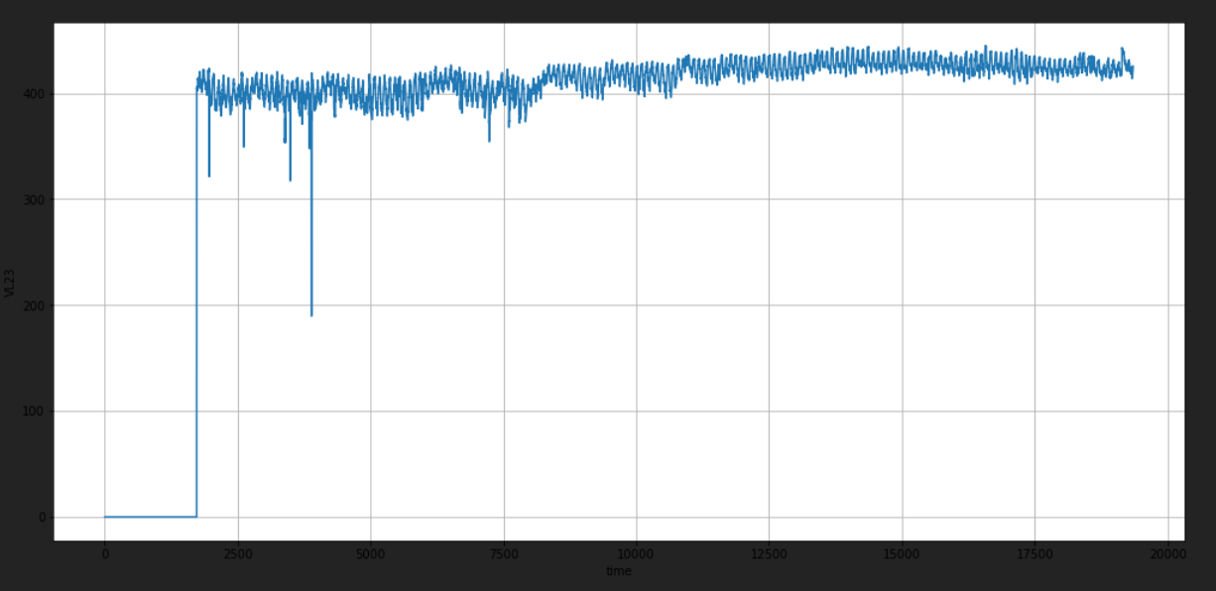

VL23<350:(For sudden drops)

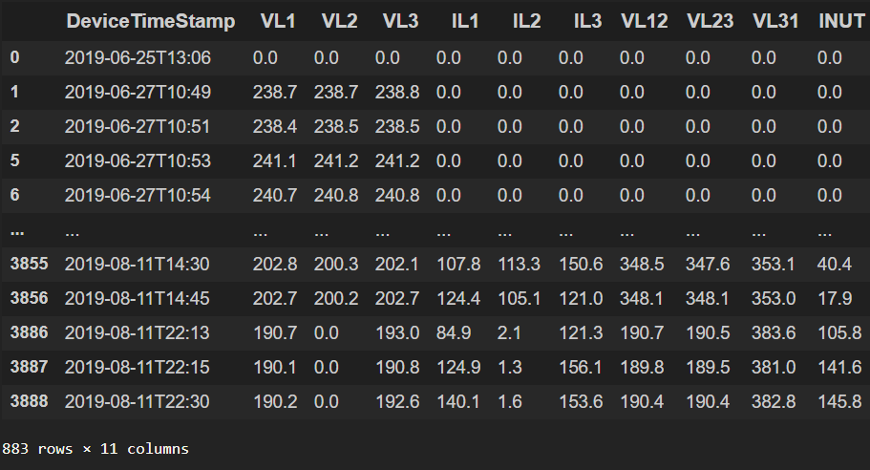

Fault may occur at 3886, 3887, 3888- because at VL2 There sudden change in load

VL31

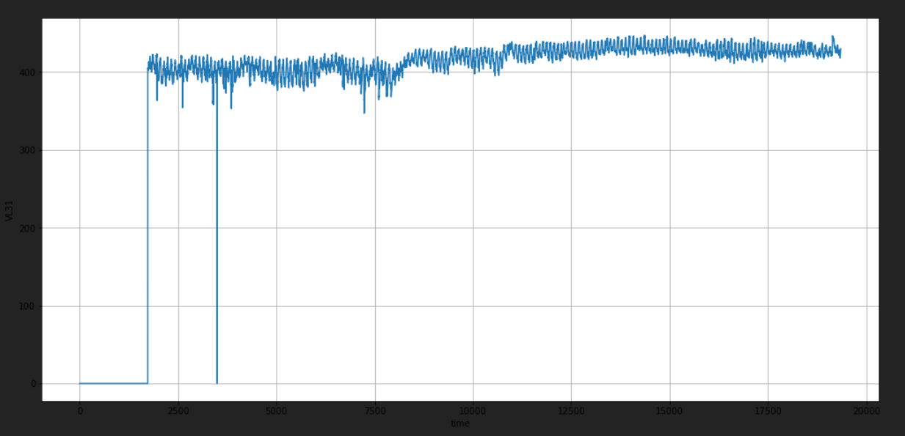

VL31<350(For sudden drops)

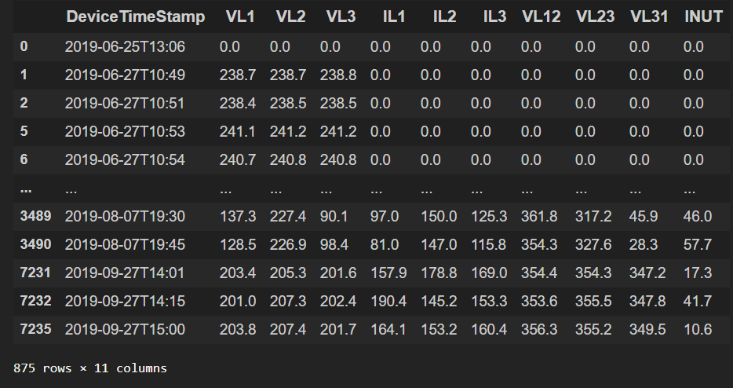

Fault may occur at 3489, 3490.

VL1

there are 16 instances when VL1 is less than 200.

there are 11 instances when VL2 is less than 200.

there are 11 instances when VL3 is less than 200.

VL12

881 times below 350.

VL23

883 times below 350

VL31

875 times below 350

**Power Factor**

Dataset:

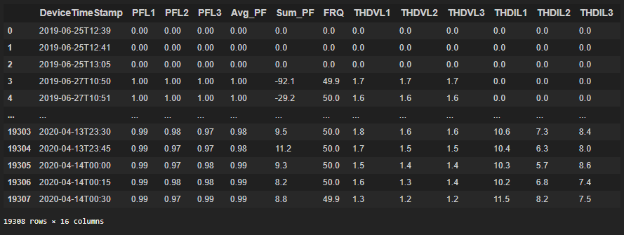

PFL1, PFL2, PFL3 with time:

(PFL1 - Blue line

PFL2 - Orange Line

PFL3 - Green line)

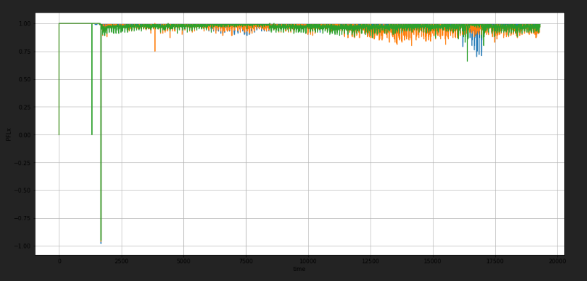

Sum_PF with time:(doubtful)

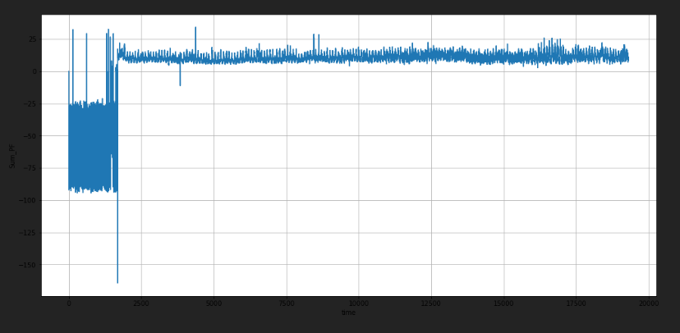

FRQ with time:

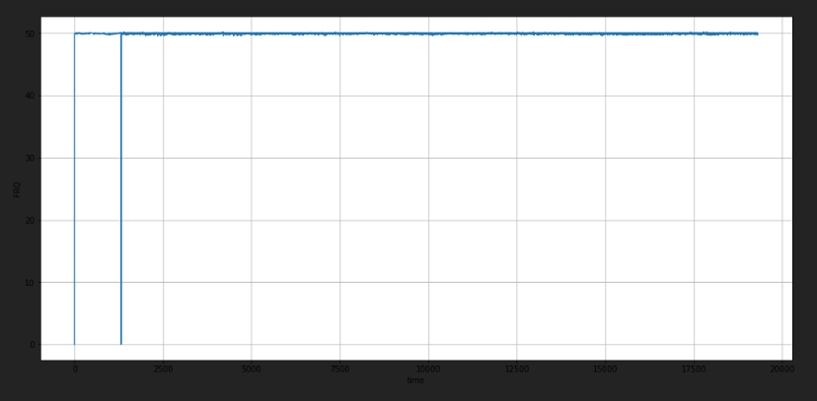

THDVL1, THDVL2, THDVL3 with time:

(THDVL1 - Blue line

THDVL2 - Orange Line

THDVL3 - Green line)

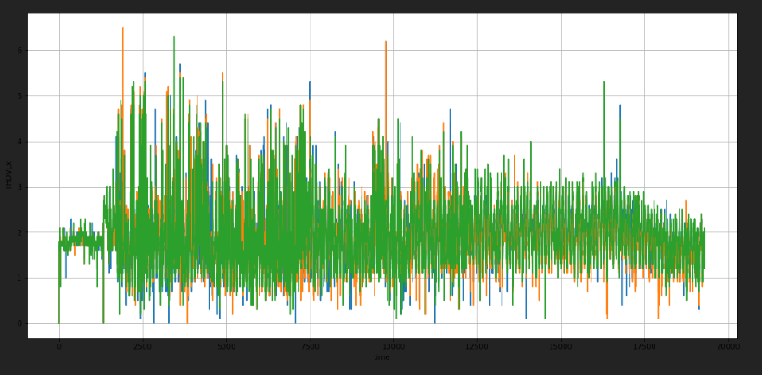

THDIL1, THDIL2, THDIL3 with time:

(THDIL1 - Blue line

THDIL2 - Orange Line

THDIL3 - Green line)

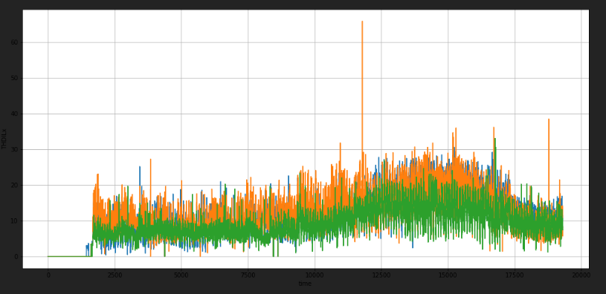

MDIL1, MDIL2, MDIL3 with time:

(MDIL1 - Blue line

MDIL2 - Orange Line

MDIL3 - Green line)

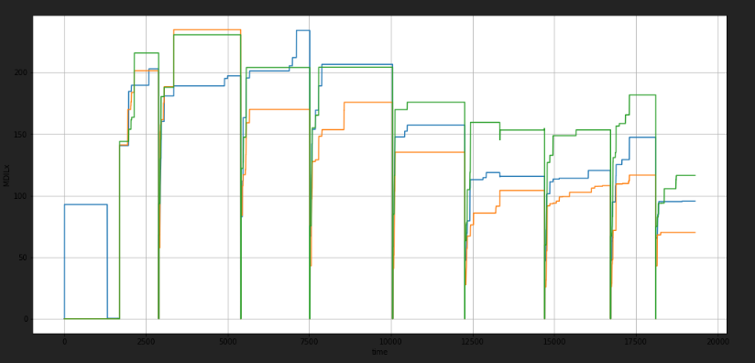

PFL should be above 0.9

PFL1

49 times below 0.9

was 1 708 times.

PFL2

283 times below 0.9

was 1 792 times.

PFL3

32 times below 0.9

was 1 791 times.

Sum_PF

785 times below 0.

FRQ

was 0 5 tims.

**Power**

Dataset:

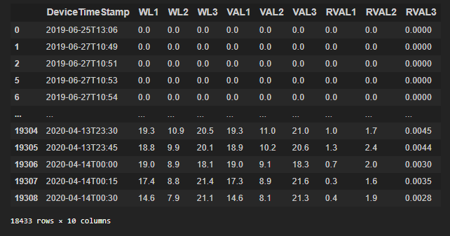

WL1, WL2, WL3 with time:

(WL1 - Blue line

WL2 - Orange Line

WL3 - Green line)

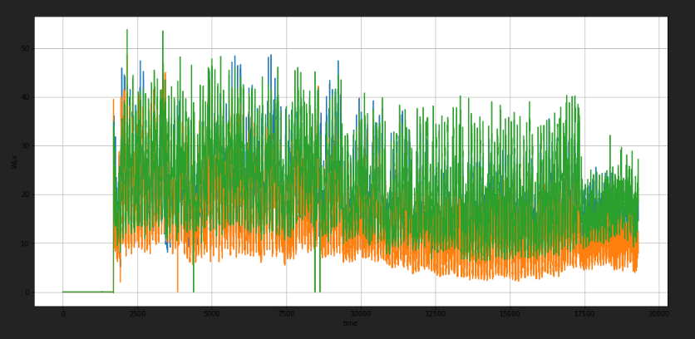

VAL1, VAL2, VAL3

(VAL1 - Blue line

VAL2 - Orange Line

VAL3 - Green line)

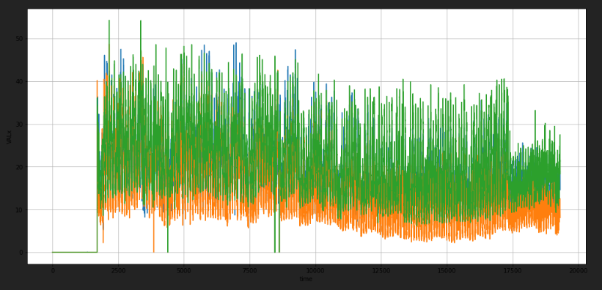

RVAL1 with time:

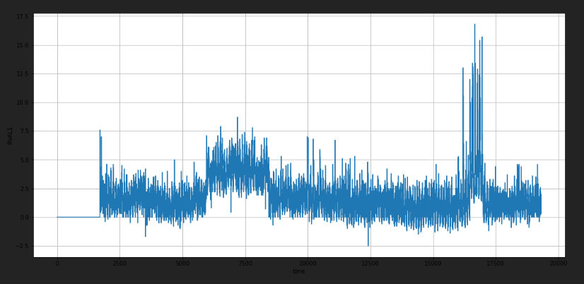

RVAL2 with time

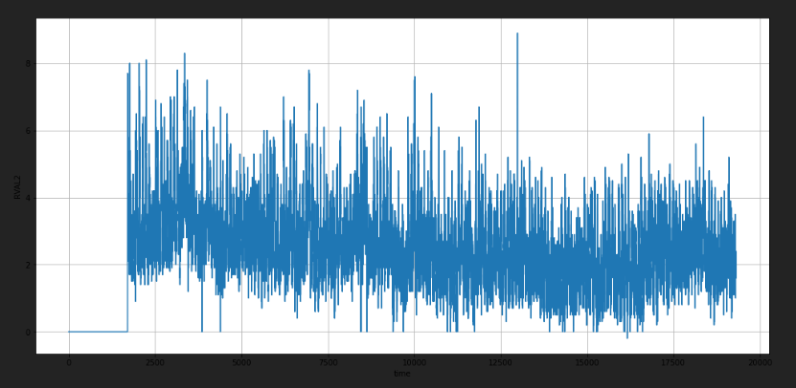

RVAL3 with time

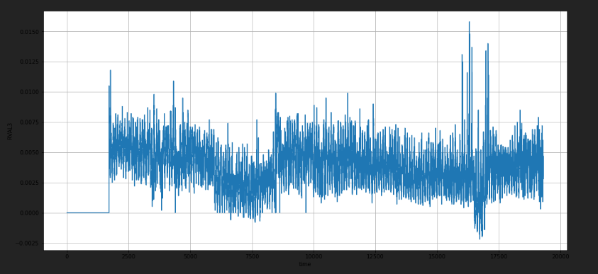

**Total Power**

Dataset:

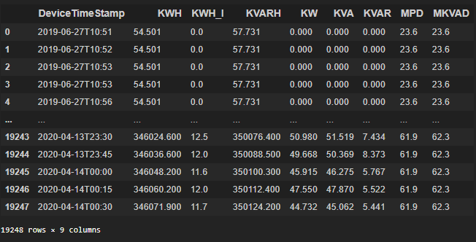

KWH, KVARH with time:

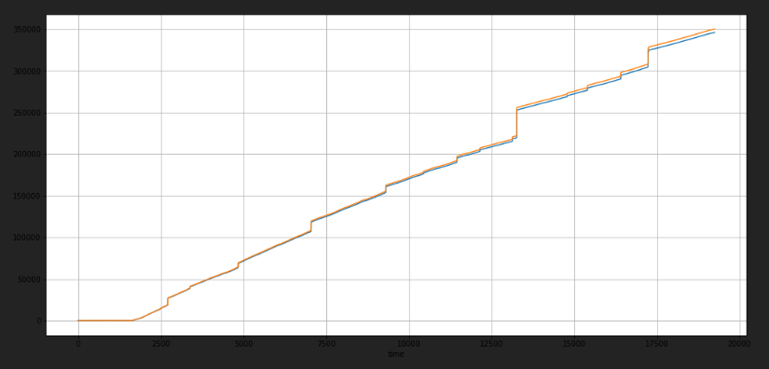

KWH_I with time

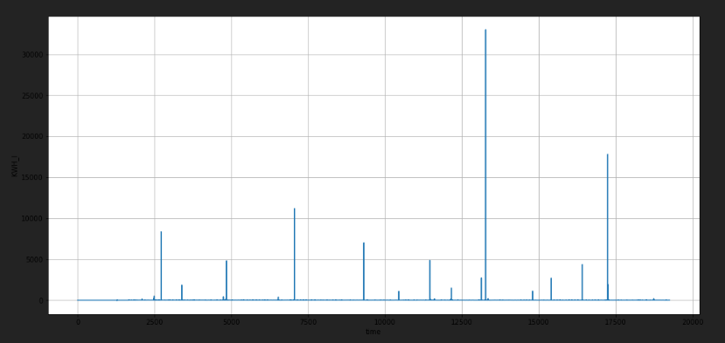

KW, KVA with time

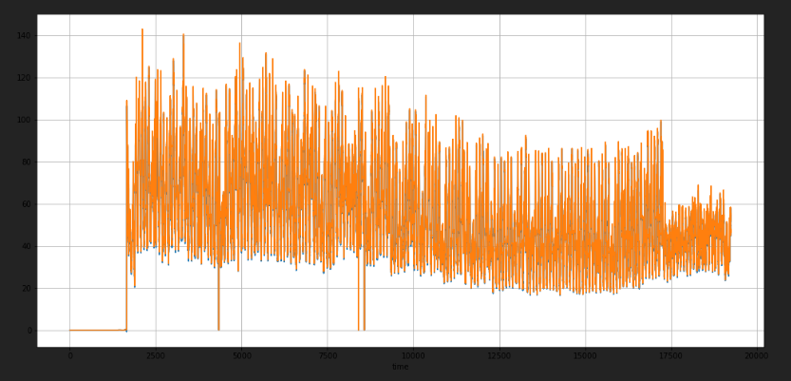

KVAR with time

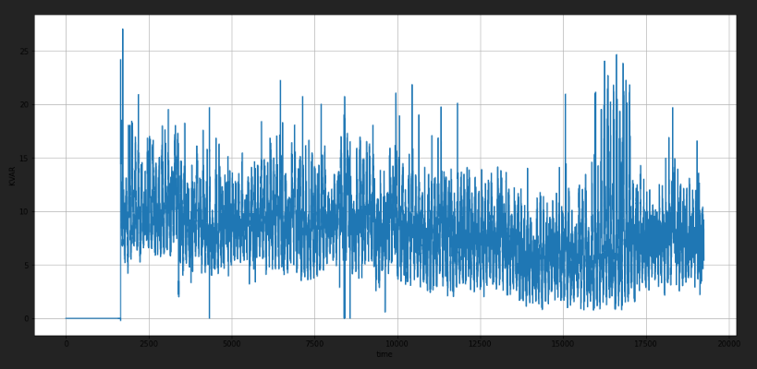

MPD and MKVAD with time

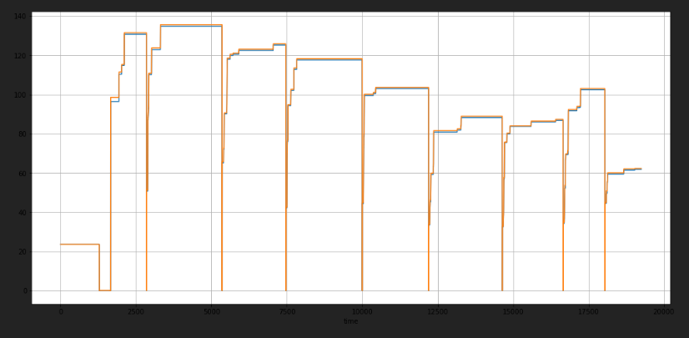

**Heat Map:**

This is the Correlation matrix formed from all the datasets merged using Device time stamp.

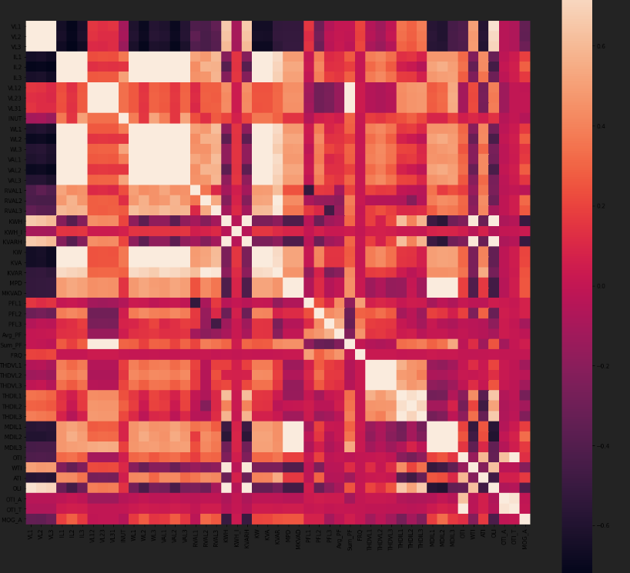

Bigger Picture:(Observations)

1. VL1, VL2, VL3 are negatively correlated with IL1, IL2, IL3, WL1, WL2, WL3, VAL1, VAL2, VAL3, RVAL1, RVAL2, RVAL3, KW, KVA, KVAR, MPD, MKVAD, MDIL1, MDIL2, MDIL3, OTI and ATI.

2. IL1, IL2, IL3, WL1, WL2, WL3, VAL1, VAL2, VAL3, KW, KVA and KVAR are highly correlated with each other.

3. Sum_PF is highly correlated with VL12, VL23, VL31

4. KWH, KVARH are highly correlated with WTI and OLI.

5. MPD, MKVAD are highly correlated ith MDIL1, MDIL2, MDIL3

6. OLI is highly correlated with VL1, VL2, VL3. KWH, KVARH, THDIL1, THDIL2 and THDIL3.

7. OTI has positive correlation with IL1, IL2, IL3, VL12, VL23, VL31, WL1, WL2, WL3, VAL1, VAL2, VAL3, RVAL1, RVAL2, RVAL3, KW, KVA and KVAR

8. THDVL1, THDVL2, THDVL3 are highly correlated with THDIL1, THDIL2, THDIL3.

9. MDIL1, MDIL2, MDIL3 are positively correlated with IL1, IL2, IL3, WL1, WL2, WL3, VAL1, VAL2, VAL3, RVAL1, RVAL2, RVAL3, KW, KVA and KVAR.

10. OTI is negatively correlated with VL1, VL2, VL3.

11. OLI is negatively correlated with VL1, VL2, VL3, WL1, WL2, WL3, VAL1, VAL2, VAL3, RVAL1, RVAL2, KW, KVA, KVAR, MPD, MKVAD, PFL2, MDIL1, MDIL2 and MDIL3.

**Analyzing with the given threshholds:**

power factor <0.9

average power factor <2.7

frequency<49.5

THDVL>3

THDIL>25

VL<220

IL>240

VL line>445

WL>40

VAL>40.6

RVAL>7

KW>115

KVAR>17

ATI>40

OTI>65

OLI<39

OTI_A>0

OTI_T>0

MOG_A>0

INUT>65

i max=240

v max=445

this are the assumed limits for the various parameters.

then the assumed rating of transformer is 105KVA or 100KVA

if the oil level inside the conservator tank falls below the 39 then MOG_A will activate as 1

if the ATI increases beyound 40 then the OTI_A should activate to turn on all the cooling system

if the OTI increases beyond 65 then OTI_T should activate and give warning as overloaded or oil leakage

if frequency falls below 49.5 then it should indicate as the turbine is running slow at the source and viceversa

flux propotional V/F

flux is constant in the transformer, if frequency decreses below 49.5 the to build the required flux automatically the voltage will increase this causes stress on the insulation inside transformer

and the over voltage causes spark production between the contacts

the three conductors should carry approximately equal amount of currents so that the circuit is balanced,if not the imbalance in the system will cause current to flow in the neutral wire

and this imbalance critical will be found from the THD values, if it is not limited single conductor may be over loaded

the power factor will be used to find the active power supplied to the load with respect to the apparent power.

if the power factor falls below 0.9 then apperent power load on the system will be incresed but the utilization of power will remain same, and this will increase the rating of transformer to be installed

this low power factor cause increase in current in the conductors and the temperature of conductor also increases.

**Queries on the dataset:**

The filename of the corresponding results and graphs(to visualize how each condition affects other parameters)

is given after each query.

1. (PFL1<0.9 or PFL2<0.9 or PFL3<0.9) and Avg_PF<2.7

Result:

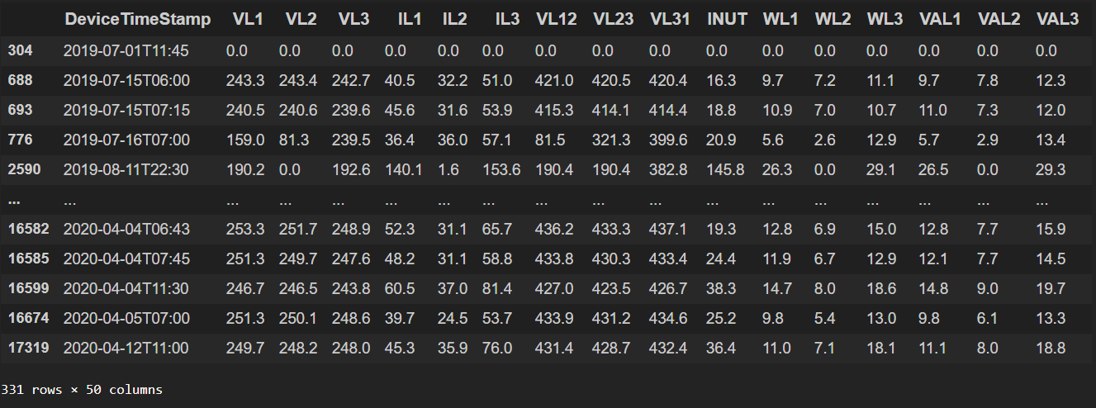

There are 331 instances.

Filename: res21

2. FRQ<49.5

Result:



We have only 1 instance where all the readings are 0s but OTI, ATI and OLI

Filename: res22

3. THDVL1>3 or THDVL2>3 or THDVL3>3

Result:

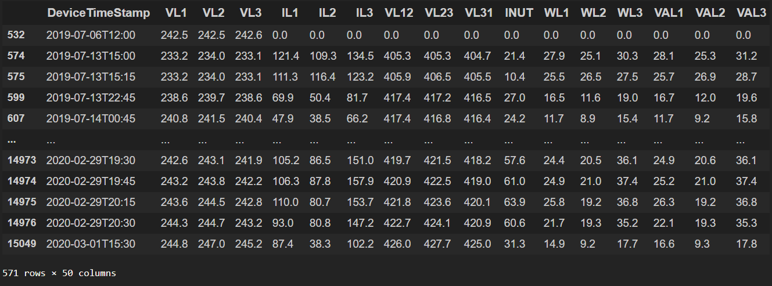

We have 571 instances for the above condition.

Filename:res23

4. THDIL1>25 or THDIL2>25 or THDIL3>25

Result:

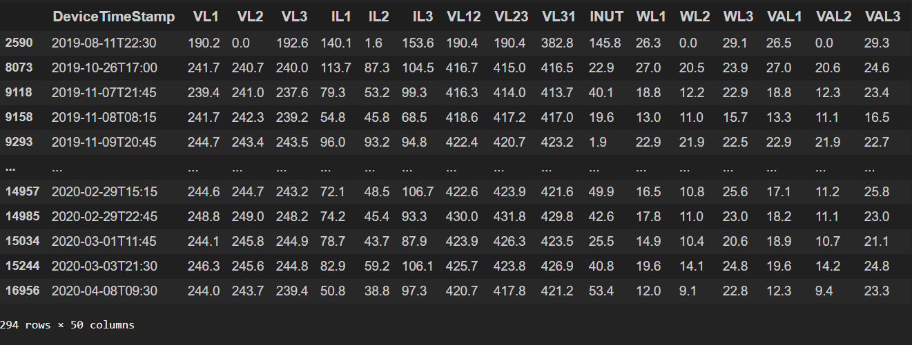

294 times the above condition is satisfied.

Filename: res24

5. VL1<220 or VL2<220 or VL3<220

Result:

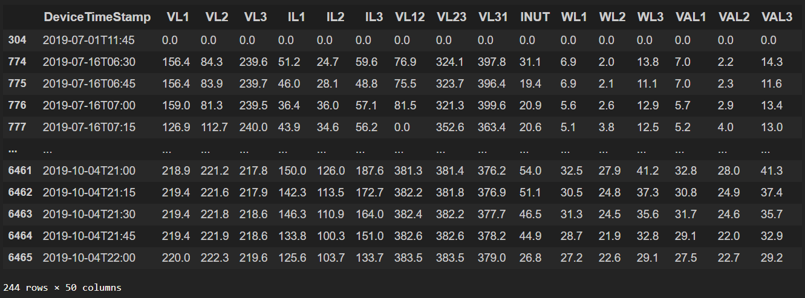

244 instances satisfied the above condition.

Filename: res25

6. WL1>40 or WL2>40 or WL3>40

Result:

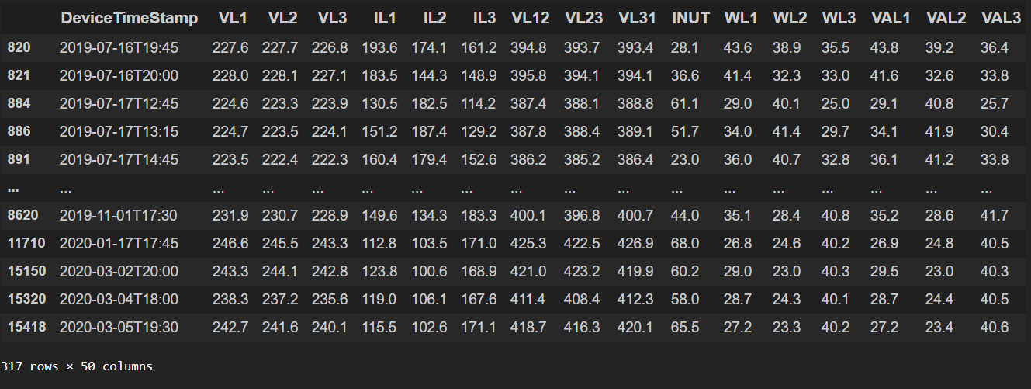

317 times the above condition is satisfied.

Filename: res26

7. VAL1>40 or VAL2>40 or VAL3>40

Result:

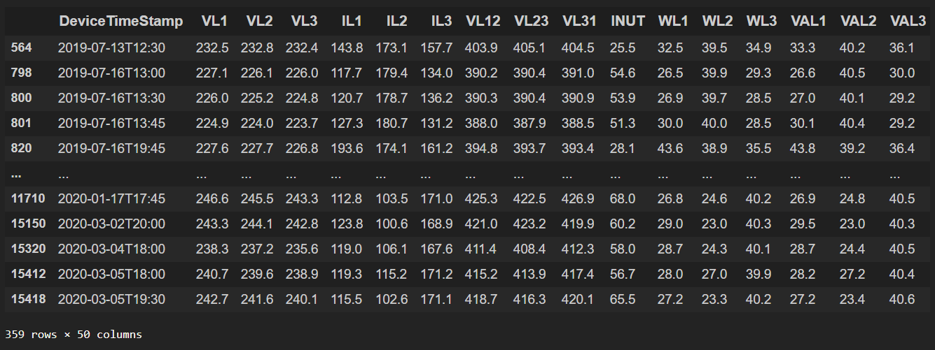

There are 359 instances that satisfy the above condition.

Filename: res27

8. RVAL1>7 or RVAL2>7 or RVAL3>7

Result:

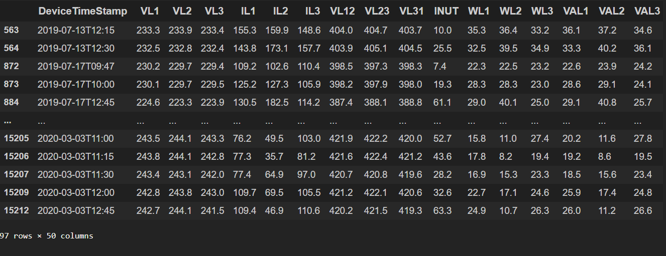

There are 97 rows where this condition occurs.

Filename: res29

9. KW>115

Result:

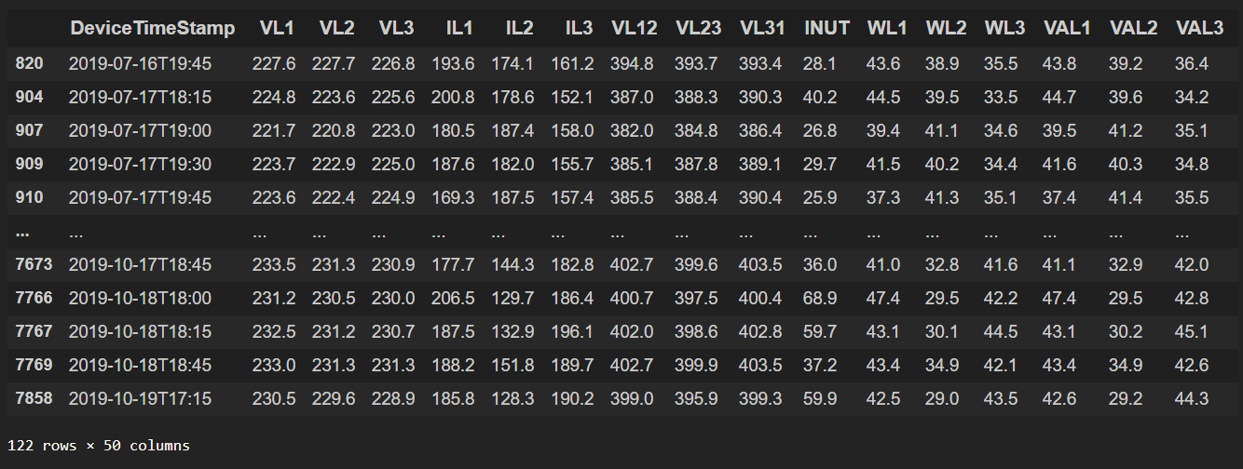

The result has 122 rows.

Filename: res30

10. KVAR>17

Result:

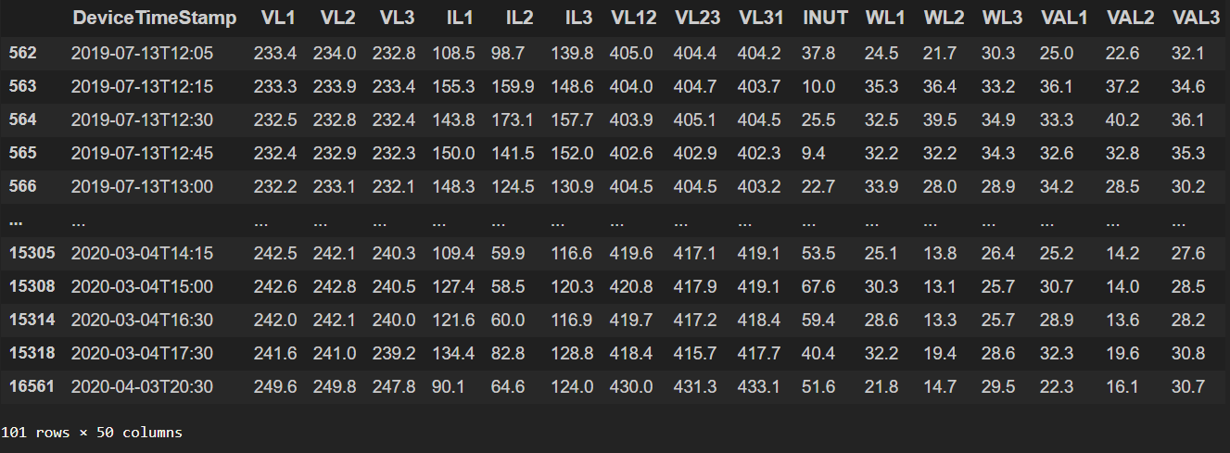

101 instances when KVAR>17

Filename: res31

11. ATI>40

Result:

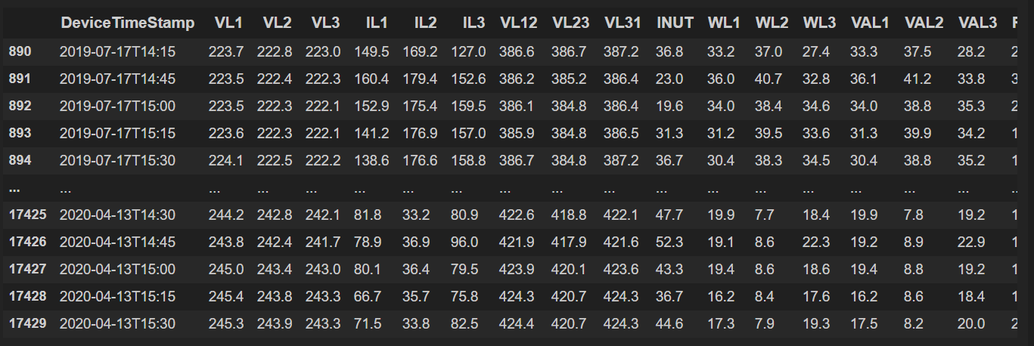

199 results are shown.

Filename: res32

12. OTI>65

Result:

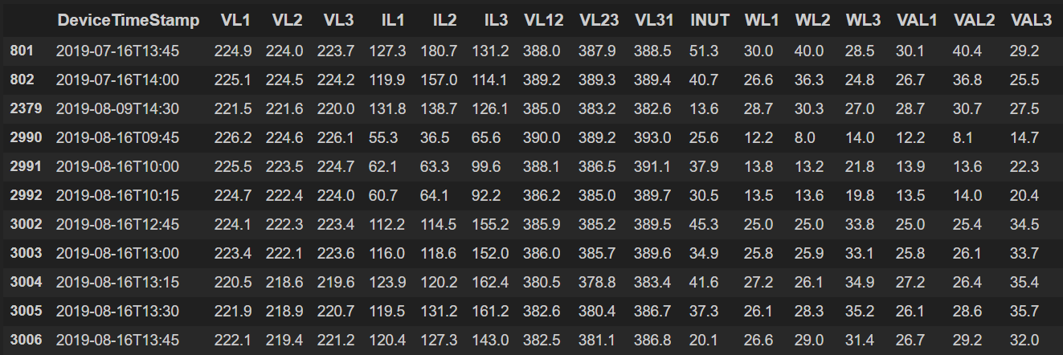

33 results are shown.

Filename: res33

13. OLI<39

Result:

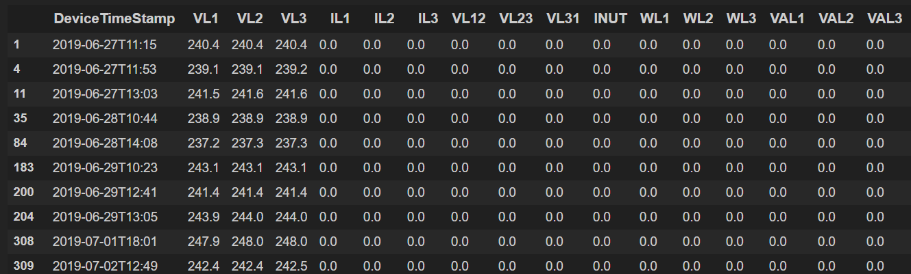

33 results are shown.

Filename: res34

14. OTI_A>0

Result:

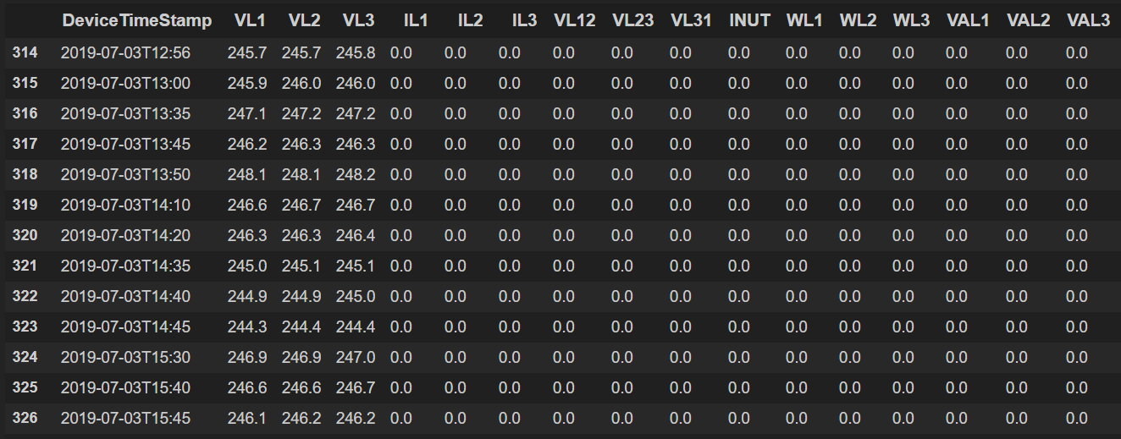

56 instances satisfy the above condition.

Filename: res35

15. OTI_T>0

Result:

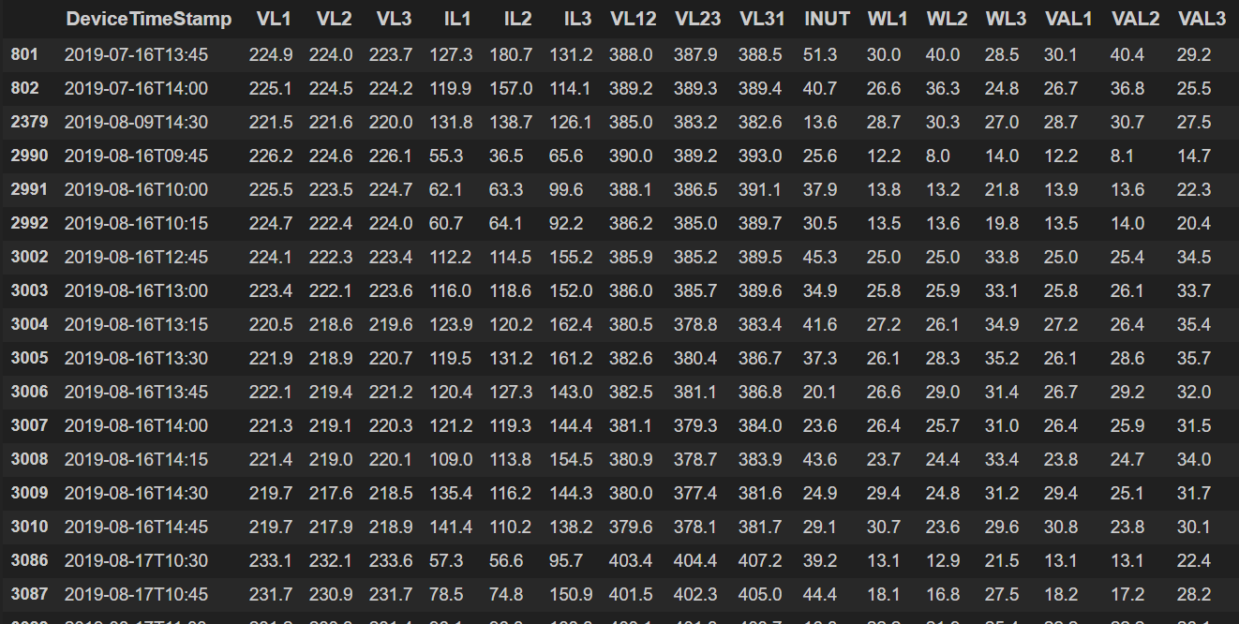

33 instances satisfy the above condition.

Filename: res36

16. MOG_A>0

Result:

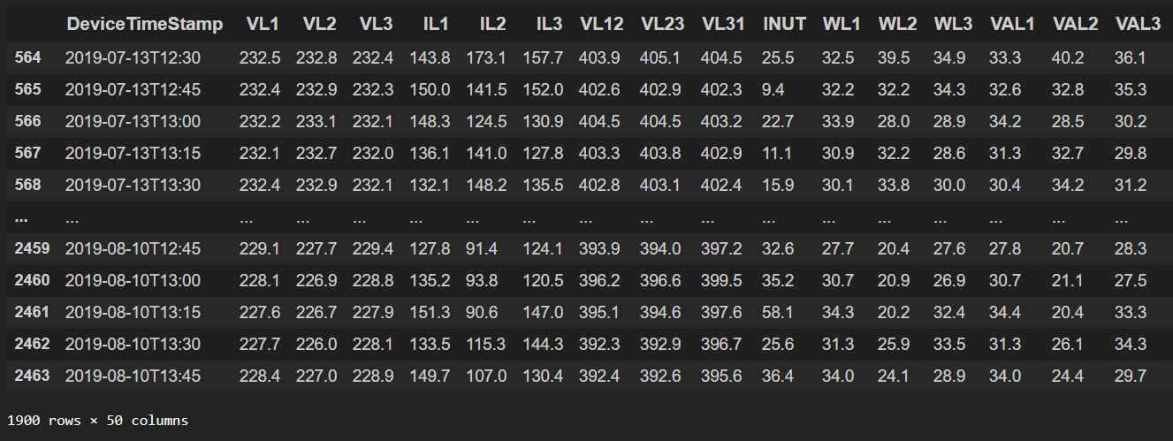

1900 results are shown.

Filename: res37