Sreepathy Jayanand

CED17I038

High Performance Computing LAB - 4

Analysis of parallelization fraction

**Processor Specifications:**

* Intel i5 - 5350U
* Base clock speed - 1.80GHz
* Max clock speed - 2.90GHz
* Physical Cores - 2
* Threads / Core - 2
* Logical Cores - 4
* L1 cache size (per core) - 64 KB
* L2 cache size (per core) - 256 KB
* L3 cache size - 3 MB
* Main memory - 8GB

Question 1: Vector Addition

Input size : 3 x 1e8

Segmentation fault : 5 x 1e8

Let the total processes = p

Let n = array size

Strategy: The master process sends n/p indices to work for each process using send() function and computes the sum of corresponding indices 0 - n/p itself.

Then it uses recv() to get the computed values from the slave processes.

Table 1:

| No of processors | Exec time |
| --- | --- |
| 1 | 56.25 |
| 2 | 75.02 |
| 4 | 22.42 |
| 8 | 11.16 |
| 16 | 11.41 |
| 32 | 15.54 |
| 64 | 47.12 |
| 128 | 171.54 |
| 140 | 183.14 |

The most efficient processor size for this program is 8

According to Amdahl’s law :

Speed up = 1/((1-p) + p/N)

Or

Parallelization factor = (N - N/S.U)/(N - 1)

So here N = 8;

Speed Up = 56.25/11.16 = 5.04

PF = (8 - 8/5.04)/7 = .91

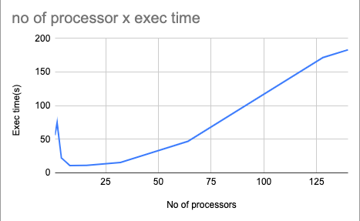

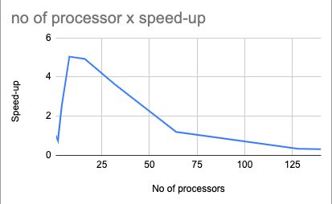

Question 2:

Input size : 3 x 1e8

Segmentation fault : 5 x 1e8

Let the total processes = p

Let n = array size

Strategy: The master process sends n/p indices to work for each process using send() function and computes the product of corresponding indices 0 - n/p itself.

Then it uses recv() to get the computed values from the slave processes.

Table 2:

| No of processors | Exec time(s) |
| --- | --- |
| 1 | 35.35 |
| 2 | 48.38 |
| 4 | 76.48 |
| 8 | 11.43 |
| 16 | 11.64 |
| 32 | 13.33 |
| 64 | 39.82 |
| 128 | 109.04 |
| 140 | 127.15 |

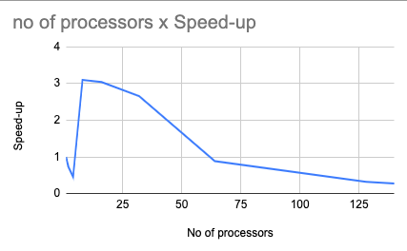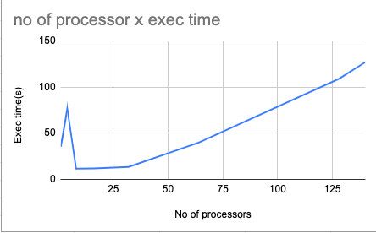

The most efficient processor size for this program is 8

According to Amdahl’s law :

Speed up = 1/((1-p) + p/N)

Or

Parallelization factor = (N - N/S.U)/(N - 1)

So here N = 8;

Speed Up = 35.35/11.43 = 3.44

PF = (8 - 8/3.44)/7 = .81