1.Define Data visualization. Explain the role of Data Visualization in Day to day life.?
A:- Data visualization is the graphical representation of information and data in a pictorial or graphical format(Example: charts, graphs, and maps). Data visualization tools provide an accessible way to see and understand trends, patterns in data, and outliers. Data visualization tools and technologies are essential to analyzing massive amounts of information and making data-driven decisions. The concept of using pictures is to understand data that has been used for centuries. General types of data visualization are Charts, Tables, Graphs, Maps, Dashboards.
the role of Data Visualization in Day to day life
• a simple formatted number representing a single item of interest, such as the gross national product (GNP) of the U.S.;
• a train and subway map with times used for determining train arrivals and departures;
•a map of the region, to help select a route to a new destination;
• a weather chart showing the movement of a storm front that might influence your weekend activities;
• a highway sign indicating a curve, merging of lanes, or an intersection.
• a graph of stock market activities that might indicate an upswing (or
downturn) in the economy;Visualization is used on a daily basis in many areas of employment as well such as
• the result of a financial and stock market analysis;
• a breast cancer MRI for diagnosis and therapy;
• the study of actuarial data for confirming and guiding quantitative analysis;
• the simulation of a complex process.
2.Explain the difference between structured data and unstructured data?

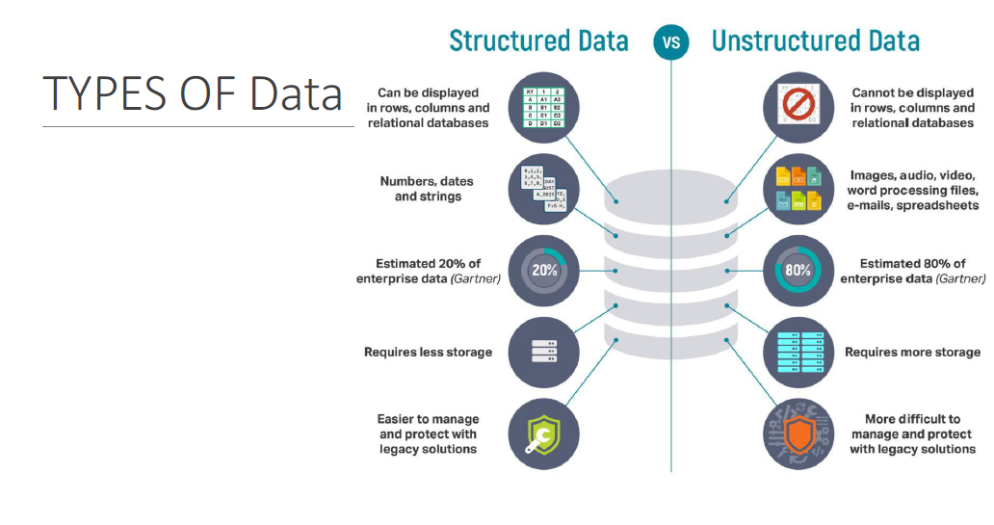
3.Explain about visualization process in detail?
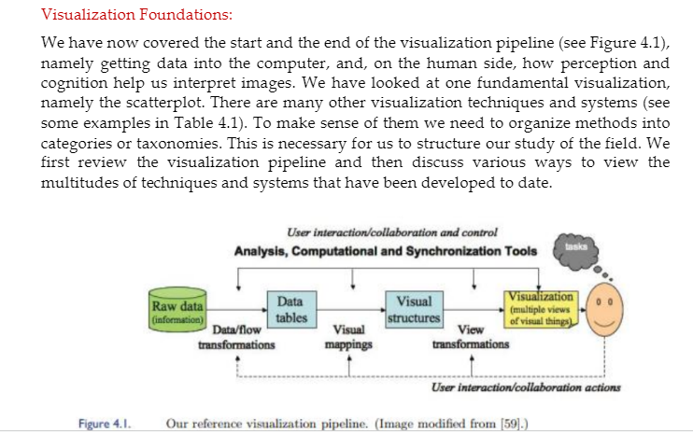
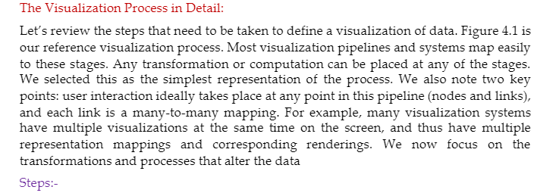
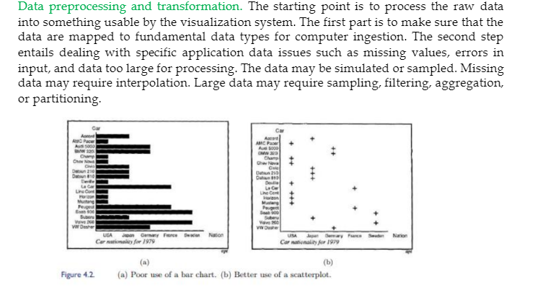
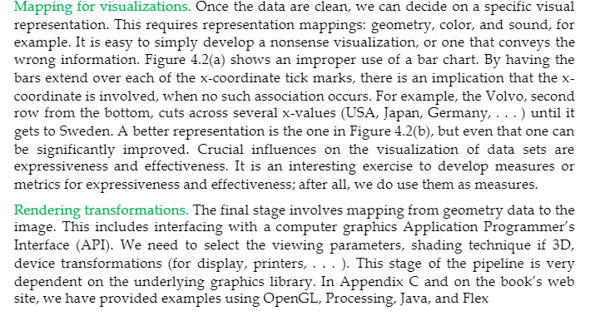
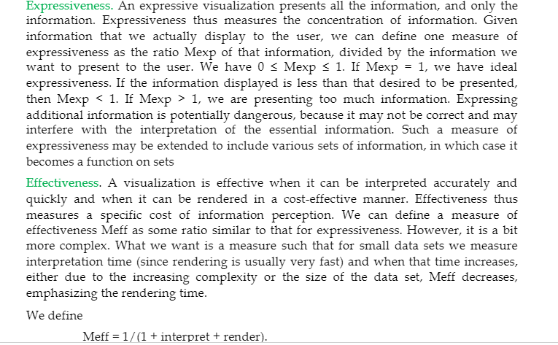
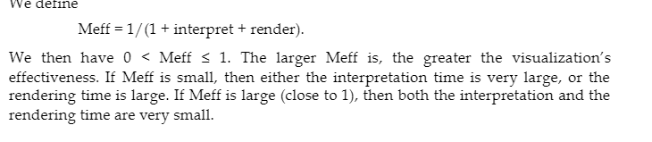
4.explain briefly about relationships between visualization &other fields?
Relationship between Visualization and Other Fields

What Is the Difference between Visualization and Computer Graphics?

Originally, visualization was considered a subfield of computer graphics, primarily because visualization uses graphics to display information via images. As illustrated by any of the computer-generated images shown earlier, visualization applies graphical techniques to generate visual displays of data. Here, graphics is used as the communication medium. In all visualizations, one can clearly see the use of the graphics primitives (points, lines, areas, and volumes). Beyond the use of graphics, the most important aspect of all visualizations is their connection to data. Computer graphics focuses primarily on graphical objects and the organization of graphic primitives; visualizations go one step further and are based on the underlying data, and may include spatial positions, populations, or physical measures. Consequently, visualization is the application of graphics to Display data by mapping data to graphical primitives and rendering the display. However, visualization is more than simply computer graphics. The field of visualization encompasses aspects from numerous other disciplines, including human-computer interaction, perceptual psychology, databases, statistics, and data mining, to name a few. While computer graphics can be used to define and generate the displays that are used to communicate the information, the sources of data and the way users interact and perceive the data are all important components to understand when presenting information.
A network showing the relationships between genes in human DNA, generated with the Circos package.

Our view is that computer graphics is predominantly focused on the creation of interactive synthetic images and animations of three-dimensional objects, most
often where visual realism is one of the primary goals. A secondary application of computer graphics is in art and entertainment, with video games, cartoons, advertisements, and movie special effects as typical examples. Visualization, on the other hand, does not emphasize visual realism as much as the effective communication of information. Many types of visualizations do not deal with physical objects, and those that do are often communicating attributes of the objects that would normally not be visible, such as material stress or fluid flow patterns. Thus, while computer graphics and visualization share many concepts, tools, and techniques, the underlying models (the information to be visualized) and goals (what the viewer hopes to extract) are fundamentally different.
Thus, computer graphics consists of the tools that display the visualizations seen in this book. This includes the graphics-programming language (OpenGL, DirectX, Processing, Java3D), the underlying graphics hardware (NVidia or ATI/AMD graphics cards), the rendering process (flat, Gouraud, Phong, ray tracing, or radiosity), the output format (JPEG, TIFF, AVI, MPEG), and more. We consider computer graphics to be the underpinning of visualization and thus need to keep abreast of it. In Appendix A we provide a brief history of computer graphics. The visualization in Figure 1.30 shows the dependency of interactive visualization on computer graphics. The visualization displays a patient’s heart (scientific/medical visualization) in the upper left window with two other frames showing additional parameters not easily displayable on the heart. These last two are the ones that are often considered information visualizations, but clearly all three are! Computer graphics is the rendering engine for this integrated visualization.
Scientific Data Visualization vs. Information Visualization

Although during the 1990s and early 2000s the visualization community differentiated between scientific visualization and information visualization, we do not. Both provide representations of data. However the data sets are most often different. Figure 1.30 highlights the importance and value
of having both. Biomolecular chemistry, which once only considered the
visual representation of molecules as stick and balls, has migrated over time

