Query to investigate GRE scores which look off/incorrect; query is in gre_check.sql
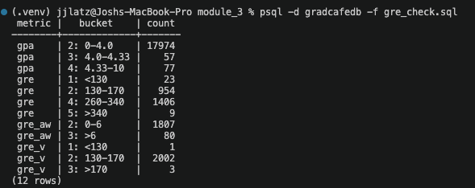
Questions 1-9 plus user questions 1 and 2 output:
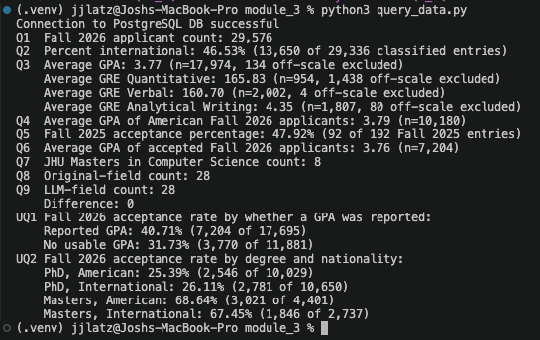
Questions_scratch output to dig into q8 and q9 count matches
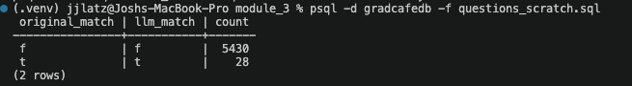
Generate the ORM model and mappings, ensure that it matches the table
Part 6 orm_queries.py console output
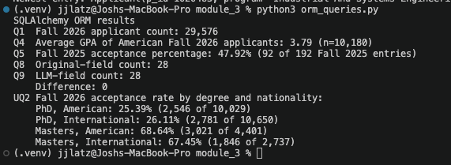
Screenshots from flask app (run 1, section 8)
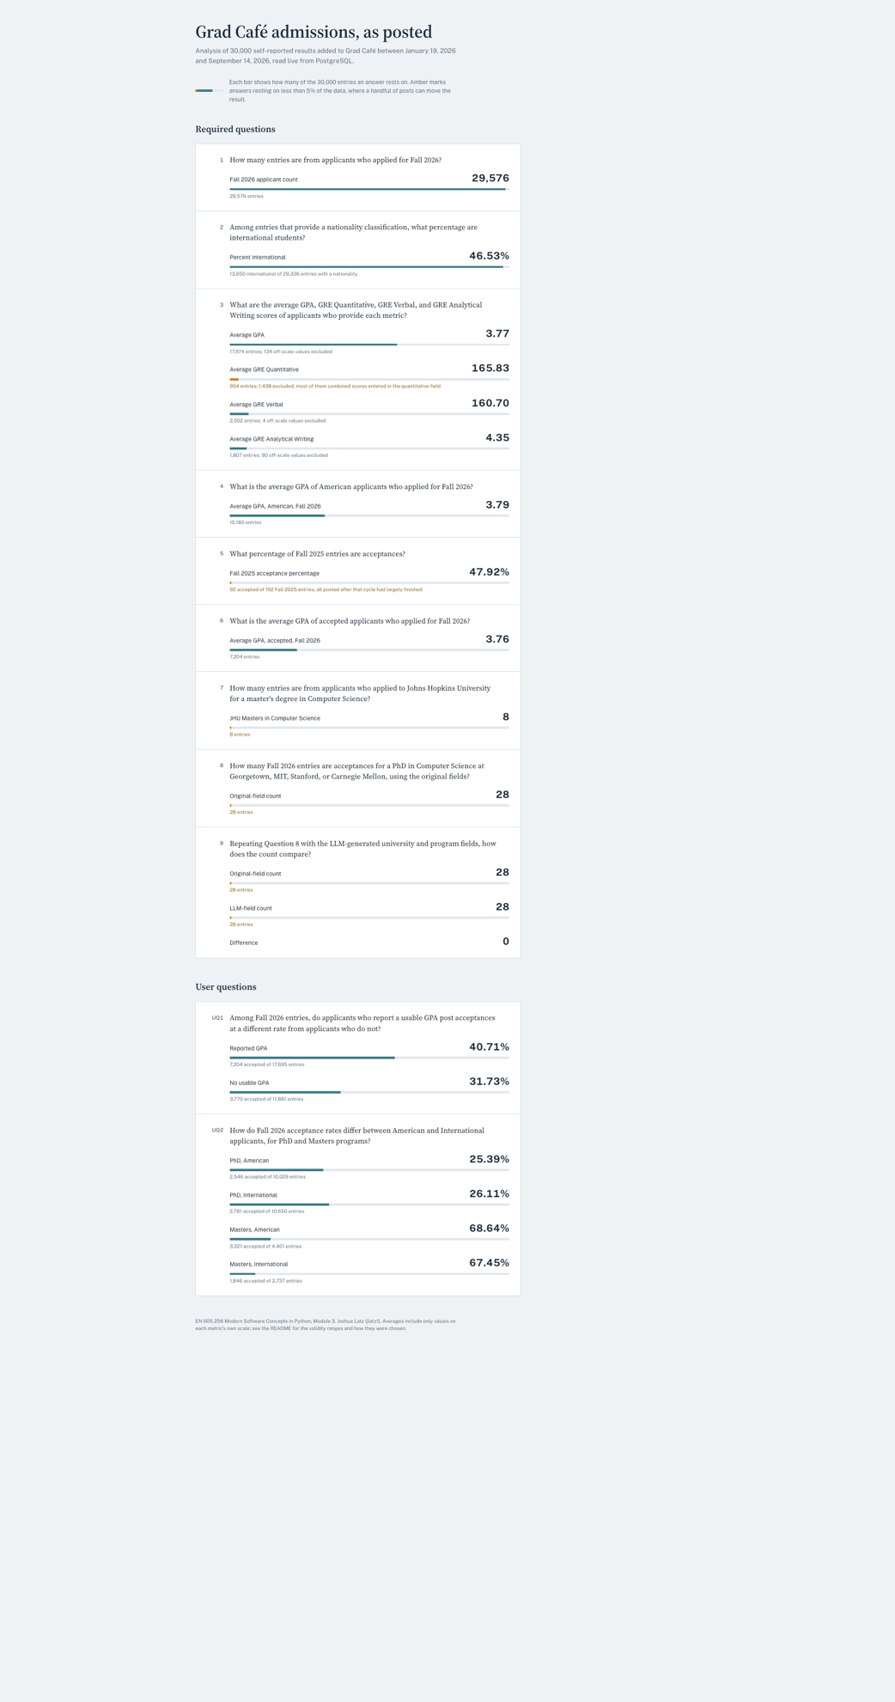
Screenshots from flask app (run 2, section 9)
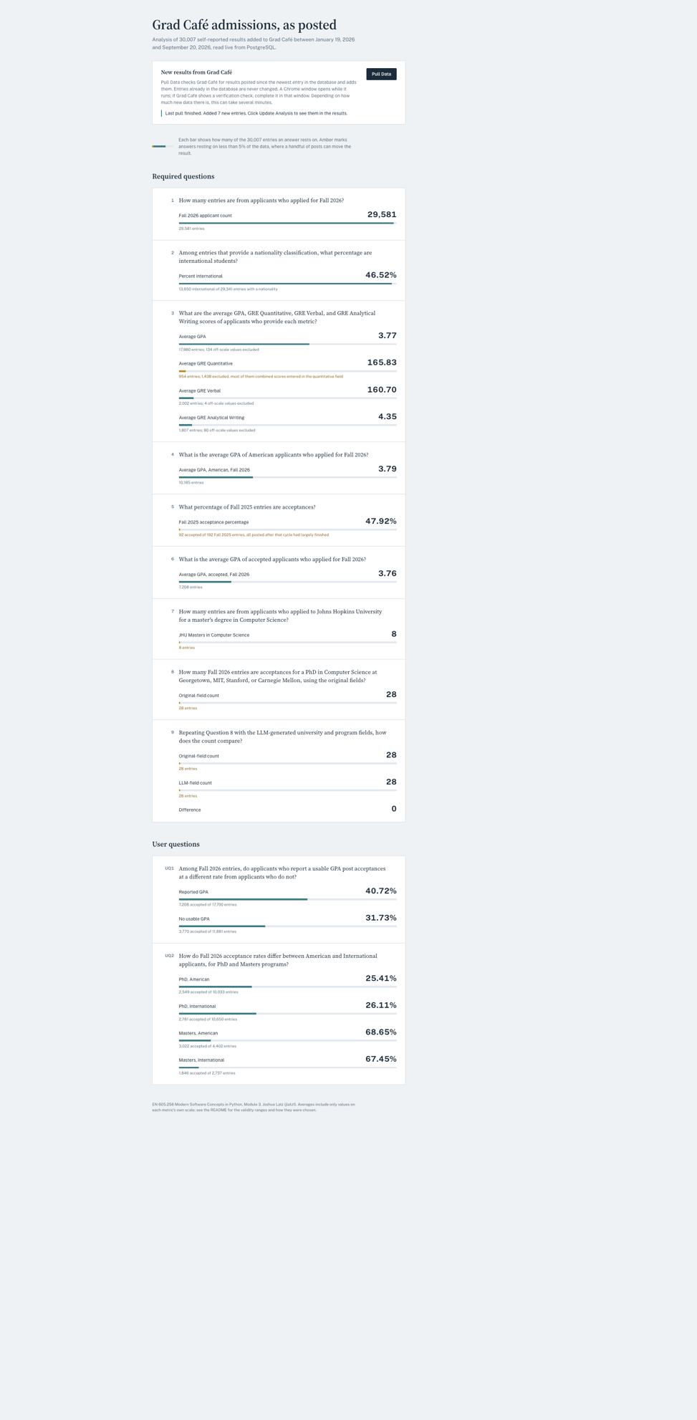
Screenshots from flask app (run 3, section 10)

