**GRAPH**

1)

B -> A ->C ->D -> F->E -> G-> H -> I

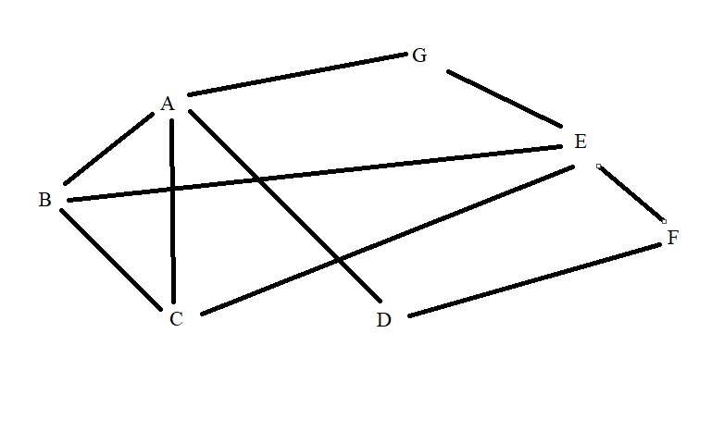2)

A-> B -> C -> D -> G -> E -> F

3)

A -> B -> C -> D -> F -> G -> E -> H-> I -> J -> K

4)

Choose 1 -> 2 (1)

Choose 2 -> 3 (1 + 2)

2-> 4 (1 + 5)

2 -> 5(1 + 10)

We see that, 2 ->3 is spend less than 2->4 and 2->5 so that we choose 2-> 3

Choose 3 -> 5 (complete path)

* 1 -> 2 -> 3 -> 5 spend 1+2+3 = 6

12)

A : 1 -> B: 2 -> C: 3 -> D: 2 -> G:3 -> I:2 -> E:1-> F: 3-> H:1

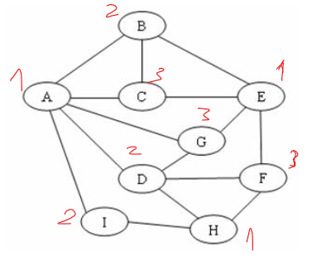

13 )

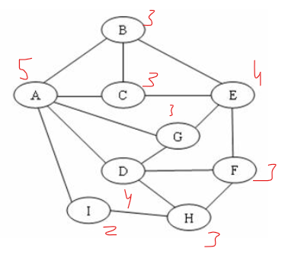

A:1 -> D:2 -> E:1 -> B:2->C:3->F:3->G:3->H:1 ->I:2

10)

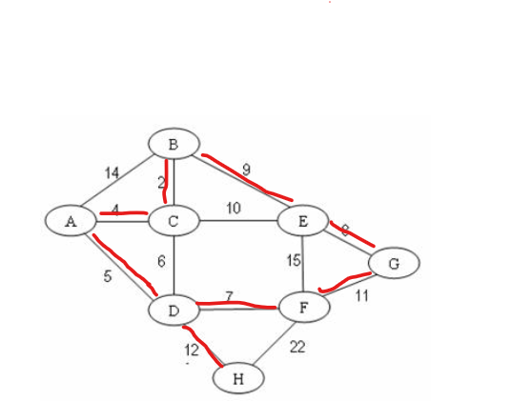

Total : 2+4+5+7+8+9+11+12 = 58

11)

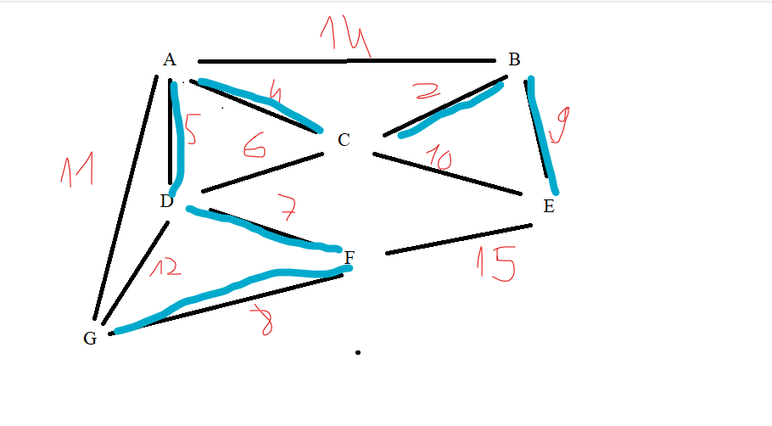

2+4+5+7+8+9 = 35