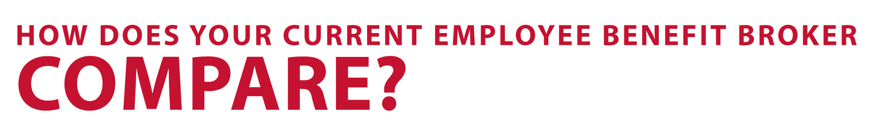



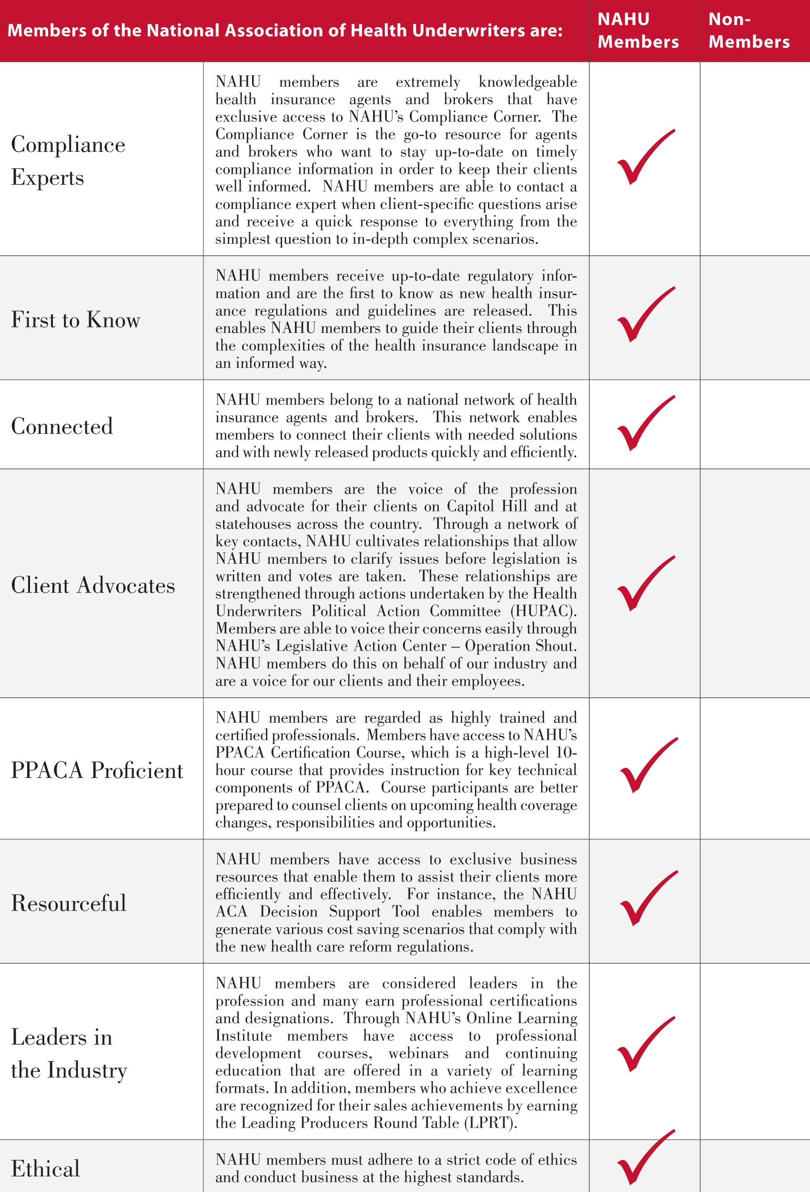

**PLACE YOUR LOGO AND CONTACT INFORMATION HERE.**

Experts • Connected • Industry Leaders • Ethical • First to Know