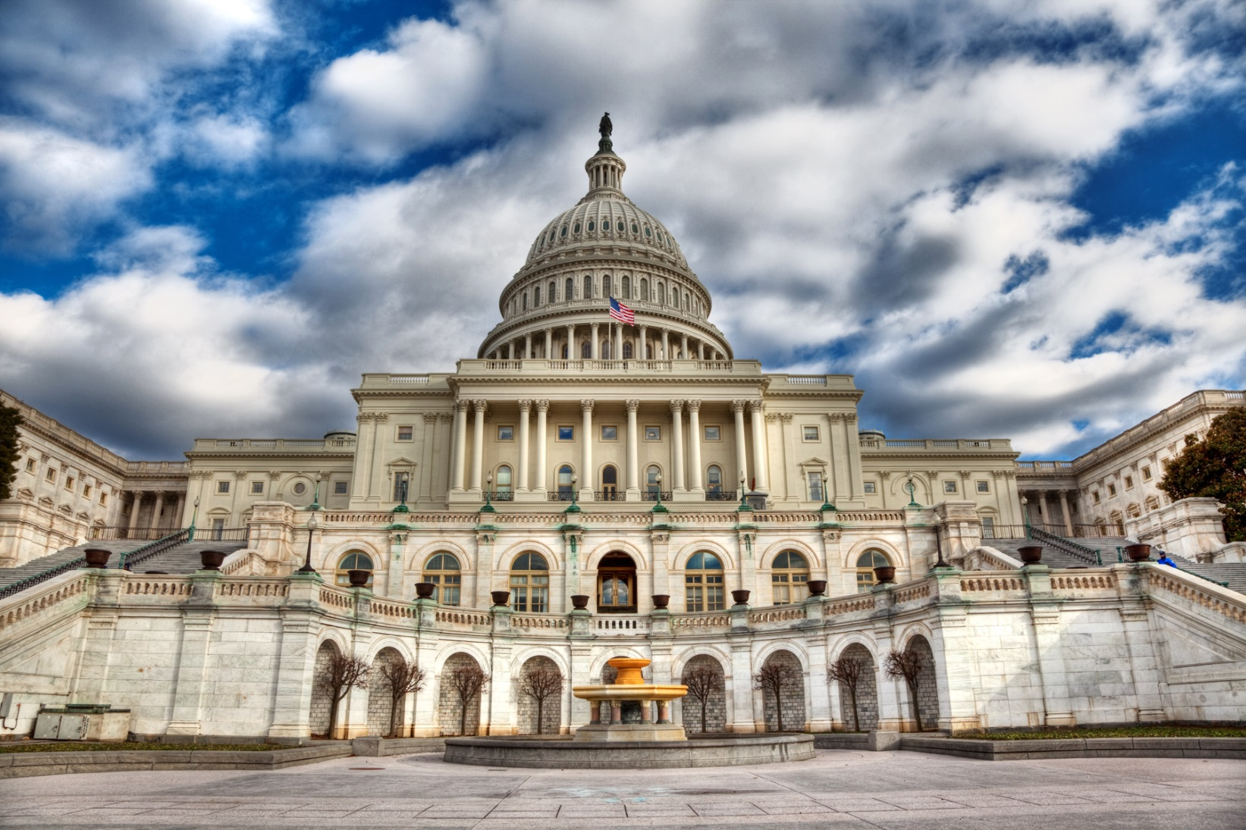

**National Association of Health Underwriters**

**2018 Capitol Conference -- February 26-28 -- Washington, D.C.**

**Preliminary Agenda**

**Sunday, February 25**

6:00–8:00 p.m. Attendee Welcome Reception

8:00–11:00 p.m. HUPAC Bowling Party

**Monday, February 26**

7:30 a.m.–5:00 p.m. Registration

7:30–8:00 a.m. Continental Breakfast with Sponsors

8:00–9:00 a.m. Breakout Meetings for:

* *State and Local Legislative Chairs* 
  + *This meeting will serve as a training session for new and current state and local legislative chairs. It will include a panel of experienced legislative chairs, a review of the manual, and presentation of new state tracking services.*
* *HUPAC Chairs*

9:15–11:30 a.m. General Session

12:00–1:15 p.m. Lunch on own

1:30–2:45 p.m. Town Hall Meeting

2:45–3:15 p.m. Afternoon Break with Sponsors

3:15–4:45 p.m. Breakout Session

5:00–6:00 p.m. NAHU Regional Meetings

6:00 p.m. Dinner on your own

**Tuesday, February 27**

7:00–8:00 a.m. Continental Breakfast with Sponsors

8:00–11:30 a.m. General Session

11:30 a.m.–1:00 p.m. Lunch on your own

1:00–5:00 p.m. Lobbying on Capitol Hill

* *Member-arranged visits with congressional representatives.*

5:30–7:30 p.m. HUPAC Reception at the Top of the Hill (ticket required)

**Wednesday, February 28**

7:00–8:00 a.m. Continental Breakfast with Sponsors

8:00–11:30 a.m. General Session

11:30 a.m.–1:00 p.m. Lunch on your own

12:00–2:30 p.m. HUPAC Capitol Club Luncheon (by invitation)

1:00–5:00 p.m. Lobbying on Capitol Hill

* *Member-arranged meetings with congressional offices.*