National Association

of Health Underwriters

Political Action Committee

**2015-2016**

**Candidate Questionnaire**

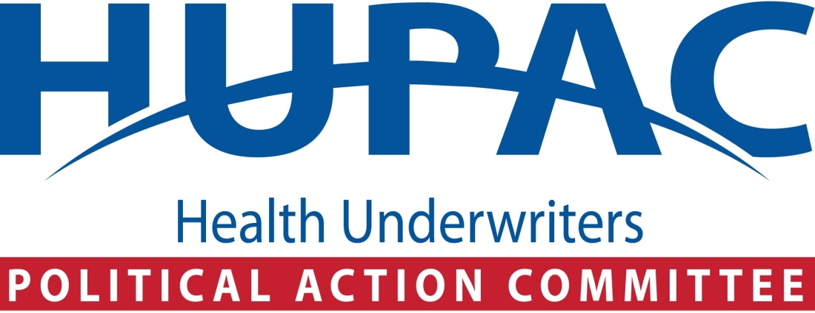

1212 New York Avenue, NW, Suite 1100  
Washington, D.C. 20005

(202) 595-3678 -- phone

(202) 747-6820 -- fax

info@hupac.org

**HUPAC Candidate Survey**

National Association of Health Underwriters (NAHU) represents more than 100,000 professional insurance agents and brokers nationwide. HUPAC is its political action committee and how NAHU members help to elect candidates dedicated to ensuring that the health care industry – and private health insurance – continues to be a strong and affordable choice for all Americans.

HUPAC is registered with the Federal Election Commission. Candidates seeking HUPAC support please complete and return the candidate survey below to:

*Anthony Perez*

*Manager of HUPAC*

*1212 New York Avenue, NW, Suite 1100*

*Washington, D.C. 20005*

202-808-0675 *– aperez@nahu.org*

**Part I: Candidate and Campaign Information**

|  |  |  |  |  |  |
| --- | --- | --- | --- | --- | --- |
| Date: | |  | | | |
| Name: | |  | | | |
| Permanent Address: | |  | | | |
| City: |  | State: |  | Zip: |  |
| Office Being Sought: | |  | |  | |
| District/State: | |  | |  | |
| Are you an incumbent? | | Yes  No | | | |
| If Yes, for how long? | |  | | | |
| Have you run for office before? | | Yes  No | | | |
| If Yes, what office? | |  | | | |
| Previous Elected Position(s): | |  | | | |

**Campaign Information:**

|  |  |  |  |  |  |  |
| --- | --- | --- | --- | --- | --- | --- |
| FEC ID #: |  | | | | | |
| Committee Name: |  | | | | | |
| Campaign Address: |  | | | | | |
| City: |  | State: | |  | Zip: |  |
| Phone: |  | | | Fax: |  | |
| Campaign Chair or Committee Chair: | | |  | | | |
| Campaign Manager or Political Director: | | |  | | | |
| Senior Campaign Strategist or  Campaign Consultant: | | |  | | | |

**Party Affiliation:**

Democrat Independent Republican Other

**Please include a demographic profile of your district:**

|  |
| --- |
|  |

**HUPAC Support Request For:**

|  |  |  |  |
| --- | --- | --- | --- |
|  | Primary Election |  | Date of Election |
|  | General Election |  | Date of Election |
|  | Special Election |  | Date of Election |
|  | Run-off |  | Date of Election |

Have you received HUPAC support in previous campaigns?

Yes No

**Please list all candidates running for this office, including third party candidates:**

|  |  |
| --- | --- |
| **Opponent’s Name:** |  |
| Party Affiliation: |  |
| **Opponent’s Name:** |  |
| Party Affiliation: |  |
| **Opponent’s Name:** |  |
| Party Affiliation: |  |
| **Opponent’s Name:** |  |
| Party Affiliation: |  |
| **Opponent’s Name:** |  |
| Party Affiliation: |  |
| **Opponent’s Name:** |  |
| Party Affiliation: |  |
| **Opponent’s Name:** |  |
| Party Affiliation: |  |

**Candidate Background:**

1. Previous elected office(s) held (please include committee assignments):

|  |
| --- |
|  |

**2.** Prior Committee Assignments in State Legislature or Congress; specify which:

|  |
| --- |
|  |

3. What is (are) your primary area(s) of interest in legislative policymaking?

|  |
| --- |
|  |

4. Have you ever worked in the health, life or disability insurance industry? If so, please explain.

|  |
| --- |
|  |

5. Have you ever worked in any health care field? If so, please explain.

|  |
| --- |
|  |

6. Do you have working relationships with health insurance agents or brokers in your state or district?  If yes, please provide their names.

|  |
| --- |
|  |

7. Please identify support/endorsements from other political action committees or other organizations, especially in the health care field.

|  |
| --- |
|  |

**Part II: ISSUE QUESTIONS**

1. What are your top three (3) health care priorities? Please identify how these will be helpful to the health insurance markets operating competitively.

|  |
| --- |
|  |

1. What can Congress do to ensure that professionally licensed health insurance agents and brokers are able to continue to provide their services to individuals and employers?

|  |
| --- |
|  |

1. Please identify provisions of the Patient Protection and Affordable Care Act (PPACA) that you think could use modification.

|  |
| --- |
|  |

1. Today employer sponsored coverage is the way that most Americans receive health insurance benefits. What are your thoughts on the employer-based system and the tax treatment of employer-provided group health insurance benefits?

|  |
| --- |
|  |

1. Health insurance is expensive because health care is expensive. What are ways that you believe we can bend the healthcare cost curve while improving care?

|  |
| --- |
|  |

1. Employers are struggling with numerous new compliance requirements of the PPACA. What are things that Congress can do to help businesses with these requirements?

|  |
| --- |
|  |

1. What are some policy reforms that you would like to see made to Medicare and Medicaid to help make these programs more sustainable?

|  |
| --- |
|  |

1. Many seniors currently do not have long term care coverage. How can Congress address this issue and provide coverage for an increasingly aging population?

|  |
| --- |
|  |

1. Beginning in 2018, the PPACA “Cadillac Tax” will impose a 40% excise tax on health plans that exceed certain cost thresholds. How should Congress address this situation to prevent this negatively impacting employer-based coverage.

|  |
| --- |
|  |

**THANK YOU FOR RESPONDING TO THE 2015-2016   
HUPAC CANDIDATE QUESTIONNAIRE**