June 6, 2019

The Honorable R. Alexander Acosta,

Secretary of Labor

200 Constitution Avenue NW

Washington, DC 20210

RE: RIN 1235–AA24

*Submitted Electronically via www.regulations.gov*

# Dear Secretary Acosta:

# I am writing on behalf of the National Association of Health Underwriters (NAHU), a professional association representing more than 100,000 licensed health insurance agents, brokers, general agents, consultants and employee benefits specialists. We are pleased to have the opportunity to provide comments in response to the proposed rule titled “Regular Rate under the Fair Labor Standards Act” published in the *Federal Register* on March 28, 2019.

The members of NAHU work daily to help millions of individuals and employers of all sizes purchase, administer and utilize health insurance coverage. Our expertise lies in the technicalities of health-plan purchasing and administration and the real-world challenges employers face therein. As such, our membership has a keen interest in this proposal to amend 29 CFR Part 778 and its “regular rate” requirements under §7(e) of the Fair Labor Standards Act (FLSA), 29 USC §207(e). We believe that the proposed rule provides employers and group health and welfare plan sponsors with necessary clarification on the types of compensation and benefits that employers must include in the calculation of “all remuneration for employment” when determining an employee’s regular rate of pay.

In particular, the membership of NAHU would like to voice its support of the proposed rule's clarification that excludes employer-provided wellness benefits, including gym memberships, fitness classes and worksite medical and specialist treatment from the regular rate of pay. Section 7(e) of the FLSA already clearly established that the cost of employer-sponsored health insurance coverage and other specified benefits do not count toward the remuneration calculation, and employers also exclude the price of health insurance benefits from employee's taxable wages. Our organization believes that the elucidation provided by the proposed rule is a natural extension of the statute and reflects the state of health and welfare benefits that employers typically provide, or desire to deliver, today.

Many employers wish to improve the health of their employees by offering them all kinds of wellness programs and worksite medical treatment options. These benefits make the practice of keeping healthy convenient for employees, and they are valuable perks of employment that help companies attract and retain a productive workforce. Since this proposed rule gives employers certainty about how to treat such services for the rate of pay calculation, it will help ensure that employers continue to provide employees with wellness and worksite treatment options. It may even encourage new employers to begin to offer these benefits, which will improve the health of more Americans.

The members of NAHU sincerely appreciate the opportunity to express our views about the treatment of employer-provided health and wellness benefits as they relate to employee wages. If you have any questions about our comments, or if NAHU can be of assistance as you move forward, please do not hesitate to contact me at either (202) 595-0787 or [jtrautwein@nahu.org](mailto:jtrautwein@nahu.org).

Sincerely,

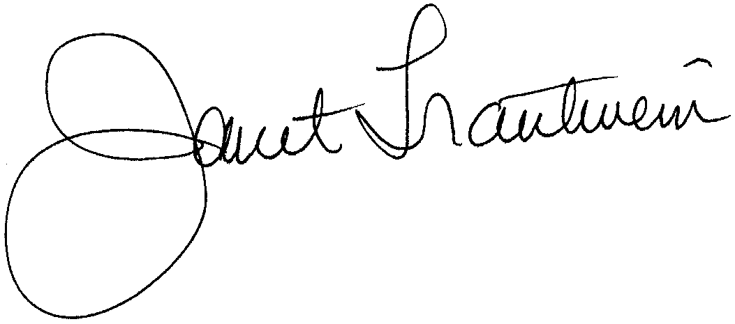

Janet Stokes Trautwein

Chief Executive Officer

National Association of Health Underwriters