RTNode-2400
Easy Zero to Reticulum Transport Node Build
Reticulum transport node firmware with LAN/WAN boundary security, a live RGB status LED, and community bug fixes
Board: Heltec WiFi LoRa 32 V4 | Radio: 915.125 MHz / SF9 / BW125 / CR5 | Written for non-coders
Mac & Windows

What You'll Need
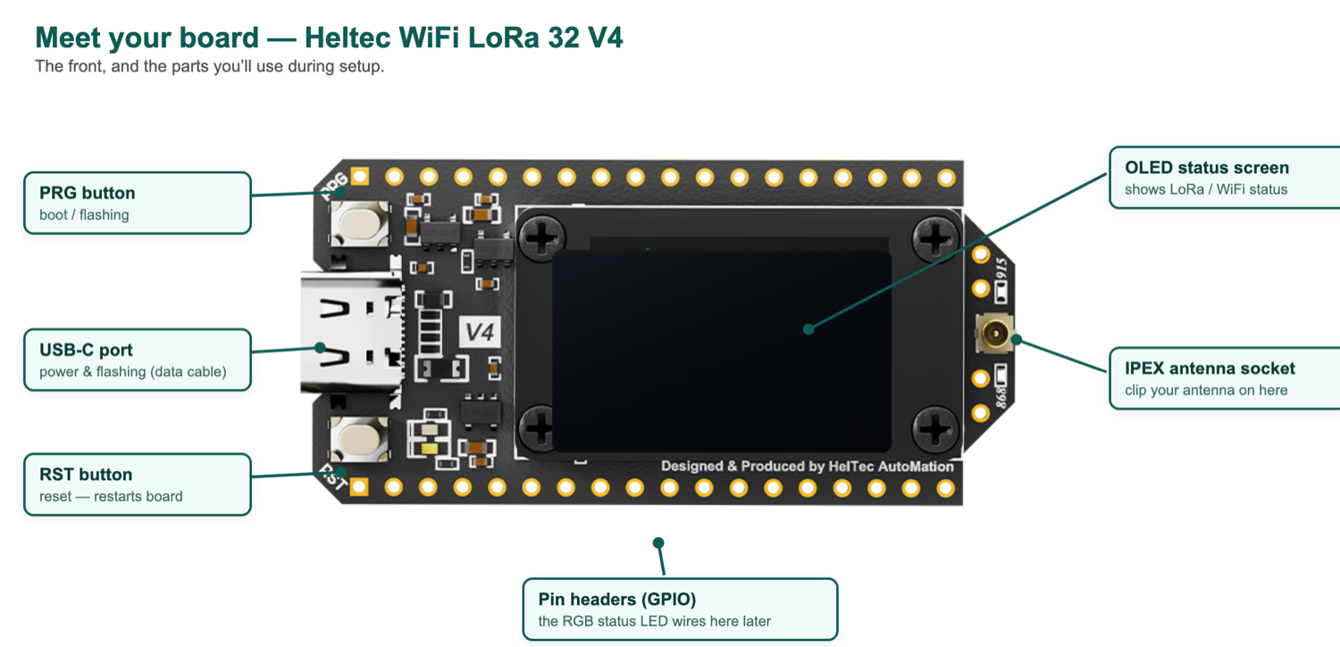
The Heltec WiFi LoRa 32 V4 — the one board you need, and the parts you’ll use during setup.
Two things: one Heltec WiFi LoRa 32 V4 board, and a USB-C cable to connect it to your computer. Buy the board directly from Heltec here:
https://heltec.org/project/wifi-lora-32-v4/
On the Heltec page the board has a few ordering options. Choose these exactly:
- MCU: choose ESP32-S3R2 (the 2 MB version). Do not pick ESP32-S3R8 — it uses a different type of memory and won’t work with this firmware.
- Display: choose OLED. You need the small screen — the board uses it to show whether LoRa, WiFi and the network are working.
- LoRa band: choose 902~928MHz. This covers the 915 MHz this firmware is set up for — the right choice for the United States, Australia and New Zealand. Only choose 863~870MHz if you are joining a mesh that runs on the 868 MHz band instead.
- Warehouse: choose whichever is closest to you — US (United States), DE (Germany, for Europe), or CN (China, which ships worldwide).
For the cable, use a USB-C cable that carries data — many phone-charging cables are power-only and won’t work. You’ll also need a computer (Mac, or Windows).
What You'll End Up With
A Heltec V4 board running RTNode-2400 firmware, configured as a standalone Reticulum transport node — bridging a local LoRa mesh to a TCP backbone (or running LoRa-only if no backbone is set up), with a web config portal for WiFi and LoRa settings, and a NeoPixel/WS2812B RGB LED showing live activity as it receives and sends data.
Works with Reticulum-Node-Medic: This firmware is designed to pair with Reticulum-Node-Medic, the companion field tool — a small portable device (think of it as an “OBD scanner”, but for a long-range radio mesh network) that can read this node’s health, check on it from a distance, and help diagnose or repair it — over WiFi when you’re nearby, or over the LoRa mesh when you’re not. You don’t need the tool to run the node, but if one is around, this firmware talks to it automatically, with nothing to set up.
Quick Setup — Just Run One Command
Everything below — installing the tools, downloading the firmware, building it, and flashing it onto your board — happens automatically when you run one command. You don't need to install VS Code, find any port names yourself, or type more than one line.
Step 1: Open Terminal
- Press and hold Command, then press Space. A search bar appears.
- Type Terminal and press Enter.
Step 2: Run the setup script
Make sure you’ve unzipped the folder you were given (it has this guide and a file called setup_rtnode2400.sh inside it). Then in Terminal, type bash and a space, drag the setup_rtnode2400.sh file into the Terminal window — that fills in its exact location for you — and press Enter. The finished line looks something like this:
bash ~/Downloads/Easy-build-RTnode-2400/setup_rtnode2400.sh
Note: Dragging the file in means you don’t have to worry about what the folder is called or where it sits — Terminal fills in the correct location automatically. (You just need to have unzipped it first.)
Note: The first time you do this on a new Mac, a small Apple window may pop up asking to install “Command Line Tools.” Click Install and agree — this is normal and happens only once. You don’t need to do anything after that; the setup waits for it to finish and then continues on its own.
Step 3: Follow the on-screen prompts
The script will:
- Install every tool it needs automatically — you don’t install or check anything yourself
- Download the firmware code
- Build it
- Ask you to plug in your Heltec V4 board via USB-C
- Find the board automatically — no need to hunt for port names
- Flash the firmware onto it
When it says “Done! Your board is flashed and ready,” you're finished with this part.
If something goes wrong: copy the exact error message Terminal shows, then find it in the Troubleshooting section at the end of this guide — the common causes and their fixes are listed there.
Part 2 — Wire Up the RGB Status LED (optional)
If you have a WS2812B/NeoPixel LED, you can wire it up to see the board's activity as it happens:
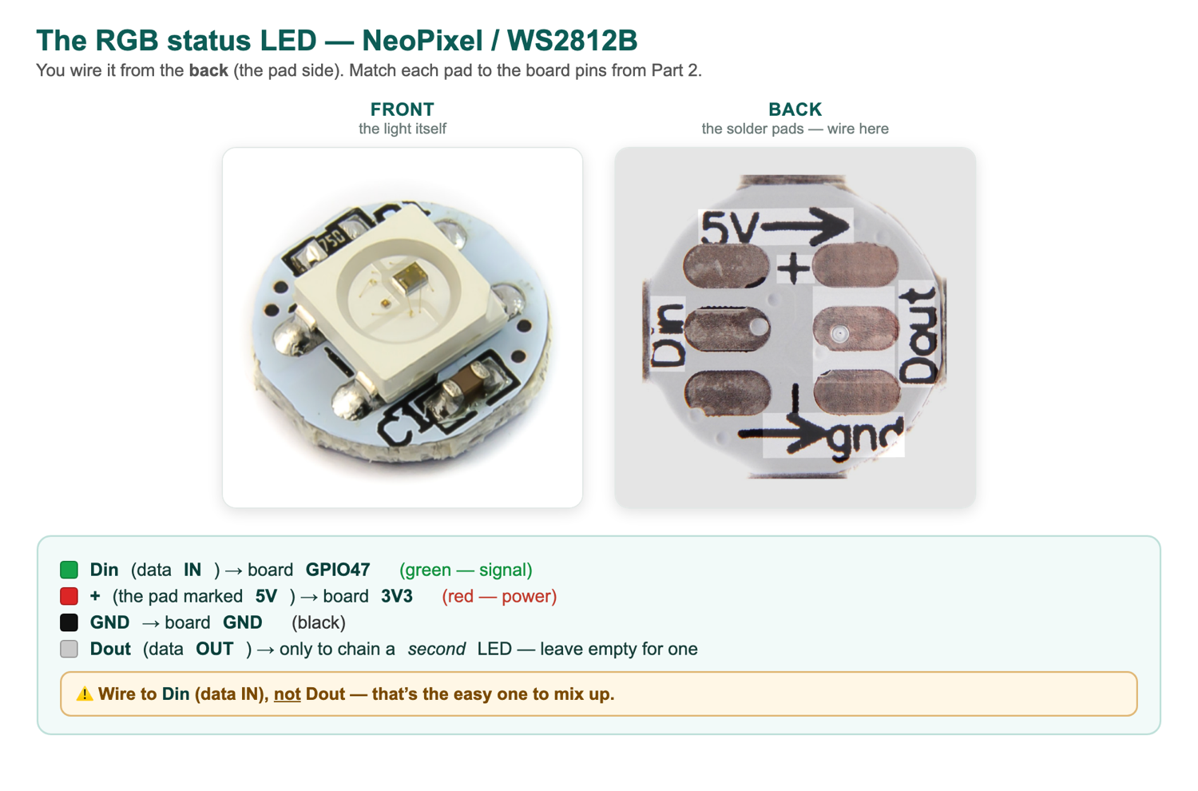
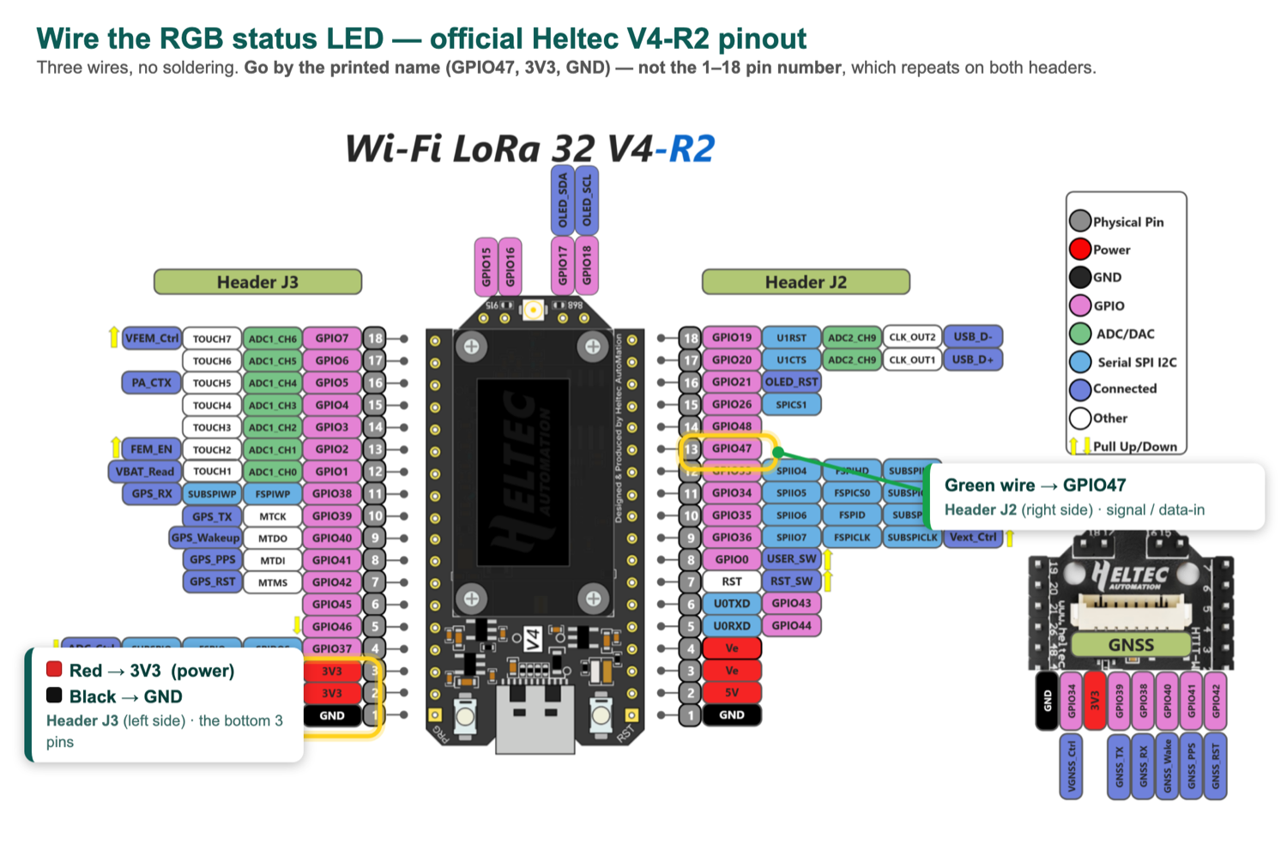
Where the three wires go — official Heltec V4‑R2 pinout. Green to GPIO47, red to 3V3, black to GND.
- DIN → GPIO47 (on the Heltec V4's J2 header, 6th pin down on the left side)
- VCC → 3V3
- GND → GND
Once wired and the board is running, here's what each color actually means (confirmed from the firmware source, not guessed):
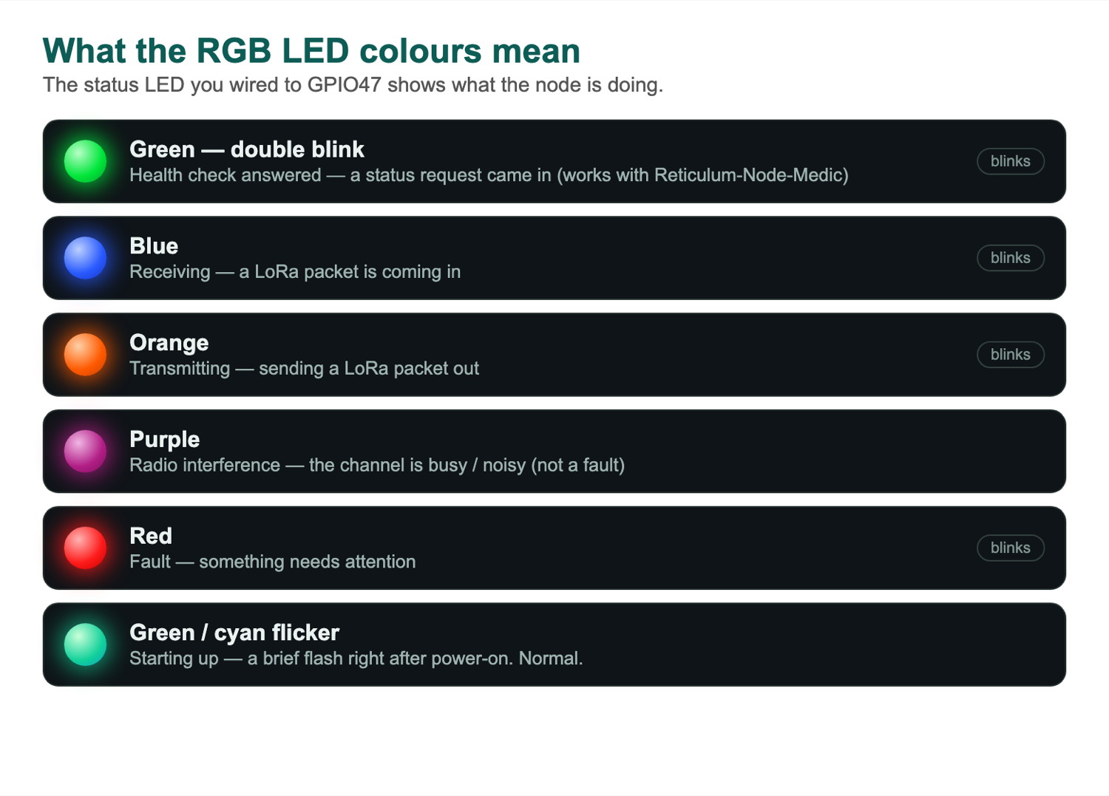
Color | Meaning
Solid blue | The board is receiving a message
Solid amber | The board is sending a message
Slow white breathing/pulse | Standby/idle — the normal “waiting” state you'll see most of the time
Blinking blue (on/off) | Info/status blink
Magenta/purple | Radio interference — the channel is busy or noisy (not a fault). Also console mode, if a serial console is connected.
Dim red pulse | Not ready yet (e.g. still booting/initializing)
Solid white, stuck on | Boot error — if it never changes, something failed and the board needs attention
Red/amber alternating flash | General error indicator
Very dim magenta flash | Airtime/duty-cycle lock — the radio hit its regulatory transmit limit and is briefly locked out from sending again
Quick green double-blink | Someone is checking this node’s health — its health page was just opened in a web browser over WiFi

Note: No extra configuration needed — this is built into the firmware already flashed in Part 3.
Part 3 — Configure WiFi and LoRa Settings
On first boot (or after a full chip erase), the board has no saved settings yet, so it starts its own WiFi hotspot so you can configure it.
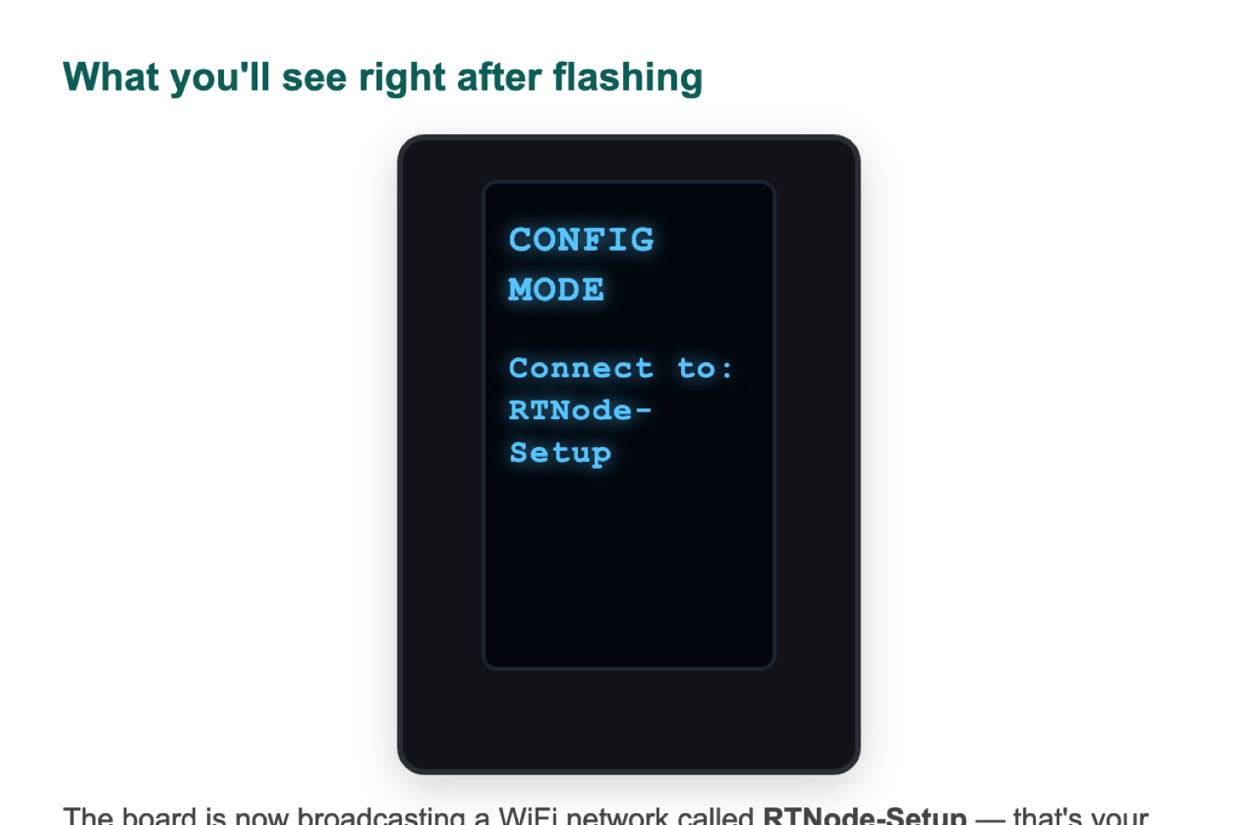
The screen right after flashing — CONFIG MODE, telling you to connect to RTNode‑Setup.
Step 4: Connect to the board's setup network
On your phone or laptop, join this WiFi network:
RTNode-Setup
Note: No password needed — it's an open setup network, only reachable if you're standing right next to the board.
Step 5: Open the config portal
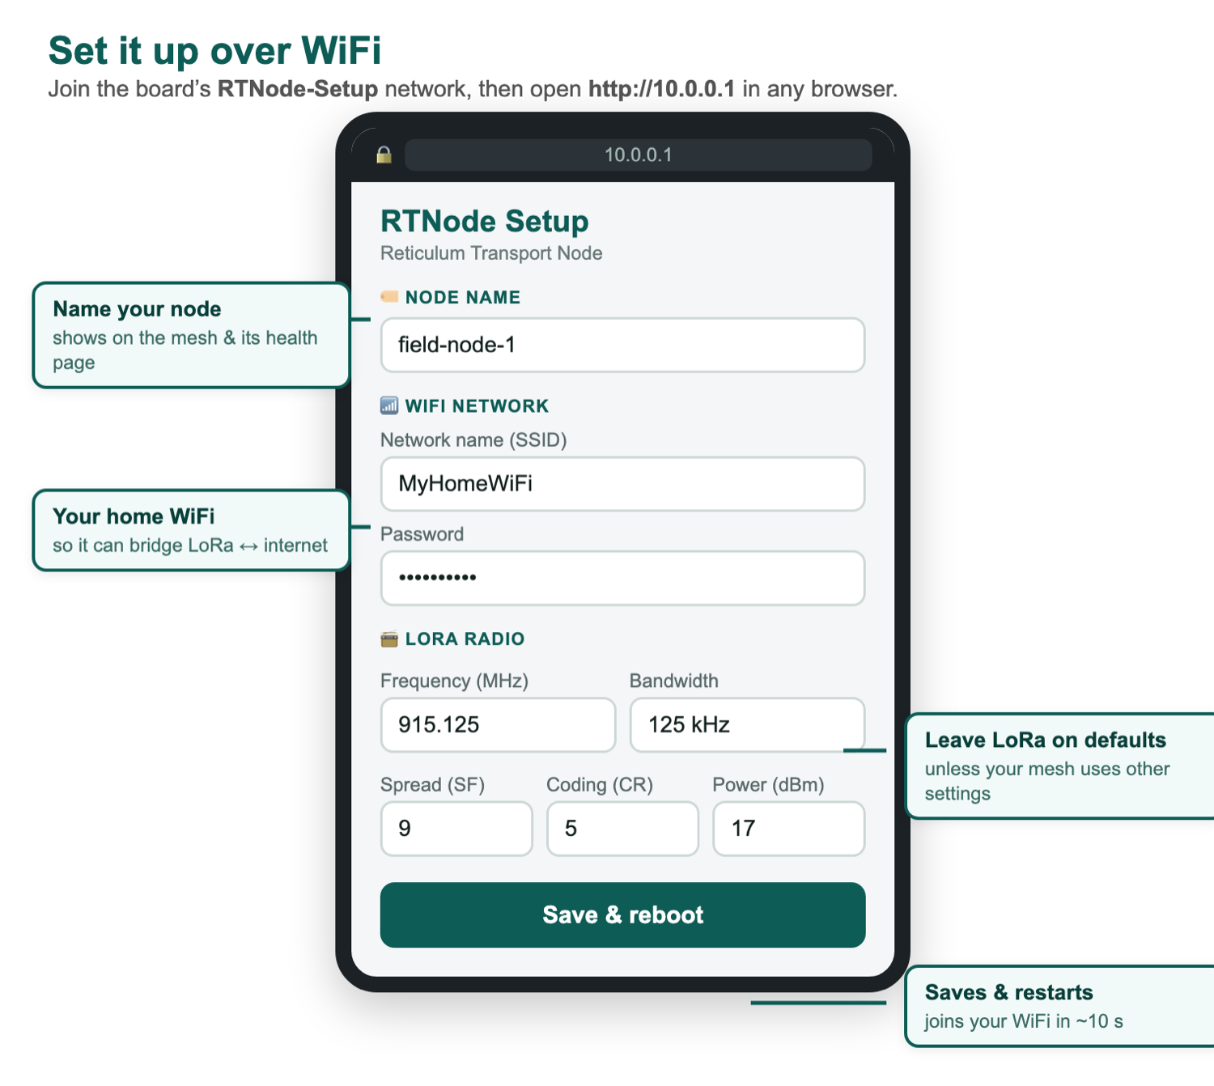
The setup page at http://10.0.0.1. Node name is at the top, then WiFi, then LoRa.
In a browser, go to:
http://10.0.0.1
If that doesn't load, try http://rtnode.local instead.
Step 6: Fill in these settings exactly
Work through the portal page and set the following. Anything not listed here — leave at its default, don't guess:
- Node name — whatever you want to call this node (e.g. yourname-RTNode-2400)
- Local network name (mDNS) — leave enabled, leave hostname blank (it'll default to something like rtnode1234.local using part of the board's own hardware address — this is fine and expected)
- WiFi network — enable it, enter your home WiFi name and password
- TCP backbone — leave set to Disabled (this build is deliberately configured without a backbone connection)
- Local TCP server — set this to Enabled, port 4242 (this is what lets apps like MeshChat or Sideband connect to the board over your WiFi — don't skip this one)
- LoRa radio — set these to match your mesh exactly — the values below are the standard settings for this network:
  - Frequency: 915.125 MHz
  - Bandwidth: 125 kHz
  - Spreading Factor: 9
  - Coding Rate: 5
  - TX Power: 17 dBm
Note: If you’re joining a different mesh, confirm these four values against that network’s settings first — radios that don’t match exactly on all four settings can’t hear each other, even on the same frequency.
- 15 second / 1 hour duty-cycle limits — leave both as whatever the portal already shows by default. Don't change these.
- Network access (IFAC) — leave disabled
- Device advertisement — leave disabled
- Display — orientation and blink timing are just personal preference, change if you like
Step 7: Save and reboot
Click Save and Reboot (or similar). The board will restart and join your home WiFi instead of its own setup hotspot.
Step 8: Confirm it's working
Check the board's OLED screen. You should see:
- LoRa — lit/active
- WiFi — lit/active
- LAN — lit/active (confirms the local TCP server started — if this stays off, double check Step 14's “Local TCP server” setting was actually saved as Enabled)
- WAN — off (this is correct and expected — the backbone is deliberately disabled on this build)
If LoRa, WiFi, and LAN are all lit, the board is fully configured and ready to use.
Troubleshooting
- Board not showing up when you plug it in / can't find the port: try a different USB cable — some cables are power-only and don't carry data.
- Upload fails / times out: press and hold the board's reset button, start the upload command, then release reset right as it starts trying to connect.
- Build fails with errors: this is almost always a temporary download problem, not a real fault. Make sure the computer has internet, then run the exact same command again — it continues from where it stopped and usually finishes on the second try.
- The command says “no such file” or “command not found”: the RTNode2400 Setup folder isn’t sitting directly on your Desktop, or its name is slightly different. If you were given a zip file, double-click it first to unzip it, then move the RTNode2400 Setup folder onto your Desktop and run the command again.
- The “RTNode-Setup” WiFi network doesn’t appear: the board is probably still starting up. Wait about 30 seconds after plugging it in, then refresh your WiFi list. If it still doesn’t show, unplug the board, plug it back in, and wait again. This network only appears on a brand-new board, before WiFi has been set up.
- The setup page (http://10.0.0.1) won’t open: first make sure your phone or laptop is connected to the RTNode-Setup WiFi network, not your home WiFi. On a phone, also switch off mobile data so it uses the board’s network. If it still won’t load, try typing http://rtnode.local instead.
- After setup, the board won’t join your home WiFi (the screen shows WiFi off): the two most common causes are a mistyped password (it’s case-sensitive), or a 5 GHz-only network — this board can only join 2.4 GHz WiFi. Re-open the setup portal, re-enter the details carefully, and make sure you’re using your 2.4 GHz network name.
- The Terminal fills with fast-scrolling text: that’s completely normal — it’s just showing its progress. Leave the window alone and don’t close it until it says “Done! Your board is flashed and ready.”
What This Firmware Includes
This build has a few things worth knowing about, in plain terms:
- A fix for a bug where the board could get stuck spamming its own log and potentially freeze up, if the TCP backbone was set to client mode with no host configured. Fixed so this can't happen.
- A security fix that stops a LAN-connected app (like MeshChat) from accidentally leaking outside network traffic into the board's local TCP server and having it rebroadcast over LoRa — keeping local and wide-area traffic properly separated, as intended.
- RGB status LED support — a WS2812B/NeoPixel LED wired to GPIO47 shows what the board is doing: blue when receiving a message, amber when sending one, plus a few other states (see Part 4 above).
- A build fix so the firmware compiles correctly from a completely fresh download, with nothing cached — which is exactly what you just did.
- A live health page you can open in a web browser. While the board is on your home WiFi, you can visit its address and see a plain summary of how it’s doing — free memory, WiFi signal strength, how long it has been running, and whether its radio and network connections are healthy. This is what Reticulum-Node-Medic (the field tool) reads.
- It no longer restarts when WiFi drops. If your home WiFi disconnects, the board used to reboot itself. Now it stays running and keeps passing LoRa mesh messages along the whole time, then quietly reconnects to WiFi on its own when it comes back.
- It sends a small health check-in over the LoRa mesh to home base — about every two hours, and straight away if it notices a real problem. This lets a node out in the field be checked on from a distance even with no WiFi at all, and home base can also ask a node to report in on demand.
- It keeps an eye on its own memory and only raises an alarm once a problem sticks — it gives itself three chances to recover first, so a brief hiccup never triggers a false alarm.
Making It Field-Ready (optional)
The node works as soon as it’s flashed and configured. These two upgrades turn it into a proper node that can live outdoors and run on its own power.
A proper antenna (recommended)
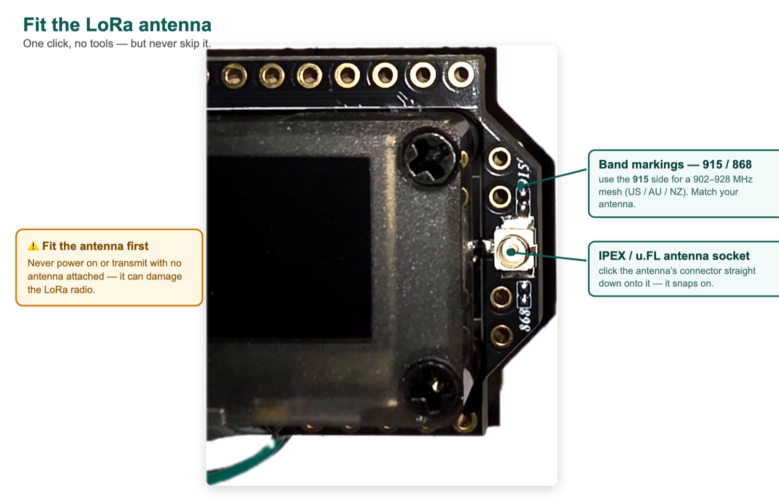
The gold IPEX / u.FL socket and the 915 / 868 band markings. Clip a matching antenna straight down.
The board comes with a small built-in antenna that’s fine for testing on a bench, but weak for real range. It also has a tiny gold antenna socket (called IPEX or u.FL) for a proper external antenna.
- It must match the radio’s band: 902~928MHz (the 915 MHz setting). A WiFi (2.4 GHz) or 433 MHz antenna will not work — and transmitting into the wrong antenna can damage the radio.
- Easiest path: get a short IPEX-to-SMA adapter lead (pigtail) plus a 915 MHz SMA antenna. A 3 dBi rubber “stubby” is a good all-rounder; a taller fibreglass antenna reaches further.
- Always keep an antenna connected before the board transmits — running the LoRa radio with no antenna attached can damage it.
Battery & solar (for off-grid nodes)
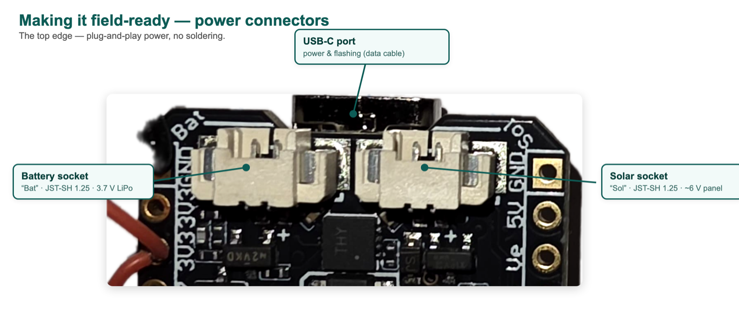
Battery (“Bat”) and solar (“Sol”) plug into the JST‑SH sockets — USB‑C sits between them.
The V4 is built to run unplugged. It has two small sockets on the board for this:
- Battery: plug a single-cell 3.7 V lithium (LiPo) battery into the battery socket. The board charges it automatically whenever USB or solar power is connected, so the node keeps running through power cuts. A 1000–3000 mAh battery is a good size.
- Solar: the V4 has a dedicated solar input (a small 2-pin SH1.25 socket). Connect a small 5–6 V solar panel (about 1–2 W) here and the board trickle-charges the battery from sunlight — letting a node run in a remote spot with no mains power at all.
- Match the plugs: batteries and panels come with different connectors, so make sure the plug fits the board’s socket (or use a matching adapter lead), and get the battery polarity right — reversing it can damage the board.
This firmware helps here too: it keeps the node running through WiFi drop-outs instead of restarting, which is easier on the battery.
Thanks
This firmware stands on the work of several people who built the actual foundations it's made from:
- Mark Qvist — creator of the Reticulum Network Stack itself, and the original RNode firmware this is all built on
- GrayHatGuy (Jason Russell) — RTNode-2400, the base project this firmware comes from
- jrl290 — RTNode-HeltecV4, which RTNode-2400 itself builds on
- attermann — the microReticulum C++ stack used inside this firmware
The two bug fixes, the build fix, the RGB LED support, and the new health-monitoring features (the web health page, staying online through WiFi drops, and the LoRa mesh health check-in) in this particular build were done by Suga — everything else is their work, not ours.
No Internet? Just Flash the Ready-Made Firmware
Use this if the computer you’re on has no internet, or you simply don’t want to build the firmware yourself. Your folder already contains a ready-made firmware file — you flash it straight onto the board, with no building and almost no internet.
Note: What “offline” means here — no downloading the source code, no builder, and no big toolchain. The only thing you have to fetch is one small tool called esptool (a few megabytes), just once. If you’ve used the Arduino app or any ESP32 tools before, you probably already have it.
Note: Don’t double-click the .bin files. They’re firmware images, not zip files — on a Mac they show an archive-style icon, so double-clicking opens Archive Utility and you’ll see “Unable to expand… unsupported format.” That’s completely normal, just ignore it. Leave every file in the firmware folder exactly as it is; the command below reads the file directly.
Step 1: Install esptool (one time)
You’ll need Python 3 (Macs already have it; on Windows, install it from python.org and tick “Add Python to PATH”). Then, in Terminal, run:
pip install esptool
If it says pip isn’t found, try pip3 install esptool instead.
Step 2: Plug in the board
Connect the Heltec V4 with a USB-C data cable (not a charge-only one).
Step 3: Find the board’s port
In Terminal, run this to see the board’s connection name:
ls /dev/cu.usbmodem*
You’ll get something like /dev/cu.usbmodem2101. (On Windows: Device Manager → Ports → note the COM number. On Linux: ls /dev/ttyUSB* /dev/ttyACM*.)
Step 4: Point Terminal at the folder
The flash command looks inside a firmware folder, so Terminal needs to be in your unzipped folder first. Type cd and a space, then drag the whole unzipped folder into the Terminal window (that fills in its location for you), and press Enter:
cd ~/Downloads/Easy-build-RTnode-2400
Step 5: Flash it (one command)
Copy the line below, replace YOUR_PORT with what you found in Step 3, and press Enter:
esptool --chip esp32s3 --port YOUR_PORT --baud 921600 write_flash 0x0 firmware/rtnode2400_heltecV4_merged.bin
You should see Writing at 0x… (100 %), then Hash of data verified. and Hard resetting… — that means it worked. (If esptool isn’t found as a command, use python3 -m esptool … instead.)
Note: If it says “Failed to connect” — hold the PRG button, tap RST, release RST, then release PRG. That forces the board into “download mode.” Then run the command again. (PRG is the button next to the USB-C port.)
Step 6: Set it up (WiFi + name)
Flashing only puts the firmware on the board. Now set it up exactly as in Part 3 (“Configure WiFi and LoRa Settings”) earlier in this guide: the board makes its own WiFi network called RTNode-Setup — join it, open http://10.0.0.1 in a browser, fill in the form (a name for the node, plus your home WiFi), and Save.
Prefer to build from source instead? The full firmware isn’t bundled in the folder (it’s large), but you can get it any time from github.com/5ugAv/RTNode-2400 — or just use the one-command setup at the start of this guide, which downloads, builds and flashes it all for you.

