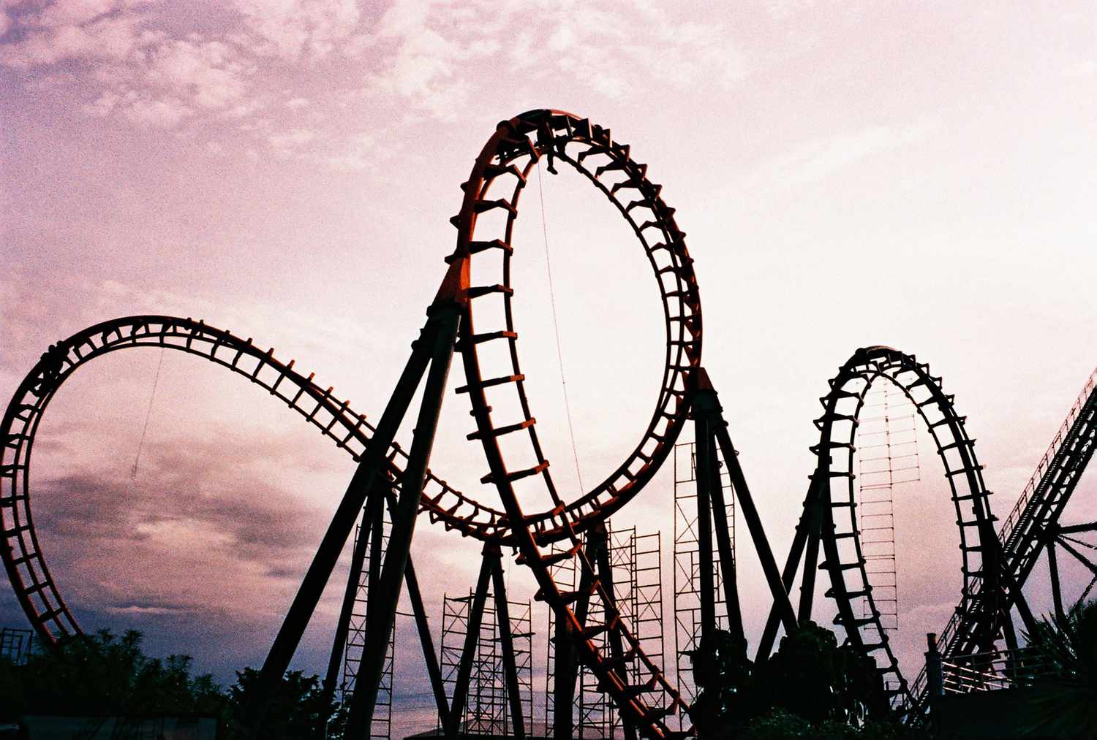  
  
print("welcome to the rollercoster")  
hight = int(input("what is your hight in cm? "))  
  
if hight >= 120 :  
 print("you can ride roller coster")  
 age = int(input("what is your age "))  
 if age <= 12:  
 print("Child ticket are 5$")  
 bill = 5  
 elif age < 18 :  
 print("youth ticket are 7$")  
 bill = 7  
 else:  
 print("adult ticket are 12$")  
 bill = 12  
 want_photo = input("do you want a photo taken? Y and N ")  
 if want_photo == "Y":  
 bill += 3  
 print(f"your final bill is {bill}")  
else:  
 print("sorry you cannot ride the rollar coster")