**FINITE DIFFERENCE METHODS**

**FOR SOLVING ODEs**

***Using computer-programming code it is possible to analyse the dynamics of a damped single and double pendulum in order to test the stability of different methods for integrating systems of ODEs. By using finite difference methods, namely the explicit Euler, Leapfrog, fourth-order Runge-Kutta and implicit Euler, each method was coded and provided with various parameters. Results were stored in a text file to be reproduced graphically. The fourth-order Runge-Kutta was found to be the most stable method for analysing the damped single pendulum and this method was therefore used to analyse the dynamics of a damped double pendulum.***

**Introduction and Theory**

The use of programming packages in physics provides an easier and quicker method to model physical outcomes. Problems that may require a substantial amount of time to solve can often be solved quickly using powerful programming software. However, when finding solutions to a problem, computers are only able to find approximate solutions because they cannot implement infinitesimal changes. So finite difference methods are usually used to solve analytical problems. To determine whether a particular finite difference method is a good one, it is necessary to evaluate the consistency, accuracy, convergence, efficiency, and stability of the method. This project will focus mainly on the latter, where the dynamics of a damped single and double pendulum are analysed.

Each method uses initial parameters, describing the position and velocity of the pendulum. The methods then use the gradient or weighted gradients at various points, along with the initial values to calculate the parameters at a later time $\Delta$\textit{t}. In essence each method runs through the solution of the ODE in discrete time steps. It is in this way, one is able to analyse the motion of the pendulum by viewing its position and velocity at discrete time steps.

The suitability of these methods for solving the system of ODEs is dependent upon four factors: consistency, accuracy, stability and efficiency. To check the consistency of a method one must check that the method reduces to the correct continuous solution in the limit of the step size, as h> 0. The accuracy of a method depends on the global error of the solution, which is the total error in the solution at the end of the calculation. The stability describes whether the local error increases or decreases as the solution of the ODE is calculated. Finally the efficiency is dependent upon the number of computations required for each step in calculating the solution.

It was concluded that the RK-4 method was the most suitable and so this was subsequently used in analysing the motion of a double pendulum in terms of the relative masses in the double pendulum.

When a ray intersects with a surface, such as that of a lens, it is refracted in accordance with Snell’s Law, as defined mathematically below [1]. Propagation continues to the next surface until the ray reaches the output of the system.

$n_{1}\sin{θ_{1}}=n_{2}\sin{θ_{2}}$

(1)

In words, this equation states that as a light ray approaches an interface between two dielectric media, its angle of refraction $θ_{2}$ can be determined by knowledge of the refractive indices of the media, $n_{1}$ and $n_{2}$, and the angle of incidence $θ_{1}.$ In situations where $\sin{θ_{1}}> \frac{n_{2}}{n_{1}}$, total internal reflection is said to have been undergone.

**Experimental Method**

In order to simplify the task at hand, the physical problems had to broken down into smaller sub problems and approached individually. Python’s object-oriented nature is especially useful for this as it allows a potentially massive bundle of code to be divided up using classes.

The procedure undergone involved initially creating a constructor class so that rays and lenses could be defined. This then progressed into producing new methods such as ones to allow current positions and directions to be returned. The propagate methods defined in the SphericalRefraction and OutputPlane derived classes [3] made use of the intercept and refract methods that determined how rays would propagate from their initial position through the refracting surface and onto the output plane.

Execution of the code started off by creating ray and lens objects in Terminal defined using various initial parameters. If the ray of light was able to intercept with the optical surface, it was propagated according to the statements defined in the SphericalRefraction propagate method [3] mentioned above. Ray positions and directions would then be updated using the append method and the same procedure would be undergone again for a plano-convex lens. After a single execution of this method for a typical convex lens or twice for a plano-convex lens, the propagate method in the OutputPlane class [3] made the ray travel up to the output plane and its position and direction were stored as a list to be used for ray tracing.

**Results, Errors and Discussion**

Discussion of results can be broken down into two sections. The first contains analysis of the results for a thin convex lens and the latter for a plano-convex lens.

**Convex Lens**

By defining a curvature of $0.03 mm^{-1}$, a beam diameter of $10 mm$, and refractive indices of $1$ and $1.5$ for the air and the lens respectively, spot diagrams have been plotted to show a cross-section of the x and y positions of the light ray bundle perpendicular to the optical axis.

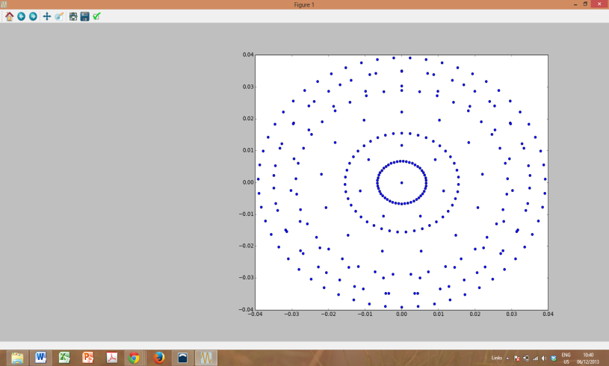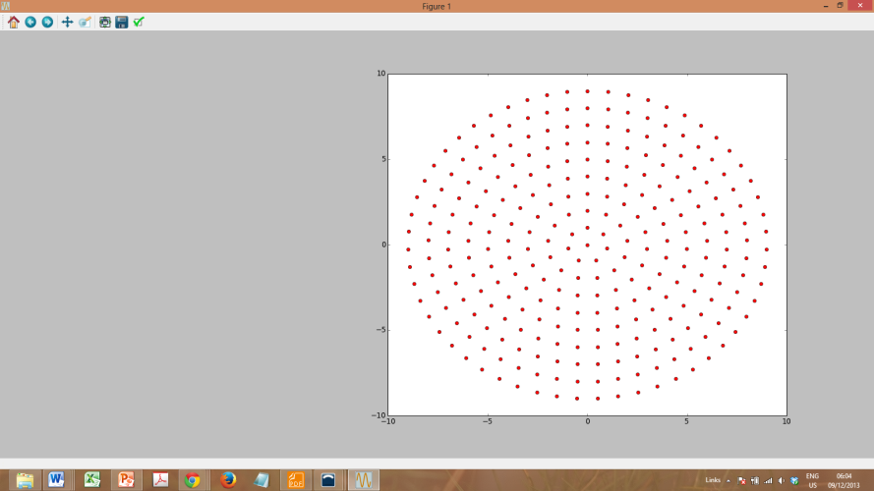

*Figure 1: The image on the left shows a spot diagram of the bundle before undergoing refraction and the right side is a spot diagram in the optical focal plane. The rays do not focus at one point in the focal plane due to spherical aberration [2].*

On creation of the light beam, shown by the left image, each ray appears to be evenly spaced out as expected. After passing through the refracting surface, due to the symmetry of the right image, it is clear that the beam was propagating along the direction of the optical axis before refraction took place. The shape of the refracted spot diagram illustrates the effect of spherical aberration on the focal plane, where rays deviate from their ideal behaviour as the distance of the input ray from the optical axis increases [1]. If a lens was to be unaffected by spherical aberration a single spot would be formed from all the light rays at this point. However that has not happened and bands of light rays are viewable on the image. The most shaded band represents the region where most rays are currently concentrated. On this spot diagram, there are mixtures of different light rays. Some are in the process of converging to the centre, and some are diverging, whilst extremely few appear to actually be at the focal point on the optical axis.

The paraxial focus is defined as the ideal focus in the limit of a narrow input beam [1]. Its position was determined using a beam with a diameter of $0.1 mm$, close to the optical axis, as the affect of spherical aberration is minimal at this width. The focal length calculated by the object-oriented software was a value of $97.7 mm$, which is a large value in comparison to the beam diameter, but understandable considering the curvature of the refracting surface was extremely small.

The minimum RMS deviation at the focal point was found to be a value of $3.18 × {10}^{-11} m$ for the larger beam diameter of $10 mm$, which is rather small in comparison to the diffraction limit of $5 × {10}^{-7} m$. This can be explained by considering that the diffraction limit does not account for refraction but as a result it does provide a reasonable upper limit for the size of the focal point.

**Plano-Convex Lens**

By defining a curvature of $0.1 mm^{-1}$, a beam diameter of $4 mm$, and refractive indices of $1$ and $1.5$ for the air and the lens respectively, a spot diagram has been plotted to show a cross-section of the x and y positions of the light ray bundle perpendicular to the optical axis at $z=5.11mm$. Below it, the beam can be seen from a different point of view, where the effect of spherical aberration is easier to see.

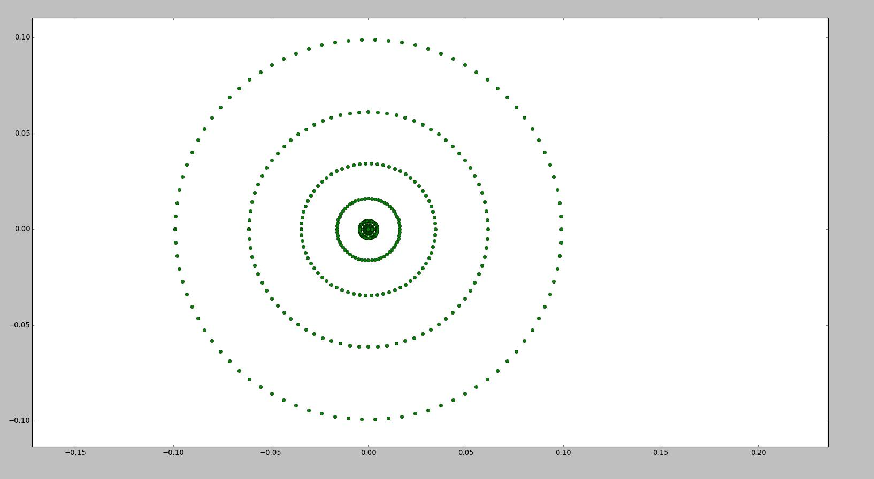

*Figure 2: The image at the top shows a spot diagram of a ray bundle in the optical focal plane whilst the one below it has been modelled using the same parameters but is shown from a different point of view. This is the case for a refracted ray after passing through a plano-convex lens.*

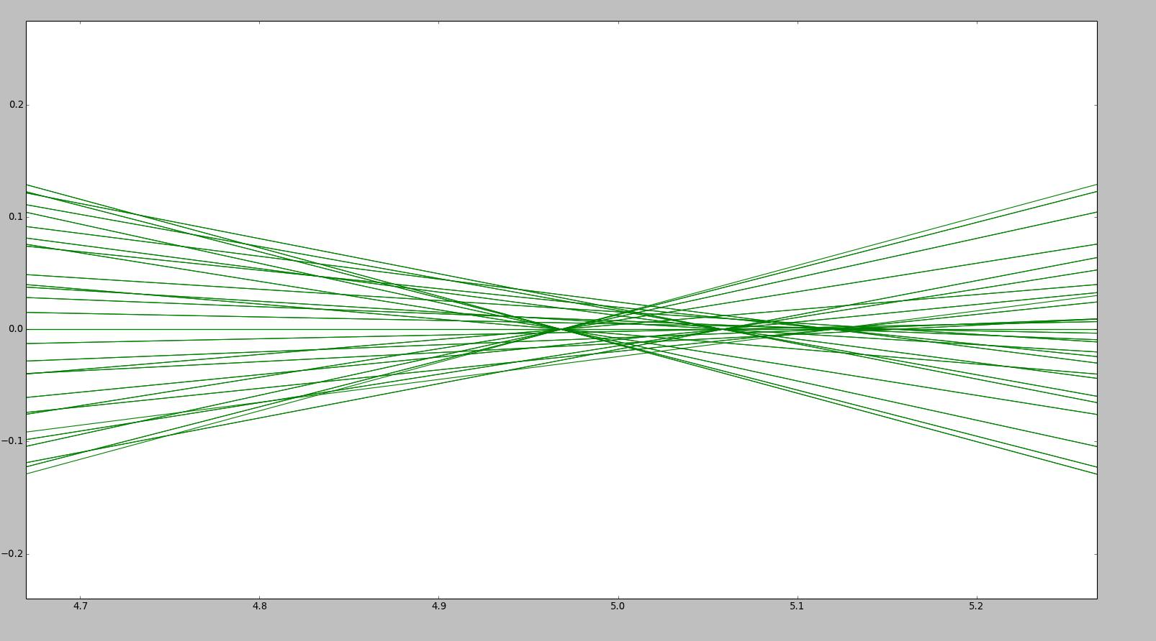

Analysis of the immediate images above is very useful as it shows that rays closer to the optical axis take longer to converge than rays further away. This means that the inner rays, which actually converge roughly to the paraxial focus, converge at a greater distance from the input plane than the outer rays do resulting in some bands on the spot diagram to consist of converging and diverging rays. As the focal plane has been calculated as being at $z=5.11mm$, visually it is evident that most outer bands must represent diverging rays, whilst the innermost spot must be made up from converged rays and rays that are just beginning to diverge.

Interestingly, the focussing of light rays for a plano-convex lens varies in relation to which end the rays intercept first: the convex or plane surface. By constructing a plano-convex lens with a curvature of $0.02 mm^{-1}$ at one end, a surface separation of $5mm$, and refractive indices of $1$ and $1.5168$ for the air and the lens respectively, this phenomenon was investigated.

By making use of rays placed very close to the optical axis, the paraxial focus was estimated to be at a focal length of $88.76 mm$ when refracting through the curved surface first, and at a focal length of $120.9 mm$ after initially refracting through the plane surface. Then by changing the beam diameter to $10 mm$ it was clear that the spherical aberration was greater for the latter case as propagation through the curved surface first was able to produce a more focussed spot. The more focussed point obviously meant a smaller RMS deviation, producing a value of $1.53 × {10}^{-11} m$ when the collimated beam propagated through the curved surface first, and a value of $6.38 × {10}^{-11} m$ when initially refracting through the plane surface.

**Conclusion**

The object-oriented ray tracer program proved to be very useful for modelling light rays propagating through both convex and plano-convex lenses. For convex lenses, investigation showed that due to spherical aberration, inputted light rays deviated from their ideal behaviour at increasing distances from the optical axis. It was evident that for plano-convex lenses the inner rays of the collimated beam converged at a greater distance from the input plane than the outer rays did. Due to the symmetry of the spot diagrams shown, it is clear that the beam was only made to propagate along the direction of the optical axis. The ray tracer was capable of propagating rays in other directions, but only in a positive z direction, limiting the model substantially. Improvements could be made to the system by expanding the model to correctly propagate rays from any direction and further investigations could be performed into measuring the effects of optical problems such as the spherical aberration and the RMS deviation for rays inputted at an angle.

**References**

[1]: Computing document, physics department, Imperial College London

[2]: <http://amazing-space.stsci.edu>

[3]: Sunil Jindal code listings, student of physics department, Imperial College London