实验一 熟悉HTML和CSS

**【实验目的】**

1. 掌握HTML的基本结构和常用标记
2. 掌握CSS的基本语法和使用方法
3. 熟练使用代码编辑器编写基本的HTML+CSS程序
4. 熟练使用Chrome浏览器验证HTML+CSS程序效果、以及代码查看、复用方法。

**【实验内容】**

（任意定义一个管理系统，如学籍管理系统）使用HTML+CSS创建登录、用户注册与用户管理页面。要求使用HTML标记进行页面布局、CSS进行页面元素样式调整。

登录页面包含用户名、用户密码、用户类型，重置按钮、登录按钮、验证码等内容，用户类型包含学生用户、教师用户和管理员三类；

注册页面包含用户类型、用户名（学号或工号）、姓名、设置密码、确认密码、手机号码、邮箱、所在单位、验证码、重置按钮、注册按钮等内容；

用户管理页面包括一个用户信息列表，显示所有用户信息（包括用户名、姓名、用户类型、手机号码、邮箱、所在单位等），页面中包含对用户信息进行操作的功能，如删除、查找、修改、重置密码等。

**【实验程序】**

注册：

<!DOCTYPE html>

<html lang="en">

<head>

    <meta charset="UTF-8">

    <meta name="viewport" content="width=device-width, initial-scale=1.0">

    <title>注册-3180911020</title>

    <style>

        .wrap{

            background-color: rgb(121, 151, 38);

            background-image: url("https://timgsa.baidu.com/timg?image&quality=80&size=b9999_10000&sec=1600707673374&di=72c4673e4f52e90c138c0e14ff3b6a2f&imgtype=0&src=http%3A%2F%2Fimage.huahuibk.com%2Fuploads%2F20190130%2F19%2F1548847674-AkIBarxYdT.jpg");

            background-repeat:repeat-x;

            height:600px;

        }

        #one{

            text-align: center;

            color: black;

        }

    </style>

</head>

<body>

    <div class="wrap">

        <h1 id="one">注册</h1>

        <form action="" method="POST" >

            <table width="420" border="0" align="center">

                <tr>

                    <td align="center" valign="center">姓&nbsp&nbsp&nbsp&nbsp&nbsp&nbsp名：</td>

                    <td><input name = "name" type="text"></td>

                </tr>

                <tr>

                    <td align="center" valign="center">手&nbsp&nbsp机&nbsp&nbsp号：</td>

                    <td><input name = "phone" type="text"></td>

                </tr>

                <tr>

                    <td align="center" valign="center">工作&nbsp单位：</td>

                    <td><input name = "workPlace" type="text"></td>

                </tr>

                <tr>

                    <td align="center" valign="center">用&nbsp户&nbsp名：</td>

                    <td><input name="userName" type="text"></td>

                </tr>

                <tr>

                    <td align="center">密&nbsp&nbsp&nbsp&nbsp&nbsp&nbsp码：</td>

                    <td><input name = "passwd" type="password"></td>

                </tr>

                <tr>

                    <td align="center">确认密码：</td>

                    <td><input name="repasswd" type="password"></td>

                </tr>

                <tr>

                    <td align="center">验&nbsp&nbsp证&nbsp码：</td>

                    <td><input name = "vertifiCode" type="password"></td>

                    <td><img src="images/code.jpg" width="70" height="20"></td>

                </tr>

                <tr>

                    <td align="center">用户类型：</td>

                    <td align="center">

                        学生<input name="UserType" type="radio" class="noborder" value="学生" >

                        教师<input name="UserType" type="radio" class="noborder" value="教师" >

                        管理员<input name="UserType" type="radio" class="noborder" value="管理员">

                    </td>

                </tr>

                <tr>

                    <td align="center">

                        <button type = "button" onclick="window.location.href='#'">注册</button>

                        <!--<input name="Submit" type="submit" value="登录">-->

                    </td>

                    <td align="center">

                        <input name="Reset" type="reset" value="重填">

                    </td>

                </tr>

            </table>

            <center>

                <p>

                    忘记密码？<a href="refindPassward.html">立即找回</a>

                </p>

                <p>

                    已有账户？<a href="SignIn.html">去登陆</a>

                </p>

            </center>

        </form>

    </div>

</body>

</html>

登录：

<!DOCTYPE html>

<html lang="en">

<head>

    <meta charset="UTF-8">

    <meta name="viewport" content="width=device-width, initial-scale=1.0">

    <title>沈新源</title>

    <style>

        .wrap{

            margin:0px;

            background-size: cover;

            background-repeat: no-repeat;

            background-image: url(images/bk_image.jpg);

            height: 600px;

            background-position: center;

        }

    </style>

    <script>

        function sign(){

            if(wrap.myform.value==""){

                alert("请输入用户名！");

                wrap.myform.focus().return;

            }else if(wrap.myform.passwd.value==""){

                alert("请输入密码！");

                wrap.myform.focus().return;

            }else if(){

                alert("用户名或密码错误");

            }else if(){

                alert("验证码错误!");

            }else{

                wrap.myform.submit();

            }

        }

    </script>

</head>

<body>

    <div class="wrap">

        <center><h1>用户管理</h1></center>

        <form action="Manage.html" method="POST" name="myform">

            <table width="420" border="0" align="center">

                <tr>

                    <td align="center" valign="center">用&nbsp户&nbsp名：</td>

                    <td><input name="userName" type="text"></td>

                </tr>

                <tr>

                    <td align="center">密&nbsp&nbsp&nbsp&nbsp&nbsp&nbsp码：</td>

                    <td><input name="passwd" type="password"></td>

                </tr>

                <tr>

                    <td align="center">验&nbsp&nbsp证&nbsp码：</td>

                    <td><input name="vertification" type="password"></td>

                    <td><img src="images/code.jpg" width="70" height="20"></td>

                </tr>

                <tr>

                    <td align="center">用户类型：</td>

                    <td align="center">

                        学生<input name="UserType" type="radio" class="noborder" value="学生" checked>

                        教师<input name="UserType" type="radio" class="noborder" value="教师" >

                        管理员<input name="UserType" type="radio" class="noborder" value="管理员">

                    </td>

                </tr>

                <tr>

                    <td align="center">

                        <input name="Button" type = "button" onclick="sign()" value="登录">

                        <!--

                            <input name="Submit" type="submit" value="登录">

                        onclick="window.location.href='Manage.html'

                    -->

                    </td>

                    <td align="center"><input name="Reset" type="reset" value="重填"></td>

                </tr>

            </table>

        </form>

        <center>

            <p>

            还没有账号？<a href="register.html">立即注册</a>

            </p>

            <p>

                忘记密码？<a href="refindPassward.html">立即找回</a>

            </p>

        </center>

    </div>

</body>

</html>

管理：

<!DOCTYPE html>

<html lang="en">

<head>

    <meta charset="UTF-8">

    <meta name="viewport" content="width=device-width, initial-scale=1.0">

    <title>管理信息</title>

    <style>

    #one{

        color:#1f160e;

        padding-inline-start: 5px;

    }

    .two{

        background-color: rgb(59, 59, 190);

    }

    .wrap{

        border-radius:10px;

        height: 50px;

        padding-top: 10px;

        font-family: 宋体;

        font-size: 25px;

        color: white;

        background-color: rgb(7, 175, 7);

    }

    .nav_1{

        float: left;

        margin-left: 10px;

        width: 120px;

    }

    .nav_2{

        float: left;

        margin-left: 100px;

        height: 20px;

    }

    #nav_3{

        float: left;

        margin-left: 900px;

        height: 25px;

        margin-top:auto;

    }

    .body{

        border-radius:10px;

        height: 250px;

        margin-top: 20px;

        background-color: rgb(214, 151, 91);

    }

    .fooster{

        font-family:'Times New Roman', Times, serif;

        text-align: center;

        color: aliceblue;

        margin-top: 15px;

        padding-top: 10px;

        padding-bottom: 10px;

        background-color: rgb(66, 66, 61);

        border-radius:10px;

    }

    </style>

    <script>

        function checkPasswd(){

            var txt;

            if (confirm("确认修改密码？")) {

            } else {

            }

            //document.getElementById("demo").innerHTML = txt;

        }

        function checkInfo(){

            var txt;

            if (confirm("确认修改？")) {

            } else {

            }

            //document.getElementById("demo").innerHTML = txt;

        }

        function checkDel(){

            var txt;

            if (confirm("确认删除？")) {

            } else {

            }

            //document.getElementById("demo").innerHTML = txt;

        }

        function getTime()

        {

            setInterval("document.getElementById('datetime').innerHTML=new Date().toLocaleString();", 1000);

        }

    </script>

</head>

<body>

    <div class="wrap">

        <div class="nav_1">用户管理</div>

        <script>

            Date.prototype.format = function (fmt) {

                var o = {

                    "y+": this.getFullYear, //年

                    "M+": this.getMonth() + 1, //月份

                    "d+": this.getDate(), //日

                    "h+": this.getHours(), //小时

                    "m+": this.getMinutes(), //分

                    "s+": this.getSeconds() //秒

                };

                if (/(y+)/.test(fmt)) fmt = fmt.replace(RegExp.$1, (this.getFullYear() + "").substr(4 - RegExp.$1.length));

                for (var k in o)

                    if (new RegExp("(" + k + ")").test(fmt)) fmt = fmt.replace(RegExp.$1, (RegExp.$1.length == 1) ? (o[k]) : (("00" + o[k]).substr(("" + o[k]).length)));

                return fmt;

            }

            setInterval("document.getElementById('nav_3').innerHTML = (new Date()).format('yyyy-MM-dd hh:mm:ss');", 1000);

        </script>

        <div class="nav_2">

            <button type="button" onclick="window.location.href='SignIn.html'"> 返回</button>

        </div>

        <div id="nav_3"></div>

    </div>

    <div class="body">

        <h1 id="one">管理</h1>

        <form action="" method="POST">

            <input name="UserName",type ="text" size="20">

            <input name="Search", type="button" value="查找">

            <input name="Reset", type="reset" value="重新填写">

            <input name="Correct", type="button" onclick="checkInfo()" value="修改">

            <input name="Delete", type="button" onclick="checkDel()" value="删除">

            <table width = "900" border="2" align="center">

                <tr>

                    <td class="two" align="center" >用户名&nbsp</td>

                    <td class="two" align="center">姓名&nbsp</td>

                    <td class="two" align="center">用户类型&nbsp</td>

                    <td class="two" align="center">手机号&nbsp</td>

                    <td class="two" align="center">邮箱&nbsp</td>

                    <td class="two" align="center">所在单位&nbsp</td>

                    <td class="two" align="center">操作&nbsp</td>

                </tr>

                <tr>

                    <td align="center">张三</td>

                    <td align="center">张三</td>

                    <td align="center">学生</td>

                    <td align="center">17561234560</td>

                    <td align="center">576243756@xaut.edu.cn</td>

                    <td align="center">水利学院</td>

                    <td align="center" ><botton style="color: rgb(68, 31, 231);font-family:'Times New Roman', Times, serif;" type="button" onclick="checkPasswd()">修改密码</botton></td>

                </tr>

                <tr>

                    <td align="center">李四</td>

                    <td align="center">李四</td>

                    <td align="center">学生</td>

                    <td align="center">17561234560</td>

                    <td align="center">576243756@xaut.edu.cn</td>

                    <td align="center">计算机学院</td>

                    <td align="center" ><botton style="color: rgb(68, 31, 231);font-family:'Times New Roman', Times, serif;" type="button" onclick="checkPasswd()">修改密码</botton></td>

                </tr>

                <tr>

                    <td align="center">王五</td>

                    <td align="center">王五</td>

                    <td align="center">老师</td>

                    <td align="center">17561234560</td>

                    <td align="center">576243756@xaut.edu.cn</td>

                    <td align="center">机械学院</td>

                    <td align="center" ><botton style="color: rgb(68, 31, 231);font-family:'Times New Roman', Times, serif;" type="button" onclick="checkPasswd()">修改密码</botton></td>

                </tr>

            </table>

        </form>

    </div>

    <div class="fooster">

        <p>Shenxinyuan@xaut.edu.cn</p>

        <p>Copyright©2020 沈新源</p>

        <p>信息部备案号：******</p>

        <p>******版权所有</p>

    </div>

</body>

</html>

找回密码：

<!DOCTYPE html>

<html lang="en">

<head>

    <meta charset="UTF-8">

    <title>Title</title>

    <style type="text/css">

        * {

            box-sizing: border-box;

        }

        body {

            margin: 0;

            padding: 0;

            font: 16px/20px microsft yahei;

        }

        .wrap {

            width: 100%;

            height: 100%;

            padding: 10% 0;

            position: fixed;

            opacity: 0.8;

            background: linear-gradient(to bottom right, #000000, #656565);

            background: -webkit-linear-gradient(to bottom right, #50a3a2, #53e3a6);

        }

        .container {

            width: 60%;

            margin: 0 auto;

        }

        .container h1 {

            text-align: center;

            color: #FFFFFF;

            font-weight: 500;

        }

        .container input {

            width: 320px;

            display: block;

            height: 28px;

            border: 0;

            outline: 0;

            padding: 6px 10px;

            line-height: 24px;

            margin: 20px auto;

            -webkit-transition: all 0s ease-in 0.1ms;

            -moz-transition: all 0s ease-in 0.1ms;

            transition: all 0s ease-in 0.1ms;

        }

        .container input[type="text"],

        .container input[type="password"] {

            background-color: #FFFFFF;

            font-size: 16px;

            color: #50a3a2;

        }

        .container input[type='submit'] {

            font-size: 16px;

            letter-spacing: 2px;

            color: #666666;

            background-color: #FFFFFF;

        }

        .container input:focus {

            width: 400px;

        }

        .container input[type='submit']:hover {

            cursor: pointer;

            width: 400px;

        }

        .to_login {

            color: #a7c4c9;

        }

        .text {

            color: #e2dfe4;

        }

        .wrap ul {

            position: absolute;

            top: 0;

            left: 0;

            width: 100%;

            height: 100%;

            z-index: -20;

        }

        .wrap ul li {

            list-style-type: none;

            display: block;

            position: absolute;

            bottom: -120px;

            width: 15px;

            height: 15px;

            z-index: -8;

            border-radius: 50%;

            box-shadow: inset -30px -30px 75px rgba(0, 0, 0, .2),

                inset 0px 0px 5px rgba(0, 0, 0, .5),

                inset -3px -3px 5px rgba(0, 0, 0, .5),

                0 0 20px rgba(255, 255, 255, .75);

            background-color: rgba(255, 255, 255, 0.15);

            animotion: square 25s infinite;

            -webkit-animation: square 25s infinite;

        }

        .wrap ul li:nth-child(1) {

            left: 0;

            animation-duration: 10s;

            -moz-animation-duration: 10s;

            -o-animation-duration: 10s;

            -webkit-animation-duration: 10s;

        }

        .wrap ul li:nth-child(2) {

            width: 40px;

            height: 40px;

            left: 10%;

            animation-duration: 15s;

            -moz-animation-duration: 15s;

            -o-animation-duration: 15s;

            -webkit-animation-duration: 11s;

        }

        .wrap ul li:nth-child(3) {

            left: 20%;

            width: 25px;

            height: 25px;

            animation-duration: 12s;

            -moz-animation-duration: 12s;

            -o-animation-duration: 12s;

            -webkit-animation-duration: 12s;

        }

        .wrap ul li:nth-child(4) {

            width: 50px;

            height: 50px;

            left: 30%;

            -webkit-animation-delay: 3s;

            -moz-animation-delay: 3s;

            -o-animation-delay: 3s;

            animation-delay: 3s;

            animation-duration: 12s;

            -moz-animation-duration: 12s;

            -o-animation-duration: 12s;

            -webkit-animation-duration: 12s;

        }

        .wrap ul li:nth-child(5) {

            width: 60px;

            height: 60px;

            left: 40%;

            animation-duration: 10s;

            -moz-animation-duration: 10s;

            -o-animation-duration: 10s;

            -webkit-animation-duration: 10s;

        }

        .wrap ul li:nth-child(6) {

            width: 75px;

            height: 75px;

            left: 50%;

            -webkit-animation-delay: 7s;

            -moz-animation-delay: 7s;

            -o-animation-delay: 7s;

            animation-delay: 7s;

        }

        .wrap ul li:nth-child(7) {

            left: 60%;

            width: 30px;

            height: 30px;

            animation-duration: 8s;

            -moz-animation-duration: 8s;

            -o-animation-duration: 8s;

            -webkit-animation-duration: 8s;

        }

        .wrap ul li:nth-child(8) {

            width: 90px;

            height: 90px;

            left: 70%;

            -webkit-animation-delay: 4s;

            -moz-animation-delay: 4s;

            -o-animation-delay: 4s;

            animation-delay: 4s;

        }

        .wrap ul li:nth-child(9) {

            width: 50px;

            height: 50px;

            left: 80%;

            animation-duration: 20s;

            -moz-animation-duration: 20s;

            -o-animation-duration: 20s;

            -webkit-animation-duration: 20s;

        }

        .wrap ul li:nth-child(10) {

            width: 75px;

            height: 75px;

            left: 90%;

            -webkit-animation-delay: 6s;

            -moz-animation-delay: 6s;

            -o-animation-delay: 6s;

            animation-delay: 6s;

            animation-duration: 30s;

            -moz-animation-duration: 30s;

            -o-animation-duration: 30s;

            -webkit-animation-duration: 30s;

        }

        @keyframes square {

            0% {

                -webkit-transform: translateY(0);

                transform: translateY(0)

            }

            100% {

                bottom: 400px;

                -webkit-transform: translateY(-500);

                transform: translateY(-500)

            }

        }

        @-webkit-keyframes square {

            0% {

                -webkit-transform: translateY(0);

                transform: translateY(0)

            }

            100% {

                bottom: 400px;

                -webkit-transform: translateY(-500);

                transform: translateY(-500)

            }

        }

    </style>

</head>

<body>

    <div class="wrap">

        <div class="container">

            <form>

                <h1 style="color: white; margin: 0; text-align: center">reFindPassward</h1>

                <label><input type="text" placeholder="Your username" /></label>

                <label><input type="text" placeholder="Your email" /></label>

                <label><input type="text" placeholder="The Vertification code" /></label>

                <label><input type="password" placeholder="password" /></label>

                <label><input type="password" placeholder="Please confirm your password" /></label>

                            <input type="submit" value="Upload" />

                            <p class="change_link" style="text-align: center">

                                    <span class="text">Have a member ?</span>

                                    <a href="SignIn.html" class="to_login">Return to signIn </a>

                                </p>

            </form>

        </div>

            <ul>

                <li></li>

                <li></li>

                <li></li>

                <li></li>

                <li></li>

                <li></li>

                <li></li>

                <li></li>

                <li></li>

                <li></li>

           </ul>

    </div>

</body>

</html>

**【实验截图】**

**登录：**

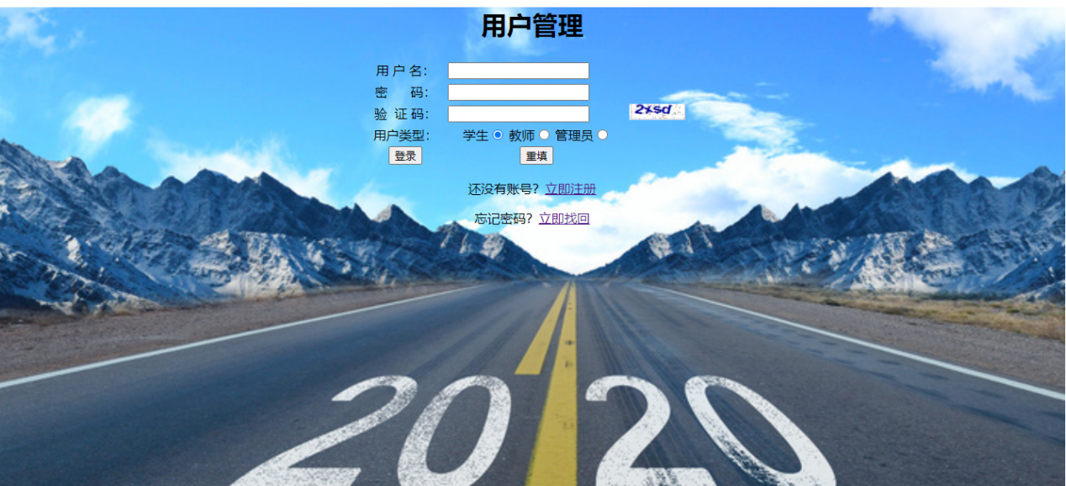

注册：

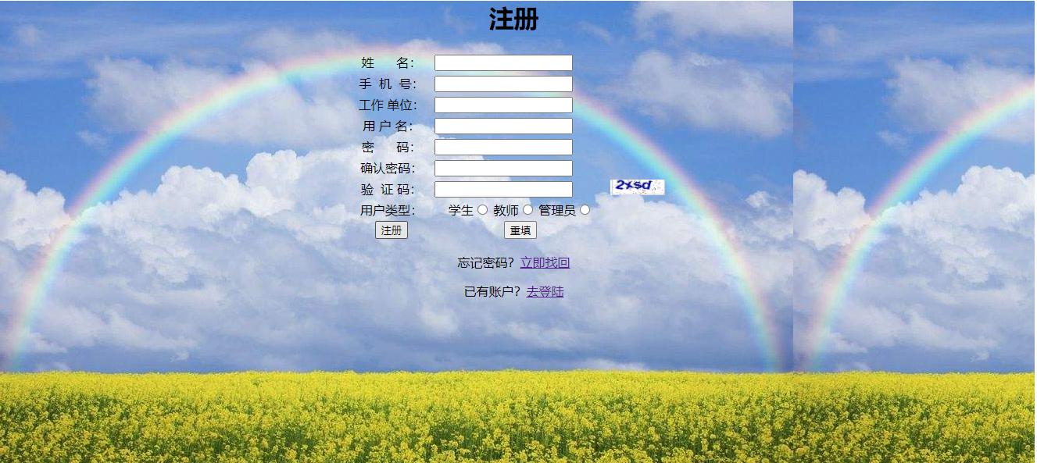

管理：

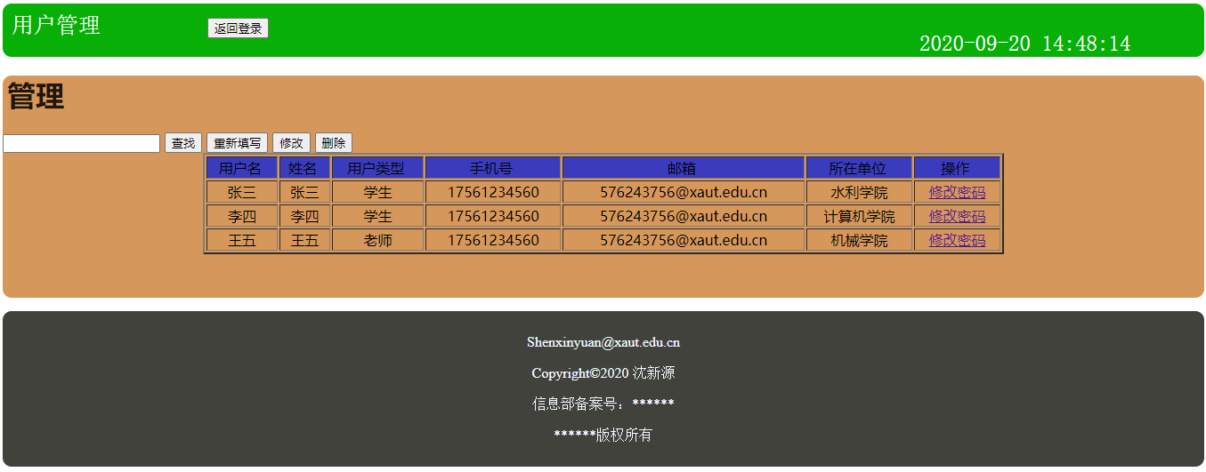

（贴自己完成的主要程序运行截图）

找回密码：

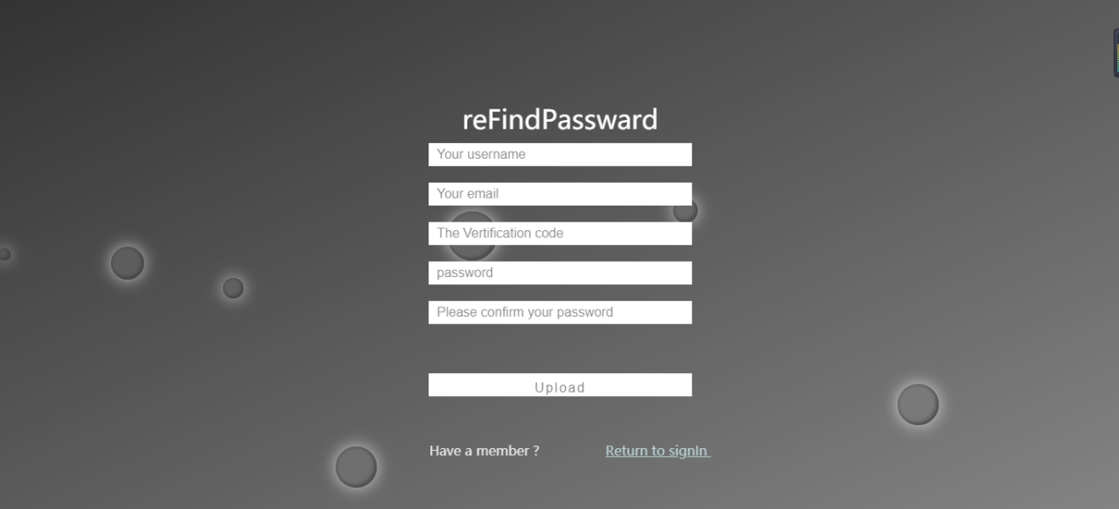

**【实验心得】**

实验内容先按照陈浩老师的指导实现一遍，尽可能的用课堂所学的知识，完成了基本功能后，回顾写的程序，拓展视野，发现问题补充更多功能，必要的时候可以参考别人的优秀程序，认真专研，把那些优秀的思路和知识变成自己的东西。