Clinical Patient Management System
System Design Report

1. Introduction
The Clinical Patient Management System is a desktop healthcare application developed using Python and Tkinter. The purpose of this system is to simulate a simplified electronic health record (EHR) environment where different healthcare roles can interact with patient data in a controlled and structured way.
The system is designed to demonstrate core healthcare informatics concepts, including patient data management, role-based access control, encounter tracking, and audit logging. While it is not intended to replace enterprise systems like Epic, it reflects many of the same underlying principles used in real-world clinical environments.

2. System Purpose and Objectives
The primary goal of the system is to provide a functional model of how patient data is managed across different roles in a healthcare setting.
Objectives:
- Allow clinicians and nurses to manage patient data and documentation
- Enable administrators to analyze encounter and workload data
- Provide management with operational insights
- Track all user activity through audit logging for accountability
- Maintain consistent and structured data through normalization

3. System Architecture Overview
The system follows a modular architecture with separation between interface, logic, and data storage.
Main components include:
- User Interface (GUI), built using Tkinter for user interaction
- Application Logic, which handles operations such as retrieval, counting, and validation
- Data Layer, using CSV-based storage for patient, encounter, and note data
- Logging System, which tracks all user actions for auditing
This structure allows the system to remain lightweight while still demonstrating core architectural concepts used in healthcare IT systems.

4. User Roles and Access Control
The system implements role-based access control (RBAC), which is critical in healthcare systems for protecting sensitive data.
User roles include:
Clinician / Nurse
These users interact directly with patient data. They have access to patient records, visits, and notes, and are responsible for documentation and patient lookup.
Administrator
Administrators focus on system-level analytics. They are responsible for reporting and workload tracking and do not modify patient data directly.
Management
Users have access to high-level operational metrics and focus on provider workload and overall system performance.
Each user only sees the functionality relevant to their role, which reduces the risk of unauthorized actions and aligns with real-world EHR security practices.

5. Functional Design

5.1 Patient Management
The system allows users to retrieve patient records, add new patients, and remove existing patients. These features simulate core patient lifecycle operations found in healthcare systems.

5.2 Encounter Management
Encounters represent patient visits and are used to track how often patients are seen, associate providers with visits, and support reporting and workload analysis.

5.3 Notes Management
Clinical notes are stored separately and linked to patient IDs. This reflects how documentation is handled in EHR systems, where notes are structured and tied to specific encounters or patients.

5.4 Reporting and Analytics
Administrative functions provide encounter counts per patient, encounter distribution by department, and provider workload metrics. These features simulate real-world dashboards used for operational decision-making.

6. Data Design
The system uses CSV files to store structured data, representing a simplified database model.
Data files include:
- patients.csv — stores patient demographics and basic information
- encounters.csv — stores visit-level data including provider and department
- notes.csv — stores clinical notes associated with patients
- credentials.csv — stores user login information and roles
- usage_log.csv — stores system activity logs for auditing
Data Relationships (Conceptual):
- A patient can have multiple encounters
- A patient can have multiple notes
- Providers are associated with encounters
This structure mirrors relational concepts used in database-driven systems.

7. ID Normalization and Data Integrity
To maintain consistency, patient IDs are normalized into standard formats:
- Patients and Encounters use P# format (e.g., p0007 → P7)
- Notes use P### format (e.g., p1 → P001)
This ensures consistent data retrieval, reduces matching errors, and improves overall data integrity.

8. Audit Logging System
Audit logging is a critical feature for compliance, security, and traceability.
Each log entry includes:
- Timestamp
- Username
- User role
- Action performed
- Status (success or failure)
This logging system helps track user activity, identify errors, and ensure accountability, reflecting real-world requirements for handling sensitive patient data.

9. System Workflow
Typical workflow:
- User logs into the system
- System authenticates credentials via credentials.csv
- User is presented with a role-specific menu
- User performs actions (e.g., retrieve patient, view notes)
- Data is accessed or modified through CSV files
- Each action is recorded in usage_log.csv
This demonstrates how front-end interactions connect with backend data and logging mechanisms.

Essential Actions and Role-Based Availability
The project specification lists eight essential actions that the system may support: (1) Add Patient, (2) Remove Patient, (3) Retrieve Patient, (4) Count Visits, (5) View Note, (6) Generate Key Statistics, (7) Monitor Revenue, and (8) Monitor Provider Workload.
However, these actions are not intended to be available to every user. The system follows strict role-based access control (RBAC), meaning each user role only sees the actions that are appropriate for their responsibilities and permissions. This matches the project instructions, which state that “the menu shown to a user should depend on the type of the user” and that administrative or management users should not be prompted to access PHI.
In this implementation:
- Clinicians and Nurses have access to patient-related actions: Retrieve Patient, Add Patient, Remove Patient, Count Visits, and View Notes.
- Administrators have access to system-level analytics: Count Encounters Per Patient, Count Encounters By Department, and Monitor Provider Workload.
- Management users have access to high-level operational metrics. (Monitor Revenue can be included or excluded depending on system scope.)
This design ensures that the system supports the full set of essential actions across all roles collectively, while maintaining proper data access boundaries. No single user role is expected to perform all eight actions, which aligns with both the assignment requirements and real-world healthcare system design.

10. Technologies Used
- Python 3
- Tkinter (Graphical User Interface)
- CSV file storage
- Custom-built logging system

11. Design Considerations
The system was designed with simplicity and usability in mind. It emphasizes clear separation of roles, demonstrates core informatics concepts, and remains lightweight by avoiding database dependencies.

12. Limitations
While functional, the system has several limitations:
- No relational database (uses CSV instead)
- No data encryption for sensitive information
- No concurrency handling (assumes single-user use)
- Permanent deletion of patient records
- Limited scalability compared to enterprise systems
For this project, clinicians and nurses can add + remove patients just to keep things simple. In real healthcare systems, that wouldn’t really happen. Patient creation is usually handled by admin/registration roles, and deleting patients is either restricted or not allowed at all because of legal and documentation requirements. This was just simplified for the scope of the assignment.

13. Future Improvements
Potential enhancements include:
- Migration to a relational database (e.g., SQL)
- Implementation of secure authentication (password hashing)
- Expanded role-based permissions
- Integration with APIs or external systems
- Improved UI/UX design

ER Diagram
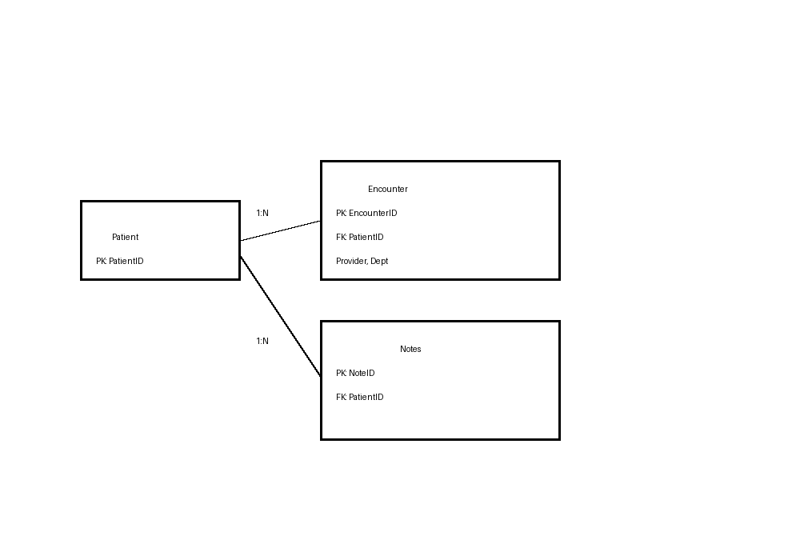

Data Flow Diagram (DFD)
