The Basics of making a ROBOT
Instantiating AMR Development @ UST-Global

Table of Contents

Acknowledgments
Abstract
Chapter 1: Introduction
1.1. What is Robotics?
1.2. Motivation
1.3. Goal

Chapter 2: Software and simulation
2.1. Basic Requirements
2.2. CAD model and analysis
2.3. Making URDF file
2.3.1. Setting up transformations
2.3.2. Setting up Odometry
2.3.3. Setting up sensors
2.4. Setting up robot’s footprint
2.5. Setting up navigation plugins

Chapter 3: Hardware Interfacing
3.1. Mecanum Wheels
3.1.1. Enccoder and Hall-effect sensor
3.2. Command Flow
3.3. Feedback Flow
3.4. Raspberry Pi
3.5. Full connection

Chapter 4: Software-Hardware Integration
Chapter 5: References

Motivation
Having a mechanical background, kinematics and mechanics had always been my field of absolute interest. The idea of automating the mechanical movements so as to achieve a purpose along with increase in efficiency, preciseness, strength fascinated me the most.
Goal
Understanding and becoming proficient in implementing c++ algorithms in robot development. Developing a full-fledged robot using ROS2-foxy.

Chapter 1: Introduction

What is Robotics?
Robotics is a broad, fascinating engineering field aimed to develop devices capable of assisting humans in wide variety of tasks. Robots can be found useful in multiple instances of this dynamic world. An integration of conception, design, mechanical operation makes an robot intelligent. An intelligent robot can be deployed in Army, Space, Hospitals, Warehouses, and pretty much everywhere. A robotic dependency can be a life changer for the disabled.

Prerequisites
Design of a robot is a key component of making a robot. CAD designing in freeCAD is suitable for the purpose. For analysis, COMSOL provided the best interface to develop the understanding.
Talking about the code, programming in c++ provides the fastest way to communicate to hardware. Python on the other hand provides us with the multiple libraries best for implementation probably because of the simplicity of the language. Knowledge and proficiency in these two languages can create a strong base in pursuing the field.

AMR
Automotive Mobile Robots can be deployed for multiple applications. One such application is moving packages and cargo within a warehouse which can improve workflow and productivity. AMR are already deployed in some huge Amazon Warehouses and uses guide lanes for guided movement. The difference in the objective of this paper is to develop AMR for dynamic warehouse environments.
Physical conditions like temperature, terrain, moisture, etc. can vary in different warehouses. Keeping these things in mind the objective of AMR development at UST proposes the following objectives:
- Avoiding use of guide lanes to make it compatible with different terrains.
- Using an efficient path planning algorithm RRT*.

Chapter 2: Software and simulation

2.1. Basic Requirements

Robot Operating System (ROS) is a set of libraries, tools and algorithms for building robot applications. It is an open source tool which provides a systematic and convenient way to design the robot software. It is also termed as the middle-ware of Robotics. ROS also provides with simulation tools and libraries so as to keenly introspect the bot before deploying in physical environments.
In this paper I would be using ROS2-Foxy Fitzroy version of ROS2. Although this is not the latest version, we used this because of the availability of proper documentation and examples to aid us throughout the development.
Linux based open source environments are considered best for ROS based robotics software development as they provide flexibility by giving root access to the system and code. The operating system Ubuntu 20.04-Focal Fossa supports the aforementioned ROS version.

2.2. CAD Modeling

Modeling the basic design can useful to begin the development with. For the cad model of AMR, Fusion 360 is used. Parts and joints are made separately and are imported and assembled to achieve the final product. The parts include Mecanum wheels, screws, L-shaped joints, Truss, Motors, Frame.
Next, a proper stress-strain analysis is done on the model with varying load points and areas to determine the deflection. Factor of safety measure is set to analyze the peak load. The mentioned AMR model supports around 100Kg load as per the software analysis.

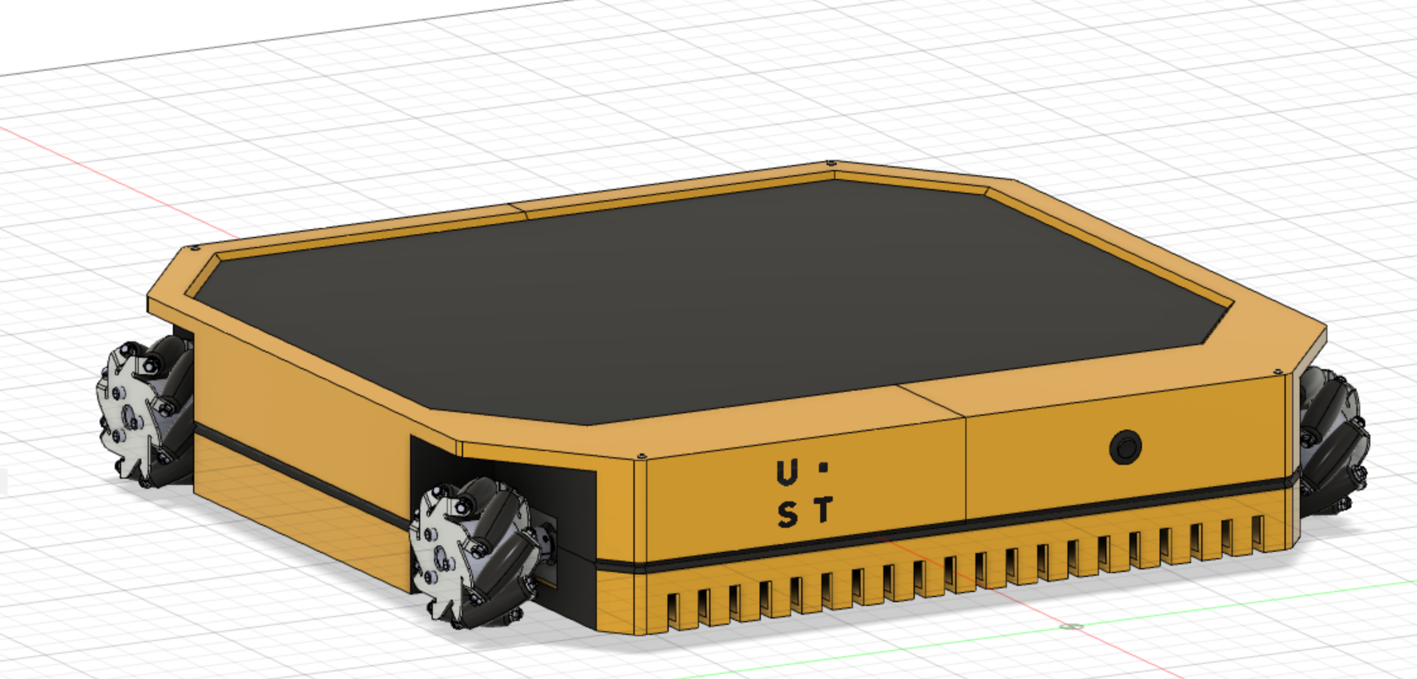
Figure 1: CAD model for AMR

2.3. Creating URDF file
URDF(Unified Robot Description Format) is a file format for specifying the geometry and organization of Robot in ROS. It follows XML style format. One can model transformations, set up Odom of a robot and establish sensors.

2.3.1. Applying Transformations
Transforms allow Nav2 to interpret information coming from various sensors and odometry by transforming them to the desired coordinate frame. It refers to separate coordinate axis frame for each movable joint, sensor.
Generally CAD file mentioned before is converted to URDF file format using converer plugins in software. Make a second check on the URDF file to ensure the authenticity of the code.
For Nav2 to function, three primary transformations are necessary:
- map -› odom
- odom -› base_link
- base_link -› base_laser
MAP refers to the physical surroundings and environment present.
ODOM refers to the pose and velocity related inputs from odometry sensors such as wheel encoders.
base_link is a point on robot which corresponds to point representation of robot while navigating.
base_laser is the coordinate frame of the sensing components.
Map odom transformation is provided by a different ROS package dealing with localization and mapping such as AMCL.

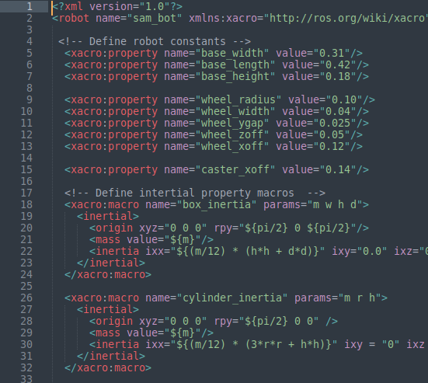Figure 2: Instance of URDF file

2.3.2. Setting up Odometry
The odometry system is responsible to determining the pose and velocity of the robot accurately based on its motion. Odometry information can be retrieved from numerous sensors such as IMU, Lidar, Radar, VIO and wheel encoders.
Some odometry sensors can be used to counter the negative effects produced by other. For instance, IMU sensor readings drift over time whereas encoder values drift over distance. The information published is less accurate over distance but still can be used to navigate the robot to its immediate vicinity.

2.3.3. Setting up sensors
There are a multitude of sensors that can be used in robotics for the purpose of perceiving the environment. The obtaind information

References
- ROS2 Documentation: https://docs.ros.org/en/foxy/index.html#
- Nav2-First Time Robot Setup Guide: https://navigation.ros.org/setup_guides/index.html

